**Quiz 5**

1. Write a Ruby program that Reads from sample.txt (contains plain text) and creates a new config file called text.cfg

Code:

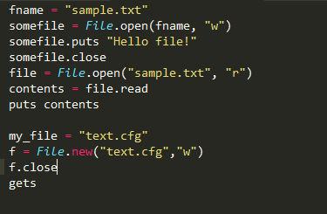

Output:





2.Write a sample ruby program that uses XML and JSON parsing

Code:

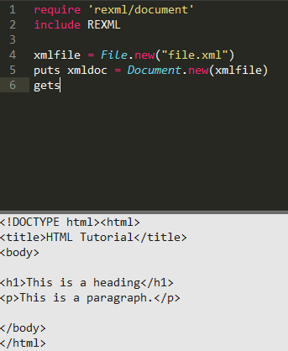

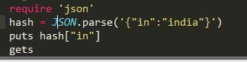

Output:



3.Write a sample program that converts a string or array to YAML ?

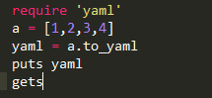

Output:

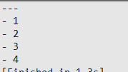

4.Write a Program that converts string to YAML and shows difference between different ways of YAML conversion.

Code:

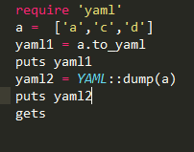

Output:

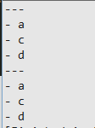

5. Write a sample ruby program for YAML File  and try to modify YAML file

Code:

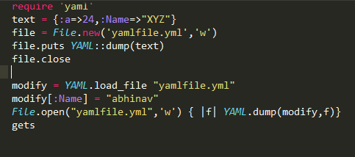

Output:



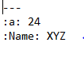



6.Write a Sample ruby program for Parsing YAML

Code:

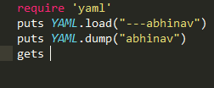

Output:



7.Write a program using YAML which checks for user id and password

8. Write a sample program that connects to database and create a table in database

9.Write a program that creates a connection to an HTTP server. Use net/http

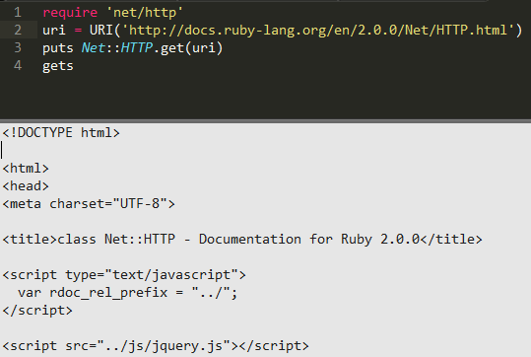

10.Write another sample program that uses NET::HTTPS