**Quiz 2 arun**

1. Ruby program when that accepts a date in a month and prints it out the appropriate suffix. For example, for 1 as input, print 1st, 2 as input 2nd, 3 as input 3rd etc

answer :

require_relative ordinalize

class Integer

puts "enter month number"

number = gets.to_i

if ((number>0)&&(number<31))

puts number.ordinalize

else

puts "invalid month number"

end

end

gets

2. Write your own ruby program using a case statement

answer:

print "Enter your grade: "

grade = gets.chomp

case grade

when "A"

puts 'pass!'

when "B"

puts 'just pass!'

when "C"

puts 'fail'!!!'

else

puts "take test again!"

end

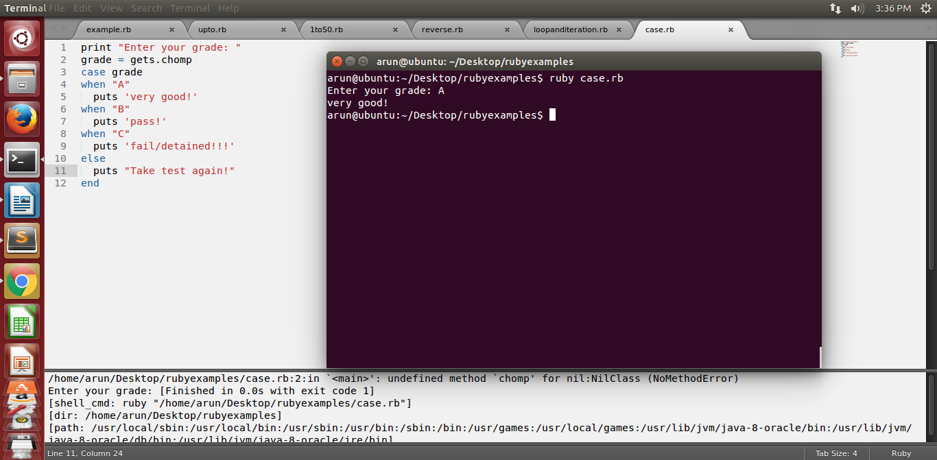

3. Ruby Program that iterates numbers with upto loop

answer: 5.upto(10) { |i| print i, " " }

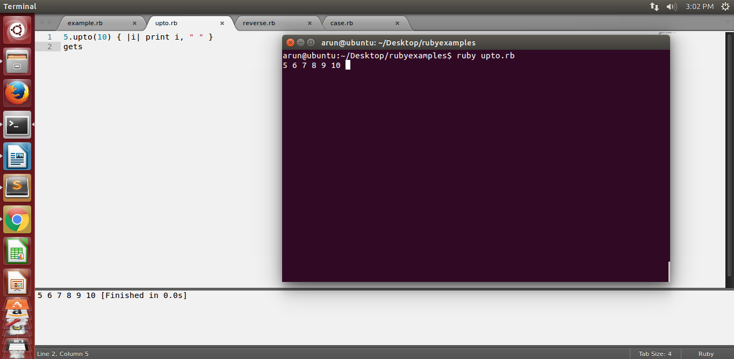

4. Write a Ruby program to print numbers from 1 to 50 and also in reverse order

answer:

def int

int = gets.to_i

for i in int..10

puts i

end

end

int

gets



reverse 1 to 50 :

for n in 50.downto( 0 ) do

puts n

end

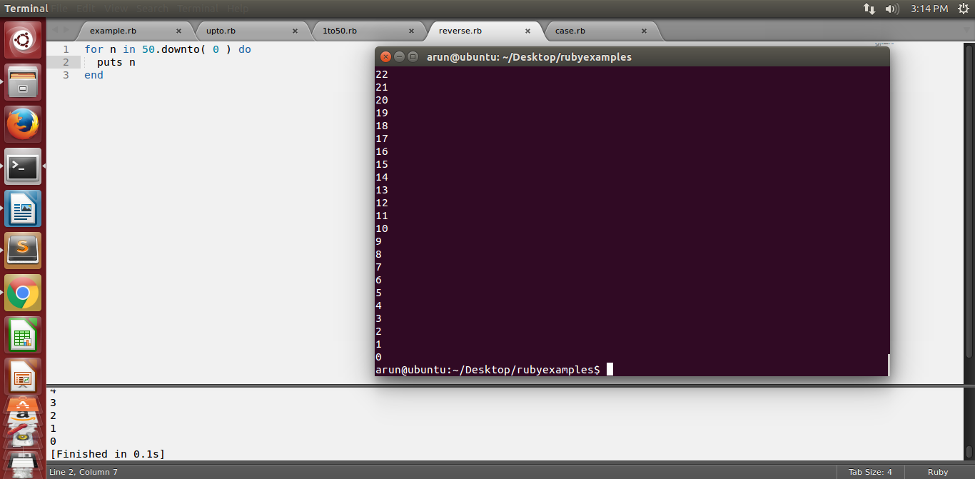

5. Write your own Ruby program using loops and iterators. Explain the difference between loops, iterators and blocks

answer:

i = 10

while i < 50

puts i

i += 10

4.times do

puts "i"

end

end

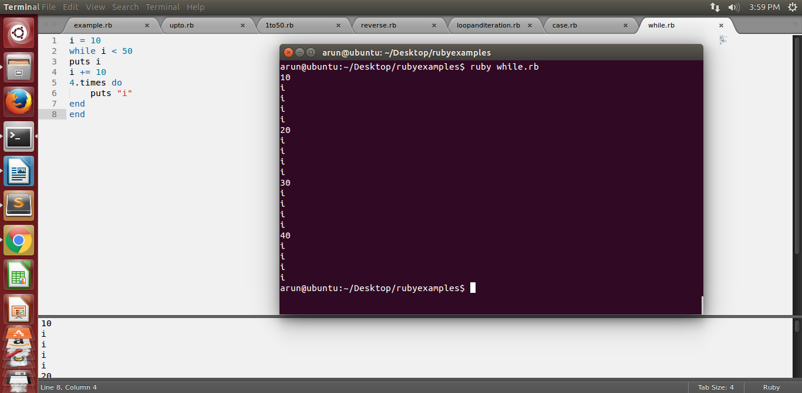

6. Write a Ruby program that loops through a array and checks if a pattern existsin the array elements

answer:

def has_dog?(acct)

[acct.title, acct.description, acct.tag].each do |text|

return true if text.include?("dog")

end

return false

end

gets

7. Write your own Ruby program using a Hash that loops through :

answer:

Print all Values while looping with Keys

Print all Keys while looping through Values

Print Keys, Values as pair.

Answer:

array=["java","ruby","python"]

array.each{|a| puts "pattern value #{a} in array" if a=="java"}

array.each{|b| puts "pattern value #{b} in array" if b=="ruby"}

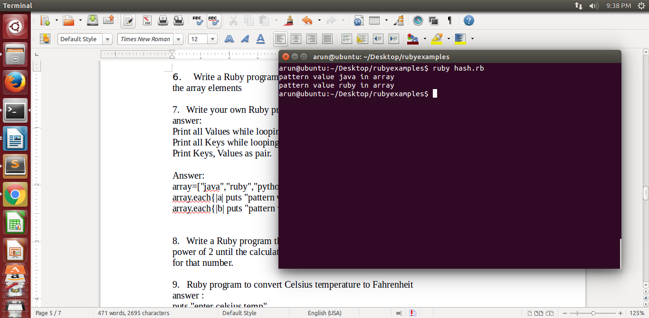

8. Write a Ruby program that takes number as input and recursively calculates the power of 2 until the calculated number is less than 10000 and prints the maximum power for that number.

9. Ruby program to convert Celsius temperature to Fahrenheit

answer :

puts "enter celsius temp"

celsius = gets.to_i

fahrenheit = (9/5) * celsius + 32

puts "fahrenheit value is #{celsius} && celsius is #{fahrenheit}"

gets

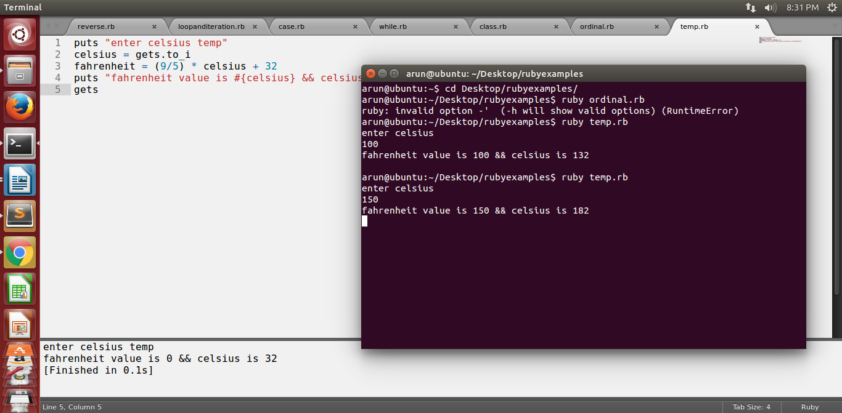

10. Write a program to create a Calculator class with add(), substract(), multiply() and divide(), then take two numbers and choice of operation from user and display output using objects

answer:

class Cal

attr_accessor:val1,:val2

def initialize(val1,val2)

@val1 = val1

@val2 = val2

end

def add()

puts @val1 + @val2

end

def sub()

puts @val1 - @val2

end

def multi()

puts @val1 * @val2

end

def div()

puts @val1 % @val2

end

end

puts "enter val1 for math"

@val1 = gets.to_i

puts "enter val2 for math"

@val2 = gets.to_i

c = Cal.new(@val1,@val2)

puts "enter your selection"

puts "+ or - or * or %"

math = gets.chomp

case math

when "+"

c.add

when "-"

c.sub

when "*"

c.multi

when "%"

c.div

else

puts "invalid choice"

end

