**Quiz 3**

1. Write if/else ruby statement in only one line

answer: puts ( 5 == 5 ? "equal!" : "not equal!" )

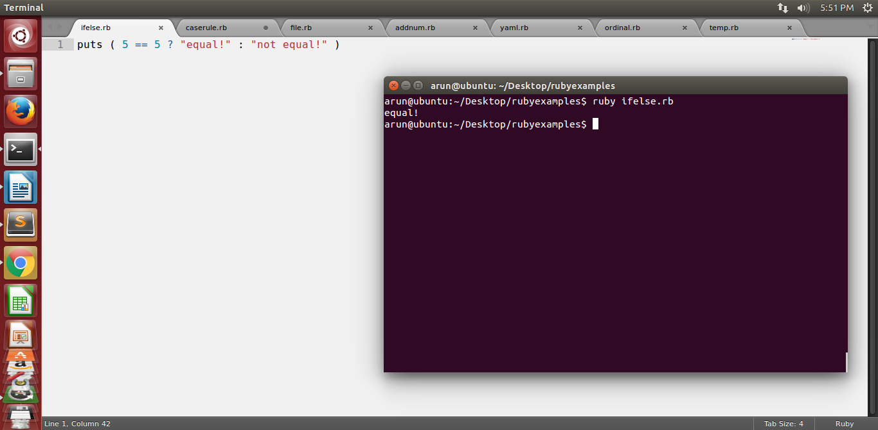

2. Ruby program that calculatesthe sum of all the numbers between 0 and 100 that are divisible by both 3 and 5?

answer:

sum = 0

if i in 0..100

if(i % 3 == 0 && i % 5 == 0)

puts i

sum +=i

end

end

print "the sum is :"sum

gets

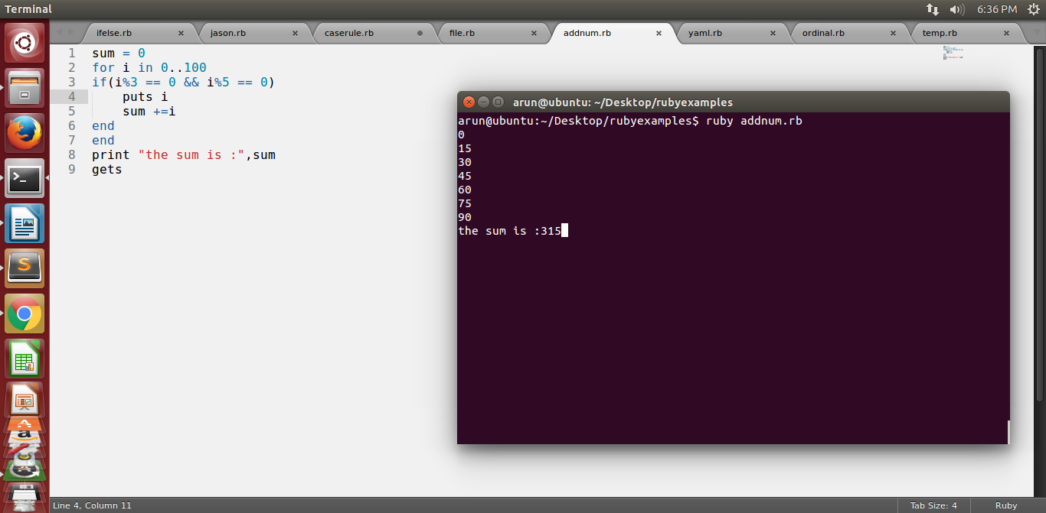

3. Write a Ruby program to convert user input to upper, lower and capital letters

answer:

puts "enter a string value : "

string = gets.chomp

string = string.capitalize

puts string

string = string.downcase

puts string

string = string.upcase

puts string

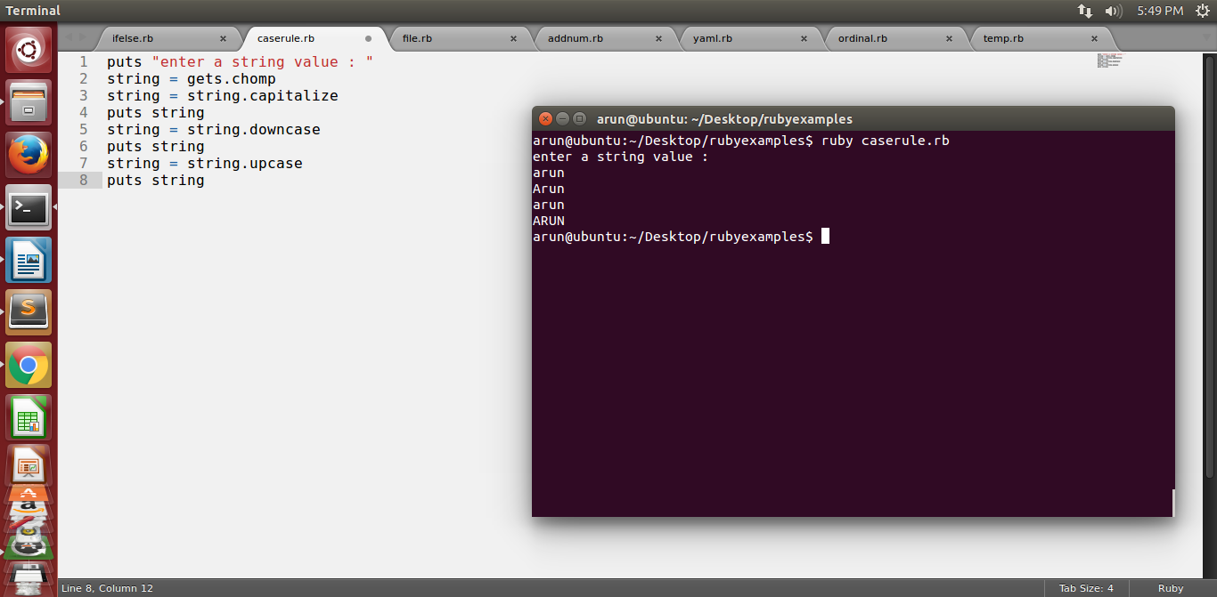

4. File Operations with Ruby

write your own ruby program that :creates a file and writes some text into it, then closes it,open the same file, and print all lines inside that file,

then, delete that file.

Answer:

fname = "rubyfile.txt"

rubyfile = File.open(fname, "w")

rubyfile.puts "Hello ruby !

Ruby is a good programming lang"

rubyfile.close

file = File.open("rubyfile.txt", "r")

contents = file.read

puts contents

def remove_file(file)

File.delete(sample.txt)

end

puts “file is deleted”

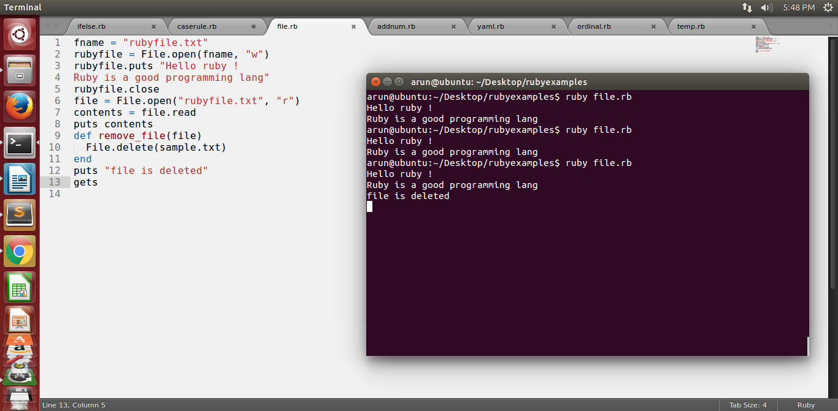

5. write your own Ruby program that converts a array to yml and loads the yml output and print array using:

load()

dump()

answer: require 'yaml'

names = %w[arun pavan kiran rajesh]

yaml_example1 = names.to_yaml

puts yaml_example1

yaml_example1 = YAML::load('yaml_example1.yml')

puts yaml_example1['Hello']

yaml_example1 = YAML::dump(names)

puts yaml_example1

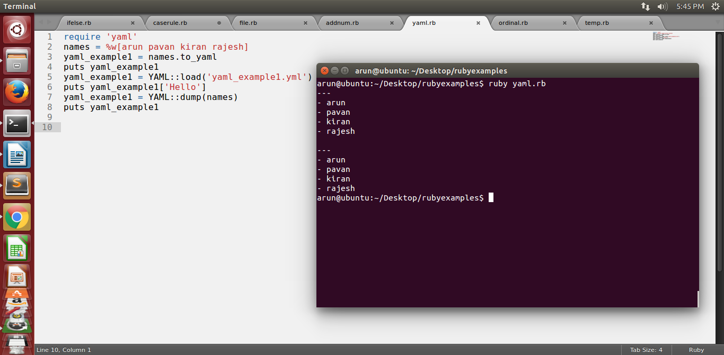

6. Write a Ruby program that converts a array into json, now parse your json looking for a specific array element

7. Write a Ruby program to generate json using  pretty

answer:

require 'json'

my_json = { :array => ['arun','pavan','kiran']}

puts JSON.pretty_generate(my_json)

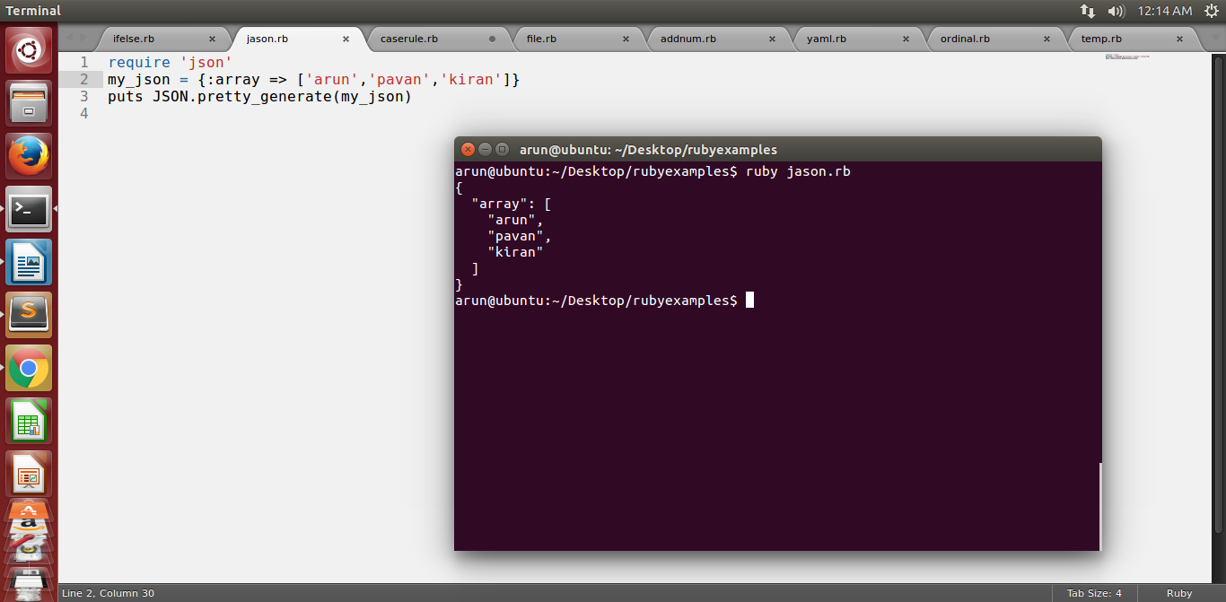

8. Write a Ruby program that connects to MySQL Database in your pc and executes a select query