**Quiz 4**

1. Ruby Program that prints the Time in different time zones

answer: time=Time.new

t=time.to_a

puts Time.local(*t)

puts Time.gm(*t)

puts Time.utc(*t)

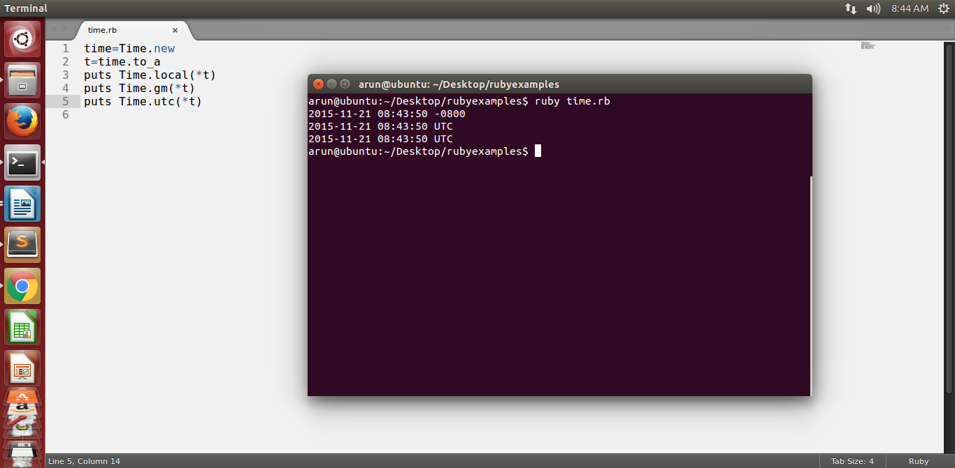

2. Write a program that iterates over an array and builds a new array that is the result of incrementing each value in the original array by a value of 2. You should have two arrays at the end of this program,

The original array and the new array you've created.Print both arrays to the screen using the p method instead of puts.

Answer:

array1=[1,2,3,4,5]

array2=[]

j=0

array1.each{

|elements| array2[j]=elements+2

j+=1

}

p array1

p array2

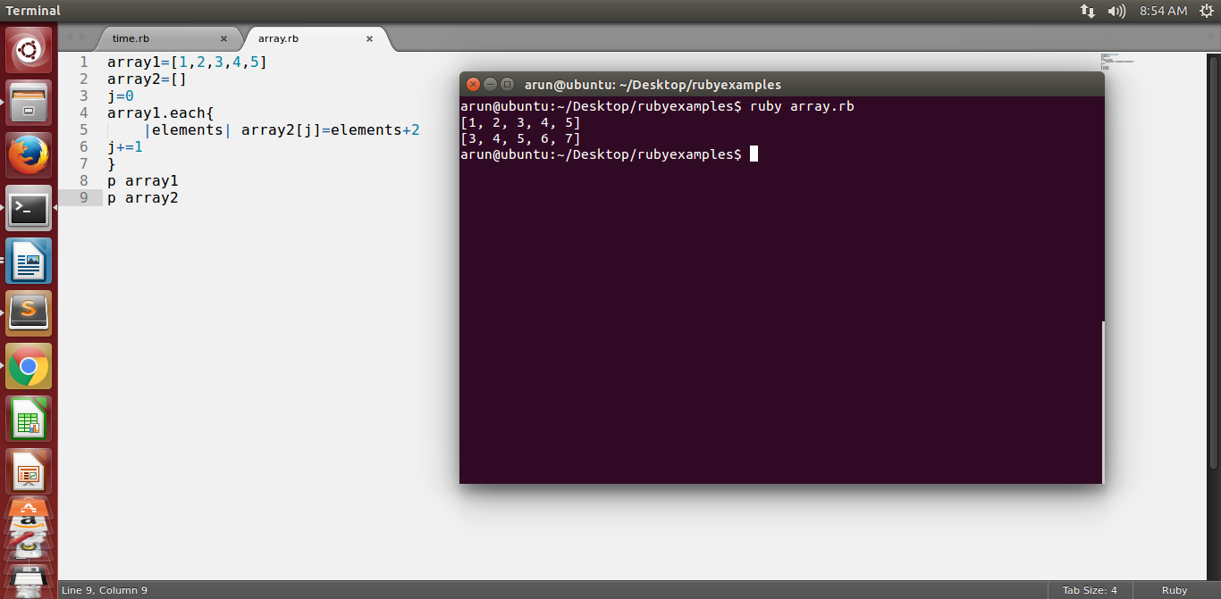

3. Ruby program to find the leap year when start and end year are given.

Answer:

puts "enter starting year"

starting=gets.to_i

puts "enter ending year"

ending=gets.to_i

(starting..ending).each do |year|

next if year % 4 != 0

next if year % 100 == 0 && year % 400 != 0

puts year

end

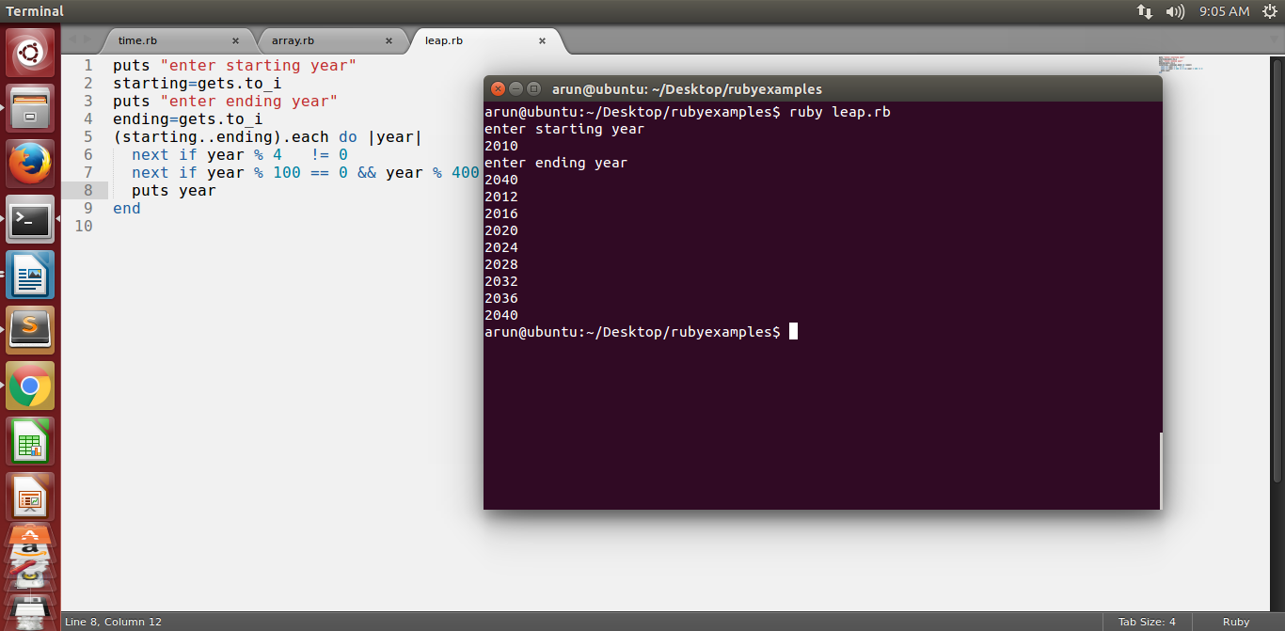

4. Ruby program that takes a numerical value and give the output as Roman number

answer:

RomanNo = Hash[ 1000 => "M", 900 => "CM", 500 => "D", 400 => "CD", 100 => "C", 90 => "XC", 50 => "L", 40 => "XL", 10 => "X", 9 => "IX", 5 => "V", 4 => "IV", 1 => "I"]

print "Enter the number:"

num = gets.to_i

if num < 1000

RomanNo.keys.sort{|a,b| b <=> a }.each do

|n|

while num >= n

num = num-n

print RomanNo[n]

end

end

else

puts "Please enter the number below 999"

end

gets

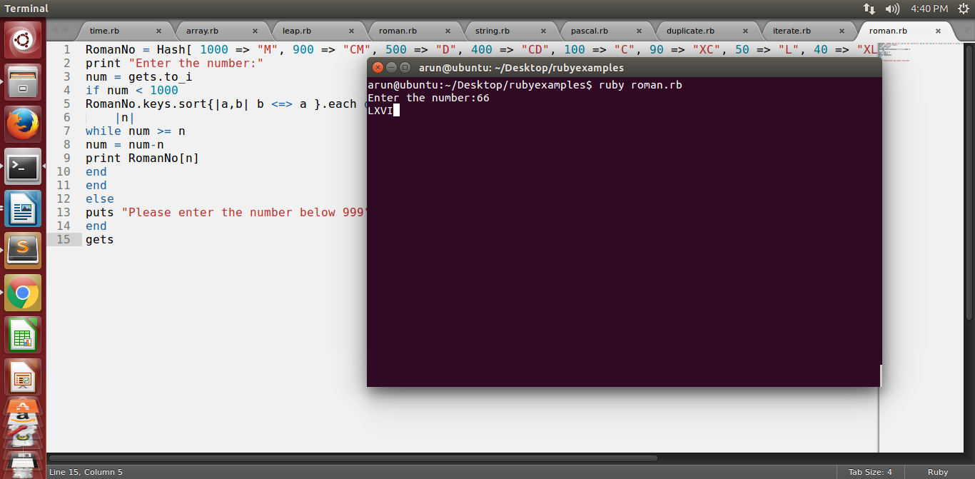

5. Write a your own ruby program that uses a Queue

answer:

arr =[1,2,3,4]

print arr.unshift(5)

puts "\nSize of the Queue is:" ,arr.size

print "\nInserting Values:",arr.push(6)

puts "\nSize of the Queue is: " ,arr.size

gets

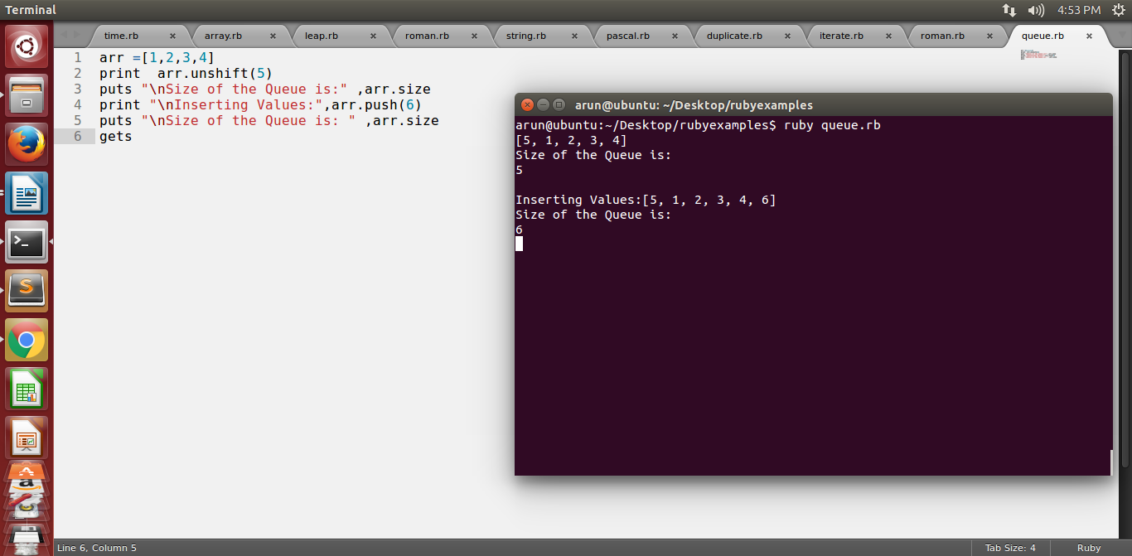

6. Write your own ruby program that uses each_with_index method to iterate through an array that prints each index and value

answer:

array = ["Arun", "varun", "Charan"]

array.each_with_index {|val, index| puts "#{val} => #{index}" }

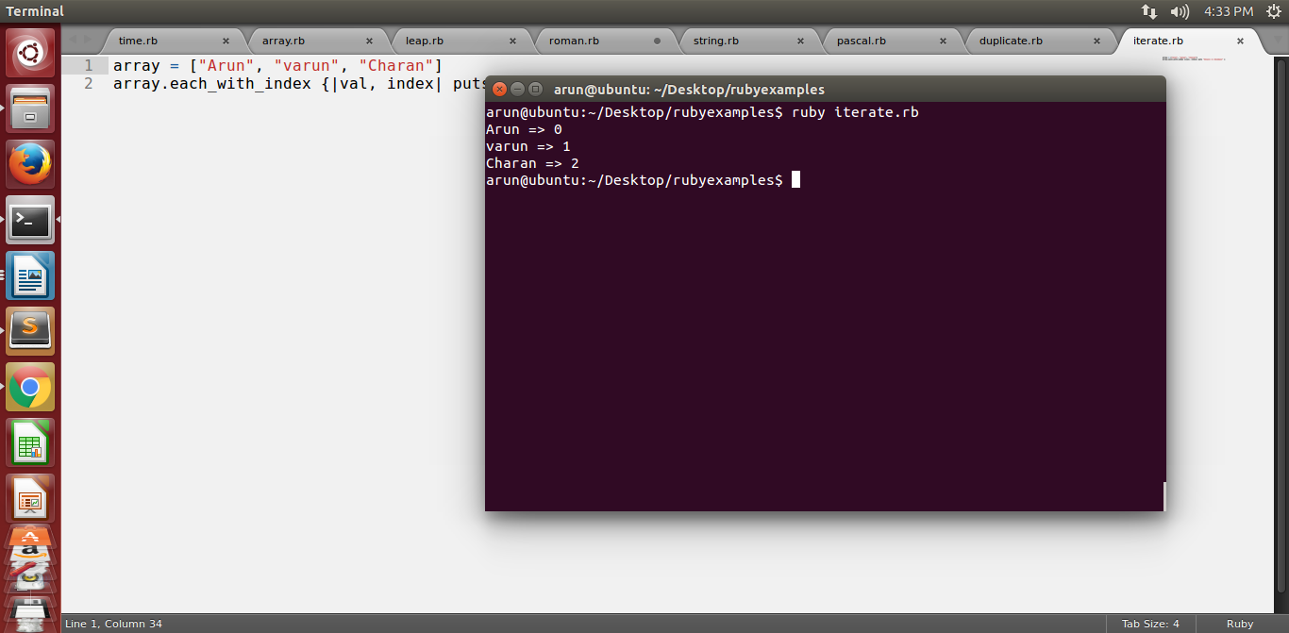

7. Ruby Program that prints if duplicates existing in a array

answer:

a = [1,1,3,4,5,5,6]

duplicate = a.select{ |e| a.count(e) > 1 }

puts duplicate

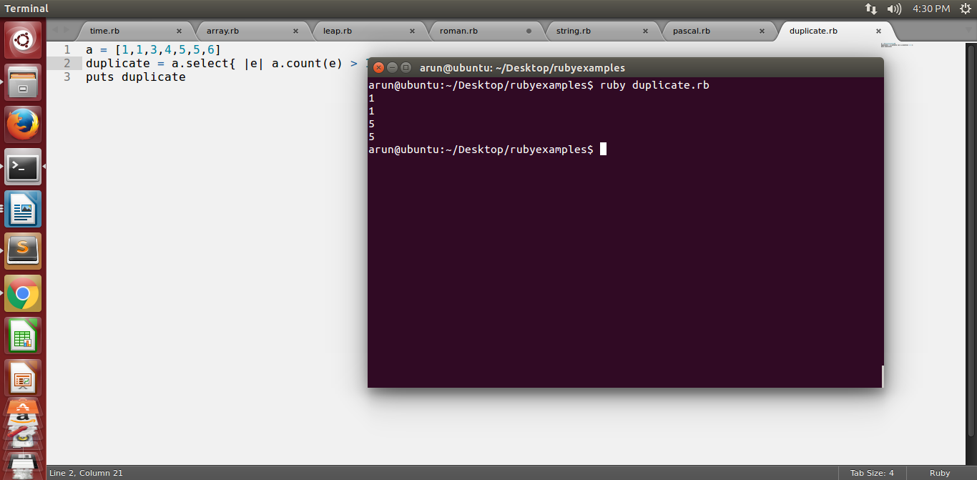

8. Write a Ruby program that prints pascal triangle

answer:

def pascal(n)

raise ArgumentError, "must be positive." if n < 1

yield ar = [1]

(n-1).times do

ar.unshift(0).push(0)

yield ar = ar.each_cons(2).map{|a, b| a + b }

end

end

pascal(4){|row| puts row.join(" ").center(20)}

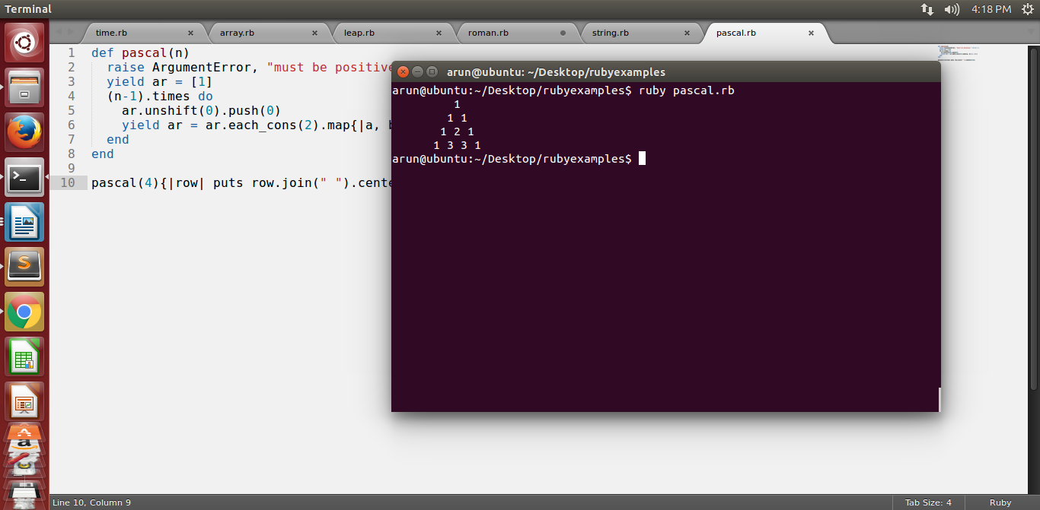

9. Write a Ruby program that prints the length of the common string when two strings are compared.

Answer :

puts "Enter the first string"

string1 = gets.chomp

puts "Enter the second string"

string2 = gets.chomp

if string1 === string2

puts "string length : ",string1.length

else

puts "please Enter the same string"

end

gets

