**Quiz 3**

**kiranraj jonnalagadda**

1. Write if/else ruby statement in only one line

answer:

puts **"please enter a number"**

num=gets.to_i

puts **"kiran" if**(num>5)

output:

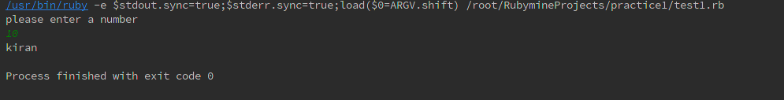

**answer:2**

**puts "please enter a number"**

num=gets.to_i

puts (num>5)?**"true"** :**"false"**

**output:**

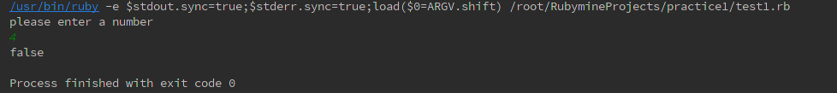

2. Ruby program that calculatesthe sum of all the numbers between 0 and 100 that are divisible by both 3 and 5?

answer:

**sum=0**

**for** *i* **in** 0..100

**if** (*i*%3==0 **and** *i*%5==0)

puts *i*

sum +=*i*

**end**

**end**

print **"the sum of the numbers is :"**,sum

output:

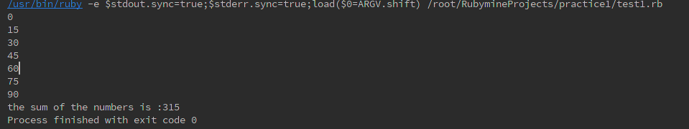

3. Write a Ruby program to convert user input to upper, lower and capital letters

answer:

puts **"please enter a name:"**

name=gets.chomp

puts name.upcase

puts name.downcase

puts name.capitalize

output:

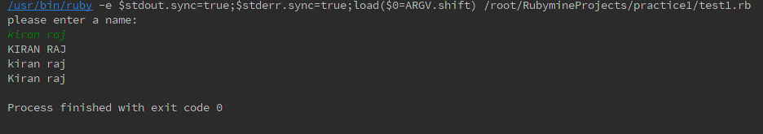

4. File Operations with Ruby

write your own ruby program that :

creates a file and writes some text into it, then closes it,

open the same file, and print all lines inside that file,

then, delete that file

answer:

writing to a file:

file=File.new(**"./sample.txt"**,**"w"**)

file.puts **"hello good morning every body"**

file.puts **"how is it going on!"**

file.puts **"good news today there is no class!"**

file.close()

reading from a file:

file=File.open(**"./sample.txt"**,**"r"**)

file.each {|*line*| puts *line*}

output:

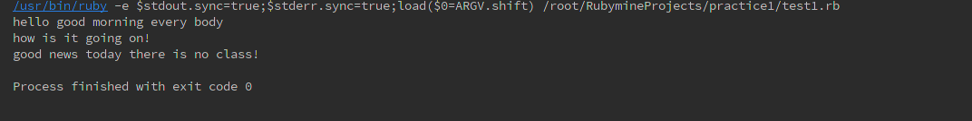

deleting a file:

file=File.delete(**"./sample.txt"**)

output:



5. write your own Ruby program that converts a array to yml and loads the yml output and print array using:

load()

dump()

answer:

require 'yaml'

rubyclass=[**"kiran"**,**"pavan"**,**"rajesh"**,**"arun"**,**"jagadesh"**]

ytype=YAML::dump( rubyclass )

puts ytype

clas=YAML::load(ytype)

puts clas

output:

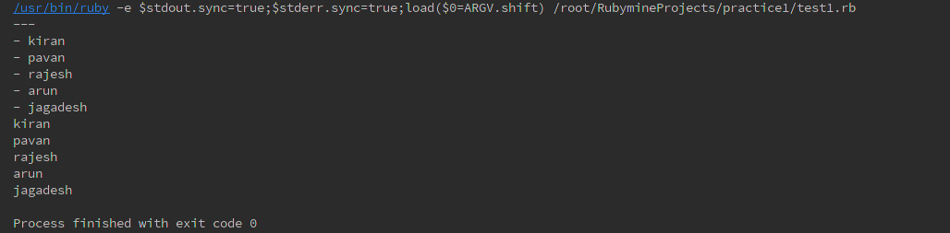

6. Write a Ruby program that converts a array into json, now parse your json looking for a specific array element

answer:

require 'json'

arr=[**"kiran"**,**"arun"**,**"rajesh"**,**"pavan"**]

jarr=arr.to_json

puts jarr

JSON.parse(jarr).each{|*name*|

**if** *name*==**"kiran"**

puts **"kiran Present"**

**end**

**if** *name*==**"anil"**

puts **"anil present"**

**end**

}

output:

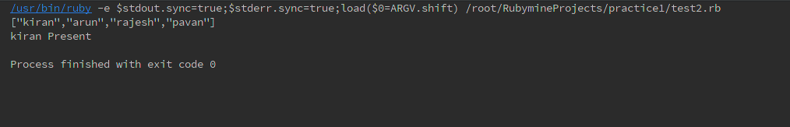

7. Write a Ruby program to generate json using  pretty

answer:

arr=[**"kiran"**,**"arun"**,**"rajesh"**,**"pavan"**]

puts JSON.pretty_generate(arr)

output:

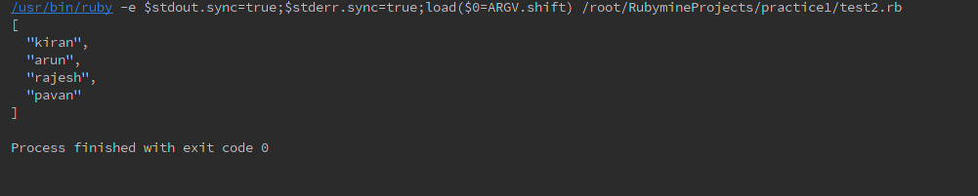

8. Write a Ruby program that connects to MySQL Database in your pc and executes a select query

answer:

require **"mysql"** *#* ***if*** *needed*

con=Mysql.new('localhost','kiran','kiran','testdb')

result=con.query('select * from student')

result.each {|*h*| puts *h*}

con.close

output:

