**Quiz 4**

**jonnalagadda kiranraj**

1. Ruby Program that prints the Time in different time zones

answer:

time=Time.new

t=time.to_a

puts Time.utc(*t)

puts Time.gm(*t)

puts Time.local(*t)

output:

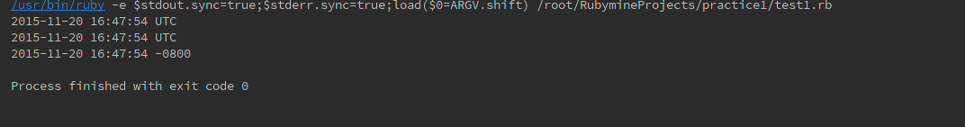

2. Write a program that iterates over an array and builds a new array that is the result of incrementing each value in the original array by a value of 2. You should have two arrays at the end of this program,

The original array and the new array you've created.Print both arrays to the screen using the p method instead of puts.

Answer:

arr1=[1,2,3,4,5,5,6,]

arr2=[]

i=0

arr1.each {

|*elements*|

arr2[i]=*elements*+2

i+=1

}

p arr1

p arr2

output:

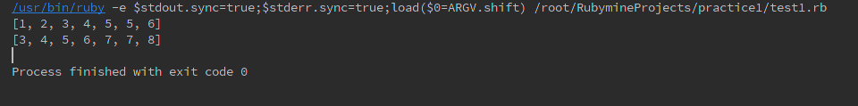

3. Ruby program to find the leap year when start and end year are given.

Answer:

require 'date'

puts **"please enter a starting year"**

*Syear*=gets.to_i

puts **"please enter a ending year"**

*Eyear*=gets.to_i

**for** *i* **in** Syear..Eyear

**if** Date.leap?( *i* )

print *i*,**" is a leap year** \n**"**

**end**

**end**

output:

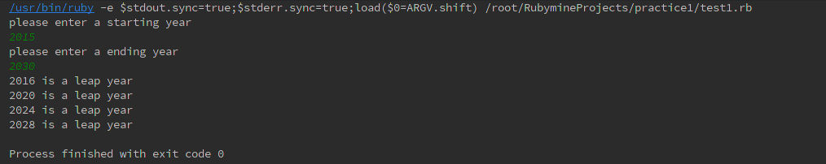

4. Ruby program that takes a numerical value and give the output as Roman number

answer:

puts **"please enter a number :"**

num=gets.to_i

**if** ((num>0) && (num<4000))

thousands=[**" "**,**"M"**,**"MM"**,**"MMM"**]

hundreds=[**" "**,**"C"**,**"CC"**,**"CCC"**,**"CD"**,**"D"**,**"DC"**,**"DCC"**,**"DCCC"**,**"CM"**]

tens=[**" "**,**"X"**,**"XX"**,**"XXX"**,**"XL"**,**"L"**,**"LX"**,**"LXX"**,**"LXXX"**,**"XC"**]

unit=[**" "**,**"I"**,**"II"**,**"III"**,**"IV"**,**"V"**,**"VI"**,**"VII"**,**"VIII"**,**"IX"**]

tho=num/1000

hud=(num/100)%10

te=(num/10)%10

un=num%10

print **"Roman Equilent is :"**,thousands[tho],hundreds[hud],tens[te],unit[un]

**else**

puts **"please enter a valid number"**

**end**

output:

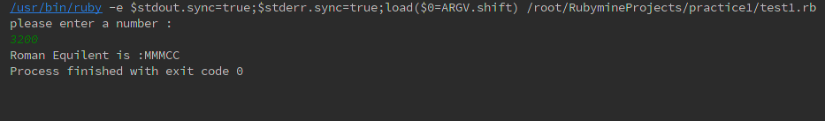

5. Write a your own ruby program that uses a Queue

answer:

arr=[]

arr.unshift(**"arun"**)

arr.unshift(**"kiran"**)

arr.unshift(**"anil"**)

puts arr.size

arr.pop()

puts arr

puts arr.size

output:

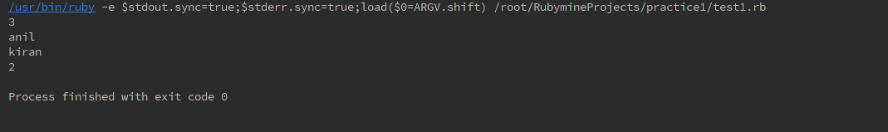

6. Write your own ruby program that uses each_with_index method to iterate through an array that prints each index and value

answer:

arr=[1,2,3,4,5,6,7]

arr.each_index {|*index*| print *index*,**"=>"** ,arr[*index*],**"**\n**"**}

output:

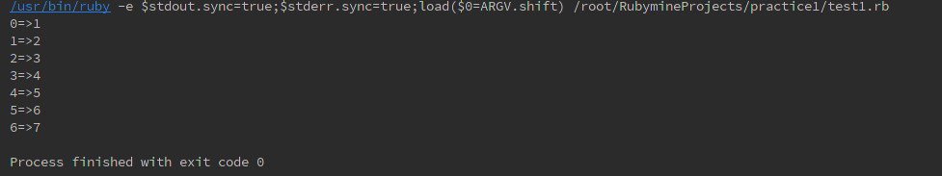

7. Ruby Program that prints if duplicates existing in a array

answer:

arr=[1,2,3,5,5,6,6]

res = arr.select{|*element*| arr.*count*(*element*) > 1 }

puts res.uniq

output:

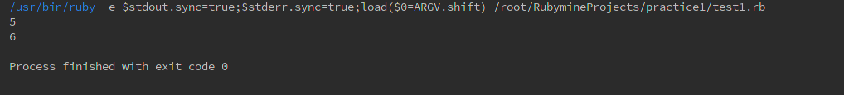

8. Write a Ruby program that prints pascal triangle

answer:

puts **"please enter a number "**

rows=gets.to_i

triangle = []

**if** rows >= 1

triangle.push([1])

**end**

**if** rows >= 2

triangle.push([1, 1])

**end**

last_row = [1, 1]

count = 3

**while** count <= rows

next_row = [1]

index = 0

**while** index < last_row.length - 1

next_row.push last_row[index]+last_row[index + 1]

index = index + 1

**end**

next_row.push(1)

triangle.push(next_row)

last_row = next_row

count = count + 1

**end**

number_length = last_row[last_row.length / 2].to_s.length

triangle_length = last_row.length * number_length + last_row.length - 1

triangle.each **do** |*row*|

final_row = []

*row*.each **do** | *number*|

final_row.push(*number*.to_s.center(number_length))

**end**

puts final_row.join(' ').center(triangle_length)

**end**

output:

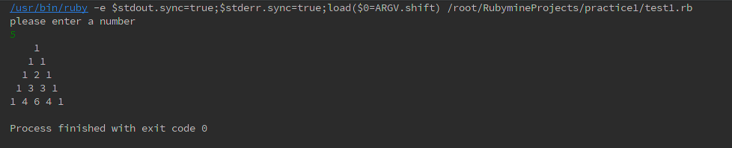

9. Write a Ruby program that prints the length of the common string when two strings are compared.

Answer:

puts **"please enter a name:"**

name1=gets.chomp

puts **"please enter a name:"**

name2=gets.chomp

**if** name1===name2

puts **"two strings are equal"**

print **" the length of the string is "**,name1.length

**end**

output:

