**Quiz 3**

1. Write if/else ruby statement in only one line

**ANs) #!/usr/bin/env ruby**

puts ( 10 == 10 ? "true!" : "false!" )

Output:-

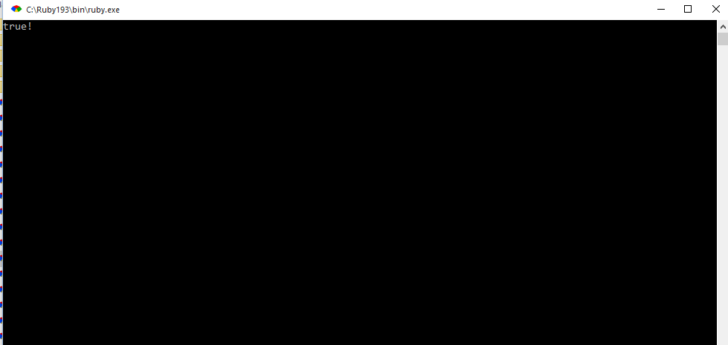

2. Ruby program that calculatesthe sum of all the numbers between 0 and 100 that are divisible by both 3 and 5?

Ans) #!/usr/bin/env ruby

sum = 0

for i in 0..100

if(i%3==0)&&(i%5==0)

sum = sum+i

puts i

end

end

puts "the sum of numbers is :",sum

gets

Output:-

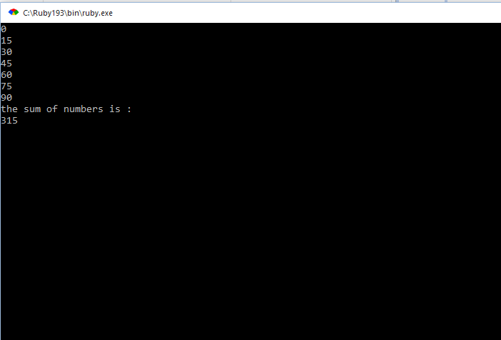

3. Write a Ruby program to convert user input to upper, lower and capital letters

Ans) #!/usr/bin/env ruby

puts "enter a string value : "

string = gets.chomp

string = string.capitalize

puts string

string = string.downcase

puts string

string = string.upcase

puts string

Output:-



4. File Operations with Ruby

write your own ruby program that :

creates a file and writes some text into it, then closes it,

open the same file, and print all lines inside that file,

then, delete that file

5. write your own Ruby program that converts a array to yml and loads the yml output and print array using:

load()

dump()

Ans) #!/usr/bin/env ruby

require 'yaml'

names = %w[India Uk Us Uae ]

#Example 1: dump()

yaml_example1 = YAML::dump(names)

puts yaml_example1

#Example 2: load()

array_example = YAML::load(yaml_example1)

puts array_example

gets

Output:-

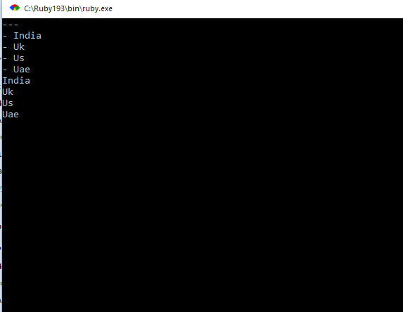

6. Write a Ruby program that converts a array into json, now parse your json looking for a specific array element

Ans):-

7. Write a Ruby program to generate json using  pretty

Ans) #!/usr/bin/env ruby

require 'json'

my_json = { :array => [“India”,”Usa”,”Uk”]}

puts JSON.pretty_generate(my_json)

gets

Output:-

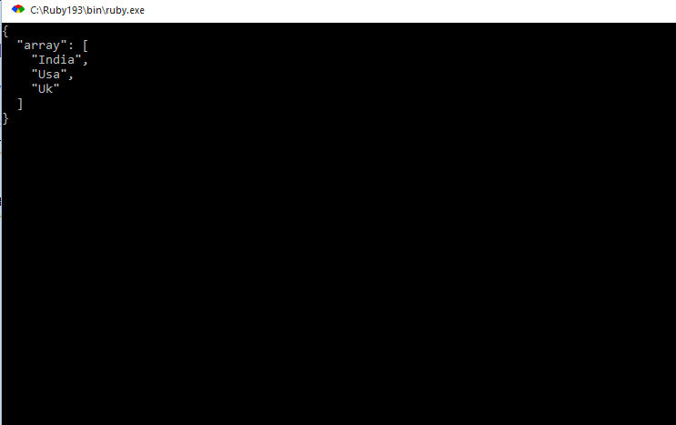

8. Write a Ruby program that connects to MySQL Database in your pc and executes a select query