**Quiz 5**

1. Write a Ruby program that Reads from sample.txt (contains plain text) and creates a new config file called text.cfg

**Ans) *file = File.new("testing.txt", "w")***

***file = File.open("testing.txt", "r")***

***file = File.new("text.config", "w")***

***file.close***

***gets***

**Output:-**

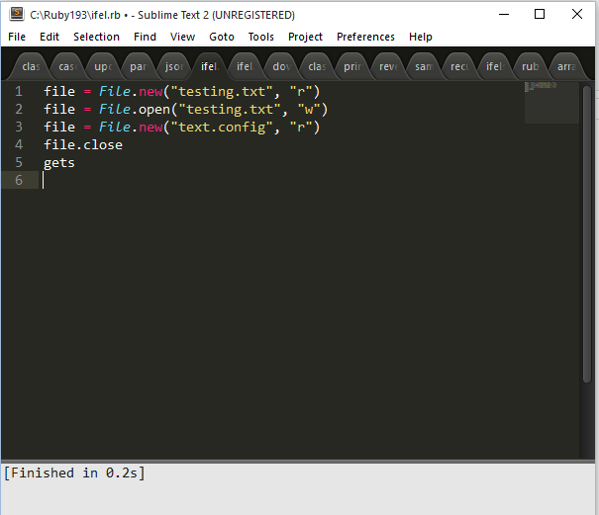

2. Write a sample ruby program that uses XML and JSON parsing

Ans) require 'json'

my_hash = JSON.parse('{"India": "USA"}')

puts my_hash["India"]

gets

Output:-

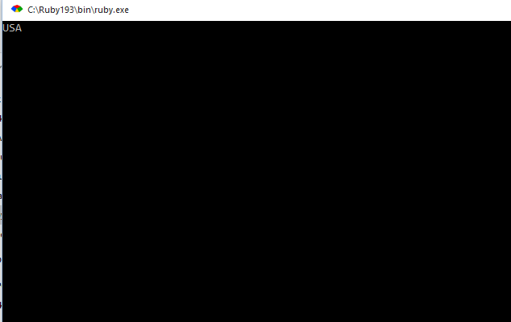

require 'rexml/document'

include REXML

xmlfile = File.new("testfile.xml")

puts xmldoc = Document.new(xmlfile)

gets

Output:-

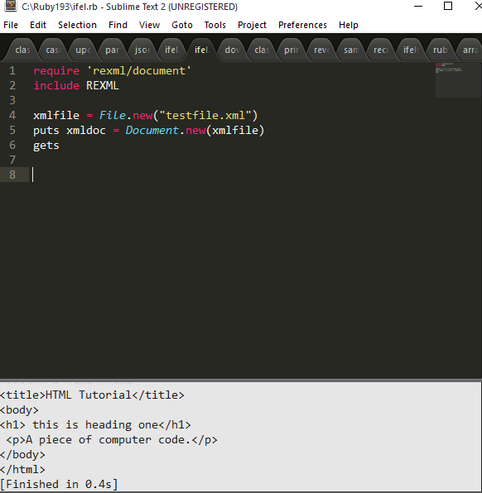

3. Write a sample program that converts a string or array to YAML ?

Ans) require 'yaml'

names = %w[pavan lissy levi]

yaml_arraytoyaml = names.to_yaml

puts yaml_arraytoyaml

gets

Output:-

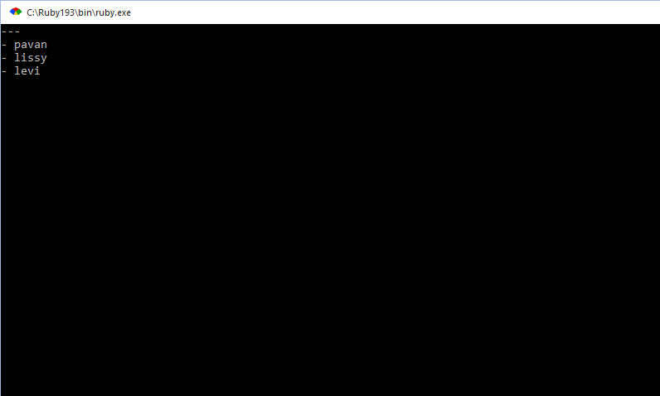

4. Write a Program that converts string to YAML and shows difference between different ways of YAML conversion.

ANs)

require 'yaml'

names = %w[pavan lissy levi]

Example 1 : Converting an array into YAML using: to_yaml

yaml_example1 = names.to_yaml

puts yaml_example1

Example 2: Converting an array into YAML using: dump()

yaml_example2 = YAML::dump(names)

puts yaml_example2

5. Write a sample ruby program for YAML File  and try to modify YAML file

Ans) require'yaml'

hash={India:100,USA:200,UK:300}

file1=File.new('sample.yml','w')

puts hash

file1.puts YAML.dump(hash)

gets

Output:-

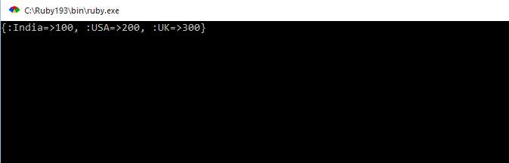

6. Write a Sample ruby program for Parsing YAML

Ans) require 'yaml'

puts YAML.load("---Pavan")

puts YAML.dump("Pavan")

gets

Output:-

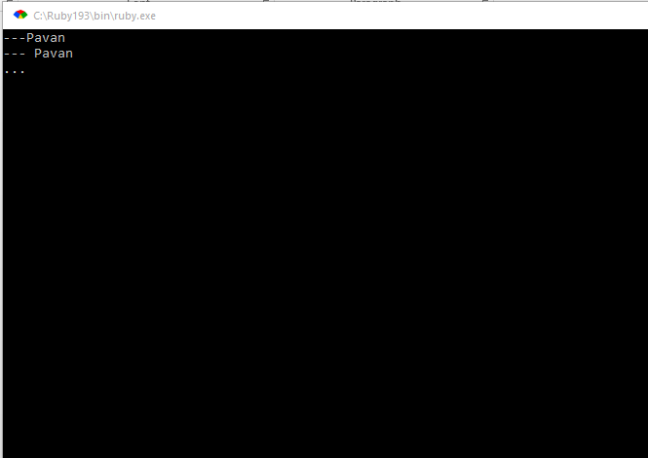

7. Write a program using YAML which checks for user id and password

8. Write a sample program that connects to database and create a table in database

9. Write a program that creates a connection to an HTTP server. Use net/http

Ans) require'net/http'

puts Net::HTTP.get('www.foxnews.com','/index.html')

gets

Output:-

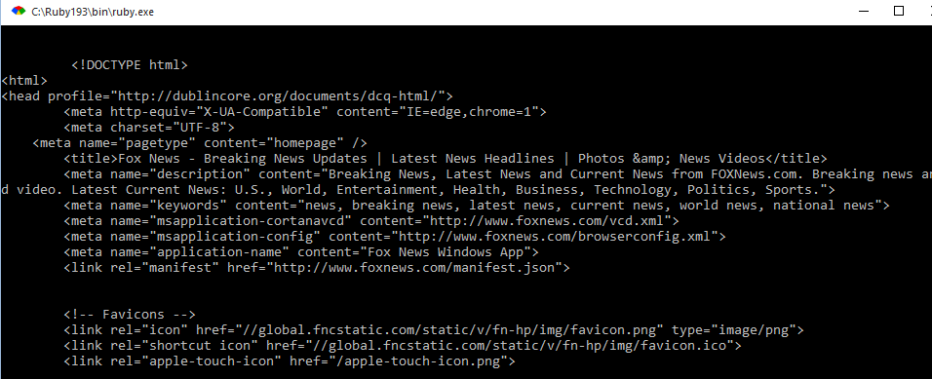

10. Write another sample program that uses NET::HTTPS