Requirements:

Ubuntu 20.04, 4GB RAM.

CPU and disk requirements are not provided by the Team but I would recommend at least 2 CPU and 80GB disk space (be ready to resize).

The script is invented for Agoric Incentivized Testnet. You may need to change it for other tesnets:

1. Change <https://testnet.agoric.net/>... In all the places to something else. As example: <https://devnet.agoric.net/>...
2. Use another Use GIT_BRANCH=…
3. Use another faucet channel in Discord.

Usage:

1. It is supposed that you are going to use separate sever for Agoric node and run it under root user.
2. Copy the script agoric_setup.sh to /root folder of your server.
3. Make it executable:

chmod +x agoric_setup.sh

1. Run the script ./agoric_setup.sh
2. It will ask the name of your node. Type it and hit enter
3. The script will install all the necessary tools. If you see such screen

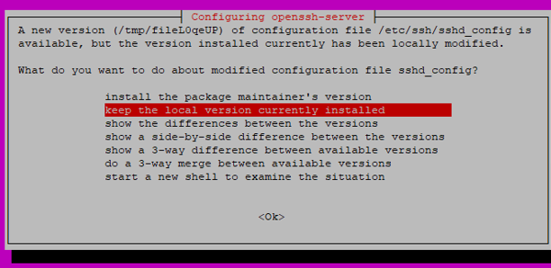

Just keep the local version

1. When the script is configuring SDK it will ask if you want to generate the new key. If you have not generated the key before or need to update it then type in ‘y’ (without quotes) and hit enter.

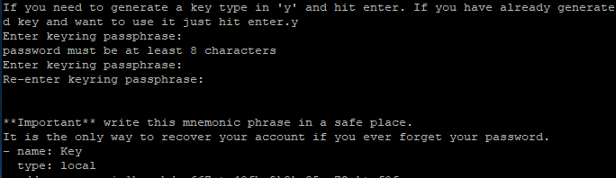

The script will also ask you to input passphrase (if you have not generated it before than make new one).

You will see your address and mnemonic phrase. Write it down. Mnemonic will also be saved to /root/mnemonic file.

Then go to Agoric discord and ask test tokens in faucet. When you got tokens hit enter and script will go further.

1. The script will configure the node, create systemd task and run it. Then it will loop until node is synced.

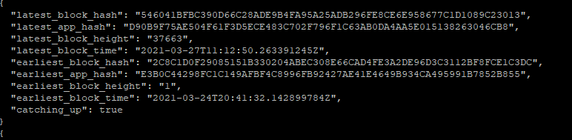

1. Then it will create tx to create validator. It will ask you to enter your passphrase and confirm tx. After this you should see confirmation message.