ODT Summative 2
Project Approval Document

Student Name | Manasa | Section | Section C
Student ID | 2025014044 | Course | ODT — Object Design & Technology
Project Title | Wanderer — A Dancing Doll Console Game
Team Members | Manasa (Lead — Electronics, Software, Assembly) | Arshia (Code & Assembly Support) | Aryan (Materials & Logistics)

Idea Brief
What is the project?
Wanderer is an interactive arcade-style installation built on two ESP32 microcontrollers. The player sits at a hand-built console and plays a rhythm game — pressing directional buttons to match falling arrow notes on an OLED display. Simultaneously, a small dancing doll on a physical stage moves its limbs in real time, reacting to each button press via a wireless ESP-NOW link. The result is an experience where the player feels like both a rhythm-game contestant and a live puppeteer.

What experience is it designed to create?
Wanderer is designed to make computing feel alive and physical rather than abstract. Most digital games exist entirely on a screen — Wanderer solves this by giving the output a body. The doll dances because you pressed a button. The goal is to be playful, surprising, and character-driven, bridging the gap between an electronic game console and a physical performance on stage.

Who is it for?
Anyone who walks up to the installation — no prior knowledge of games or electronics required. Children are drawn to the doll's physical movements; older players engage with the rhythm game challenge; technically curious viewers appreciate the electronics and wireless communication at work.

Key Technical Components:
- Console Unit: ESP32 #1 + SH1106 OLED (game display) + SSD1306 OLED (character animation) + 6 push-buttons
- Stage Unit: ESP32 #2 + PCA9685 PWM driver + 4 × SG90-class servo motors driving doll limbs
- Wireless link: ESP-NOW (low-latency, peer-to-peer Wi-Fi) for button command transmission
- Console enclosure: 3D-printed PLA shell; Stage: laser-cut MDF box-joint construction
- Software: MicroPython — game loop, note timing engine, animation state machine, ESP-NOW sender/receiver

Inspirations & References:
- Dance Dance Revolution — directional arrow rhythm game format and falling-note visual language
- Guitar Hero / Beat Saber — physical input mapped to musical timing; single-player arcade feel
- Disney Audio-Animatronics — a character that physically expresses motion in response to input
- Tamagotchi / virtual pets — a character that reacts and performs based on player actions

What problem does it solve?
Digital games produce all their output on a screen — invisible to anyone not looking directly at the display. Wanderer makes the output tangible and room-scale: a doll that visibly dances in response to a button press, visible from across the room, inviting bystanders to engage even before they touch the console.

Success Criteria (Summary):
- Button press registers within ±250 ms timing window; no double-triggers from rapid pressing
- Both OLED displays update within one 5 ms game loop cycle — no perceptible lag
- ESP-NOW command delivered console → stage in < 100 ms
- Doll limb moves to target angle and returns to neutral within 0.3 s of receiving command
- A first-time player understands the directional mechanic within 30 seconds, without explanation

Basic Idea Sketch
System Architecture Mind Map — Wanderer
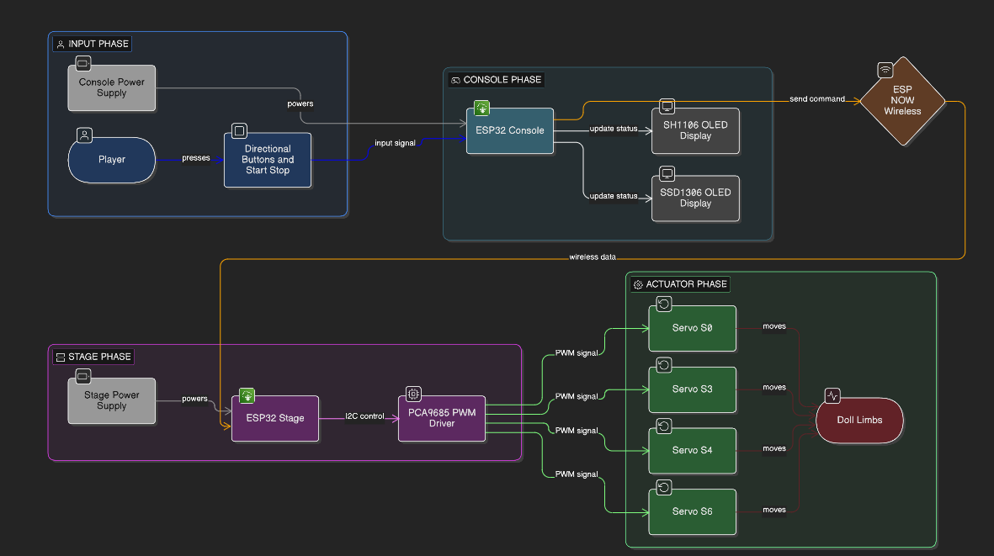

Figure 1 — Initial concept sketch: signal flow from player input (buttons) through ESP32 Console CPU, dual OLED displays, ESP-NOW wireless communication, and servo-driven doll limbs on the physical stage.

The sketch maps the four major subsystems of Wanderer: INPUT (4 directional buttons + Start/Stop), CONSOLE CPU (ESP32 #1 driving two independent OLED displays), WIRELESS COMMS (ESP-NOW link between ESP32 #1 Console and ESP32 #2 Stage), and OUTPUT / STAGE (PCA9685 PWM driver controlling servos S0, S3, S4, S6 to animate the four doll limbs). The two OLED displays serve independent roles — the SH1106 renders the rhythm game lane grid, and the SSD1306 renders the animated character reactions
(Made by Manasa ALONE).

Student Signature  Manasa | 2025014044  _______________________________ | Faculty / Reviewer Approval  Name: Nayan Prakash  _______________________________
Date Submitted: | ☐ Approved ☐ Revisions Required ☐ Rejected

