By using the Network Manager TUI on the Raspberry Pi, I set the static IPv4 to 10.200.12.23, then successfully pinged it.

Next, I sent a file from the Windows machine onto the Linux machine.

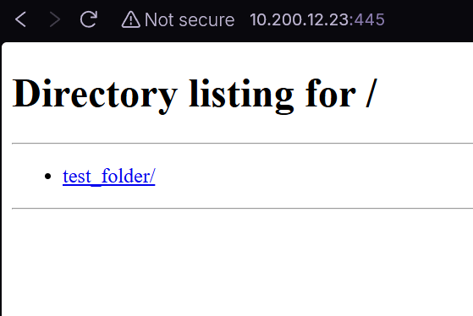

I also made a python script that shows you some simple information about your machine for later use, then committed it to GitHub.

Then, on the Raspberry Pi, I cloned and pulled the repository.

