Lab 1

1)

Phone GPS: 32.579981° N -85.495618° E

Online GPS: 32.57997° N -85.49558° E

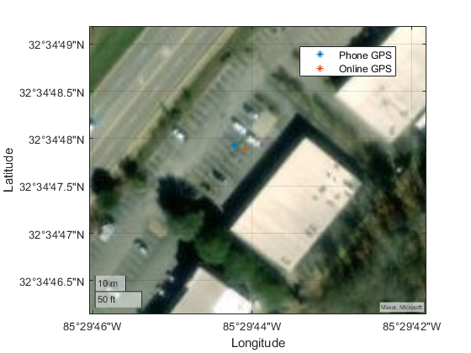

The GPS location recorded by the phone while finding the cache was relatively similar to the GPS location published by the Geocache website. The position only varied by a few meters. Some of this error in GPS location could also be due to the phone GPS location being taken slightly away from the cache itself.

2) The terrain around the cache was relatively open, as it was in a parking lot. There was a building somewhat close as well as car in the parking lot. It is unlikely that these interfered with the GPS signal. It was however a very cloudy and overcast day which could yield poor satellite visibility.

3) The location was taken at 11:21:27 a.m. on January 31, 2024.

4)

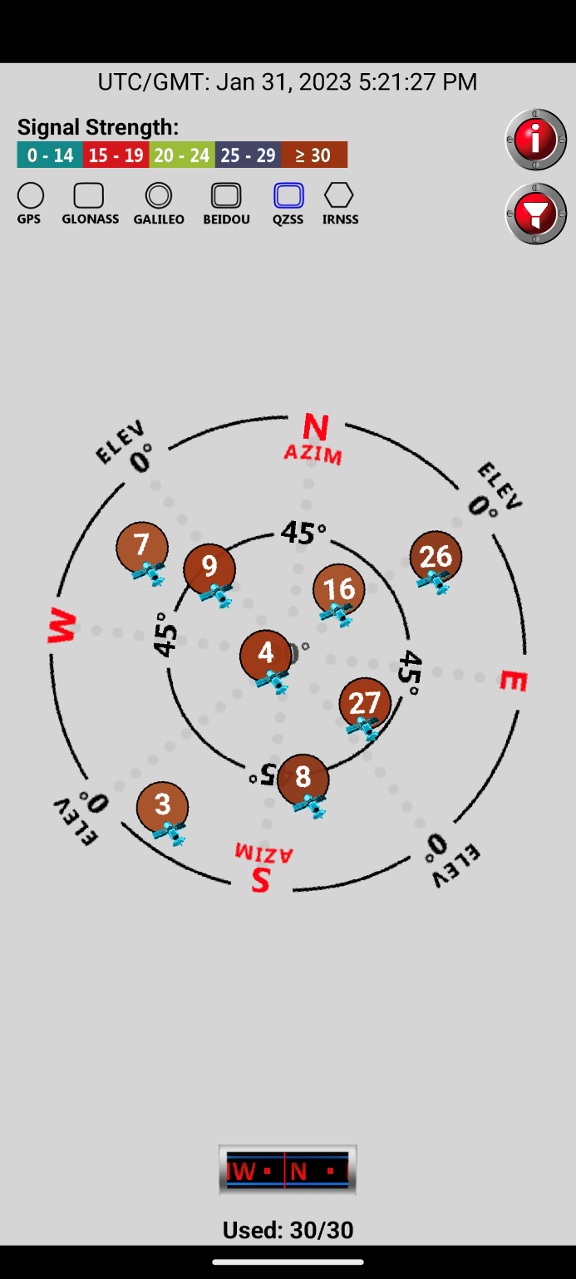

The screenshot above shows that 8 satellites were in range with relatively good signal strength. The number of which satellites were available is shown in the picture.

5)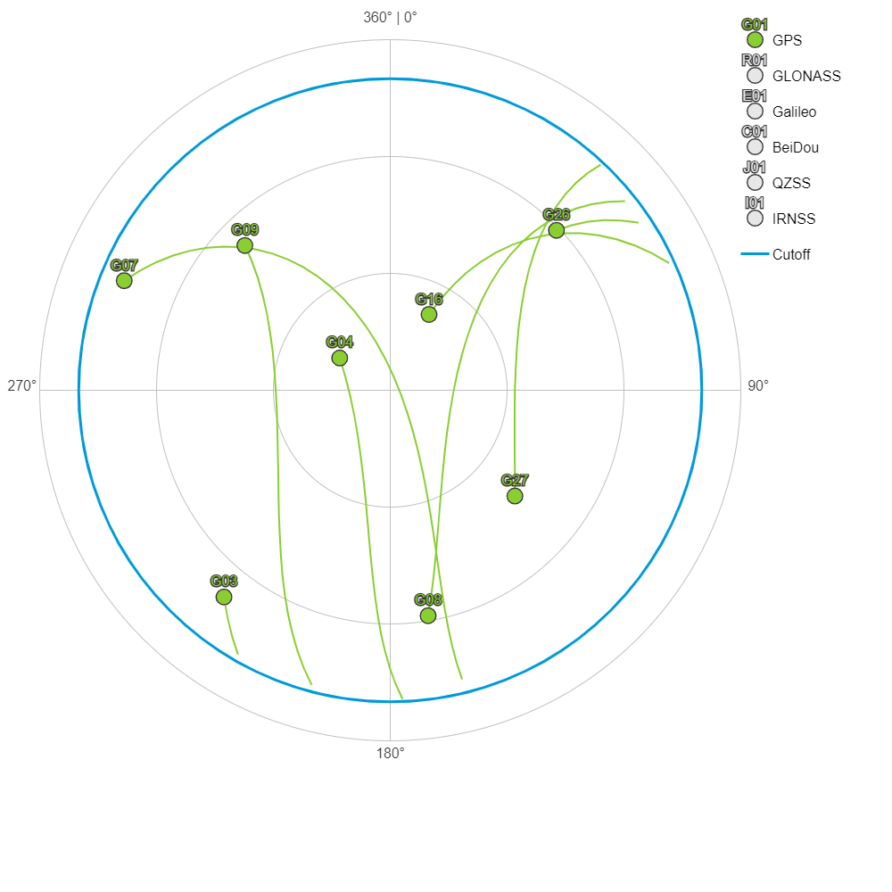

In the sky plot graph found using the Trimble website, 8 satellites were available during the time the cache was found. This is the same number of satellites found using the phone app. Additionally, the satellite numbers were the same as well as their relative positioning. For example, satellite 4 and 16 are seen near the center of the viewable zone in both cases while satellite 7 is very close to the cutoff. Little difference is seen between the two sky plots.

6)