Final Project Design Document:

Encrypting Machine

by **Carlos Rubio** and **Stephanie Gregory**

*CS2810-002: Introduction to Computer Architecture*

**Dr. L. Roy Thackeray**

Classic Encrypting Machine

Design and Features

# Project Description

A routine that can generate an encrypted message in Caesar’s cipher system based to certain parameters, including the integer from 1 to 26 that represents the key and a string of ASCII uppercase characters which represents the message. The supported encrypting system is Caesar’s Cipher. The program will consist of a main loop in which the user can input some basic arguments, and then one of the many subroutines will start, returning and exporting an encrypted message.

# Feature descriptions

1. Selection of one of two modes based on Caesar’s Cipher: an encryption mode that adds a positive key to an ASCII string, and a decryption mode that subtracts a positive key to an ASCII string.
2. The program will work on a loop, allowing multiple consecutive sessions.
3. The program error proves the input parameters and avoids unsupported arguments (Goose Typing)
4. The program handles strings of ASCII uppercase and whitespace (Space) characters properly.
5. The program handles ASCII numeric strings with with variable number of characters (digits) and converts properly them to binary for easy integer-binary arithmetic.

# User Interface (Command Line Interface)

## Welcome

|=============================|   
| Caesar’s Code Machine |  
| by Carlos Rubio and Stephany Gregory |  
|=============================|

## Selection Mode:

1. Encryption

2. Decryption

Welcome to the Encryption Machine. Select a mode by inputting a number:

## Encryption Mode (Caesar’s)

Input a string and press ENTER (use only UPPERCASE and SPACE characters):

Input the key and press ENTER:

Your encrypted message is:

## Encryption Mode (Caesar’s)

Input a string and press ENTER (use only UPPERCASE and SPACE characters):

Input the key and press ENTER:

Your decrypted message is:

# Flowcharts

## Main Routine/Program

**(CONTINUES NEXT PAGE)**

## Selection

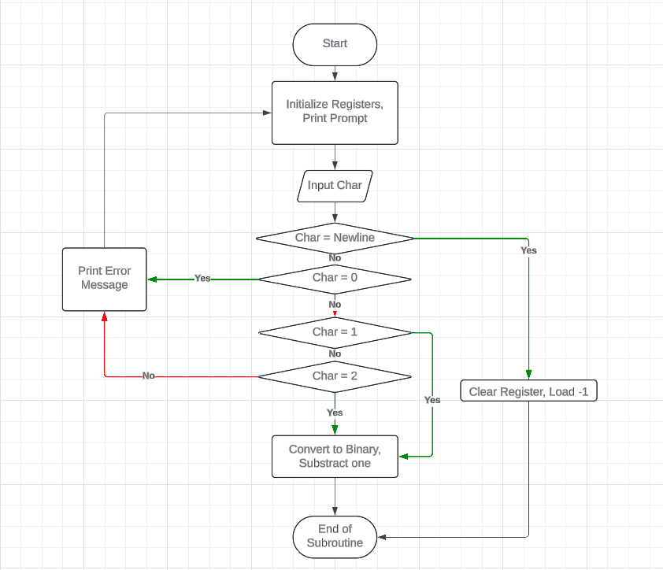**(CONTINUES NEXT PAGE)**

## Input String (Message)

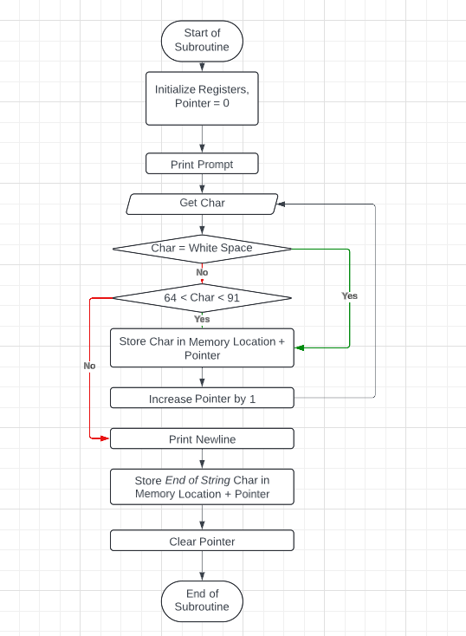**(CONTINUES NEXT PAGE)**

## Input Key

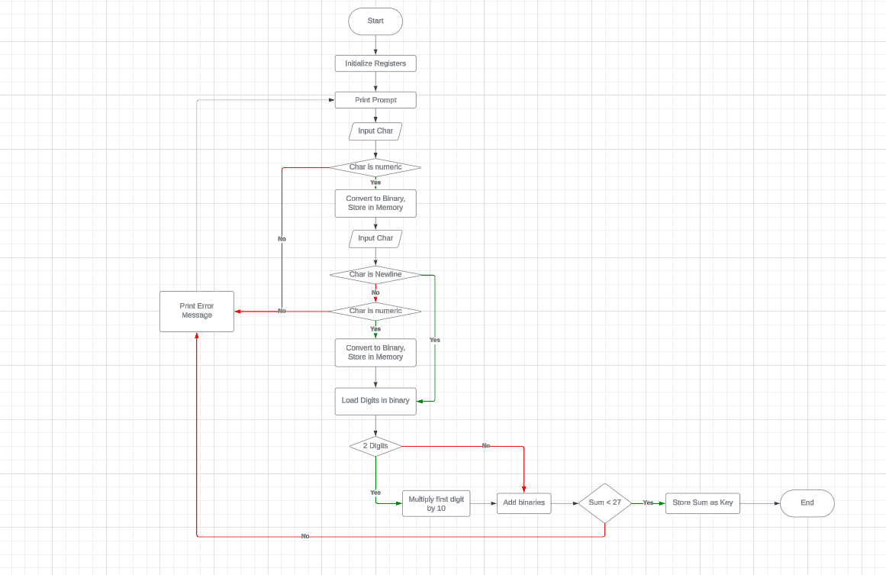**(CONTINUES NEXT PAGE)**

## Return Encrypted Message

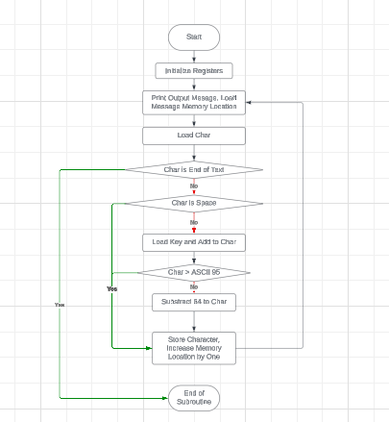

# Screenshots

## Machine Running in LC3

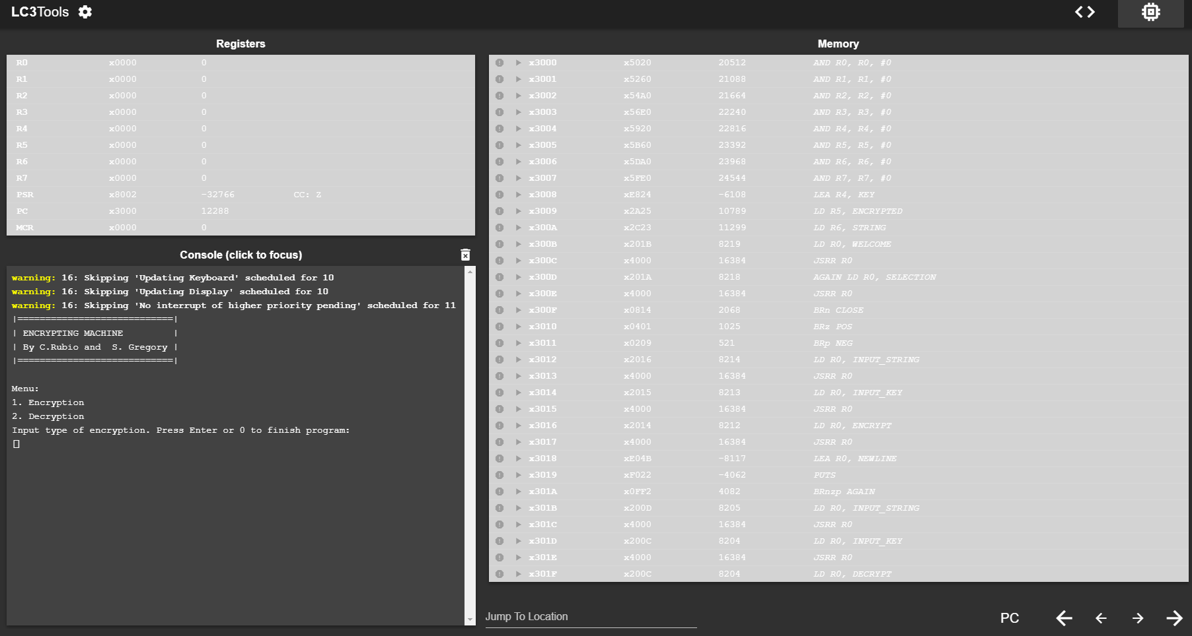**(CONTINUES NEXT PAGE)**

## Program rejects invalid inputs

## Encryption Mode

## Keys can be of variable number of digits

## Decryption Mode