*50-700 MHz Broadband Spiral Antenna Design*

Sree Nirmillo Biswash Tushar

Department of Electrical and Computer Engineering, Texas State University,

San Marcos, TX-78666, United States of America

***Abstract-* Spiral antenna is a frequency independent antenna which can be printed in a flexible substrate. The lower and higher frequency band is limited by the inner and outer radius of the antenna. In this project, a 55 MHz-700 MHz range broadband antenna is designed with HFSS. Then, S11, VSWR, gain and directivity of this antenna is measured and the designed is optimized. The analysis shows that shrinking the antenna size creates a lot of fluctuation in S11 and VSWR plot and at some smaller size, antenna becomes totally reflective. Lastly, the performance metrics relation with the antenna parameters are analyzed.**

Keywords ***–Spiral Antenna, Substrate, Excitation***

1. INTRODUCTION

Flexible electronics has been the reason for transformation of the the shape and the weight of the electronics product for the last decade. It has the capability to shrink the size of electronics at a level that can be integrated in small ICs. Due to the advanced printing technology, any designed antenna can be printed on suitable substrate in a fairly short amount of time with higher precision. The dimension of the antenna and the excitation port are two key parameters to meet the requirement of the antenna. The performance metrics of the antenna is user defined but a well-designed antenna should maintain voltage standing ratio close to unity, perfect impedance matching and very low reflection from the antenna.

Spiral antenna is in the family of frequency independent antenna since their geometry can be specified by angles. These antennas are scalable. That means that the factor by which the size of the antenna is reduced, the resonating frequency increases by that same factor. The lowest frequency occurs where the antenna length is equal to the wavelength [balanis]. The spiral antenna should be fed by an electrically and geometrically symmetric line. The geometric balancing can be achieved by feeding one arm by coaxial cable and feeding other arm by dummy cable. The circularly polarized beam will be produced in the spiral antenna perpendicular to the plane.

In this project, I have designed a spiral antenna that operates in 55 MHz-700 MHz range. The design is then optimized for lower S11, voltage standing wave ratio is less than 2.5 and higher gain.

1. BACKGROUND

The spiral antenna structure consists of 3 things: (1) Spiral arm (2) Substrate (3) Excitation Port.

The spiral arm:

The spiral arm was a perfect conductor plane in our design. Due to the geometrical complexities, it became very difficult to make a 3D spiral with width defined. Two variables that has been tuned in the spiral arm were flare rate (radius in HFSS terminology) and width of the spiral arm. Those two parameters are also tuning the gap between the turns of the arm. The lower end of the frequency is related to the length of the arm or outer radius of the arm whereas higher frequency is limited by the inner radius of the arm. The inner and outer radius is termed as *rout* and *rin*in figure-1 [2].

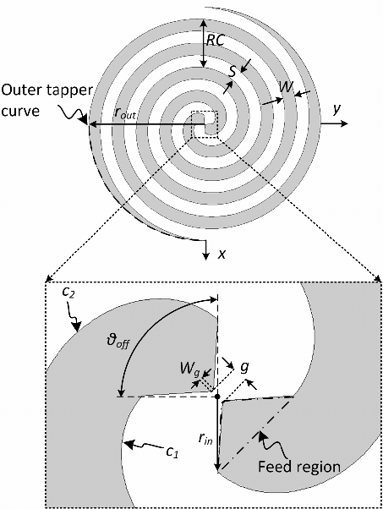

Fig. 1 Geometry of a spiral arm

The lower and higher frequency can be expressed as equation 1 and 2 [3]:

(1)

(2)

Where and defines the lower and higher frequency. C is the speed of light

The distance of the arm from the center at any number of turns can be defined as:

Where N is the number of turns and a is the flare rate

Substrate:

According to the instructions given, I have chosen silicon (material) which has dielectric constant 11.9. Substrate is made large enough to hold the spiral. The increment of dielectric constant has a favorable effect on antenna performance [4]. A previous study done in [5] found that substrate size variation does not make significant change in performance. However, the main limitation of the substrate size is that large antenna makes it infeasible in many applications. Therefore, miniaturization of the substrate was one of the goals of this project.

Excitation Port:

Excitation method is one of the key factors in the performances of the antenna. In this lumped port is chosen as the excitation method since the frequency was very low. Positive excitation is given in one arm and other arm is kept as reference. In figure 2, positive excitation is given in red arm and black arm is the reference.

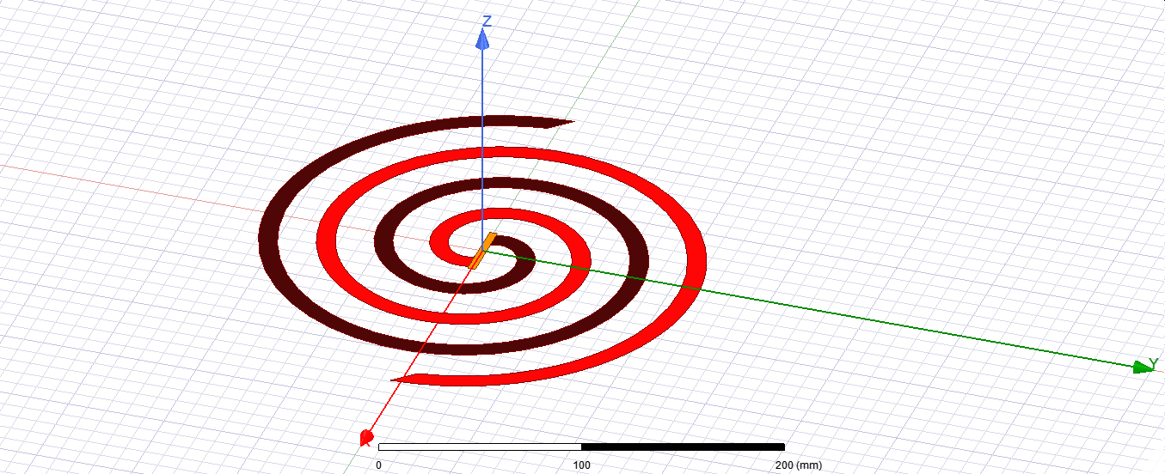

Fig. 2 Geometry of a spiral arm

1. Experimental Design

HFSS software was used to design the antenna. Using HFSS, any structure of any material can be run as an antenna of any size. First, we created a 3D structure as a substrate. The substrate thickness was set to 12 mm and substrate material, silicon, has a dielectric constant 11.9. Later, a 2D spiral is created by subtracting a 3D spiral from a 2D plane. This restricts us from assigning any spiral material. When I inserted 3D spiral in the design, it was giving 3D model error that I could not solve. Then, a 2D plane touching both arms is assigned as a lumped port. Lastly, an airbox is created as the radiation boundary that has a height at least equal to the quarter wavelength.

After this stage, an analysis is set up from 55 MHz from 700 MHz with 401 frequency point. The sweep type was fast since it can give fast results. The inner and the outer radius were calculated using equations (1) and (2) and the value was 868 mm and 68 mm respectively. All the parameters that are tuned are given below:

1. Number of Turns:
2. Radius change, Flare rate:
3. Arm width:
4. Substrate length:

The performance metrics that were chosen to tune the model was

1. S11 plot
2. VSWR plot
3. Gain 3D plot
4. Directivity plot

A number of experiments are done to find the response of the antenna with the parameter given above.

1. Result and Analysis

The performance requirement of the antenna is based on application and therefore, very user specific. In this section, I will discuss the performance of the antenna in terms of various performance metrics.

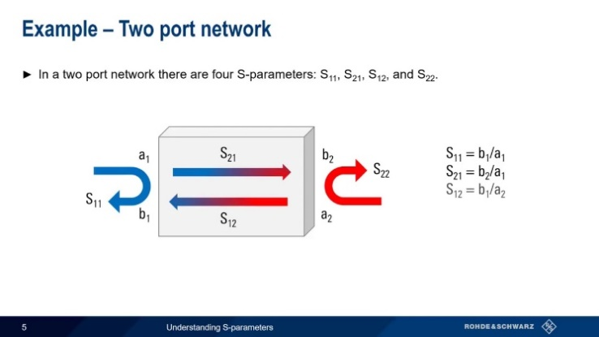

Fig. 3 Signal flow in two port network and S11 parameter

1. S11:

S11 parameters define the amount of reflection from antenna arm to the port. This can be shown as fig-3 [6]. This value should be very low for the antenna and below -10dB is expected for proper functioning of antenna. The S11 value declines when width of the arm reduces. In figure 4 (a), (b) and (c), the arm width was 5, 10 and 20 mm respectively and therefore the average S11 is lowest in (c) and highest in (a).

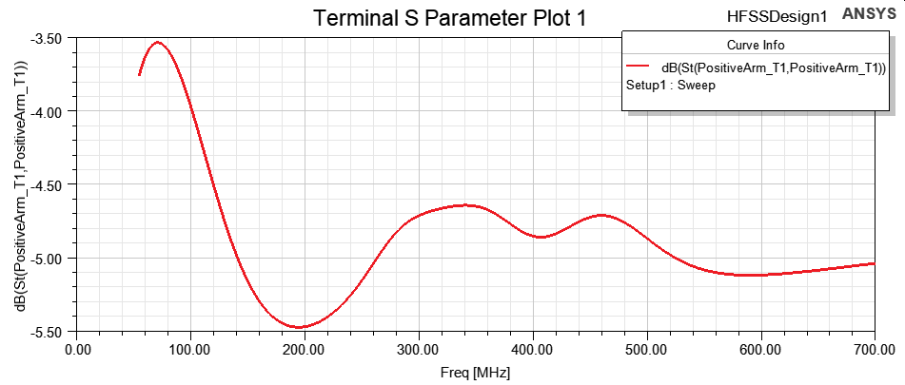

(a)

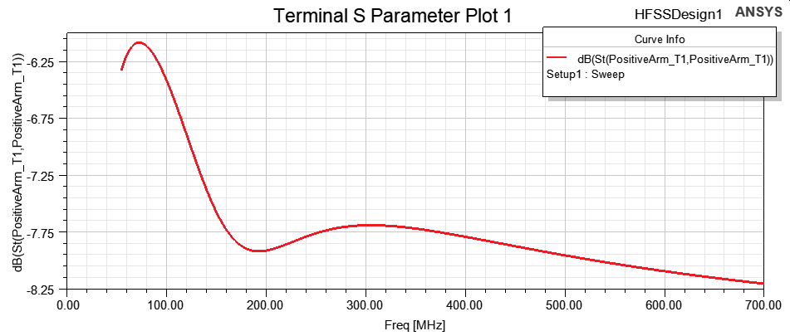

(b)

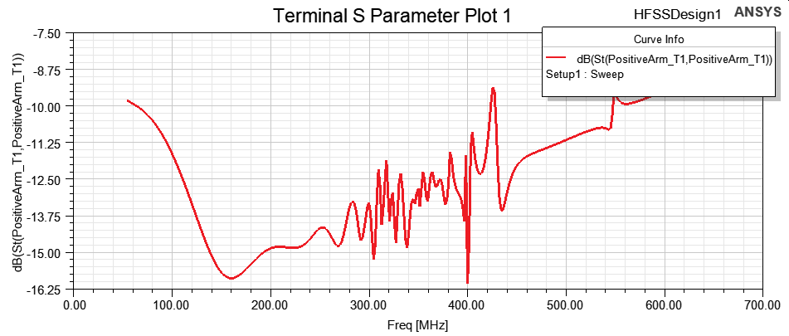

(c)

Fig. 4 S11 parameter variation with arm width, number of turns=7.23, radius=58, substrate length=1000 mm (a) arm width=5 mm (b) arm width=10 mm (c) arm width=20 mm

From figure 5, it is also obvious that the reduction of the antenna size creates a lot of fluctuations and therefore (b) is fluctuating a lot whereas (a) is a smooth curve. Lastly, the number turns is increased and it is appeared from figure-6 that S11 is lower than higher number of turns. Substrate dielectric constant is another parameter that was tuned and it is found that S11 is lower for substrate of higher dielectric constant.

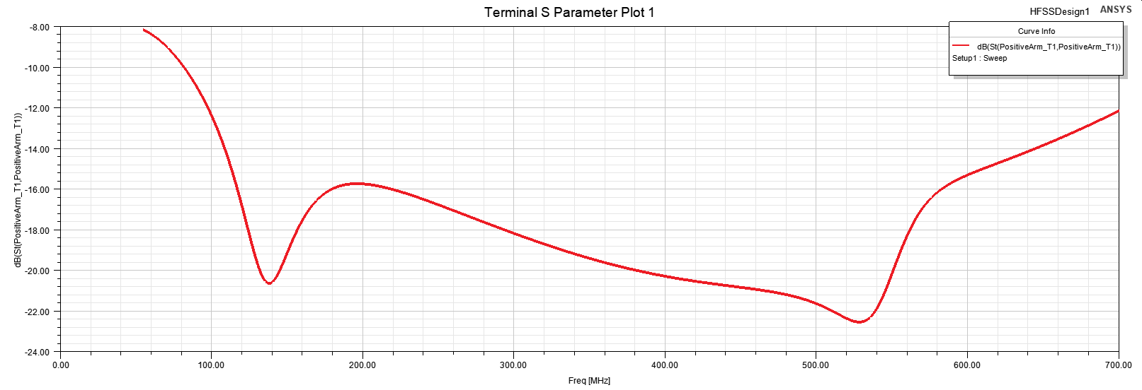

(a)

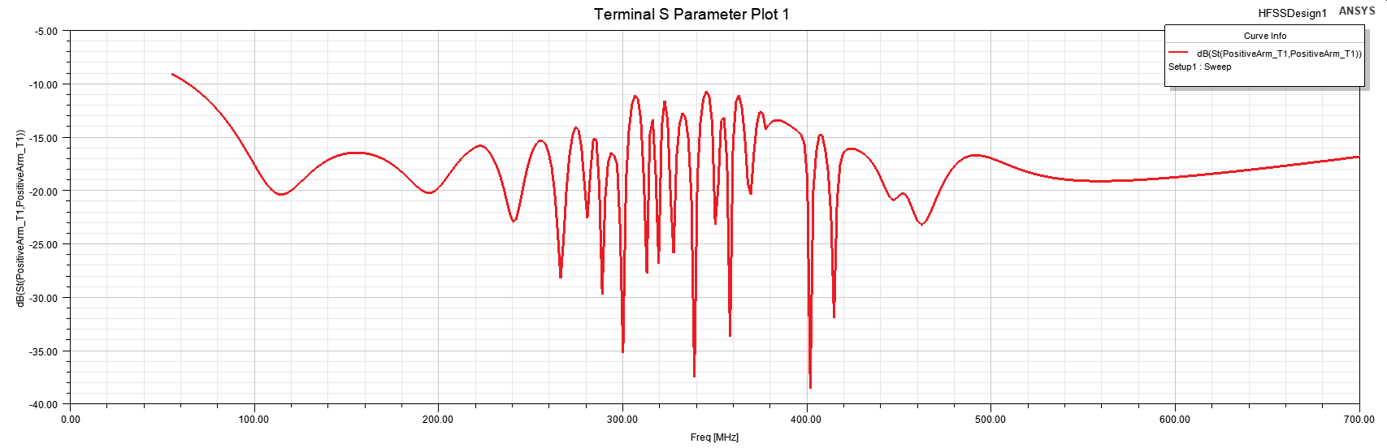

(b)

Fig. 5 S11 parameter variation with antenna size shrinkage (a) Number of Turns: 7.23, Radius Change: 50, Arm Width=17mm and Substrate length =862 mm, (b) Number of Turns: 7.23, Radius Change: 40, Arm Width=13.8 mm and Substrate length =690 mm

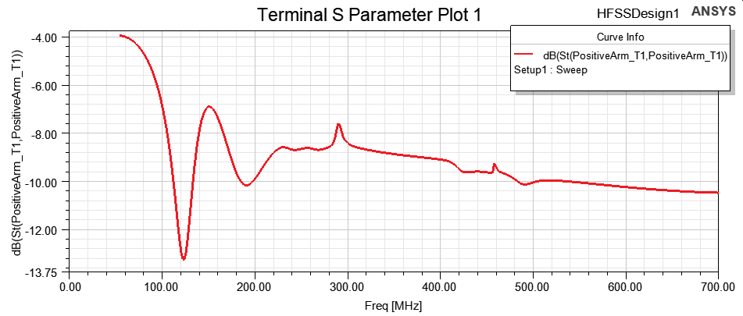 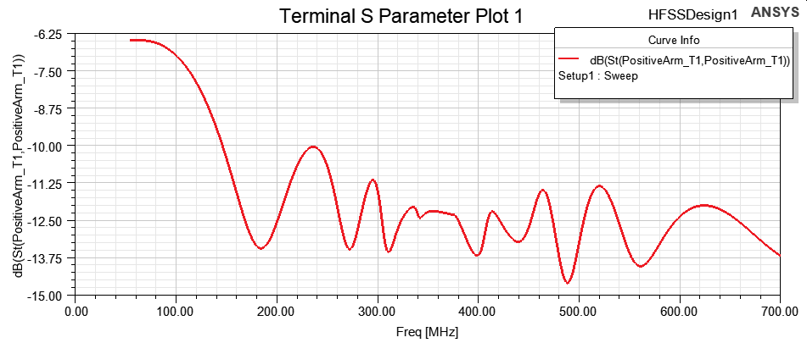

Fig. 6 S11 parameter variation with antenna size shrinkage (a) Number of Turns 8, Radius Change: 50.75, Arm Width 10 mm, Substrate length: 1000 mm (b) Number of Turns: 10, Radius Change: 42, Arm Width: 10.9 mm, Substrate length: 1000 mm

1. VSWR:

VSWR stands for voltage standing wave ratio. It is the ratio of the transmitted power from port to antenna to the reflected power from antenna to port. Therefore, it measures the efficiency in transferring power from port to antenna. The expected value of VSWR should be less than 2.5.

VSWR shows a smooth response in all frequency range for large substrate and antenna structure (figure-7(a)). When the structure starts to shrink, a lot of fluctuations appear in VSWR curve (figure-7(b)). The reduction arm width may play a great role in this. The cavity may become unstable because of the size shrinking and therefore shows a huge nonlinearly in its behavior. At some smaller size, VSWR goes to negative (figure-7(c)) which means that reflection coefficients becomes greater than unity. So, at some size, antenna will become completely reflective.

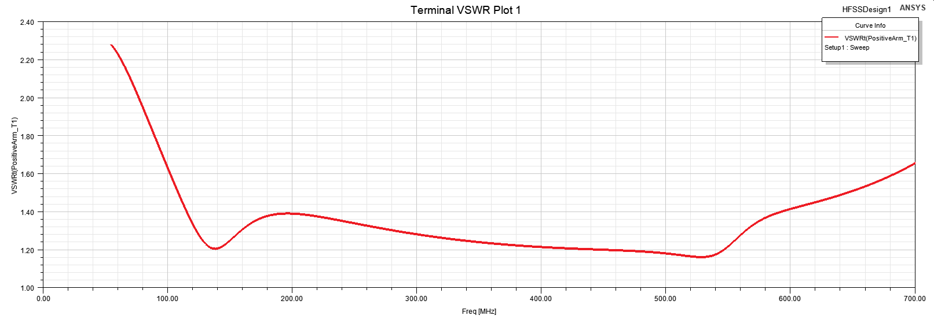

(a)

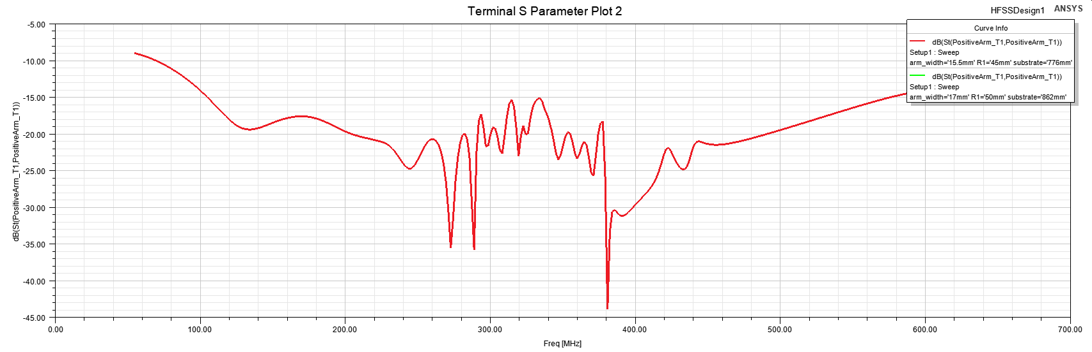

(b)

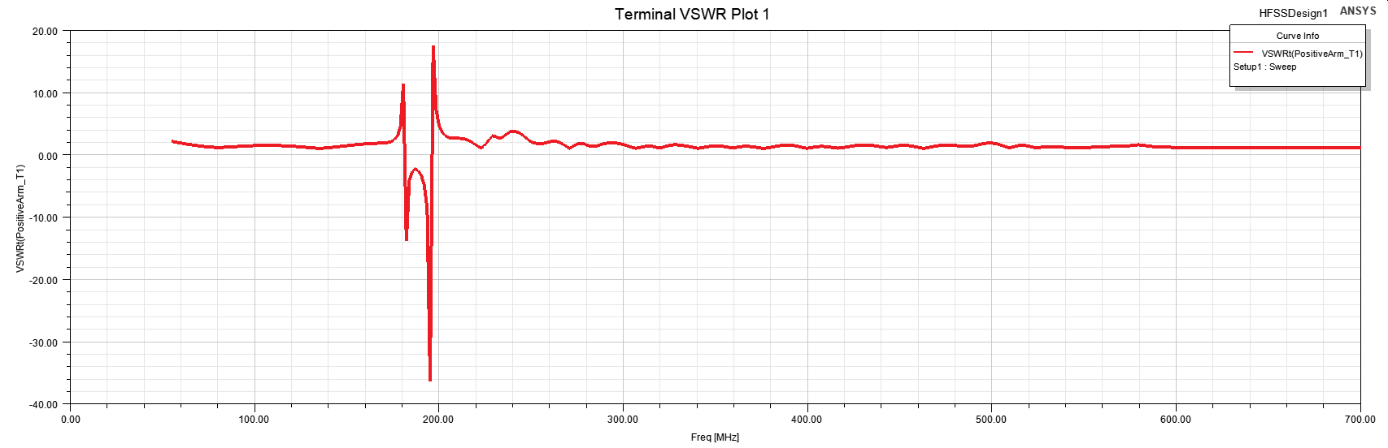

(c)

Fig. 7 VSWR variation with antenna size shrinkage (a) Number of Turns: 7.23, Radius Change: 50, Arm Width=17 mm and Substrate length=862 mm (b) Number of Turns: 7.23, Radius Change: 45, Arm Width=15.5 mm and Substrate length=776 mm (c) Number of Turns: 7.23, Radius Change: 20, Arm Width=7.2 mm and Substrate length=400 mm

1. Gain:

The gain of the antenna is responsive to the arm width and the number of turns in the spiral. If arm width is increased, gain starts to increase. From figure-8, the gain in (b) is greater than (a) since arm in (b) is wider than arm in (a).

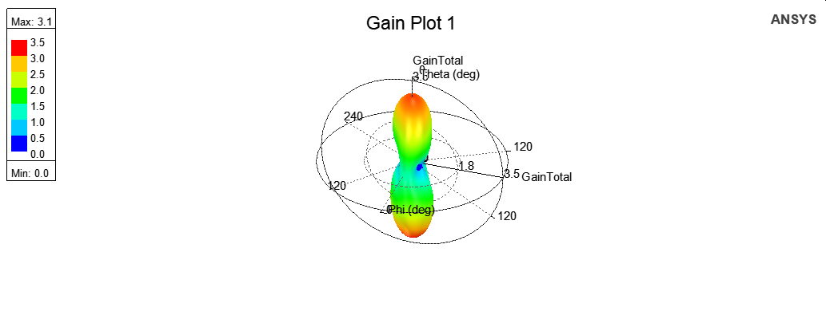

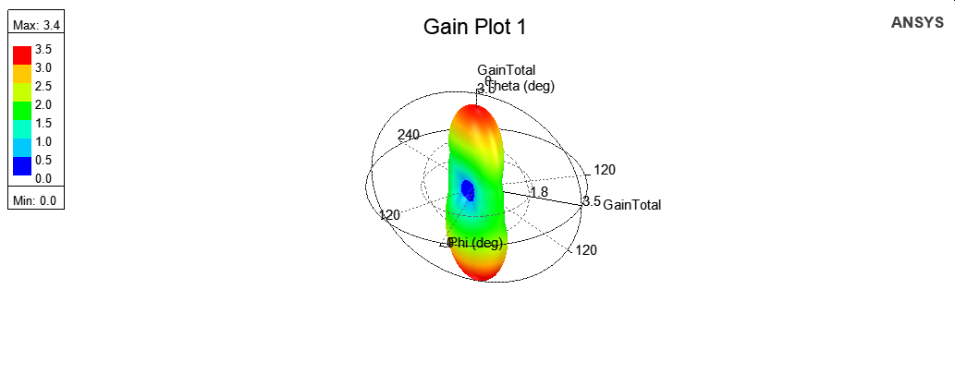

Fig. 8 Gain variation with arm width, number of turns=7.23, radius=58, substrate length=1000 mm (a) arm width=10 mm (b) arm width=20 mm

The number of turn has showed a good correlation with number of turns. When the number of turns goes bigger, the gain also follows number of turns and goes higher. Figure-9 is illustrating this trend where for 10 turns, maximum gain was 3.2 dB while for 8 turns, maximum gain reduces to 3.1 dB.

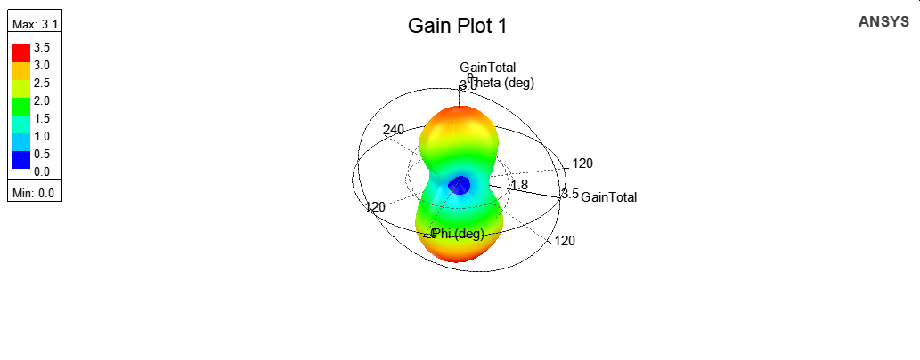

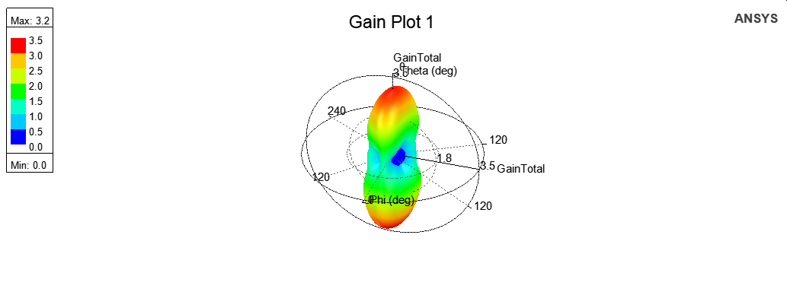

Fig. 9 Gain variation with arm width, number of turns=7.23, radius=58, substrate length=1000 mm (a) arm width=10 mm (b) arm width=20 mm

1. Directivity:

The directivity of the gain is showing that antenna is propagating perpendicular to the antenna structure. This tells us that the antenna is very directive. It is evident from figure-10 that bigger size has higher radiation energy in the propagation direction.

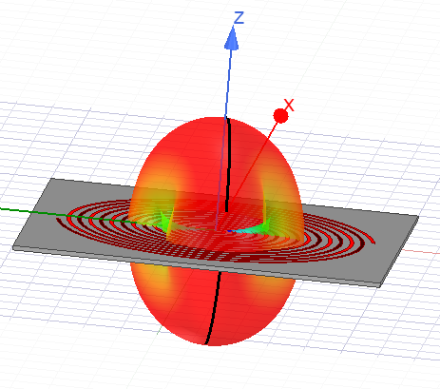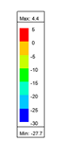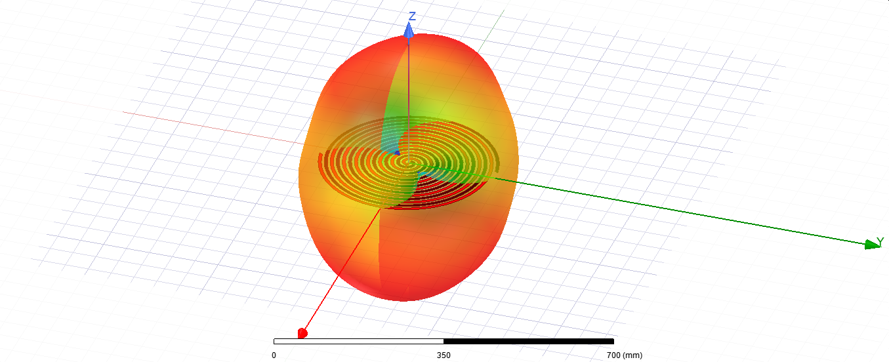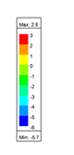

Fig. 10 Directivity variation with size shrinking (a) Number of Turns: 7.23, Radius Change: 58, Arm Width=15 mm and Substrate length=1000 mm (b) Number of Turns: 7.23, Radius Change: 25, Arm Width=9 mm and Substrate Length=450 mm

1. CONCLUSION

Shrinking antenna size creates a lot of fluctuations. S11 decreases with increasing arm width, increasing number of turns and shrinking the size of the antenna. VSWR creates a lot of fluctuations when antenna size is shrunk. Gain from the antenna increases with the arm width and number of turns. This study needs more data to make any precise statement.

ACKNOWLEDGEMENT

We would like to thank Dr. Maggie for guiding me through the project. I also want to thank all my classmates for sharing thoughts, especially Benjamin for running a lot simulations for me.

REFERENCES

[1] Constantine A. Balanis, ” Antenna Theory: Analysis and Design”, 2005, Wiley-Interscience, USA.

[2] Chen, Teng-Kai & Huff, Gregory, “Modal Resistance of Spiral Antenna”, Journal of Electromagnetic Analysis and Application,2013, 5. 223-228., 10.4236/jemaa.2013.55036.

[3] P. Bevelacqua, “Spiral Antennas,” *Spiral Antenna*. [Online]. Available: <http://www.antenna> theory.com/antennas/travelling/spiral.php.

[4] Shire, Abdirahman & Che Seman, Fauziahanim. (2013). Effects of dielectric substrate on performance of UWB Archimedean Spiral Antenna. 412-415. 10.1109/IconSpace.2013.6599506.

[5] J. M. O’Brien, J. E. Grandfield, G. Mumcu and T. M. Weller, "Miniaturization of a Spiral Antenna Using Periodic Z-Plane Meandering," in IEEE Transactions on Antennas and Propagation, vol. 63, no. 4, pp. 1843-1848, April 2015, doi: 10.1109/TAP.2015.2394796. [6]YouTube[Online].Available:https://www.youtube.com/watch?app=desktop.