Game Design Document

Fill up the following document

1. Write the title of your project.

The balloon game

1. What is the goal of the game?

Hot air balloon should no be touching the obstacles.

1. Write a brief story of your game.

There is one hot air balloon and some obstacles like building and birds.The balloon should not be touching the obstacles to keep playing the game.There are points also to collect in game.

1. Which are the playing characters of this game?

* Playing characters are the ones who respond to the user based on the input from the user.
* Cars, monkeys, dinos, wizards, etc., are the playing characters in the game.

|  |  |  |
| --- | --- | --- |
| Number | Character Name | What can this character do? |
| 1 | Hot air balloon | It can move up and down with the help of keys(up arrow). |
| 2 |  |  |
| 3 |  |  |
| 4 |  |  |
| 5 |  |  |
| 6 |  |  |
| 7 |  |  |
| 8 |  |  |

1. Which are the Non-Playing Characters of this game?

* Non-Playing characters are the ones that don't have an action or behavior when the user interacts with the game.
* Hurdles, stones, bananas, coins, etc., are non-playing characters in the game.

|  |  |  |
| --- | --- | --- |
| Number | Character Name | What can this character do? |
| 1 | Building(obstacle) | Make the game challenging. |
| 2 | Bird(obstacle) | Make the game challenging. |
| 3 | Lamp(obstacle) | Make the game challenging. |
| 4 |  |  |
| 5 |  |  |
| 6 |  |  |
| 7 |  |  |
| 8 |  |  |

Draw your imagination of this game. What does this game look like?

* Draw the game either on your computer or on paper.
* Add images of the game scenes to show each of the playing and non-playing characters at least once.

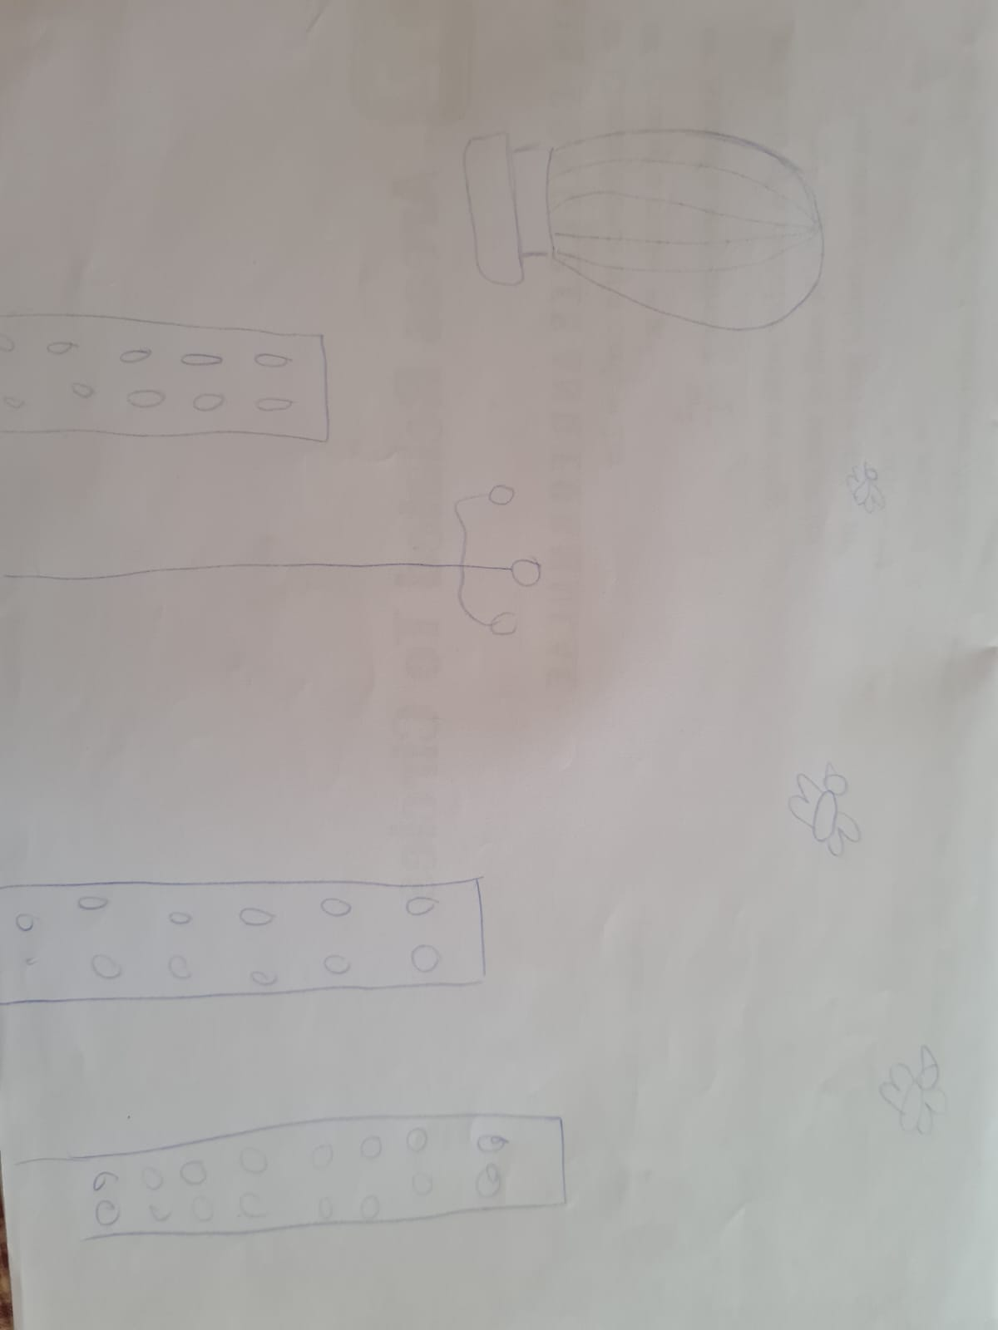

How do you plan to make your game engaging?

With the help of points .