

**RESTAURANT MANAGEMENT DATABASE**

**INNOVATIVE ASSIGNMENT**



March 29, 2021

DBMS

NIRMA UNIVERSITY, ITNU

**Stuti Patel**

**Kanisha Shah**

**Meet Vora**

**Restaurant Management Database**

**Aim**

The following Restaurant database holds the records of its Employees, chef, waiters/delivery boys, food items, drinks and their customer details. The GUI interface navigates the user through different portals where they can access the details of customer, employees, food items etc.

**Description**

* We have customer, restaurant and delivery sections.
* Restaurant end we have
  + All the food items and drinks the customer can order
  + Track of all the employee details
  + Chef details along with their speciality in a specific cuisine
* Customer end we have
  + Customer details
  + Details for Payment and
* Delivery end to track all the deliveries done

**Characteristics**

* Add Record
* Delete Record
* Display Record
* Update Record

**External Interface Requirements**

* Front end: Python
* Backend: MySQL

**Functional Requirements**

* User authentication during login
* Email Verification while sign up

**ER MODEL**

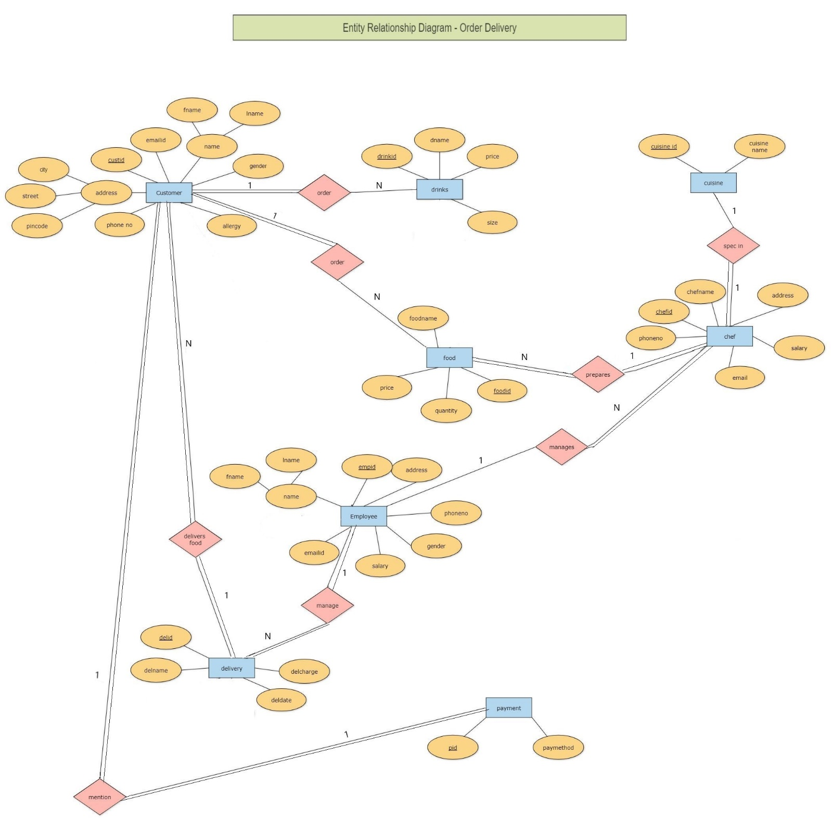

**RELATIONAL MODEL**

|  |  |  |
| --- | --- | --- |
|  | CUSTOMER |  |
| ATTRIBUTES | **DEFAULT VALUE** | **CONSTRAINTS** |
| FNAME |  | NOT NULL |
| LNAME |  | NOT NULL |
| CUSTID |  | PRIMARY KEY |
| EMAILID |  | NOT NULL,  CHECK should contain @ .com |
| CITY | AHMEDABAD |  |
| STREET |  | NOT NULL |
| PINCODE |  | NOT NULL  CHECK count = 6 |
| GENDER |  | NOT NULL  Values (‘M’,’F’,’O’) |
| PHONENO |  | NOT NULL  CHECK count = 10 |
| ALLERGY | NULL |  |

|  |  |  |
| --- | --- | --- |
|  | CUISINE |  |
| ATTRIBUTES | **DEFAULT VALUE** | **CONSTRAINTS** |
| CUISINEID |  | PRIMARY KEY |
| CUISINE NAME |  | NOT NULL |

|  |  |  |
| --- | --- | --- |
|  | EMPLOYEE |  |
| ATTRIBUTES | **DEFAULT VALUE** | **CONSTRAINTS** |
| EMPID |  | PRIMARY KEY |
| FNAME |  | NOT NULL |
| LNAME |  | NOT NULL |
| EMAILID |  | NOT NULL,  CHECK should contain @ .com |
| ADDRESS |  | NOT NULL |
| PHONE NO |  | NOT NULL  CHECK count = 10 |
| GENDER |  | NOT NULL  Values (‘M’,’F’,’O’) |
| SALARY |  | NOT NULL  CHECK Greater than 0 |

|  |  |  |
| --- | --- | --- |
|  | CHEF |  |
| ATTRIBUTES | **DEFAULT VALUE** | **CONSTRAINTS** |
| CHEFID |  | PRIMARY KEY |
| CHEFNAME |  | NOT NULL |
| ADDRESS |  | NOT NULL |
| PHONENO |  | NOT NULL  CHECK count = 10 |
| SPEC |  | Foreign key references ‘**CUISINEID**’ of **CUISINE** table. |
| EMPID |  | Foreign key references ‘**EMPID**’ of **EMPLOYEE** table. |
| EMAIL |  | NOT NULL,  CHECK should contain @ .com |
| SALARY |  | NOT NULL  CHECK Greater than 0 |

|  |  |  |
| --- | --- | --- |
|  | FOOD |  |
| ATTRIBUTES | **DEFAULT VALUE** | **CONSTRAINTS** |
| FOODID |  | PRIMARY KEY |
| FOODNAME |  | NOT NULL |
| PRICE |  | NOT NULL  CHECK Greater than 0 |
| QUANTITY |  | NOT NULL  CHECK Greater than 0 |
| CUISINEID |  | Foreign key references ‘**CUISINEID**’ of **CUISINE** table. |
| INGID |  | Foreign key references ‘**INGID**’ of **INGREDIENT** table. |
| CHEFID |  | Foreign key references ‘**CHEFID**’ of **CHEF** table. |

|  |  |  |
| --- | --- | --- |
|  | DRINKS |  |
| ATTRIBUTES | **DEFAULT** | **CONSTRAINT** |
| DRINKID |  | PRIMARY KEY |
| DNAME |  | NOT NULL |
| PRICE |  | NOT NULL,  CHECK can’t be 0 |
| SIZE |  | Values(‘large’, ’medium’, ’small’) |

|  |  |  |
| --- | --- | --- |
|  | DELIVERY |  |
| ATTRIBUTES | **DEFAULT** | **CONSTRAINT** |
| DELID |  | PRIMARY KEY |
| DELNAME |  | NOT NULL |
| CUSTID |  | Foreign key references ‘**CUSTID**’ of **Customer** table. |
| EMPID |  | Foreign key references ‘**EMPID**’ of **Employee** table. |
| DELCHARGE |  | NOT NULL  CHECK can’t be 0 |
| DELDATE |  | NOT NULL |

|  |  |  |
| --- | --- | --- |
|  | ORDER |  |
| ATTRIBUTES | **DEFAULT** | **CONSTRAINT** |
| ORDID |  | PRIMARY KEY |
| TOTALCOST |  | NOT NULL  CHECK can’t be 0 |
| FOODID |  | Foreign key references ‘**FOODID**’ of **Food** table. |
| DRINKID |  | Foreign key references ‘**DRINKID**’ of **Drink** table. |
| DELID |  | Foreign key references ‘**DELID**’ of **Delivery** table. |

|  |  |  |
| --- | --- | --- |
|  | PAYMENT |  |
| ATTRIBUTES | **DEFAULT** | **CONSTRAINT** |
| PID |  | PRIMARY KEY |
| PAYMETHOD |  | Values (‘credit card’, ’cash’, ’debit card’, ’paytm’) |
| CUSTID |  | Foreign key references ‘**CUSTID**’ of **Customer** table. |
| ORDID |  | Foreign key references ‘**ORDID**’ of **Order** table. |