PROJECT REPORT
CyberVault
A Java Cybersecurity Toolkit for File Encryption, Integrity Verification, and Credential Management
Submitted in fulfillment of the evaluated project requirement for
Programming in Java
Submitted by: Stuti Gupta
Enrollment / Roll No.: 24BCY10141
Course Platform: Vityarthi
Date: September 16, 2026
Repository: https://github.com/stutigupta486-bcy/24BCY10141-JAVA-PROJECT

Table of Contents
Abstract
1. Introduction
1.1 Background
1.2 Problem Statement
1.3 Objectives
2. Background Concepts
2.1 AES and GCM Mode
2.2 PBKDF2 (Password-Based Key Derivation Function 2)
2.3 SHA-256
2.4 Password Entropy and Secure Randomness
3. System Design
3.1 Architecture Overview
3.2 Encrypted File and Vault Format
3.3 Encryption, Decryption, and Vault Workflow
4. Implementation
4.1 Technology Stack
4.2 Module Summary
4.3 Key Implementation Snippet
5. Testing and Results
6. Security Analysis
6.1 Why AES-256-GCM Instead of AES-CBC
6.2 Why PBKDF2 With a High Iteration Count
6.3 Role of the Random Salt and IV
6.4 Secure Randomness in Password Generation and Scoring
6.5 Known Limitations
7. Conclusion and Future Scope
References

Abstract
CyberVault is a command-line cybersecurity toolkit developed in Java that brings together five practical security capabilities into a single application: authenticated file encryption, file integrity verification, password strength analysis, secure password generation, and an encrypted local credential vault. Rather than a single-purpose demonstration, the project addresses five related problems that a security-conscious developer or end user regularly encounters, using only the standard Java Cryptography Architecture (JCA/JCE) with no third-party dependencies. Files are protected with AES-256 in Galois/Counter Mode (GCM), with the encryption key derived from a user-supplied password through 65,536 rounds of PBKDF2WithHmacSHA256 rather than being used directly, and a freshly generated random salt and initialization vector for every operation. File integrity is independently verifiable via SHA-256 checksums, password quality is scored using a composition- and entropy-based model, and credentials stored in the built-in vault are themselves encrypted as a single unit under a master password before ever touching disk. This report documents the motivation behind the project, its architecture and cryptographic design, the testing performed to validate both correctness and the intended security guarantees, and an analysis of the design decisions made, along with acknowledged limitations and directions for future work.

1. Introduction

1.1 Background
Protecting data at rest and managing credentials safely are two of the most persistent problems in everyday computing. Files stored on a laptop, a USB drive, or a shared server are vulnerable to unauthorized access if left unencrypted, and many freely available “encryption” utilities either use outdated algorithms, hardcode keys, or provide no way to detect tampering. Separately, weak or reused passwords remain one of the leading causes of account compromise, and users who try to keep track of many strong, unique passwords often resort to insecure habits such as writing them down in plain text. This project was undertaken to apply the Java programming concepts covered in this course to these two connected, real-world security problems, rather than to a purely academic exercise.

1.2 Problem Statement
Design and implement a Java application that allows a user to: (a) encrypt and decrypt arbitrary files using a password such that confidentiality is preserved and any tampering with the encrypted file or use of an incorrect password is detectable; (b) independently verify that a file has not been altered using a cryptographic checksum; (c) evaluate the strength of a chosen password and generate strong passwords on demand; and (d) store multiple credentials in a local vault that is itself encrypted as a whole, so that no field is ever written to disk in plain text — all while relying only on well-established cryptographic primitives available in the standard Java library.

1.3 Objectives
- Implement password-based symmetric file encryption using industry-recommended algorithms.
- Ensure the solution detects incorrect passwords and tampered ciphertext rather than failing silently.
- Provide an independent, checksum-based mechanism for verifying file integrity.
- Help users evaluate and generate strong, high-entropy passwords using cryptographically secure randomness.
- Offer a minimal encrypted credential vault that never stores plaintext secrets on disk.
- Avoid third-party dependencies by using only the Java Cryptography Architecture (JCA/JCE).
- Document the security rationale behind each design decision.

2. Background Concepts
This section briefly summarizes the cryptographic building blocks used across CyberVault's five modules.

2.1 AES and GCM Mode
The Advanced Encryption Standard (AES) is a symmetric block cipher that encrypts data in fixed-size blocks using a shared secret key. Galois/Counter Mode (GCM) is a mode of operation for block ciphers that provides authenticated encryption: alongside the ciphertext, it produces an authentication tag that allows the receiver to verify that the data has not been altered and was encrypted with the correct key. This is in contrast to older modes such as CBC, which only provide confidentiality and require a separate mechanism, such as an HMAC, to detect tampering. CyberVault uses AES-256-GCM for both direct file encryption and for protecting the encrypted vault, so the same authenticated-encryption guarantee applies in both places.

2.2 PBKDF2 (Password-Based Key Derivation Function 2)
Human-chosen passwords are not suitable for direct use as encryption keys because they typically have far less entropy than a proper 256-bit key and are vulnerable to dictionary and brute-force attacks. PBKDF2 addresses this by repeatedly hashing the password together with a random salt, using a configurable number of iterations. The resulting output is used as the encryption key. The salt ensures that the same password produces a different key for every file or vault, and the iteration count deliberately slows down each guess an attacker could make.

2.3 SHA-256
SHA-256 is a cryptographic hash function that produces a fixed-size 256-bit digest from an input of any size. It is used in CyberVault as a standalone integrity-checking utility, independent of the authentication already provided by GCM, so that a user can verify a file has not changed even without decrypting anything — the same technique used to validate downloaded software or forensic evidence.

2.4 Password Entropy and Secure Randomness
Password strength is commonly estimated using Shannon entropy: the number of bits of uncertainty in a password, based on its length and the size of the character pool it draws from. A longer password drawn from a larger character pool (lowercase, uppercase, digits, symbols) is exponentially harder to guess than a short one, even if both look superficially complex. CyberVault's password tools rely on java.security.SecureRandom, a cryptographically secure pseudo-random number generator (CSPRNG), rather than java.util.Random, which is statistically predictable and unsuitable for generating anything security-sensitive, including passwords, salts, and initialization vectors.

3. System Design

3.1 Architecture Overview
CyberVault follows a layered, single-responsibility design that separates user interaction from cryptographic logic. A single console-facing class delegates every security-sensitive operation to one of four independent modules, each responsible for exactly one concern and one storage artifact:
- Main.java — command-line menu and user interaction; never performs cryptography itself.
- CryptoUtil.java — all AES-256-GCM encryption, decryption, and PBKDF2 key derivation logic.
- FileIntegrityUtil.java — standalone SHA-256 file hashing and verification.
- PasswordUtil.java — password strength scoring and secure password generation.
- VaultManager.java — encrypted credential storage, built on top of CryptoUtil.
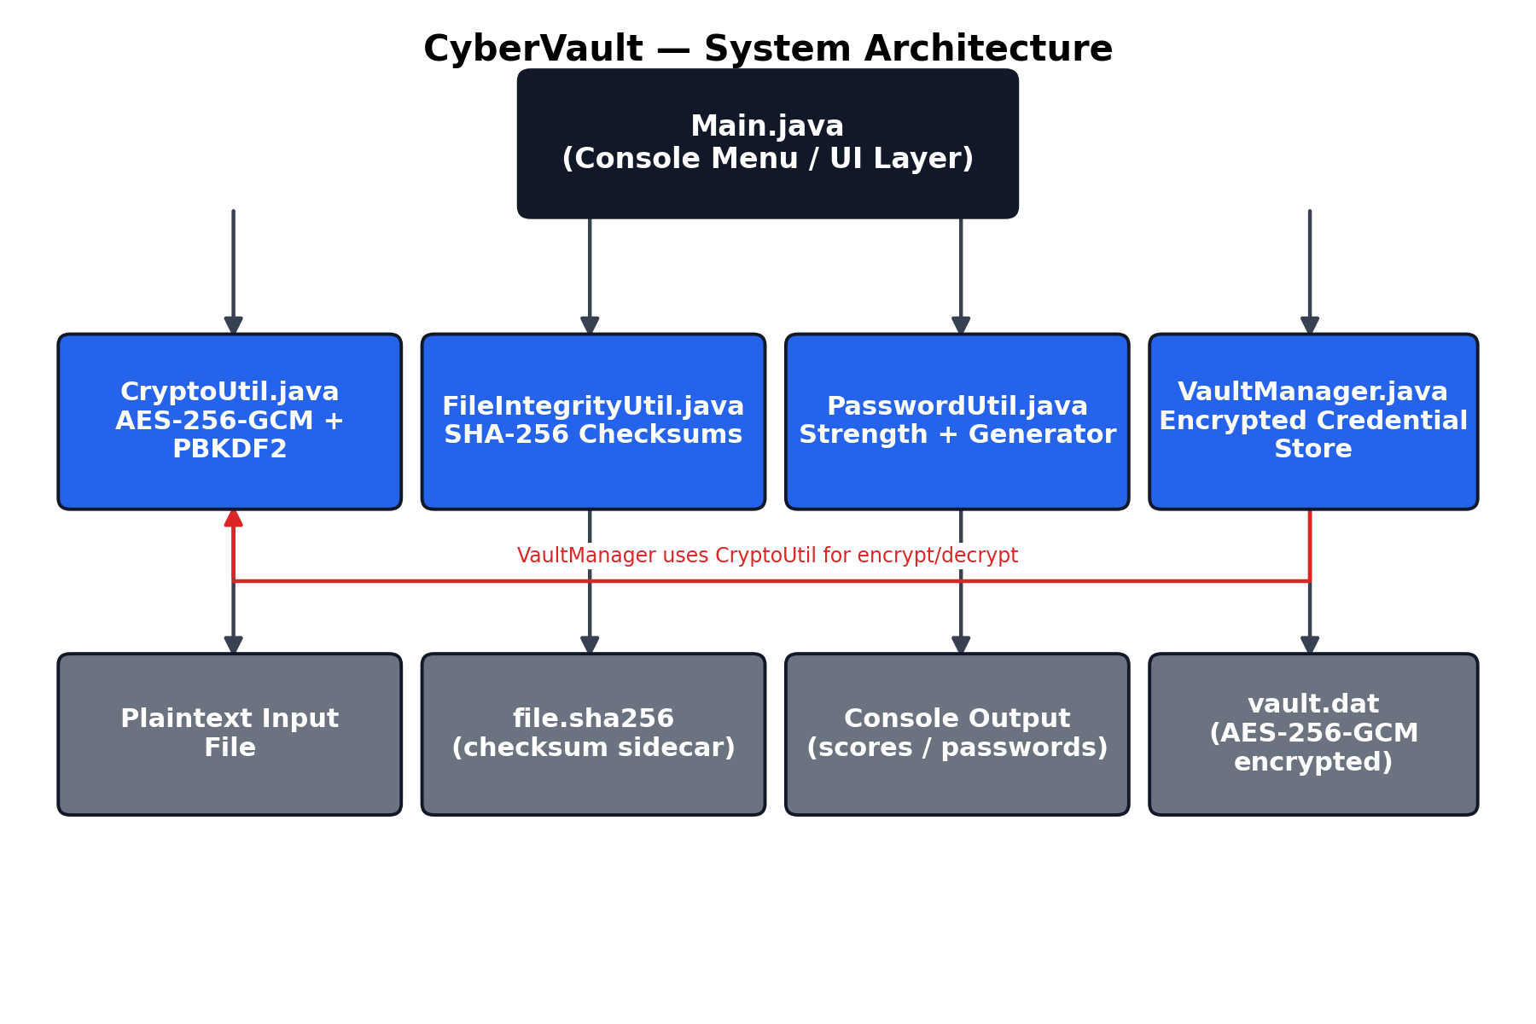
Figure 1. CyberVault system architecture — the console layer never touches cryptography directly; VaultManager itself depends on CryptoUtil to encrypt its stored entries.

3.2 Encrypted File and Vault Format
Every encrypted output — whether an individual file or the entire credential vault — is written using the same self-describing binary layout, since VaultManager delegates its own encryption to CryptoUtil:
[ 16-byte salt ][ 12-byte IV ][ ciphertext ... ][ 16-byte GCM authentication tag ]
Storing the salt and IV alongside the ciphertext is standard practice: neither value needs to be kept secret, only unpredictable and unique per encryption operation. Only the password — which is never written to disk — is required to reproduce the key. For the vault specifically, every stored (site, username, password) entry is first serialized into a single in-memory text blob, and it is this entire blob that is encrypted as one unit, meaning no individual field and no partial vault state is ever written to disk unencrypted.

3.3 Encryption, Decryption, and Vault Workflow
- Step 1: A random 16-byte salt and 12-byte IV are generated using SecureRandom.
- Step 2: The password and salt are passed through PBKDF2WithHmacSHA256 for 65,536 iterations to derive a 256-bit AES key.
- Step 3: The data (a file's bytes, or the vault's serialized entries) is encrypted using a Cipher configured for AES/GCM/NoPadding.
- Step 4: The salt, IV, and resulting ciphertext (with its embedded authentication tag) are written to the output file.
- Step 5: On decryption or vault unlock, the salt and IV are read back, the key is re-derived from the supplied password, and the cipher verifies the authentication tag before returning any plaintext.
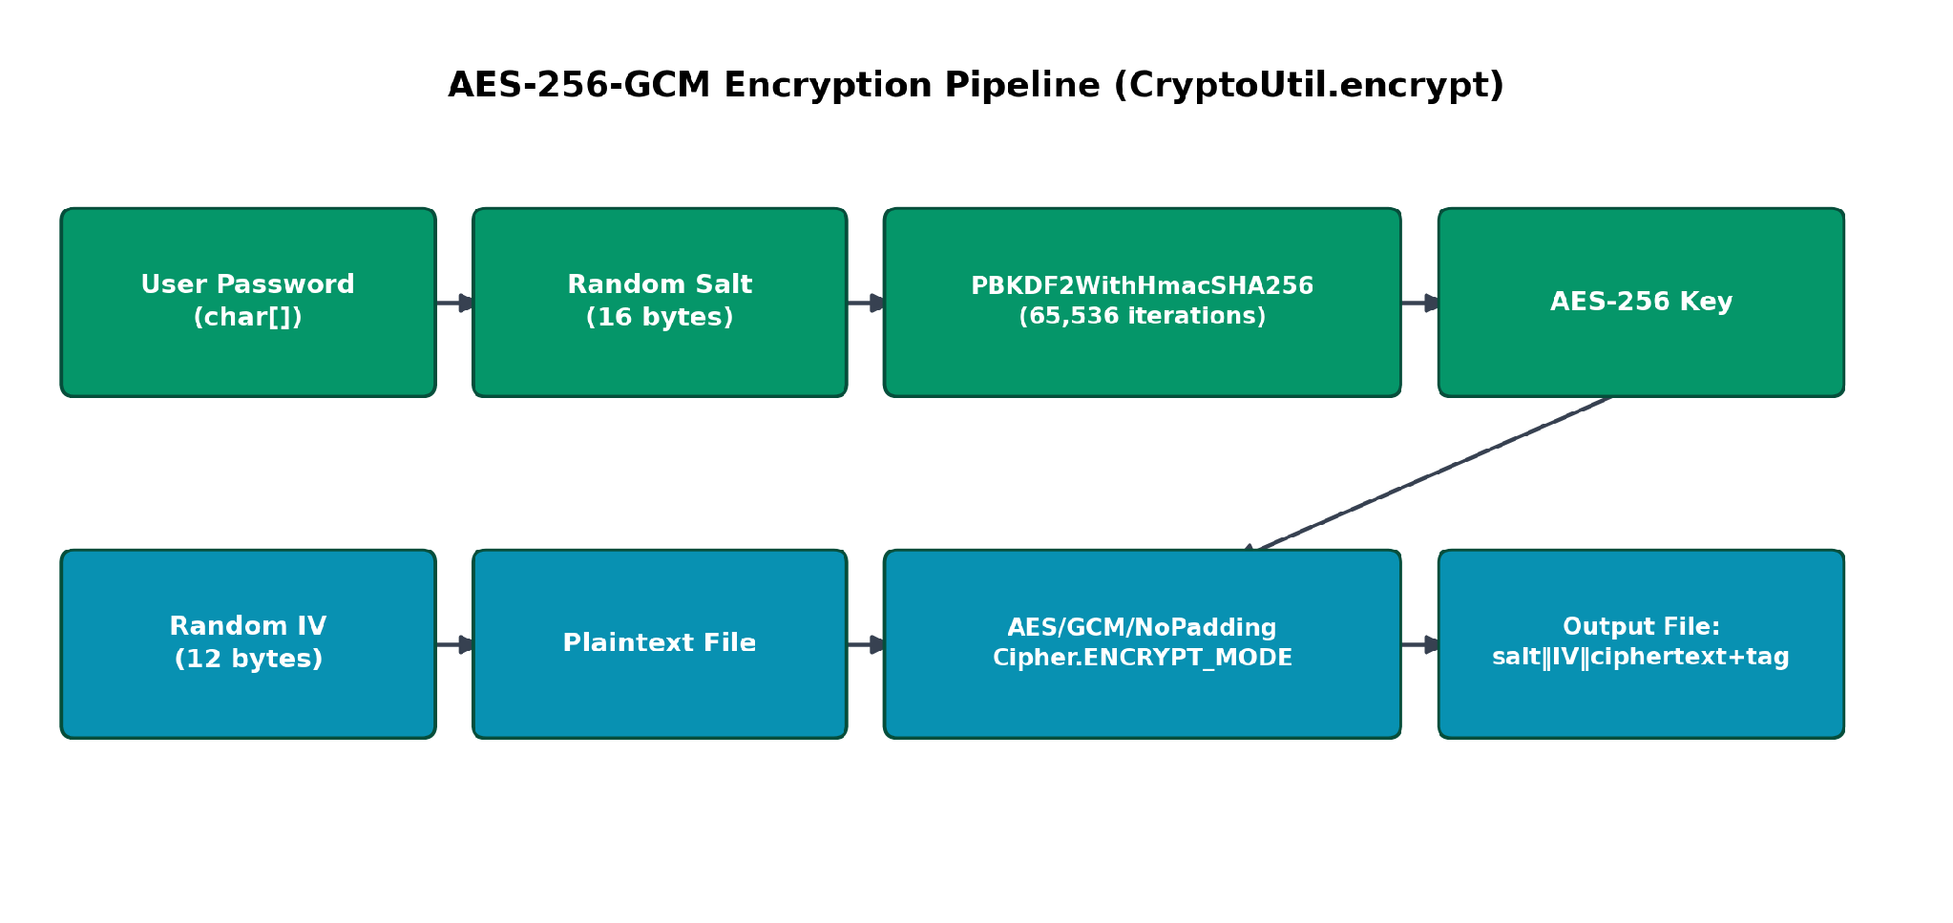
Figure 2. AES-256-GCM encryption pipeline shared by CryptoUtil.encrypt() and, by extension, VaultManager.save().

4. Implementation

4.1 Technology Stack
- Java SE (JDK 8 or later; tested against OpenJDK 21)
- javax.crypto — Cipher, SecretKeyFactory, GCMParameterSpec, PBEKeySpec, SecretKeySpec
- java.security — MessageDigest, SecureRandom
- No external/third-party libraries or build tools are required.

4.2 Module Summary
File | Responsibility | Key APIs Used
Main.java | Command-line menu; collects file paths and passwords; routes to encryption, integrity checking, password tools, or the vault. | java.util.Scanner, java.io.Console
CryptoUtil.java | Derives a key from a password via PBKDF2; performs AES-256-GCM encryption and decryption of arbitrary byte streams (used for both files and the vault blob). | javax.crypto.Cipher, SecretKeyFactory, GCMParameterSpec, PBEKeySpec
FileIntegrityUtil.java | Computes and verifies SHA-256 digests of files for independent integrity checking. | java.security.MessageDigest
PasswordUtil.java | Scores password strength using length, character-class variety, and estimated entropy; generates cryptographically random passwords. | java.security.SecureRandom
VaultManager.java | Maintains an in-memory list of credential entries; serializes and encrypts them as a single unit via CryptoUtil before writing to disk. | CryptoUtil, java.nio.file.Files

4.3 Key Implementation Snippet
The core of the encryption logic — shared by file encryption and vault encryption alike — derives the key and initializes the cipher as follows:
PBEKeySpec spec = new PBEKeySpec(password, salt, 65_536, 256);
SecretKeyFactory factory = SecretKeyFactory.getInstance("PBKDF2WithHmacSHA256");
byte[] keyBytes = factory.generateSecret(spec).getEncoded();
SecretKeySpec key = new SecretKeySpec(keyBytes, "AES");
Cipher cipher = Cipher.getInstance("AES/GCM/NoPadding");
cipher.init(Cipher.ENCRYPT_MODE, key, new GCMParameterSpec(128, iv));

5. Testing and Results
The application was tested manually against the following scenarios to validate both correctness and the security properties claimed in this report:
Test ID | Scenario | Expected Result | Outcome
TC-01 | Encrypt a file, then decrypt with the correct password | Decrypted file is byte-identical to the original | Pass
TC-02 | Decrypt an encrypted file using an incorrect password | AEADBadTagException is thrown; program reports failure instead of producing corrupted output | Pass
TC-03 | Manually flip a byte in an encrypted file, then attempt decryption | GCM authentication tag check fails; tampering is detected | Pass
TC-04 | Encrypt the same file twice with the same password | Two runs produce different ciphertext (fresh random salt/IV each time) | Pass
TC-05 | Generate a SHA-256 checksum, then verify the unmodified file against it | Verification reports MATCH | Pass
TC-06 | Modify a file after hashing, then verify against the old checksum | Verification reports MISMATCH | Pass
TC-07 | Score a known weak password (e.g. “password”) | Score ≤ 5, rating ‘Very Weak’ | Pass
TC-08 | Score a long, mixed-class random password | Score ≥ 80, rating ‘Very Strong’ | Pass
TC-09 | Create a new vault, add a credential, save, then reopen with the correct master password | Entry is present and readable after reopening | Pass
TC-10 | Reopen the vault with an incorrect master password | Unlock fails cleanly via AEADBadTagException; no entries are exposed | Pass

All test cases passed. In particular, TC-02, TC-03, and TC-10 confirm the core security claim of the project: CyberVault does not merely fail to produce meaningful plaintext on a wrong password or tampered file — it explicitly detects and rejects both cases via the GCM authentication tag, rather than silently returning corrupted data.

6. Security Analysis

6.1 Why AES-256-GCM Instead of AES-CBC
AES-CBC with PKCS5 padding was considered but rejected in favor of GCM. CBC only provides confidentiality; verifying integrity requires a separately computed HMAC, and implementing this incorrectly (for example, checking the HMAC after decrypting rather than before) is a well-known source of padding-oracle vulnerabilities. GCM avoids this class of bugs entirely by combining encryption and authentication into a single, well-vetted construction, applied uniformly across both file encryption and the vault.

6.2 Why PBKDF2 With a High Iteration Count
Using the password directly as an AES key would make the system only as strong as the password itself, and would allow an attacker with a captured file or vault to attempt keys directly. PBKDF2 with 65,536 iterations adds significant computational cost to each guess, meaningfully slowing down offline brute-force and dictionary attacks against weak passwords.

6.3 Role of the Random Salt and IV
A unique salt per operation ensures that encrypting the same file with the same password twice, or two different files with the same password, results in unrelated keys and ciphertext. This defeats precomputation attacks such as rainbow tables and prevents an observer from noticing that two encrypted files, or two vault saves, share a password.

6.4 Secure Randomness in Password Generation and Scoring
The password generator uses SecureRandom rather than java.util.Random, and guarantees at least one character from each of four classes (lowercase, uppercase, digit, symbol) before applying a Fisher–Yates shuffle so the guaranteed characters are not predictably positioned. The strength analyzer complements this by scoring user-supplied passwords against length, character variety, estimated entropy, and a small list of commonly breached passwords — giving users actionable feedback rather than a simple pass/fail verdict.

6.5 Known Limitations
- There is no key or password recovery mechanism: if a file password or the vault's master password is lost, the data cannot be decrypted. This is an intentional trade-off, not an oversight.
- The tool does not currently encrypt file metadata (original filename, size, timestamps) when encrypting individual files, only file contents.
- Password input falls back to a visible on-screen prompt when run inside an IDE or non-console environment, since java.io.Console is unavailable there.
- The common-password blacklist used by the strength analyzer is small and illustrative rather than exhaustive.

7. Conclusion and Future Scope
CyberVault successfully demonstrates how core Java cryptography APIs can be combined to build a practical, dependency-free security toolkit that meets modern expectations: authenticated encryption, proper password-based key derivation, cryptographically secure randomness, and an encrypted credential store, all built from five cleanly separated modules. The project reinforced the importance of choosing well-reviewed cryptographic constructions (such as GCM) over ad hoc combinations of primitives, and of testing failure paths — wrong passwords, tampered data, corrupted vaults — in addition to the success path.
Future work could extend the project with a graphical interface, support for encrypting entire directories with a manifest of per-file checksums, metadata encryption, migration to Argon2id for key derivation as JDK support matures, and encrypted vault export/import for backup and multi-device use.

References
- NIST Special Publication 800-38D — Recommendation for Block Cipher Modes of Operation: Galois/Counter Mode (GCM).
- NIST Special Publication 800-132 — Recommendation for Password-Based Key Derivation.
- NIST Special Publication 800-63B — Digital Identity Guidelines: Authentication and Lifecycle Management (password strength guidance).
- Oracle Java Platform, Standard Edition Security Developer's Guide — Java Cryptography Architecture (JCA) Reference Guide.
- FIPS PUB 180-4 — Secure Hash Standard (SHS), for the SHA-256 algorithm.

