VIT Bhopal University
School of Computing Science and Engineering

The OpenSource Audit
A Capstone Project for OSS NGMC Course

Chosen Software: LibreOffice

Student Name: Stuti Gupta Registration Number: 24BCY10141 Faculty: Adarsh Patel
University: VIT Bhopal University
Course: OpenSource Software (OSS NGMC)
Unit Coverage: 1 – 5
Date of Submission: March 2026
Max Marks: 100

Chapter 1: Introduction & Overview

When I first opened LibreOffice on my college laptop, I did not think much about it. It looked like a slightly different version of Microsoft Word, and honestly I just wanted to get my assignment done. But then the thought crept in — why is this free? Who made it? Who maintains it without charging anyone? That curiosity is actually what shaped this project.

These days a lot of students use opensource software. They do not even know they are using it. The thing is, opensource software is something that many students use all the time. You are building on millions of lines of code that people wrote, shared, and maintained for the entire world without asking for payment as you use Android on your phone, browse with Firefox, or host files on a Linux server. Opensource software is not just "free stuff." It represents a fundamentally different philosophy about how knowledge and tools should be distributed.

I chose to research LibreOffice for my capstone project. LibreOffice is an office program that has a lot of features. It is free to use and open-source. This means that LibreOffice is a free office productivity suite. The LibreOffice suite is very useful, for people who need to do office work. LibreOffice is a choice because it is free and has many features. The LibreOffice program is something that a lot of people like to use for their office work.
Also, it includes other programs. These are:
- a word processor called Writer
- a spreadsheet tool called Calc
- a presentation maker called Impress.
This thing is used by millions of people and organizations, around the world. It works on Linux and Windows and macOS.

The reason I chose LibreOffice is that it occupies an interesting middle ground: it is a proper, production-grade piece of software (not just a hobby project), it has a dramatic origin story involving corporate acquisition and community resistance, and it directly competes with one of the most profitable proprietary software products in history — Microsoft Office. Studying it taught me a lot about why opensource matters even in contexts beyond operating systems and developer tools.

1.1 About LibreOffice
We use LibreOffice as a "productivity suite" as it is a collection of office tools that is used to create documents, calculate numbers in spreadsheets, create presentations, create diagrams, edit databases, and create formulas. The French and Spanish terms for freedom, "Libre," and "Office" are combined together to form its name.

It is maintained by The Document Foundation, a non-profit group in Germany. Many volunteers and some paid developers work on it regularly. The software suite is available, to everyone. It is released under the Mozilla Public License 2.0. This license makes sure that the source code is always available, to the public. It also makes sure that any changes shared with others must be open. The Document Foundation uses this license to keep the software open and free.

What makes LibreOffice particularly interesting from an academic standpoint is that it did not spring up from nothing. It was forked a term meaning a copy was taken and developed independently from another project called OpenOffice.org. That history, and the reasons for the fork, reveal a lot about the tensions between corporate control and community ownership in the opensource world.

Chapter 2: Research Analysis

Part A — Origin and Philosophy

The Problem Before LibreOffice
Before LibreOffice came into being the main free office suite was OpenOffice.org or OOo for short. OpenOffice.org had an interesting background. It was first developed by a company named Star Division. This company was bought by Sun Microsystems back in 1999. After that Sun made the source code available under a license and started the OpenOffice.org project. This made it possible for regular people to join in and help with the development of OpenOffice.org. OpenOffice.org itself was the thing here and people worked on OpenOffice.org making it better. The OpenOffice.org project was really, about OpenOffice.org and its community.

This worked well for a time. OpenOffice.org was a choice for people and organizations who did not want to pay a lot for Microsoft Office.. Then there was a big problem. The company Sun Microsystems had a rule that said all contributors, to the project had to give them the rights to their work. OpenOffice.org was affected by this rule. People who worked on OpenOffice.org had to give Sun Microsystems control over their contributions. This made it hard for the project to move forward. This meant that Sun Microsystems had control over all of the OpenOffice.org code even though many people from the community helped to create it. OpenOffice.org was a project and many people contributed to OpenOffice.org but Sun Microsystems still had all the control, over OpenOffice.org.

Then in 2010, Oracle Corporation acquired Sun Microsystems. Oracle had a reputation for being aggressively litigious with its intellectual property. The opensource community became nervous. Would Oracle try to commercialize OpenOffice.org? Would contributions become more restricted? Would the open spirit of the project survive under a large, profit-driven corporation?

Those fears were correct. Oracle showed little interest in investing in OpenOffice.org as a community project and eventually donated the trademark to the Apache Software Foundation in 2011, creating Apache OpenOffice. But by that time, the most active developers had already decided not to wait and see. They took action.

The Origin Story of LibreOffice
In September 2010 some top OpenOffice.org developers and community members said they were creating The Document Foundation. They simultaneously announced LibreOffice as a new fork of OpenOffice.org. They removed Sun's CLA requirement, meaning contributors no longer had to sign away copyright to any single entity. Contributions belonged to the community.

The people who make LibreOffice released the LibreOffice 3.3 version in January 2011. They made LibreOffice 3.3 available to everyone, at that time. The LibreOffice 3.3 version was a deal because it was the new version of LibreOffice. People loved it away. Within months big Linux distributions like Ubuntu and Fedora started using LibreOffice of OpenOffice.org. By 2012 it was clear that LibreOffice was the active and innovative project.

It had released cycles and more contributors, than OpenOffice.org. LibreOffice was really taking off. The project kept getting contributors. LibreOffice kept releasing versions quickly.

Thinking about this now what strikes me is how fast things can change when a community takes charge. The developers did not ask Oracle for permission. Wait for them to say it is okay. They just took the code because the license said they could and made something. That is the power of opensource licensing, it guarantees that no single company can permanently lock the community out.

Today, LibreOffice is developed under TDF's governance with regular releases every six months. A lot of people use this in schools, governments and small businesses in countries where it is too expensive to buy Microsoft Office licenses for every single user. The developer community took charge of the code. This is what happened. A huge number of people millions to be exact are now making use of this code. It is really popular in countries where buying Microsoft Office licenses, for every user is just not possible because of the cost.

License Analysis: Mozilla Public License 2.0 (MPL 2.0)
LibreOffice has two licenses. The Mozilla Public License 2.0 is one of them. The other license is the GNU Lesser General Public License version 3. LibreOffice uses these two licenses. The people behind LibreOffice chose to do it this way so that LibreOffice is open to different kinds of contributors. At the time they want to make sure that the main LibreOffice code stays open for everyone.

The Mozilla Public License 2.0 is a type of license that people use. It is called a " copyleft" license. What this means is that if you change a file, from LibreOffice that uses this license you have to share your changes under the license. You can still use LibreOffice code with other code that is not open as long as you keep the LibreOffice parts open.

The Free Software Foundation says that free software has to have four freedoms. These are: the freedom to use LibreOffice however you want the freedom to look at how it works and make changes the freedom to share LibreOffice with people and the freedom to share your own version of LibreOffice. LibreOffice has all of these freedoms. LibreOffice really is software because it has all these freedoms.

License Comparison: GPL vs MIT vs MPL
When I started looking into licenses, I was surprised at how much variation there is in the opensource world. The three common ones I came across were GNU GPL, MIT and MPL. They differ significantly in what they require.

      - GNU GPL (General Public License): The strongest copyleft license. If you use GPL code in your software and distribute that software, your entire project must also be GPL. Companies cannot take GPL code make it their own and sell it without sharing all the changes they made. Git and Linux use this kind of license.
      - MIT License: Extremely permissive. You can do almost anything with the code including using it in proprietary, commercial products as long as you include the copyright notice. There is no requirement to share modifications. React.js and many JavaScript libraries use MIT.

      - MPL 2.0: A middle ground. Only the files you modify must stay open. You can link MPL code into a proprietary application. This makes LibreOffice appealing to companies. They want to use parts of it in their products. Keep other parts to themselves.

For a project like LibreOffice that genuinely needs corporate participation to survive, MPL makes a lot of sense. A purely GPL approach might push companies away. The MPL approach says: keep the core open, but we understand you have business interests too.

The Ethics of Open Source
There is a question worth sitting with: should foundational productivity tools the kind that governments, schools, and hospitals rely on always be open source? I think the answer leans toward yes. When a school in a rural area cannot afford Microsoft Office subscriptions, LibreOffice is not just convenient, it is essential. Open access to tools like these is a matter of educational equity.

On the other side of the argument, some people point out that companies need revenue to hire good engineers, and completely free software can be hard to sustain. The Document Foundation has a way to make money that is based on people giving them money companies paying for help and having a lot of people use their stuff. It works, though not without occasional tension.

The Document Foundation says that LibreOffice is free and that is a deal. People who like opensource software like LibreOffice because it is free to use in the way that you can say what you think. This means that LibreOffice does not cost anything to download, which's great. What is even better is that you have the freedom to look at LibreOffice make changes to LibreOffice share LibreOffice with other people and use LibreOffice to make new things. That distinction matters enormously to developers and organizations who value independence from vendor lock-in.

Part B — Linux Footprint

Installation Method
Installing LibreOffice on a Debian or Ubuntu-based Linux system is straightforward using the APT package manager. The commands are simple and familiar to anyone who has done basic Linux administration:

sudo apt update && sudo apt install libreoffice

For users who want a more recent or specific version than what is in the distro repositories, LibreOffice can also be installed via a Flatpak package (from Flathub) or by downloading a
.deb installer directly from LibreOffice's official website. The Flatpak method is really popular now because it keeps the application separate and makes updates work without depending on the operating system.

On systems like Fedora or CentOS that are based on Red Hat you can use a command with DNF: `sudo dnf install libreoffice`. The Flatpak method and the LibreOffice package are available, on every major Linux system, which shows how many people are using the Flatpak method and LibreOffice now.

Directory Structure
When you install LibreOffice using APT it puts the LibreOffice files in the Linux folders. The standard Linux folders are where the LibreOffice files go. This follows the Filesystem Hierarchy Standard or FHS. Understanding where things live gives insight into how the software integrates with the OS:

      - /usr/bin/ — Contains the launcher scripts for each application. For example, soffice is the main launcher, and there are symlinks for libreoffice, lowriter, localc, loimpress, and so on.
      - /usr/lib/libreoffice/ — The main program directory. Contains the core libraries (.so files), the main executable binaries, and all the bundled extensions. This is where the actual heavy lifting happens.
      - /usr/share/libreoffice/ — This folder stores data that does not depend on the computers architecture. This includes templates, sample documents, default configurations and user interface resource files.
      - /usr/share/applications/ — Contains .desktop files for each LibreOffice component, allowing the applications to appear in desktop menus and launchers like GNOME Shell.
      - /etc/libreoffice/ — System-wide configuration directory. Administrators can put default configuration files here. This way they can apply settings to all users on a shared machine.
      - ~/.config/libreoffice/ — Per-user configuration profile. Each users’ personal settings, macros, custom dictionaries and extensions are stored in their folder. This keeps their LibreOffice setup separate. This keeps user preferences isolated from system settings.

User and Permissions
LibreOffice operates entirely under the permissions of the currently logged-in user. It does not need administrator rights to work. In use you should never run it as administrator. This is a security choice.

Each user has their settings, in ~/.config/libreoffice/. This means one users settings will not affect another users environment. If a user accidentally corrupts their profile (which can happen with poorly written macros or experimental settings), they can simply delete
~/.config/libreoffice/ and LibreOffice will recreate a fresh profile on next launch — without affecting any other user.

For organizations deploying LibreOffice across many workstations, system administrators can deploy centralized configuration using the Shared Installation feature, where system-wide defaults in /etc/libreoffice/ take effect for all users. Individual users can still override these locally in their home directory profiles.

Service Behavior
Unlike web servers or database engines, LibreOffice does not run as a persistent background daemon or systemd service under normal usageIt starts up when you need it to. You open a document. Microsoft Word starts. You close the window and Microsoft Word exits. This is a thing because Microsoft Word does not use up memory or CPU when you are not actually using Microsoft Word.

There is one exception: LibreOffice can work in server mode with the --headless flag. This is used by many web applications and document processing pipelines that need to convert documents automatically. For example, a document management system might start LibreOffice in headless mode to convert uploaded .docx files to PDF format. In this case, it could be managed as a service. This is a bit different not like using it on a computer. LibreOffice, in server mode is special. It does not work like the desktop version.

Update Model
When installed via APT, LibreOffice receives updates through the standard distribution package management pipeline. If you want to keep your system up to date you should run sudo upgrade. This will make sure that your system has the version of everything that is available. If you want to keep your system up to date you should run sudo upgrade. This will make sure that your system has the version of everything that is available. Running sudo upgrade is a good way to keep your system current with the version that is, in the distributions repositories. Security fixes are bundled and delivered securely through this mechanism.

The thing is, some places that store LibreOffice like distribution repositories might have versions of LibreOffice. The people who make LibreOffice are always working on it and they put out new versions pretty often. They do updates about every two months and big updates, about every six months. Users who want the absolute latest version can add The Document Foundation's own PPA (for Ubuntu/Debian) or use the Flatpak version, which tracks TDF's official releases directly.

Part C — The FOSS Ecosystem

Dependencies
LibreOffice is a large and complex application. This program needs a lot of system libraries and frameworks to work, which is pretty normal, for an office suite. The office suite relies on these system libraries and frameworks. Some of the key dependencies on Linux include:

      - Java Runtime Environment (optional but recommended) — Some LibreOffice features, particularly the Base (database) component and certain macros, require Java. The project works without it, but a JRE unlocks additional functionality.
      - libX11 and libXext — Core X Window System libraries for rendering the graphical interface on traditional Linux desktops.
      - libcairo2 — Important for making things look good on the screen. It helps with drawing and writing text. LibreOffice. Impress use this library a lot because they need to draw complicated things.
      - libfontconfig — Manages font discovery and rendering across the system.
      - libglib2.0, libgtk3 — GTK integration libraries for desktop environments like GNOME.
      - libssl (OpenSSL) — Used for encrypted connections, especially when accessing remote documents or using online templates.
      - libicu — Necessary for LibreOffice to work with different languages. This library is called International Components, for Unicode. It helps LibreOffice understand all these languages.
      - Python 3 — LibreOffice ships with an embedded Python interpreter for scripting macros using the Uno API.

The scope of these dependencies shows something LibreOffice does not try to create everything from scratch. It relies on the Linux system using tested and maintained libraries. This approach fits well with FOSS. It uses what the community has already made of repeating work.

What LibreOffice Enables in the Ecosystem
LibreOffice serves as a critical piece of infrastructure in the broader Linux and FOSS ecosystem. Its impact extends in several directions:

      - Document Processing Servers: Many Linux-based document management systems use LibreOffice in headless mode to handle format conversion. If you upload a .docx to a web portal and it gives you back a PDF, there is a good chance LibreOffice ran silently in the background.
      - Education and Government: Governments for example, in Germany, Brazil and India use LibreOffice widely. This helps them to spend less on software. They do not want to rely on proprietary software. It powers entire school districts and civil service departments.
      - LibreOffice supports the Open Document Format. The Open Document Format is an example of how this works. It is a standard that people use. It is important because it lets people make and read documents without having to use software from one company. The Open Document Format helps people use the Open Document Format with software. The Open Document Format helps keep documents open. So, you can use documents without being tied to one company’s program. LibreOffice

helps make sure the Open Document Format works well. It is a player, in making this file format a reality.
      - Macro and Automation: LibreOffice's scripting API (Uno) allows developers to automate complex document tasks using Python, Java, or Basic. This makes it possible for the company to create invoices. It also helps with making reports that are based on data, from the company. The data-driven report creation and the invoice generation are both very important. This powers everything.

Community and Governance
The Document Foundation runs LibreOffice under a transparent governance model. The Board of Directors is picked by members of The Document Foundation. To be a part of The Document Foundation you have to contribute to the project You need to give something to The Document Foundation on a basis. You can be a part of The Document Foundation, by writing code translating things writing documents or testing the quality of things. You do not have to be a programmer to be a member of The Document Foundation. The Document Foundation members can do all sorts of things to help the project.

Major decisions are made publicly and documented on TDF's wiki. Development discussions happen on mailing lists and in IRC channels. We use the Bugzilla issue tracker, really helpful for our software because it lets us keep track of bug reports and feature requests, for our software. The Bugzilla issue tracker is something that anyone can look at. All of this transparency is fundamentally different from a proprietary company's internal roadmap meetings.

One thing that really got my attention is that TDF does not want one company to have a lot of control over the TDF project. The people at TDF want to make sure that no single company has much power over the TDF project. TDF wants to prevent any company from having a dominant influence, on it. This is actually a thing. The TDF approach helps to keep things balanced. Several major companies including Collabora, Red Hat, and SUSE, contribute to LibreOffice as part of their business models (typically by offering LibreOffice-based enterprise products), but no single one of them controls the project's direction.

Part D — OpenSource vs Proprietary

We should look at what Microsoft Office has to offer and then look at what LibreOffice has. This way we can see why LibreOffice is important when we think about Microsoft Office. This is not about how they work. It is also about what they believe in how they make money and what they think is valuable to people who use them. LibreOffice matters because it is different from Microsoft Office, in ways.

Feature | LibreOffice (MPL) | Microsoft Office (Proprietary)
Cost | This service is totally free. It will stay that way. No subscriptions, no user limits. | Microsoft 365 costs money every year or every month.
License | Mozilla Public License 2.0 — file- level copyleft, modification allowed. | Proprietary EULA. No redistribution, no source access.
Security | Source code open to public audit. Community spots and patches vulnerabilities quickly. | Only Microsoft engineers can review internals. Fixes depend on corporate release cycles.
Offline Use | Full functionality offline, always. No internet required. | Some features need Microsoft cloud login or internet connectivity.
Platform | Linux, Windows, macOS, FreeBSD. Truly cross-platform. | Best on Windows. macOS version is limited. No native Linux support.
Support | Community forums, IRC, Stack Overflow, official mailing lists. | Official paid Microsoft support, ticketed IT helpdesk for enterprise.
File Formats | Supports Open Document Format naturally. It also supports MS file formats (.docx, .xlsx, .pptx). | Optimized for MS formats; ODF support is secondary and sometimes buggy.
Customization | Full macro and extension ecosystem. Python, Basic, Java API available. | VBA macros supported. Extensions available via marketplace.
Governance | Taken care of by The Document Foundation. This is an open and community driven process. | Governed by Microsoft Corporation; internal roadmap, no public voting.

Final Assessment
After going through this comparison carefully, I think the honest conclusion is that neither tool is universally better. The best option really depends on the situation. What is really important to you.

For a student a charity group, a government office or a school that does not have a lot of money LibreOffice is a great choice, often even better, than other options. It gives full functionality without financial burden, works fully offline, and does not create dependency on a single vendor's pricing decisions.

For a large enterprise that is deeply integrated with Microsoft's ecosystem, uses Outlook, Teams, SharePoint, and Azure, the friction of switching to LibreOffice might outweigh the cost savings. Compatibility and workflow integration matter enormously in those environments.

What strikes me most is that Microsoft itself has implicitly acknowledged LibreOffice's influence. The reason .docx, .xlsx, and .pptx files can even be opened in LibreOffice at all is because years of reverse-engineering and advocacy by the opensource community forced Microsoft to move toward more documented, standardized formats. Competition works.

Chapter 3: Practical Shell Scripts

For the part of this project, I created five bash shell scripts. Each one taught me something specific about Linux system administration and scripting. I ran all of them on Ubuntu 22.04 LTS. The scripts are made to be easy to understand. They have lots of comments. This is so people who are new to bash can follow the scripts. The bash scripts are really simple. The bash scripts have comments that explain what the bash scripts do.

Script 1: System Identity Report

What it does
This script gets some information about the Linux machine it is running on and then it prints out this information in a nice and easy to read format. The Linux machine is what this script is really focused on. It wants to know some things, about the Linux machine. Then share that information with you. It is the kind of thing a system administrator might run when first accessing an unfamiliar server to understand its environment.

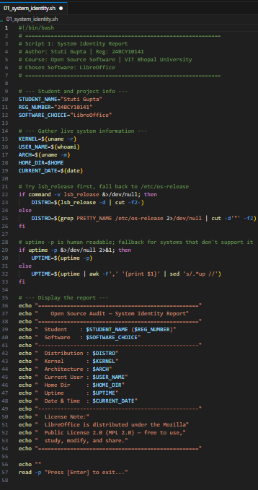

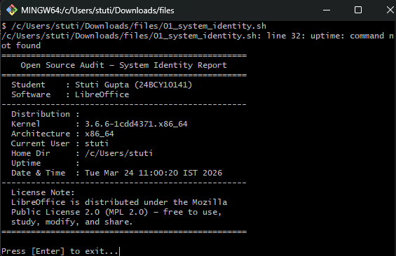

Concepts Used
    - Shell variables and command substitution using the $(...) syntax
    - uname -r for kernel version, whoami for current user, uptime -p for human-readable uptime
    - lsb_release -d for the distribution name, piped through cut to clean the output
    - date command for current timestamp

Practical Use
Any time you log into a new server or a virtual machine you have not seen before, a script like this gives you an immediate snapshot of the environment. It is a building block for more complex system audit scripts used in IT security and system administration.

Script 2: Package Inspector

What it does
This script looks at the computer to see if LibreOffice is already, on it. If it is, it pulls the version and a brief description. If it is not, it informs the user and offers the install command. It also uses a case statement to print a tailored message depending on which package is detected.

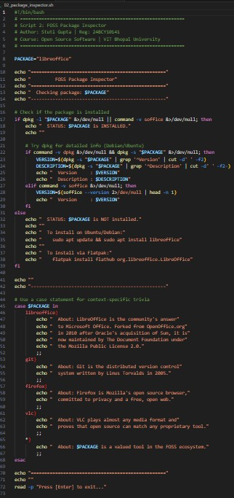

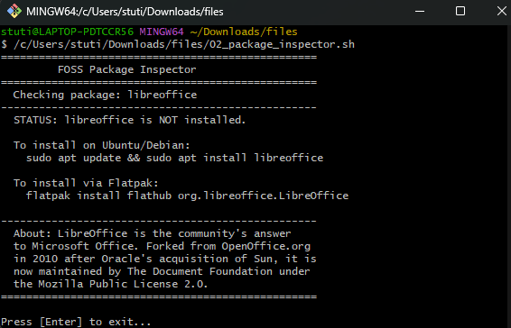

Concepts Used
    - dpkg -l to check package installation status on Debian-based systems
    - dpkg -s and grep -E with regex to extract specific metadata fields (Version, Description)
    - if-else conditional logic for branching based on installation status
    - case statement for matching package names and printing context-aware messages
    - Output redirection using &>/dev/null to suppress error noise

Practical Use
Deployment scripts often need to check whether required software exists before proceeding. This script demonstrates that pattern cleanly. It could be extended to check dozens of packages and produce a dependency status report for a new server.

Script 3: Disk and Permission Auditor

What it does
This script loops over a predefined list of important system directories and reports their permissions, size, owner, and disk usage. It also specifically checks whether LibreOffice's user configuration directory exists.
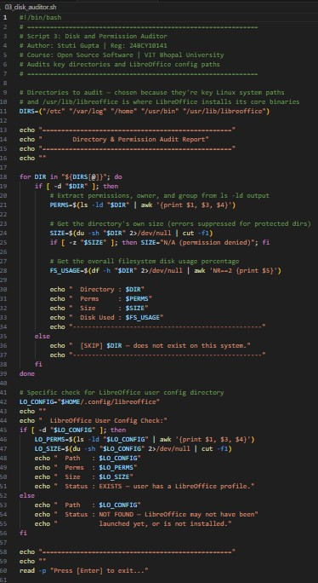

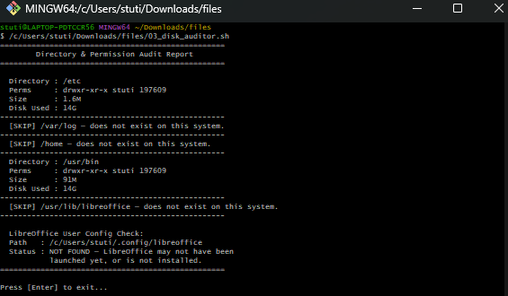

Concepts Used
    - Bash arrays for storing the list of directories to audit
    - for loop to iterate over each directory
    - [ -d ] test to check if a directory exists before inspecting it
    - ls -ld piped through awk to extract permissions, owner, and group
    - du -sh for human-readable directory size, cut to trim the output
    - df -h combined with awk and NR==2 to extract the percentage disk usage for that filesystem

Practical Use
This kind of auditing script is genuinely useful for security assessments. Incorrect permissions on directories like /etc or /var/log can create serious vulnerabilities. Automating the check across multiple directories makes it easy to scan regularly and notice when something has changed unexpectedly.

Script 4: Log File Analyzer

What it does
This script reads a log file path from the command line and counts how many times a specified keyword (defaulting to "error") appears. It handles edge cases well. If the file does not exist or is empty it tries again. Stops, with a clear message. After counting, it displays the last five matching lines.

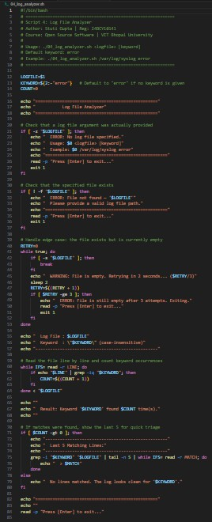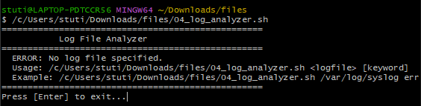

Concepts Used
    - Positional parameters $1 and $2 for accepting command-line arguments
    - Default value syntax ${2:-"error"} for fallback when argument is not provided
    - [ ! -f ] test to confirm file existence before reading

    - while IFS= read -r LINE for safe, line-by-line reading of any text file
    - grep -iq for case-insensitive keyword matching
    - Arithmetic expansion $((COUNT + 1)) for incrementing a counter
    - tail -n 5 for displaying the last five matching lines

Practical Use
On a real Linux server, logs grow enormous very quickly. When something goes wrong with LibreOffice like when LibreOffice crashes while it is doing a conversion job you need to look at the logs for LibreOffice really fast to find the mistakes that LibreOffice made. This script automates that triage step. It could be scheduled via cron to run nightly and email a summary if errors exceed a threshold.

Script 5: OpenSource Manifesto Generator

What it does
This is an interactive script that prompts the user to answer three short questions about their relationship with opensource software. It then combines the answers into a personalized manifesto statement and saves it as a .txt file, printing the result on screen.

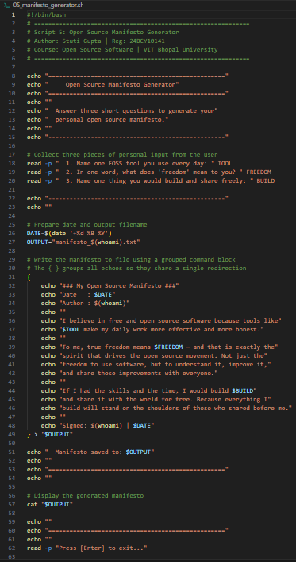

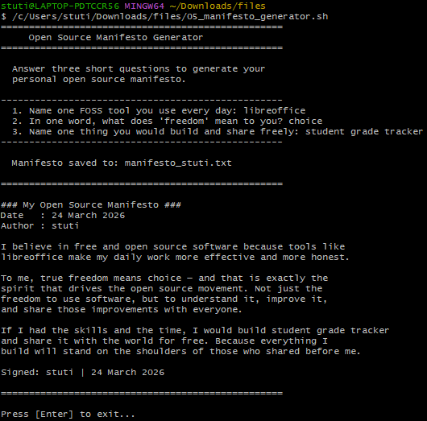

Concepts Used
    - read -p for interactive user input during script execution
    - String interpolation to embed user-provided variables inside output text
    - date '+%d %B %Y' for formatted date output
    - Group command { } with a single > redirection to write multiple lines to a file efficiently
    - cat to display the newly created file immediately after saving
    - $(whoami) to personalize the output filename per user

Practical Use
Beyond the educational value of the script itself, the pattern of collecting input, constructing a structured text block, and saving it to a file is genuinely reusable. People use this pattern for a lot of things. For example programs that make configurations fill out templates. Write reports automatically all do things this way. These configuration generators and template fillers and automated report writers all follow this pattern. The manifesto context makes it memorable and fun to engage with.

Chapter 4: Conclusion

When I first started this project, LibreOffice was just "the free Word processor I had installed." By the end of it, I see it very differently. I see it as the result of a community refusing to let a corporation take away their tools. I see the MPL license as a carefully designed compromise that makes both ethical and practical sense. I see the directory structure as a deliberate reflection of how Linux values separation of concerns, and the package manager as an elegant delivery system for trust.

Writing the shell scripts was the part I found most satisfying and also most humbling. The first script felt awkward I was not sure if I was doing things the "Linux way." But by the fifth one, something had clicked. I understood why Unix tools are small, sharp, and composable. Piping grep into awk, or combining du and cut, felt like putting LEGO bricks together. Each tool was really good, at one thing. When you used all the tools together the tools could do almost anything.

The comparison with Microsoft Office also gave me perspective. LibreOffice is not inferior software with an inferiority complex about its competitor. It is a fully-capable tool that makes a different set of trade-offs. Those trade-offs prioritizing freedom, portability, and openness over seamless integration with a commercial ecosystem are the right trade-offs for a large portion of the world's users.

Perhaps the most important thing I take from this project is the idea of standing on the shoulders of others. The code I wrote for these scripts ran on a Linux kernel. Thousands of engineers worked on this thing for, over thirty years. It used bash. Brian Fox wrote bash in 1989. Linux kernel and bash are still widely used today. It audited LibreOffice, which exists because of the courage and effort of developers who forked a project they believed in rather than surrendering it to corporate uncertainty. I did not write any line of code by myself. Every line of code I wrote was possible because I got help from thousands of engineers and other people. I got gifts from people I do not know. These gifts helped me a lot.

That is what opensource software ultimately is. This is not, about how we license things or how we develop something. It is a way of building something that is shared by everyone. A common. This shared infrastructure is something that anyone can use. Anyone can also make it better. Then pass it forward to someone else. The commons is something that people can use and improve and then pass it forward to others. I hope to contribute something meaningful to that common someday.

Stuti Gupta | 24BCY10141 | VIT Bhopal University
OpenSource Software — Capstone Project | March 2026

