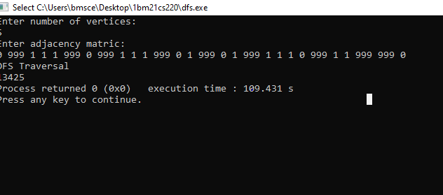

#include<stdio.h>

int a[10][10], n, vis[10];

int dfs(int v);

int main(){

int i, j;

printf("Enter number of vertices:\n");

scanf("%d", &n);

printf("Enter adjacency matric:\n");

for(i = 1; i<=n; i++)

{

for(j=1; j<=n;j++)

scanf("%d", &a[i][j]);

}

for(i = 1; i<=n; i++)

vis[i] = 0;

printf("DFS Traversal\n");

for(i = 1; i<=n; i++)

{

if(vis[i] == 0)

dfs(i);

}

return 0;

}

int dfs(int v){

int i;

vis[v] = 1;

printf("%d", v);

for(i=1; i<=n; i++)

{

if(a[v][i] == 1 && vis[i] == 0)

dfs(i);

}

}