**WEEK 3**

Write a program in LEX to recognize Floating Point Numbers. Check for all the

following input cases (Lab Program)

Program:

%{

#include<stdio.h>

#include<stdlib.h>

%}

%%

[+|-]?([0-9]*)?[.][0-9]+ printf("%s IS A FLOATING POINT",yytext);

[+|-]*[0-9]*[a-zA-Z]* {printf("not a floating point")};

.;

%%

int yywrap()

{

}

int main()

{

yylex();

return 0;

}

**OUTPUT**

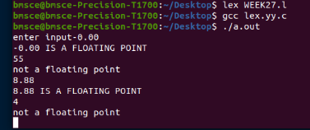

**1BM21CS220**