1.-Change the current directory to /home/<user>

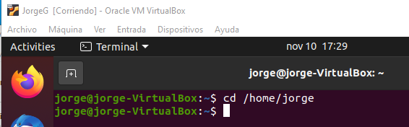

2.-Create a directory called systems



3-. Create a directory called exercises. Go to this directory and create another new directory called programming



4.-Go back to the user’s home directory. Delete the directories “exercises” and “programming” using just one command. Create the directories again with one command.

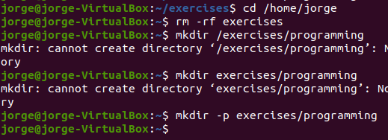

5.-Print the contents of the root directory



6.-Print all the files and directories that begin with d in the /usr/bin directory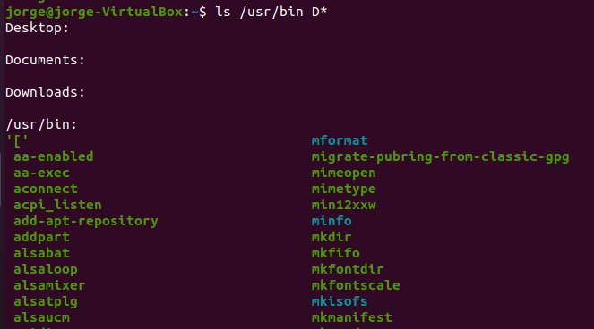

7.- List all the files and directories in /etc, including subdirectories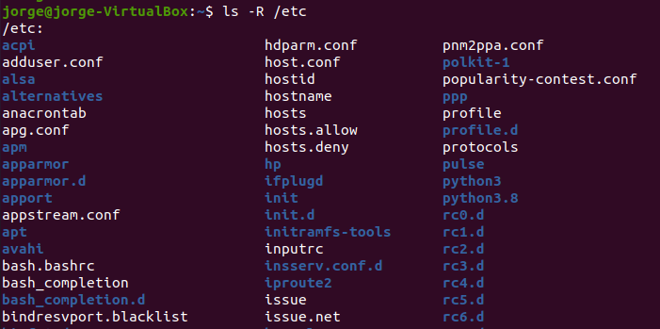

8-. Create the empty files called student.txt, student1.txt, student2.txt, list, luggage and last in the directory named “systems”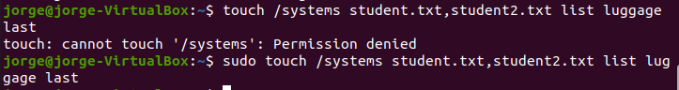

9.-Print all the files that begin with “l” in the directory “systems”



10.-Print all the files that end with “txt” in the directory “systems”



11.-Create a new directory into $HOME called “config”



12.-Copy all the files in /etc which begin with “a” into “config”

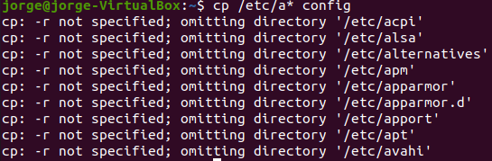

13.-Delete all the files in “config” which end with “conf”

