B.COPY RENAME AND EDIT FILES

Create the following directory structure in /home/<user>/exercises

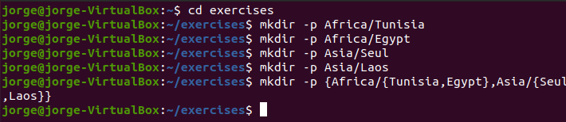

14. Create the following files using **nano** (or another editor): **song.doc** (write a few lines of a song) in the directory **Egypt**; **tv.doc** (write the name of your favourite TV programs) in the directory **Seul** and **marks** (write the marks you expect to get this year) in the directory **Tunisia**.





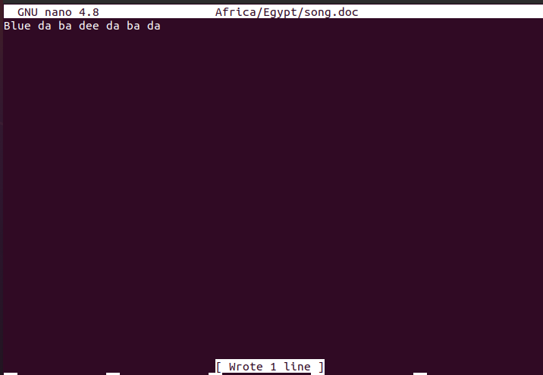



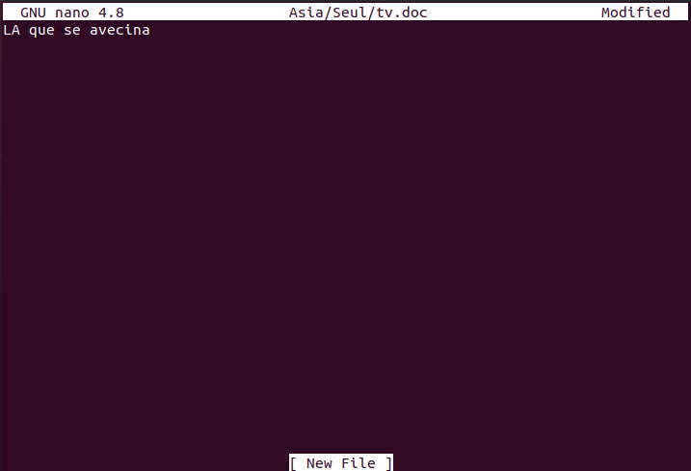



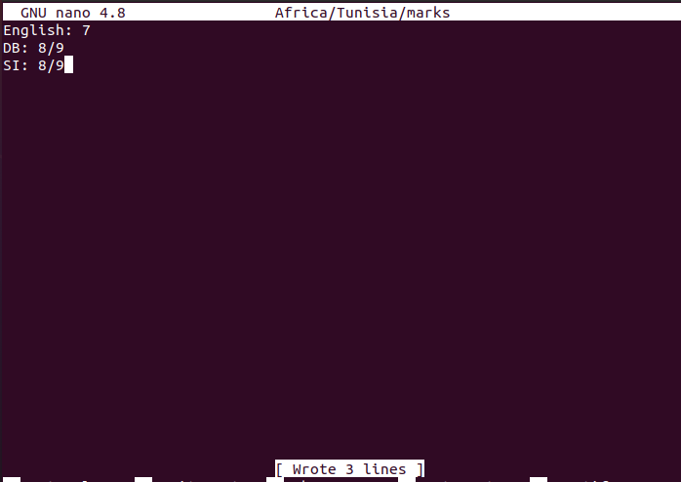

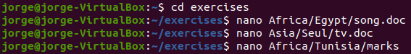

**CHANGE THE CURRENT DIRECTORY TO AFRICA AND DO THE FOLLOWING EXERCISES USING RELATIVE PATHS**

15. Copy the file “song.doc” into “Laos”



16. Copy the file “tv.doc” into “Egypt” with the name “radio.txt”



17. Rename the file “marks” to “exam.wri” (it is located in the directory named Tunisia)



18. Copy the file “song.doc” (located in “Egypt”) inside “Tunisia”



19. Print the content of the current directory using long listing format

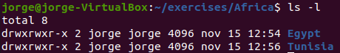

20. Rename the file “song.doc” (located in “Laos”) to “aa.doc”



21. Create the directory “Others” in “Laos”



22. Rename the directory named “programming” (which you created in the first exercises) to pro-c.



23. Create the following directory tree in “exercises” (using as few commands as possible)



24. Copy the files with txt extension from the directory named “systems” to “exercises”.

I’ve lost my VM so I have to end this only showing the command to execute it

cp ../../systems/*txt ../exercises

25.Move the files you copied in the exercise above to the directory THREE.

mv ../exercises/*txt ../ONE/THREE

26.Delete the directory named THREE, including all the files and, if so, subdirectories

rm -rf ../ONE/THREE

|  |  |
| --- | --- |
|  |  |

|  |  |  |  |
| --- | --- | --- | --- |
|  |  |  |  |
|  |  |  |
|  |  |  |