Fill in the following folder and file permissions tables based on the following criteria:

1. There are two groups: disney whose members are pluto, mickey y goofy; hanna

whose members are fred y scooby.

2. Only the group hanna can access the folder barbera to create, write and delete files.

Disney group cannot enter into this folder.

3. The users of disney can create and write files in the folder paris, but they cannot

delete them. The users of hanna can only read the files of this folder.

4. There is a file called flinstones.doc in the folder barbera. The user scooby cannot

open this file.

5. The users mickey and fred are able to copy files in the folder movies. The other users

can only read files in this folder.

6. Do not delete Administrator permissions. They will always have “Full Control” over all

the resources.

Complete this exercise considering that all the folders are at the same level.

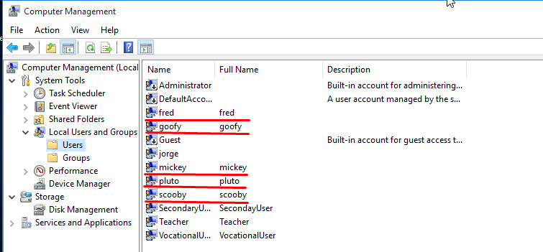

Users created

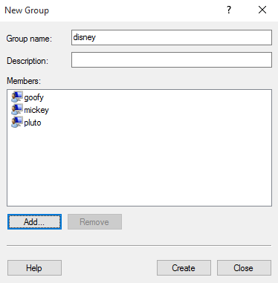

Creating groups

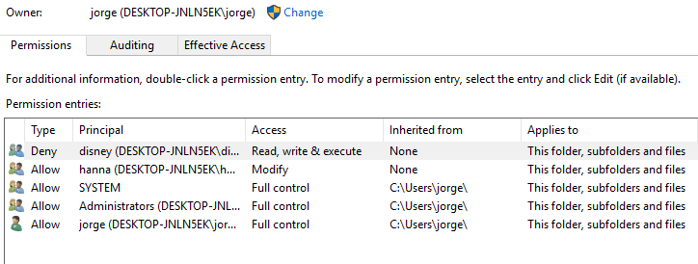

Permissions for barbera

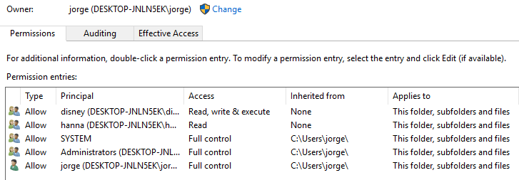

Permissions for paris

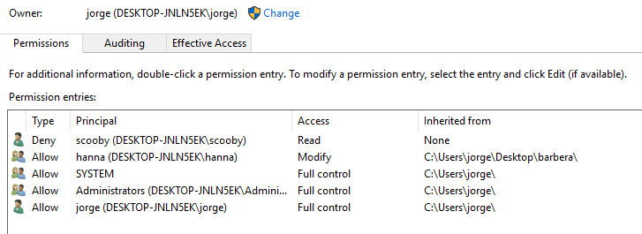

Permissions for flinstone.doc

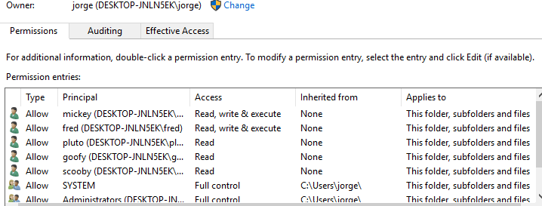

Permissions for movies

**barbera**

|  |  |  |  |  |  |  |  |  |  |  |
| --- | --- | --- | --- | --- | --- | --- | --- | --- | --- | --- |
|  | **Allow** | | | | | **Deny** | | | | |
| User/Group | **Full Control** | **Modify** | **Read & Execute** | **Read** | **Write** | **Full Control** | **Modify** | **Read & Execute** | **Read** | **Write** |
| hanna (explicit) |  | X | X | X | X |  |  |  |  |  |

**paris**

|  |  |  |  |  |  |  |  |  |  |  |
| --- | --- | --- | --- | --- | --- | --- | --- | --- | --- | --- |
|  | **Allow** | | | | | **Deny** | | | | |
| User/Group | **Full Control** | **Modify** | **Read & Execute** | **Read** | **Write** | **Full Control** | **Modify** | **Read & Execute** | **Read** | **Write** |
| disney (explicit) |  |  | X | X | X |  |  |  |  |  |
| hanna (explicit) |  |  | X | X |  |  |  |  |  |  |

**flinstones.doc**

|  |  |  |  |  |  |  |  |  |  |  |
| --- | --- | --- | --- | --- | --- | --- | --- | --- | --- | --- |
|  | **Allow** | | | | | **Deny** | | | | |
| User/Group | **Full Control** | **Modify** | **Read & Execute** | **Read** | **Write** | **Full Control** | **Modify** | **Read & Execute** | **Read** | **Write** |
| hanna (inherited) |  | X | X | X | X |  |  |  |  |  |
| scooby  (explicit) |  |  |  |  |  |  |  | X | X |  |

**movies**

|  |  |  |  |  |  |  |  |  |  |  |
| --- | --- | --- | --- | --- | --- | --- | --- | --- | --- | --- |
|  | **Allow** | | | | | **Deny** | | | | |
| User/Group | **Full Control** | **Modify** | **Read & Execute** | **Read** | **Write** | **Full Control** | **Modify** | **Read & Execute** | **Read** | **Write** |
| disney  (explicit) |  |  | X | X |  |  |  |  |  |  |
| hanna  (explicit) |  |  | X | X |  |  |  |  |  |  |
| mickey  (explicit) |  |  | X | X | X |  |  |  |  |  |
| fred  (explicit) |  |  | X | X | X |  |  |  |  |  |