Imagine we have a computer with Windows 10 for two-year courses. The first year can access two types of students: hardware and software (2 users and 1 group for the first year). The second year can access security and servers (2 users and 1 group for the second year).

The users above are standard, but we also have an advanced user called “responsible” with administrator permissions.

We want to create some folders in D:\ according to the following criteria:

* A personal folder for each user, which can only be accessed by the corresponding user. They can do everything. You only need to create the folder for one of the users, since the others are similar.
* A read-only folder for all the students called “shared”. The responsible user is able to create or delete files and folders. This folder cannot be accessed by software first-year users.
* A folder only for first year students into the shared folder, where they can create files and folders, but not delete them.
* Do the same as above for second year students (into the shared folder too).

Do the following:

1. Explain the users and groups required for the computer.
2. Explain the folders we need according to the criteria above.
3. Set the NTFS permissions for all the users and groups in each folder created in part B. For the subfolders, consider two scenarios: inheritance and non-inheritance.

You can use a table similar to below.

**Folder name**

|  |  |  |  |  |  |  |  |  |  |  |
| --- | --- | --- | --- | --- | --- | --- | --- | --- | --- | --- |
|  | **Allow** | | | | | **Deny** | | | | |
| User/Group | **Full Control** | **Modify** | **Read & Execute** | **Read** | **Write** | **Full Control** | **Modify** | **Read & Execute** | **Read** | **Write** |
|  |  |  |  |  |  |  |  |  |  |  |

a) We need to create users software, hardware (both included in group first year) and security and servers (second year group). We also create user responsible and add him to Administrators group.

b) 4 folders, one per group. 2 folders, one for each year. Also need to create the “shared” folder

c) I created the folders on C:\ because D:\ is already full space and is not relevant where are created.

For the personal folder, without inheritance:

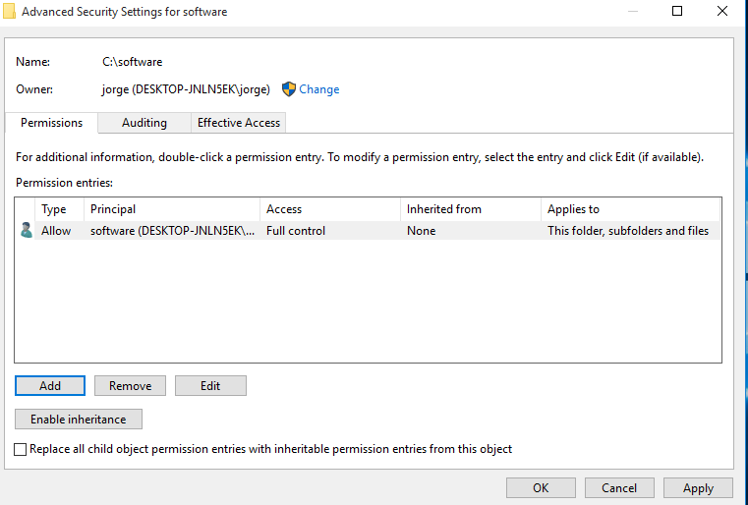

With inheritance:

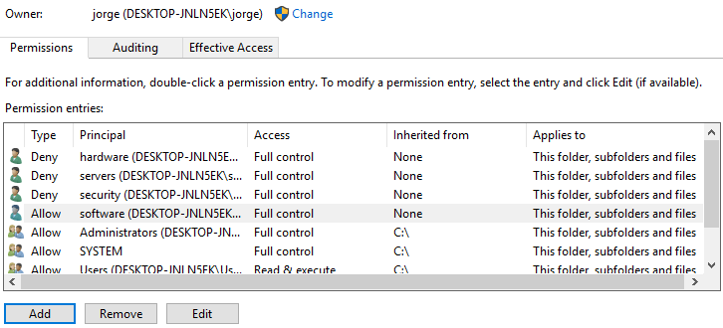

Shared folder

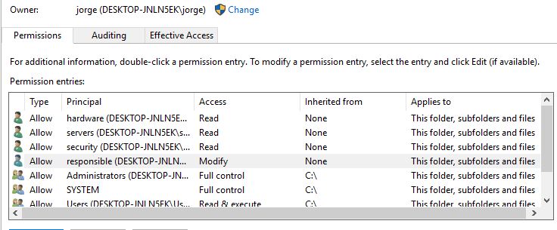

First year folder into shared folder without inheritance

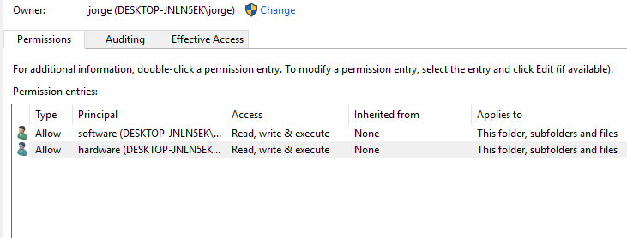

Same with inheritance

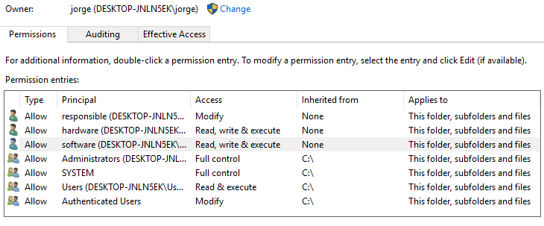

Software students won’t be able to access the folder. Is the only difference between first and second year folder.