# EXERCISE: Users, groups and permissions

We have a PC with Windows 10 that consists of two groups: Vocational and Secondary. The user “VocationalUser” will belong to “Vocational” and the user “SecondaryUser” will belong to “Secondary”. There is also a user called Teacher that belongs to the group Administrators.

Complete all the exercises considering two scenarios: disabling inheritance and with inheritance.

1. Create all the users and groups mentioned above.

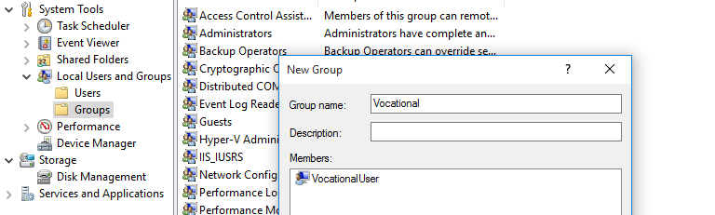

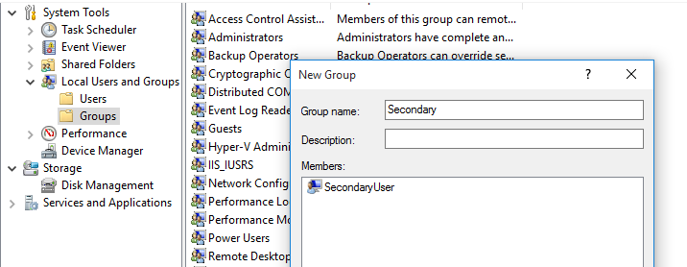

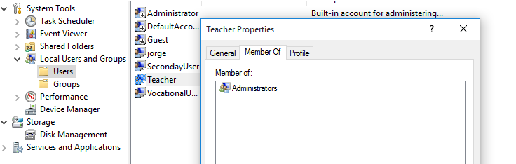

We create the groups and the users from Computer Management and add each user to its group

2. Create the following directory tree with the permissions below.

a. The directory known as “Shared” is able to be accessed by two users:

“VocationalUser” and “SecondaryUser”, but they cannot delete or create

subfolders and files. The user Teacher has Full Control over this directory.

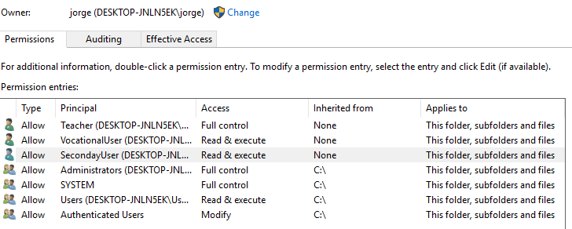

b. The directory “For secondary” cannot be accessed by the group “Vocational”,

while the group “Secondary” is able to do everything except change

permissions.

With inheritance:

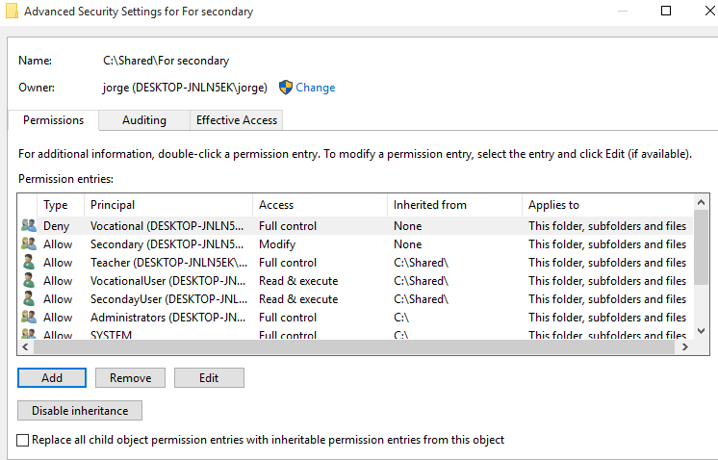

Without inheritance:

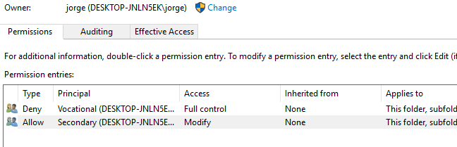

c. The directory “For vocational” cannot be accessed by the group “Secondary”,

while the group “Vocational” is able to do everything except delete this folder

and change permissions.

With inheritance:

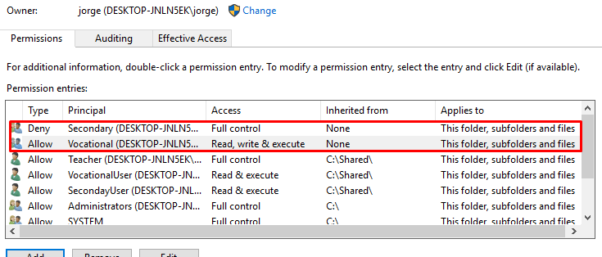

Without inheritance:

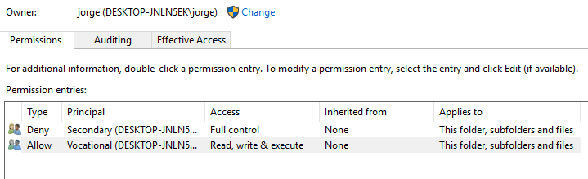

d. The directory “Only for students” can be accessed exclusively by all students

regardless of the group. They will able to create files within this folder.

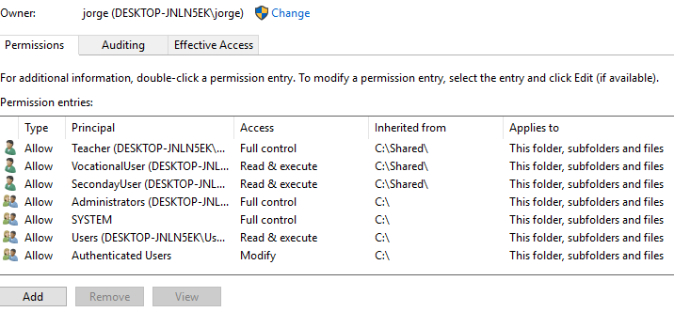

e. The directory “Only for teachers” can be accessed exclusively by all teachers

and only with read and execute permissions.

