Fill in the following folder and file permissions tables based on the following criteria:

• We have two groups: painters and musicians

• The users named goya, velazquez and leonardo belong to the group painters, among

others.

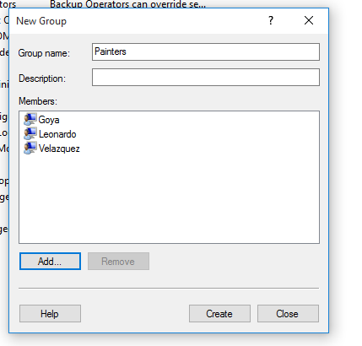

• The users named verdi, mozart and albeniz belong to the group musicians, among

others.

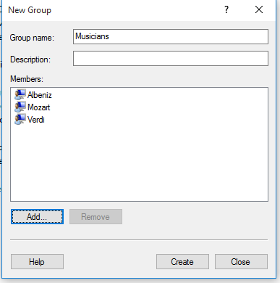

• Only the painters can access the folder canvas to create and delete files. The

remaining users cannot enter into it.

With inheritance

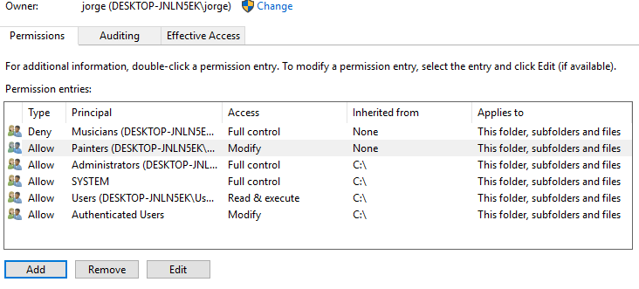

Without inheritance

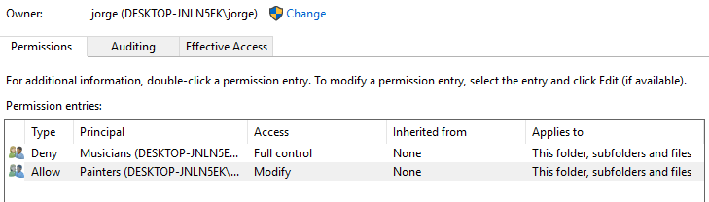

• Only the musicians can access the folder hall to create and delete files. The remaining

users cannot enter into it.

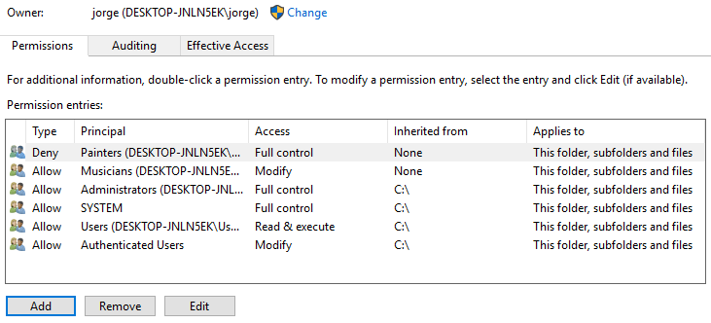

• The user leonardo cannot access the folder prado

With inheritance

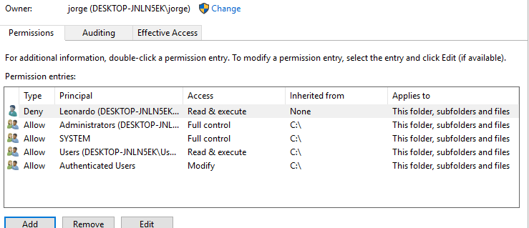

Without inheritance

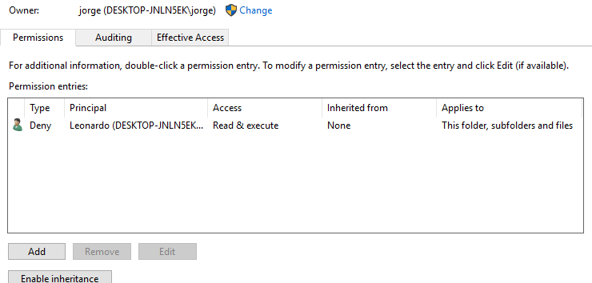

• The folder louvre can be accessed exclusively by goya and velazquez, but only with the

read permission

With inheritance

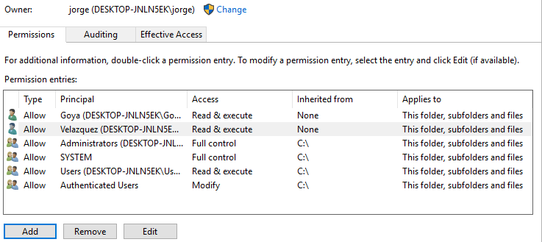

Without inheritance

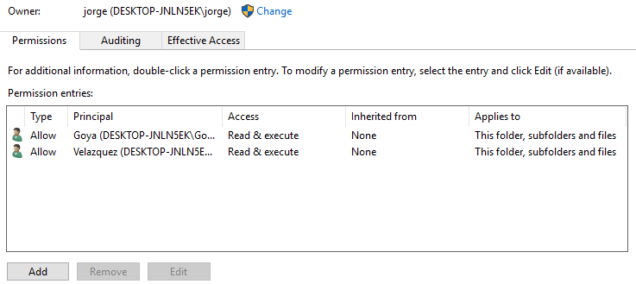

• The user albeniz cannot access the folder opera

With inheritance

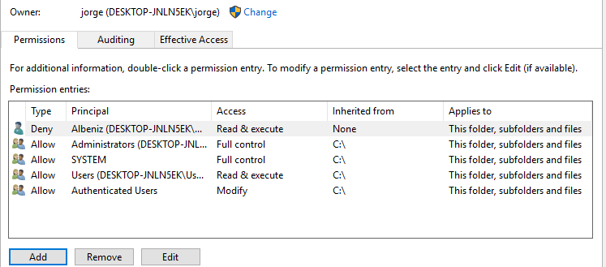

Without inheritance

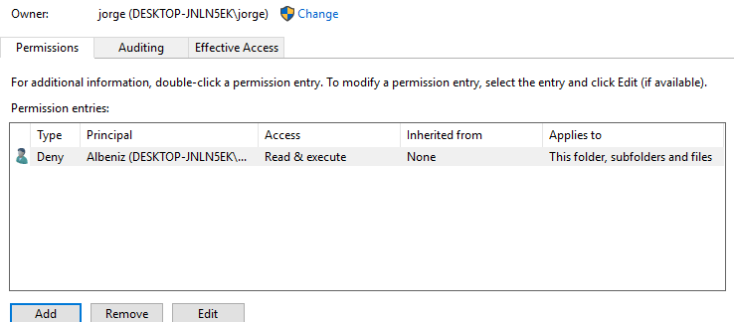

• The file donjuan.wav can be accessed exclusively by mozart.

With inheritance

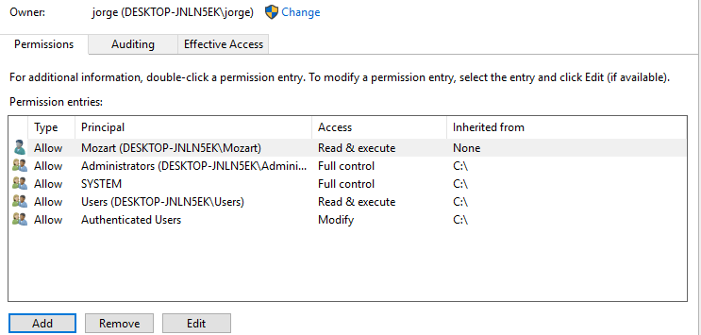

Without inheritance

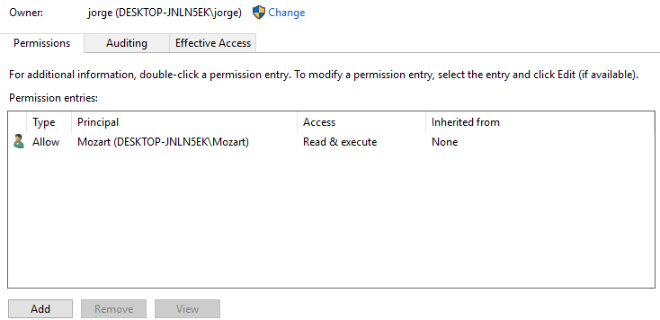

• The file lasmeninas.jpg into prado can be opened by all the painters except goya

With inheritance

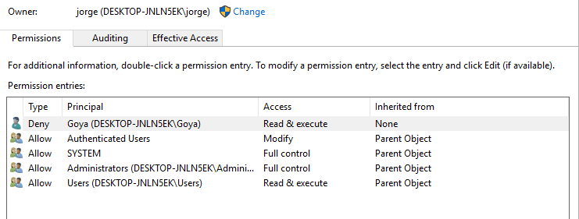

Without inheritance

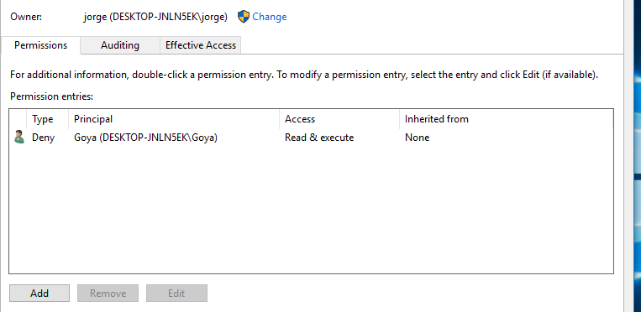

Directory tree

canvas ____prado: lasmeninas.jpg

|____louvre

hall____opera: donjuan.wav

For each folder, create a table similar to the one below in which you will include all the

necessary user and groups. Consider two scenarios: inheritance and non-inheritance.

Administrators are irrelevant. Suppose they have Full Control over all the files and folders.