**EXERCISE 1**

Suppose we have a computer that contains a folder called “tutorials” with “Full control” permissions for the standard users. We want to share the folder with “Read-only” permissions. It is necessary for the other computers’ users to log in with a password.

Explain the steps needed to complete the process and the permissions we must grant in order to access the “tutorials” folder through the network. Specify the address to access the folder from the computers.

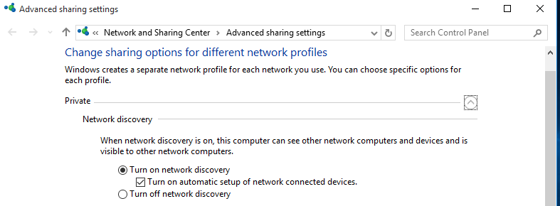

Open advanced sharing settings and turn on network discovery in your profile

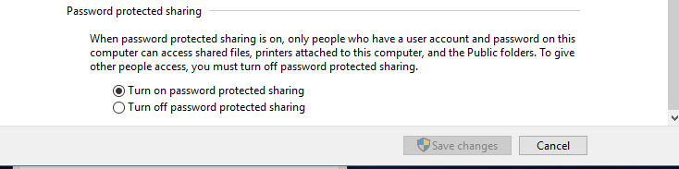

On the same page, go to all networks and enable password protect sharing

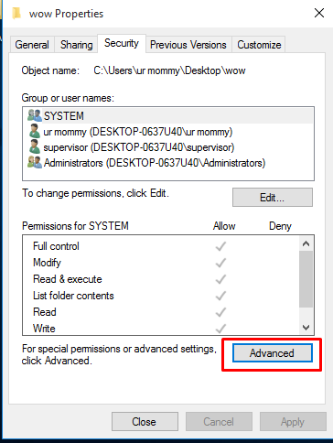

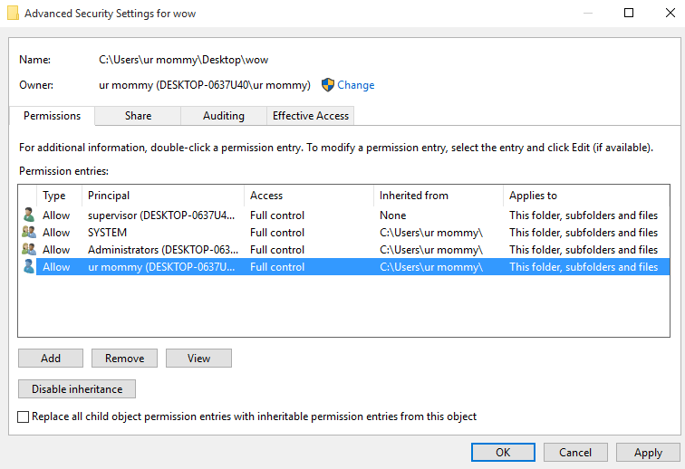

Don’t worry about the full control permissions

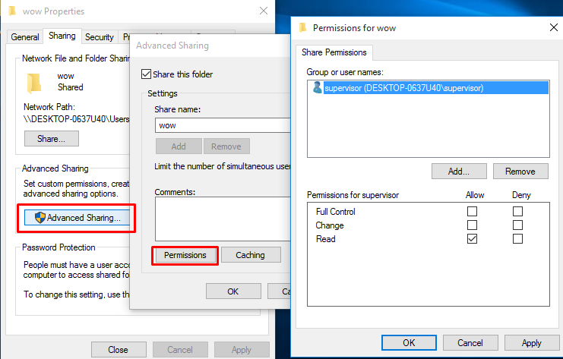

Sharing -> Advanced Sharing -> Permissions

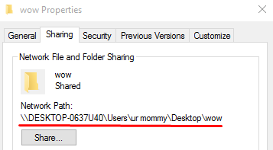

The path to the folder

**EXERCISE 2**

Suppose we have a computer that contains a folder called “family” in which the standard users can create files, but only administrators can delete them. We want to share the folder with “Full control” permissions for standard users and administrators (or the maximum level of permissions that we are able to assign).

In addition, we can grant access to the folder for users that do not have an account. The permissions will be “Read-only” in this case.

Create the shared folder according to the criteria above

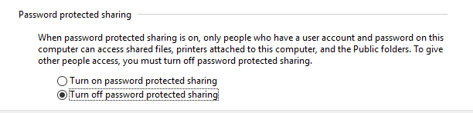

First of all, we disable the password protected sharing to access the folder without a user

The local permissions for Users are Write and for administrators are Modify

We also need to add the Read local permission for Everyone in the Security tab, to let all users access the folder.

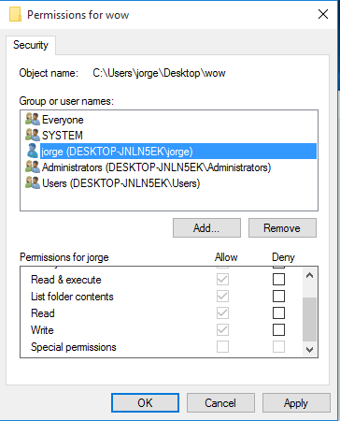



This way we can access without any password

**EXERCISE 3**

Create a shortcut for the folder “family” from “Exercise 2” using all the methods you know.

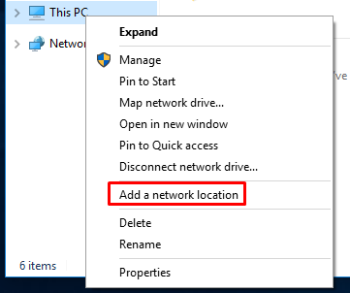

Add a network location and select the address

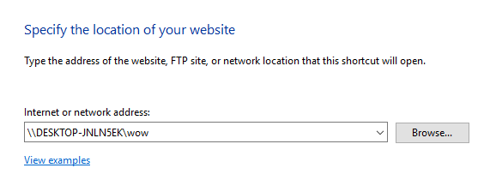

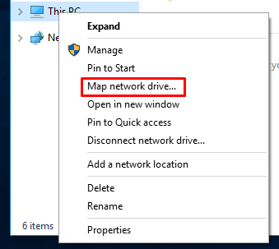

We can also map a network drive

