1.-

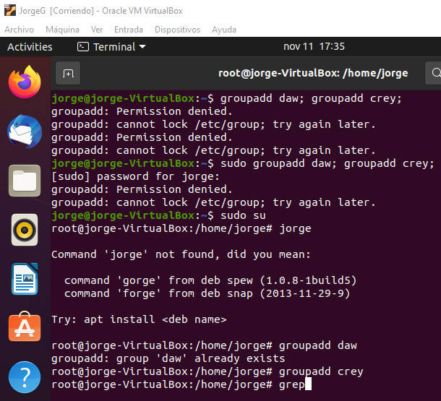

2.-

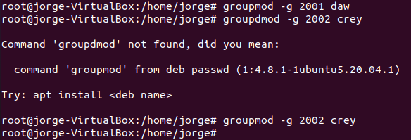

3.-



4.-

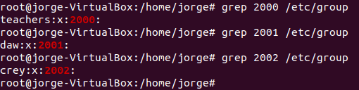

5.-



You need to use -m to create the home directory

6.-



7.-



8.-

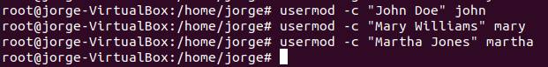

9.-

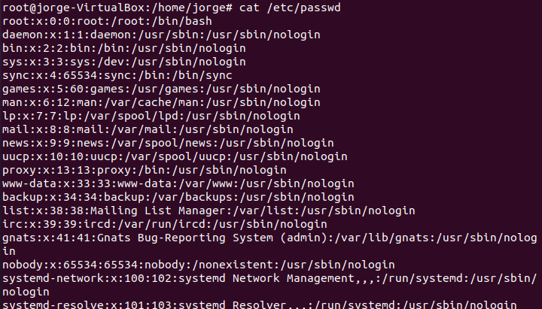

10.-





11.-

You can’t login until you create a password for them

login martha

pwd

cd $HOME

usernod -s /bin/bash john

grep john /etc/passwd

/bin/sh

usermod -G daw -a martha (-a is used to dont delete a created user with the same name)

12.-



13.-



14.-

ls -l /home

rm -rf /home/teachers



ls /home

15.- Now, log in as user “martha”. Run the command “cd $SHOME” and check that the home directory is “/home/teachers”

login martha pwd

16.- Go back to the root shell

exit

17.- Change the shell of the user named “john” to “sh”

usermod -s /bin/sh john

18.-Add the user “martha” to the secondary group “daw” without removing the already assigned secondary groups.

usermod -G daw -a martha

19.- Run a command to print the following information for each user

useradd -a jhon -g crey

useradd -a mary -gdaw

useradd -g teachers -G crey/daw

20.- Delete all the groups you have created. Could you delete them? Why?

groupdel crey

groupdel daw

groupdel teachers

No, because they are the primary groups of a user

21.- Delete all the users you have created, including the files and directories inside the home.

userdel -r john

userdel -r mary

userdel -r martha

22.- Try again to delete the groups

groupdel crey

groupdel daw

groupdel teachers

Now there are no users assigned