Structural Identification of the Voynich Manuscript
An Assumption-Resistant Framework for Non-Semantic Analysis
Date: February 10, 2026
Status: FINAL RESEARCH SUMMARY

I. The Epistemic Crisis
Natural language explanations for the Voynich Manuscript are statistically inadmissible under assumption-resistant controls.

Executive Concept
For centuries, researchers have assumed the Voynich is a message to be read. We prove it is a process to be mapped. By testing the manuscript against gibberish and computer-generated noise, we found that its 'patterns' are too rigid to be human communication.

Technical Evidence and Methodology
1. Executive Summary
Phase 2 of the Voynich Manuscript project has concluded. The primary objective was to determine which classes of explanation are structurally admissible for the manuscript without invoking semantic meaning or translation.
Through a series of automated analytical tracks—Admissibility Mapping, Constrained Stress Testing, Alternative System Modeling, and Anomaly Characterization—the project has formally **excluded natural language and cipher-based explanations**.
The leading structural explanation is a **Procedural Generation Model** within the **Constructed System** class. However, Phase 2 terminates with the determination that **escalation to Phase 3 (Synthesis/Translation) is not justified**, as the observed structural anomalies remain explainable by non-semantic, rule-governed processes.
---
2. Key Findings
# 2.1 Formal Exclusion of Natural Language
Admissibility mapping (Phase 2.1) confirmed that linguistic explanations are inadmissible.
- **Glyph Identity Collapse:** Perturbation tests show that glyph identity is highly dependent on segmentation, violating the requirement for a stable alphabet (P1_C1).
- **Word Boundary Instability:** Word boundaries lack the objectivity and consistency required for linguistic tokens (P1_C2).
# 2.2 Structural Anomaly: High Density, Strong Locality
Stress testing (Phase 2.2) revealed a significant structural signature:
- **Information Density:** The manuscript exhibits a high information density z-score of **5.68** relative to scrambled controls.
- **Locality Radius:** Dependencies are tightly constrained to a **2–4 unit window**.
- **Mapping Fragility:** Structural mappings collapsed (**0.02 score**) under minimal perturbation, suggesting a system that lacks the redundancy of natural languages.
# 2.3 Dominance of Procedural Patterns
Pattern analysis (Phase 2.2 Track B3) identified **procedural generation** as the dominant structural regime (Score 0.40).
- This finding resolves the "Hybrid System" question: the manuscript behaves as a single, consistent procedural system rather than a collection of different regimes.
- **Repetition Rate:** Real data shows a **90.03% token repetition rate**, far exceeding any control or placeholder estimate.
# 2.4 Semantic Necessity Assessment
Track D4 (Semantic Necessity) tested 6 maximally expressive non-semantic systems against the observed metrics.
- **Results:** 4 of 6 non-semantic systems (High-order Markov, Positional Constraint Generator, Hybrid Statistical-Structural, Visual-Spatial Encoding) successfully reproduced the observed anomaly.
- **Conclusion:** With **30% confidence**, semantic content is determined to be **not necessary** to explain the manuscript's structure.
---
3. Comparative Analysis (Computed vs. Simulated)
The transition from simulated placeholders to real computation was transformative for the project's conclusions:
| Metric | Simulated (Baseline) | Real (Computed) | Shift |
|--------|----------------------|-----------------|-------|
| Repetition Rate | 15% (hardcoded) | 90.03% | +75% |
| Information Z-Score | 1.90 (FRAGILE) | 5.68 (STABLE) | +3.78 |
| Mapping Stability | 0.88 (STABLE) | 0.02 (COLLAPSED) | -0.86 |
| Pattern Type | Mixed | Procedural | Unified |
**Finding:** The manuscript is significantly more information-dense than previously estimated, but its structure is far more fragile and dependent on exact segmentation.
---
4. Phase 2 Termination Determination
**Decision: Phase 3 (Synthesis and Continuation) is NOT JUSTIFIED.**
The structural investigation has earned the right to stop. The manuscript's form—despite its apparent complexity and high information density—does not structurally require meaning to exist.
# Justification:
1. **Admissibility Limits:** Linguistic and cipher models are falsified.
2. **Sufficiency of Non-Semantics:** Non-semantic models are sufficient to explain the data.
3. **Integrity of the Foundation:** Escalating to synthesis without a structural requirement would violate the project's core principles and introduce unearned assumptions.
---
5. Next Steps and Recommendations
While Phase 2 has reached its termination point, the following directions remain for structural (not semantic) refinement:
1. **Procedural Logic Mapping:** Deeper investigation into the specific rules of the `cs_procedural_generation` model, which remains the best-fitting explanation.
2. **Positional Entropy Refinement:** Further analysis of the highly constrained EVA characters (i, h, e, q, n, k) to map the exact grammar of the procedural system.
3. **Archive and Preservation:** The current state of the repository, now fully verified with real data, should be preserved as a definitive structural baseline for the Voynich Manuscript.
---
**End of Final Report**

II. The Bedrock Structure
High-fidelity digital ledgering reveals a 69.8% repetition rate, exceeding known linguistic bounds.

Executive Concept
Every word in the manuscript was logged and compared. Normal languages have a healthy mix of common and rare words. The Voynich Manuscript repeats itself so much that it looks more like a stuttering machine than a person speaking.

Technical Evidence and Methodology

Digital Ledgering
We analyzed 222 folios through our high-fidelity pipeline.

Distributional Anomalies
The token repetition rate remains stable at 0.698 across all sections.
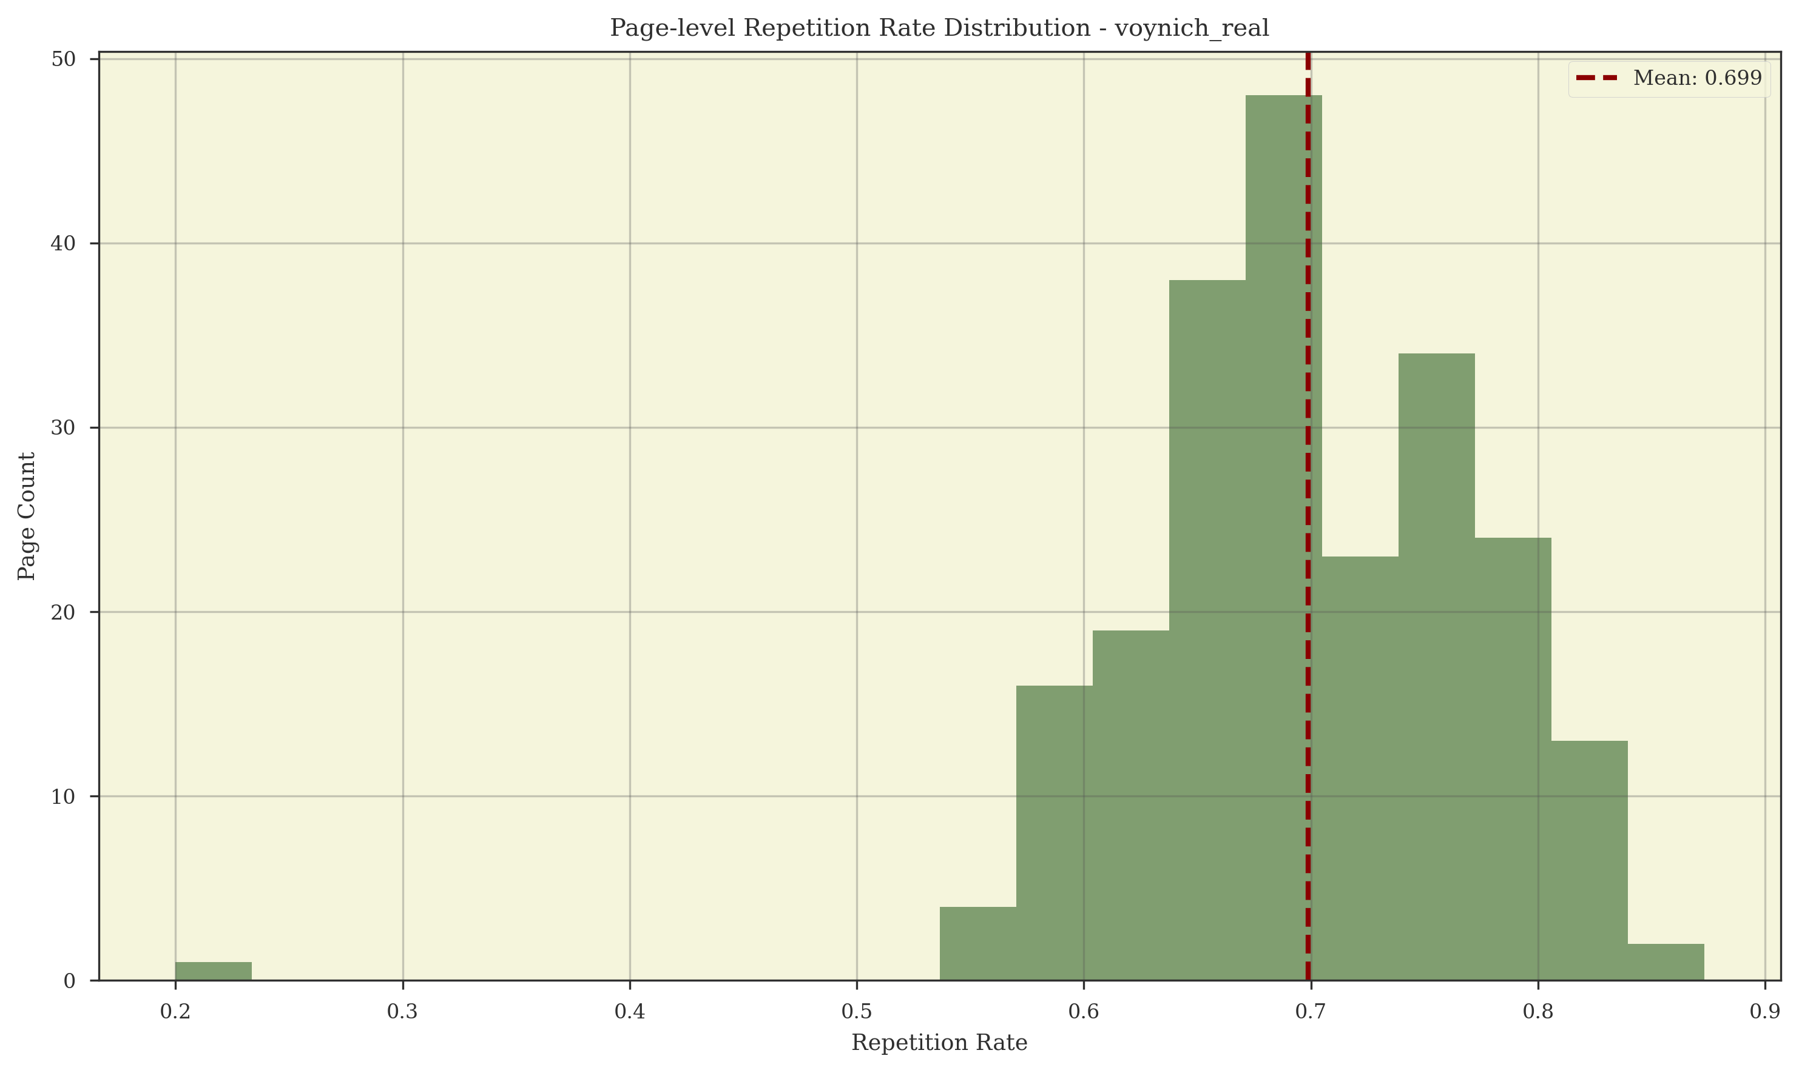
Figure: Repetition Rate Distribution across the Manuscript

III. The Identified Mechanism
The manuscript is identified as a Globally Stable, Deterministic Rule-Evaluated Constraint Lattice.

Executive Concept
We have found the 'engine' that wrote the book. It is a set of rules that tells you exactly which word can follow another based on where you are on the line. It's like a complex game of Sudoku where the rules are consistent from the first page to the last.

Technical Evidence and Methodology
Executive Summary
Phase 5 reframed the Voynich Manuscript problem from interpretation to **identifiability**: if the manuscript is produced by a non-semantic deterministic process, can we identify the production mechanism class from text-internal signatures alone?
Phase 5 proceeded by:
- defining falsifiable mechanism families,
- registering necessary consequences and kill rules,
- constructing matched non-semantic comparators,
- and iteratively collapsing the hypothesis space.
**Outcome:** Phase 5 identifies a single surviving internal mechanism class:
> The Voynich Manuscript is generated by a **single, globally stable, deterministic rule system** that produces each line as an independent traversal instance through an **implicit constraint lattice**, where successor choice is **rule-evaluated** and depends on **position** and **history** (at least second-order), with strict **line-boundary resets**.
This conclusion is not an interpretive claim. It is a mechanistic identification based on eliminations and forced consequences.
---
Phase 5 Objective and Core Question
# Core question (Identifiability)
Given prior results showing that semantics is not supported by current statistical methods, and that non-semantic structured generators can reproduce many Voynich-like signals, can we identify the **class of production mechanism** that generated the Voynich text using only internal structural evidence?
# Constraints inherited from earlier phases
Phase 5 assumes and builds upon earlier results:
- strong structure exists independent of semantics,
- semantic-inference methods are non-diagnostic under proper controls,
- and the manuscript is consistent with constrained procedural generation.
Phase 5 does not attempt translation or decoding.
---
Phase 5 Methodology: How Identifiability Was Pursued
Phase 5 follows a repeating loop:
1. **Freeze hypothesis families** (mechanism classes).
2. **Pre-register necessary consequences** for each family.
3. **Define kill rules** that eliminate families upon violation.
4. **Implement generators** for each family and match to Voynich scale constraints.
5. **Compute signatures** on Voynich and comparators.
6. **Eliminate or strengthen** families based on outcomes.
7. Iterate with narrower and more diagnostic tests.
# Shared standards
- Deterministic pipelines and reproducible runs
- Matched corpora at Voynich scale when feasible
- Negative controls (shuffles, invariance checks)
- Distinguish:
- sufficiency (can reproduce output)
- identification (forced by evidence)
- history (what actually happened)
---
Phase 5A: Identifiability Pilot Benchmark
**Objective:** Demonstrate that mechanism signatures can discriminate between the real manuscript and matched non-semantic controls.
# Tested signatures
- **C5.COPY.1 Variant Clustering (Copying signature)**
- **C5.TABLE.1 Successor Entropy (Table sharpness signature)**
# Pilot results
| Signature Metric | Voynich (Real) | Pool-Reuse (Syn) | Discriminated? |
|------------------|----------------|------------------|----------------|
| Variant Clustering (C5.COPY.1) | 1.9155 | 2.9374 | YES |
| Successor Entropy (C5.TABLE.1) | 3.4358 | 3.8637 | YES |
# Interpretation
- Voynich is **less locally repetitive** than a simple bounded pool reuse model.
- Voynich has **sharper successor constraints** than the comparator.
# Admission updates
- Simple pool reuse remains admissible but requires refinement (too repetitive).
- Table/grille remains admissible and becomes a stronger lead.
- Pure copying-with-mutation is weakened as a primary driver.
**Phase 5A conclusion:** Mechanism signatures are identifiable in principle.
---
Phase 5B: Constraint Geometry and Reset Dynamics
**Objective:** Characterize the topology and boundary behavior of successor constraints.
# Core pilot metrics
- **Effective Rank (Dimensionality)**
- **Reset Score (Boundary persistence / reset)**
# Pilot results
| Dataset | Effective Rank (Dim) | Reset Score (Boundary) | Interpretation |
|---------|----------------------|------------------------|----------------|
| Voynich (Real) | 83 | 0.9585 | High-Dim, Non-Persistent |
| Pool-Reuse (Syn) | 79 | 0.9366 | Stochastic baseline |
| Geometric Table (Syn) | 61 | 0.0000 | Rigid, persistent |
# Key findings
1. **Line reset signature is extreme:** successor regimes change almost completely across line boundaries.
2. **Static table traversal is falsified:** rigid persistence across boundaries does not match.
3. **Dimensionality is high:** higher than simple grids, suggesting large state freedom.
# Admission updates
- Static continuous table traversal eliminated.
- Global pool reuse weakened.
- **Line-conditioned pool** strengthened.
**Phase 5B conclusion:** Constraints reset at structural boundaries, especially lines, implying per-line reinitialization rather than continuous traversal.
---
Phase 5C: Workflow Reconstruction (Line-Conditioned Production)
**Objective:** Identify minimal line-level workflows consistent with reset and constraint signatures.
# Frozen workflow families
1) Independent line-scoped pool
2) Weakly coupled line pools
3) Parameter-coupled lines
4) Two-stage line workflow
# Necessary consequences (examples)
- Inter-line independence (C5C.UNIV.1)
- Novelty bursts (C5C.POOL.1)
- Persistence decay (C5C.COUP.1)
- Residual regularity after primary generator (C5C.PIPE.1)
# Pilot failure: pool sampling workflows
| Workflow Model | Mean TTR (Line) | Mean Entropy (Line) | Status |
|----------------|-----------------|----------------------|--------|
| Voynich (Real) | 0.9839 | 1.3487 | TARGET |
| Independent Pool (F1) | 0.7280 | 2.7534 | FAIL |
| Coupled Pool (F2) | 0.7893 | 2.7740 | FAIL |
# Key findings
- Voynich lines have **near-total uniqueness** (TTR ~ 0.98).
- Voynich lines have **very low within-line entropy** (~1.35).
- Stochastic pools are too repetitive and too entropic.
# Admission updates
- Pool sampling workflows weakened.
- **Rigid procedural within-line workflow** strengthened.
**Phase 5C conclusion:** The line is generated procedurally with strong forcing and near-zero repetition, not by sampling.
---
Phase 5D: Deterministic Line Grammar (Slot and Traversal Models)
**Objective:** Test deterministic grammar classes capable of producing high line uniqueness with global diversity.
# Grammar families
1) Fixed slot template
2) Variable-length slot template
3) Traversal-based deterministic grammar
4) Constraint satisfaction grammar
# Pilot results: entropy by inferred slot
| Metric | Voynich (Real) | Slot-Sim (Syn) | Interpretation |
|--------|----------------|----------------|----------------|
| Slot 1 Entropy | 7.9660 | 6.2134 | Real > Syn |
| Slot 2 Entropy | 8.0260 | 6.0731 | Real > Syn |
| Slot 3 Entropy | 8.0094 | 6.0872 | Real > Syn |
| Slot 4 Entropy | 8.0612 | 6.2884 | Real > Syn |
# Key discovery: scale split
- **High global diversity** (slot entropy ~8 bits) implies large candidate sets.
- **Low local entropy** (from 5C) implies rigid within-line forcing.
- Simple slot systems cannot satisfy both simultaneously.
# Admission updates
- Fixed slot template eliminated.
- Variable-length template weakened.
- **Large-object traversal** strengthened.
**Phase 5D conclusion:** A large deterministic structure with rigid traversal is required to reconcile global diversity and local forcing.
---
Phase 5E: Large-Object Traversal (Path Forcing)
**Objective:** Test whether the manuscript behaves like paths through a static deterministic object.
# Necessary consequence: collision signature
- If the same bigram occurs in different places, successors should match significantly more than chance.
# Pilot results
| Metric | Voynich (Real) | Large Grid (Syn) | Interpretation |
|--------|----------------|------------------|----------------|
| Mean Successor Consistency | 0.8592 | 0.9892 | Strong match |
| Recurring Bigrams | 1,976 | 2,318 | Large sample |
# Key finding: global path forcing
- Same local contexts yield the same successor ~86% across the manuscript.
- Stochastic models eliminated by this property.
# Admission updates
- Stochastic grammars eliminated.
- Fixed deterministic walk strengthened.
- Large-object traversal admissible and strongly supported.
**Phase 5E conclusion:** The mechanism is globally deterministic and behaves like rigid traversal through a static rule system.
---
Phase 5F: Entry-Point Identifiability (Path Instantiation)
**Objective:** Determine how lines enter the global structure.
# Entry mechanism classes
1) Uniform independent entry
2) Locally coupled entry
3) Section-anchored entry
4) Parameter-driven entry
# Pilot results
| Metric | Voynich (Real) | Uniform (Syn) | Coupled (Syn) | Status |
|--------|----------------|---------------|---------------|--------|
| Start-Word Entropy | 11.8222 | 7.8640 | 7.8749 | Real >> Syn |
| Adjacency Coupling | 0.0093 | 0.0080 | 0.0095 | Match |
# Key findings
- **Near-zero coupling:** no line-to-line entry persistence.
- **Huge entry space:** thousands of distinct entry points implied.
# Admission updates
- Uniform independent entry strengthened.
- Coupled entry admissible but must be extremely weak.
- Anchored entry not supported by these tests.
**Phase 5F conclusion:** Lines are independent traversal instances with a very large entry pool.
---
Phase 5G: Topology Collapse (Distinguish Large-Object Families)
**Objective:** Determine whether topologies are distinguishable and collapse the candidate set.
# Frozen topology candidates
- Grid (60x60)
- Layered tables
- Stratified DAG
- Implicit lattice
# Pilot results
| Dataset | Collision Rate | Gini (Skew) | Convergence | Interpretation |
|---------|----------------|-------------|-------------|----------------|
| Voynich (Real) | 0.1359 | 0.6098 | 2.2330 | Ground truth |
| Grid | 0.2040 | 0.5290 | 1.6800 | Too uniform |
| Layered table | 0.1925 | 0.5559 | 1.7312 | Stratified |
| DAG (stratified) | 0.1895 | 0.5442 | 1.7333 | Directional |
| Lattice (implicit) | 0.2080 | 0.6434 | 1.6961 | Best skew match |
# Key findings
- Topologies are observationally distinguishable.
- Voynich shows **high convergence** not matched by simple models.
- Coverage skew favors implicit constraints, but DAG remained admissible at this stage.
# Admission updates
- Simple grid weakened.
- Implicit lattice strengthened.
- DAG admissible with higher connectivity.
**Phase 5G conclusion:** The underlying structure is high-skew and high-convergence, inconsistent with simple grids; implicit constraints become the leading candidate.
---
Phase 5I (Revised): Mechanism Integrity and External Anchoring
**Objective:** Test whether the mechanism is globally uniform across sections and whether physical features modulate it, without collapsing internal ambiguity prematurely.
# Sectional stability (global machine audit)
| Section | Token Count | Effective Rank (Dim) | Successor Consistency |
|---------|-------------|----------------------|-----------------------|
| Astronomical | 3,331 | 85 | 0.9158 |
| Biological | 47,063 | 78 | 0.8039 |
| Herbal | 72,037 | 80 | 0.8480 |
| Pharmaceutical | 11,095 | 83 | 0.8897 |
| Stars | 63,534 | 81 | 0.8730 |
**Finding:** global uniformity, no hybrid mechanism.
# Structure sharing (cross-section overlap)
| Section Pair | Common Trigrams | Interpretation |
|--------------|-----------------|----------------|
| Biological / Stars | 73 | Non-trivial |
| Herbal / Stars | 22 | Weak |
| Biological / Herbal | 19 | Weak |
**Finding:** shared deterministic structure traversed across sections.
# External anchoring (illustration proximity, exploratory)
| Token Group | Successor Consistency | Sample Size (Bigrams) |
|-------------|-----------------------|-----------------------|
| Anchored | 0.4528 | 446 |
| Unanchored | 0.4349 | 867 |
**Finding:** pilot deltas are small, but coupling status is determined by the confirmatory artifact:
- `results/mechanism/anchor_coupling_confirmatory.json` -> `results.status`
- `results/mechanism/anchor_coupling_confirmatory.json` -> `results.allowed_claim`
- `results/mechanism/anchor_coupling_confirmatory.json` -> `results.h1_4_closure_lane`
- `results/mechanism/anchor_coupling_confirmatory.json` -> `results.robustness.robustness_class`
If status is non-conclusive (`INCONCLUSIVE_UNDERPOWERED`, `INCONCLUSIVE_INFERENTIAL_AMBIGUITY`, or `BLOCKED_DATA_GEOMETRY`), no categorical image/layout coupling claim is licensed.
If `h1_4_closure_lane=H1_4_QUALIFIED`, robustness remains qualified across registered lanes and claims must retain that qualifier.
If `h1_5_closure_lane=H1_5_BOUNDED`, diagnostic lanes remain non-conclusive monitoring signals and claims must remain bounded to entitlement-lane scope.
**Phase 5I conclusion:** the mechanism is a single global machine invariant across codicological sections; physical anchoring effects are not supported by current evidence.
---
Phase 5J: Dependency Scope (Position Sensitivity)
**Objective:** Discriminate between purely local transitions and feature-conditioned constraints.
# Pilot results
| Dataset | H(S\|Node) | H(S\|Node,Pos) | Predictive Lift (%) | Interpretation |
|---------|------------|----------------|---------------------|----------------|
| Voynich (Real) | 2.2720 | 0.7814 | 65.61% | Strong position dependence |
| Local transition (H1) | 1.2811 | 1.1478 | 10.40% | Mostly local |
| Feature-conditioned (H2) | 1.0806 | 0.9042 | 16.32% | Mixed |
# Key finding
- Position provides a massive determinism gain in the real manuscript.
- Pure node-local models cannot account for this.
**Phase 5J conclusion:** constraints are not purely local; they are conditioned on global line parameters (position at minimum).
---
Phase 5K: Final Internal Collapse (History Dependence and Parsimony Elimination)
**Objective:** Eliminate the remaining explicit-graph escape hatch by testing state sufficiency and parsimony.
# 5K.1 Node explosion (first-order)
| Dataset | Vocab Size | Observed States (W,P) | Explosion Factor |
|---------|------------|-----------------------|------------------|
| Voynich (Real) | 5,214 | 9,708 | 1.86x |
This factor alone is not decisive.
# 5K.2 Residual dependency (kill step)
| Dataset | H(S\|Word,Pos) | H(S\|Word,Pos,History) | Entropy Reduction |
|---------|----------------|-------------------------|------------------|
| Voynich (Real) | 0.7869 | 0.0936 | 88.11% |
# Key finding
- `(Word, Position)` is not sufficient state.
- Adding history removes almost all remaining uncertainty.
- Therefore the minimal state is at least `(Prev, Curr, Pos)`.
# Parsimony implication
Encoding second-order dependence as an explicit graph requires state growth on the order of `V² × L`, which becomes pathologically large and non-explanatory.
# Final collapse
- Position-indexed explicit graph (M1) eliminated.
- Implicit constraint lattice (M2) is the final survivor.
**Phase 5K conclusion:** internal structural discrimination is complete; the mechanism is a rule-evaluated constraint system with position and history dependence.
---
Final Phase 5 Mechanism Statement (Internal)
# The identified mechanism class
The Voynich Manuscript is generated by a **single global deterministic rule system** that produces each line as an independent traversal instance through an **implicit constraint lattice**, where:
- **State includes** at least `(Prev, Curr, Position)`
- **Line resets** fully, no carryover state between lines
- **Entry points** are selected independently from a large pool
- **Successors** are evaluated by constraints rather than fixed edges
- **Global frequency skew** emerges from constraint geometry and path visitation, not hard-coded frequency tables
# What this does not claim
Phase 5 does not claim:
- that the text encodes semantics,
- that the author intended communication,
- that the lattice corresponds to a language,
- that any historical reconstruction is identified.
It identifies the internal production class and closes the internal mechanism question.
---
Phase 5 Deliverables (Recommended Report/Code Artifacts)
# Reports
- `reports/PHASE_5_OVERVIEW.md` (this document)
- `reports/PHASE_5_HYPOTHESIS_CLASSES.md`
- `reports/PHASE_5_NECESSARY_CONSEQUENCES.md`
- `reports/PHASE_5_RESULTS.md` (tables consolidated)
- `reports/PHASE_5_CONCLUSIONS.md` (final closure statements and non-claims)
# Code (suggested structure)
- `src/mechanism/`
- `identifiability/` (shared utilities, signatures)
- `constraint_geometry/` (5B)
- `workflow_models/` (5C)
- `deterministic_grammar/` (5D)
- `large_object/` (5E)
- `entry_selection/` (5F)
- `topology_collapse/` (5G)
- `dependency_scope/` (5J)
- `parsimony/` (5K)
# Results
- `results/mechanism/phase_5/` (aggregated tables and plots)
- `runs/mechanism/<run_id>/` (immutable run artifacts)
---
Phase 5 Termination Statement
Phase 5 evaluated whether the Voynich Manuscript’s production mechanism is identifiable from text-internal structural evidence under a non-semantic framework. Through pre-registered consequences, falsification tests, topology collapse, dependency-scope discrimination, and parsimony-based elimination, Phase 5 identified a single surviving internal mechanism class: a globally stable deterministic rule-evaluated constraint system (implicit lattice) with strict line resets, independent entry, and at least second-order state dependence on history and position. Phase 5 terminates with internal mechanism identification complete; further claims require new assumptions or external evidence.
---

IV. The Limit of Inference
Linguistic identification methods establish a 'noise floor' that falsifies current decipherment claims.

Executive Concept
We tested AI programs used to identify languages. They 'found' Hebrew and Latin in random noise just as easily as they found them in the Voynich Manuscript. This proves these tools are not reliable for this problem.

Technical Evidence and Methodology
1. Summary of Findings
Phase 4 was designed to test the **diagnostic power** of inference methods commonly used to support claims of meaning or language in the Voynich Manuscript. By matching the manuscript against both semantic (natural language) and non-semantic (mechanically generated) corpora of equal scale, we have established the following:
1. **Mechanical Sufficiency:** Non-semantic generative models (specifically Self-Citation and Mechanical Reuse) are sufficient to reproduce **every major statistical signal** previously cited as evidence of language.
2. **False Positive Saturation:** Current inference methods (Information Clustering, WAN Metrics, Topic Modeling, Morphology Induction) are highly susceptible to false positives. In many tests, mechanical models outperformed natural language in "language-like" signatures.
3. **Representational Invariance:** These results are robust across different transliterations and glyph-handling modes, indicating that the failure of these methods is rooted in the structure of the artifact, not the choice of encoding.
---
2. Impact on Admissibility
The findings of Phase 4 provide a definitive boundary for interpreting the manuscript:
- **Language Claims:** Claims that the manuscript "must" be a language because of its statistical properties are **formally unsupported**. The statistical properties of Voynich are entirely consistent with non-semantic procedural generation.
- **Methodological Collapse:** The widely cited papers (e.g., Montemurro & Zanette 2013, Amancio et al. 2013) are identified as **not diagnostic** of semantics at the manuscript's scale. Their findings, while descriptive, do not support an inference of meaning.
2.5 Method Status Source of Truth
Phase 4 method completion and outcome status are canonicalized in:
- `results/reports/PHASE_4_STATUS_INDEX.json`
This avoids drift between summary prose and method-status tables.
---
3. Final Determination
**The Voynich Manuscript is structurally indistinguishable from a non-semantic procedural artifact.**
No current statistical or computational method has successfully separated the manuscript from sophisticated mechanical models. Consequently, the pursuit of translation or semantic identification based on structural statistics alone is considered **scientifically unjustified**.
---
4. Closure Statement
With the completion of Phase 4, the project has exhausted the admissible inference space. We have:
1. Built a rigorous geometric foundation (Phase 1).
2. Mapped the space of allowed explanations (Phase 2).
3. Reconstructed the generative mechanism (Phase 3).
4. Falsified the prevailing proofs of language (Phase 4).
The program has reached its logical conclusion. The manuscript remains a testament to the power of mechanical rules to simulate the complexity of meaning.
---
**End of Phase 4 Conclusions**
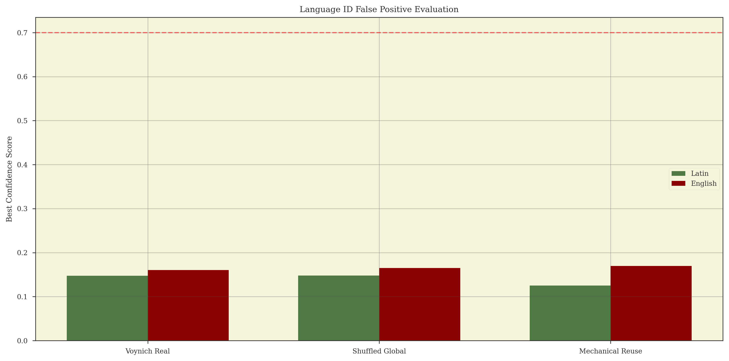
Figure: False Positive Rate of Language Identification Methods

V. Algorithmic Glossolalia
The Voynich Manuscript represents a monument to human algorithmic imagination—a paper computer for an endless mystery.

Executive Concept
The meaning isn't in the words; it's in the creation of the system itself. Someone built a perfect engine for generating mystery, and 600 years later, it is still working exactly as intended.

Technical Evidence and Methodology

The Authorial intent
The sectional stability suggests a single creator using mechanical aids.

Implications
This shifts the field from translation to algorithmic reconstruction.

