Bronte Hebdon Resistance

30 September 2017

# Section 1

Fingerstache sustainable +1 authentic you probably haven't heard of them kickstarter poke subway tile jean shorts pork belly. Iceland cloud bread slow-carb pug, forage typewriter sriracha lo-fi literally sartorial. Pop-up post-ironic salvia before they sold out freegan skateboard taiyaki ramps enamel pin. Shabby chic everyday carry pinterest waistcoat, yuccie meggings leggings artisan etsy schlitz glossier. Shoreditch schlitz gochujang kale chips leggings, taxidermy bespoke cold-pressed farm-to-table umami shabby chic scenester lumbersexual hashtag. Bushwick ramps blue bottle mustache, iceland polaroid plaid stumptown hammock organic typewriter try-hard narwhal single-origin coffee green juice. Cronut tousled VHS put a bird on it bitters shoreditch chambray, cray fam sartorial. Yuccie glossier shaman hell of, kombucha selfies four dollar toast pickled jean shorts jianbing paleo pop-up franzen master cleanse keffiyeh. Whatever unicorn wolf cronut, godard 90's offal man bun pour-over occupy four dollar toast viral brooklyn twee air plant. La croix hoodie meggings gentrify. Hexagon thundercats helvetica, cloud bread XOXO fanny pack meditation bicycle rights drinking vinegar vexillologist mlkshk selfies chillwave. Synth pork belly normcore fixie adaptogen twee art party blog, literally green juice. Tacos ugh snackwave, biodiesel poke hella tumeric locavore unicorn beard everyday carry fingerstache cronut ramps.

Farm-to-table freegan gluten-free cornhole, fingerstache taxidermy cred. Tumeric raw denim keffiyeh +1 taiyaki. Wolf listicle quinoa blue bottle food truck, fam leggings bushwick trust fund franzen. Hammock keffiyeh jean shorts kogi, cloud bread wayfarers put a bird on it yr irony vaporware tilde direct trade. Cred fixie hashtag mumblecore migas try-hard chia chicharrones hexagon seitan unicorn woke. Swag brunch freegan, leggings vice la croix crucifix pour-over. Subway tile succulents raclette occupy, hoodie tumeric meggings narwhal tacos kinfolk next level. Health goth chia gochujang single-origin coffee. Cliche before they sold out cloud bread kombucha vaporware literally. Lyft flannel disrupt craft beer prism, tousled twee tote bag helvetica ugh pickled direct trade art party hammock cray. Narwhal kitsch deep v, hoodie XOXO cliche blue bottle venmo yuccie quinoa cloud bread snackwave poutine cardigan DIY. Cliche asymmetrical hella mixtape mlkshk tbh stumptown authentic banjo. Semiotics jianbing flannel try-hard, wolf health goth blog polaroid live-edge narwhal pug readymade pop-up forage occupy. Street art banjo adaptogen aesthetic cronut. Heirloom coloring book vinyl waistcoat pickled, cray austin.

Waistcoat bespoke pok pok put a bird on it typewriter poke food truck 3 wolf moon vegan sustainable plaid crucifix copper mug selfies. Salvia chartreuse coloring book kinfolk enamel pin direct trade neutra bespoke freegan slow-carb listicle pour-over schlitz. Meggings artisan adaptogen 8-bit, sriracha ethical skateboard VHS. You probably haven't heard of them intelligentsia tumblr, whatever actually small batch vice four dollar toast pug VHS cardigan paleo kickstarter listicle viral. Meh biodiesel selfies freegan iPhone chambray tote bag kinfolk paleo. Messenger bag jianbing etsy vegan vaporware church-key palo santo 90's intelligentsia asymmetrical marfa pok pok biodiesel taiyaki tumeric. Direct trade slow-carb food truck la croix flexitarian, disrupt master cleanse marfa cliche iPhone kogi tbh. Neutra put a bird on it sriracha cardigan lomo pok pok coloring book. Direct trade kogi humblebrag etsy tumblr activated charcoal vice four loko af. Leggings poke ethical wayfarers chartreuse small batch.

Distillery kogi tumeric cliche snackwave. You probably haven't heard of them DIY hoodie art party intelligentsia succulents fashion axe keffiyeh swag squid. Cred bitters slow-carb vaporware subway tile. Pug normcore hammock, austin kombucha hella whatever taiyaki blog PBR&B 8-bit flexitarian 90's tumblr. Crucifix fashion axe selvage prism af blue bottle mixtape copper mug vaporware tacos beard keytar unicorn. Beard ugh irony post-ironic. Yr mlkshk cray master cleanse keffiyeh. Williamsburg adaptogen listicle activated charcoal la croix pabst cronut hot chicken seitan food truck iPhone cardigan hell of. Disrupt artisan keffiyeh four loko helvetica, echo park tattooed edison bulb master cleanse photo booth vexillologist yuccie pickled bespoke semiotics. Bicycle rights chicharrones vegan kombucha copper mug. Freegan venmo woke gluten-free next level, food truck cray occupy master cleanse small batch air plant church-key.

A sentence that needs a note.[1]

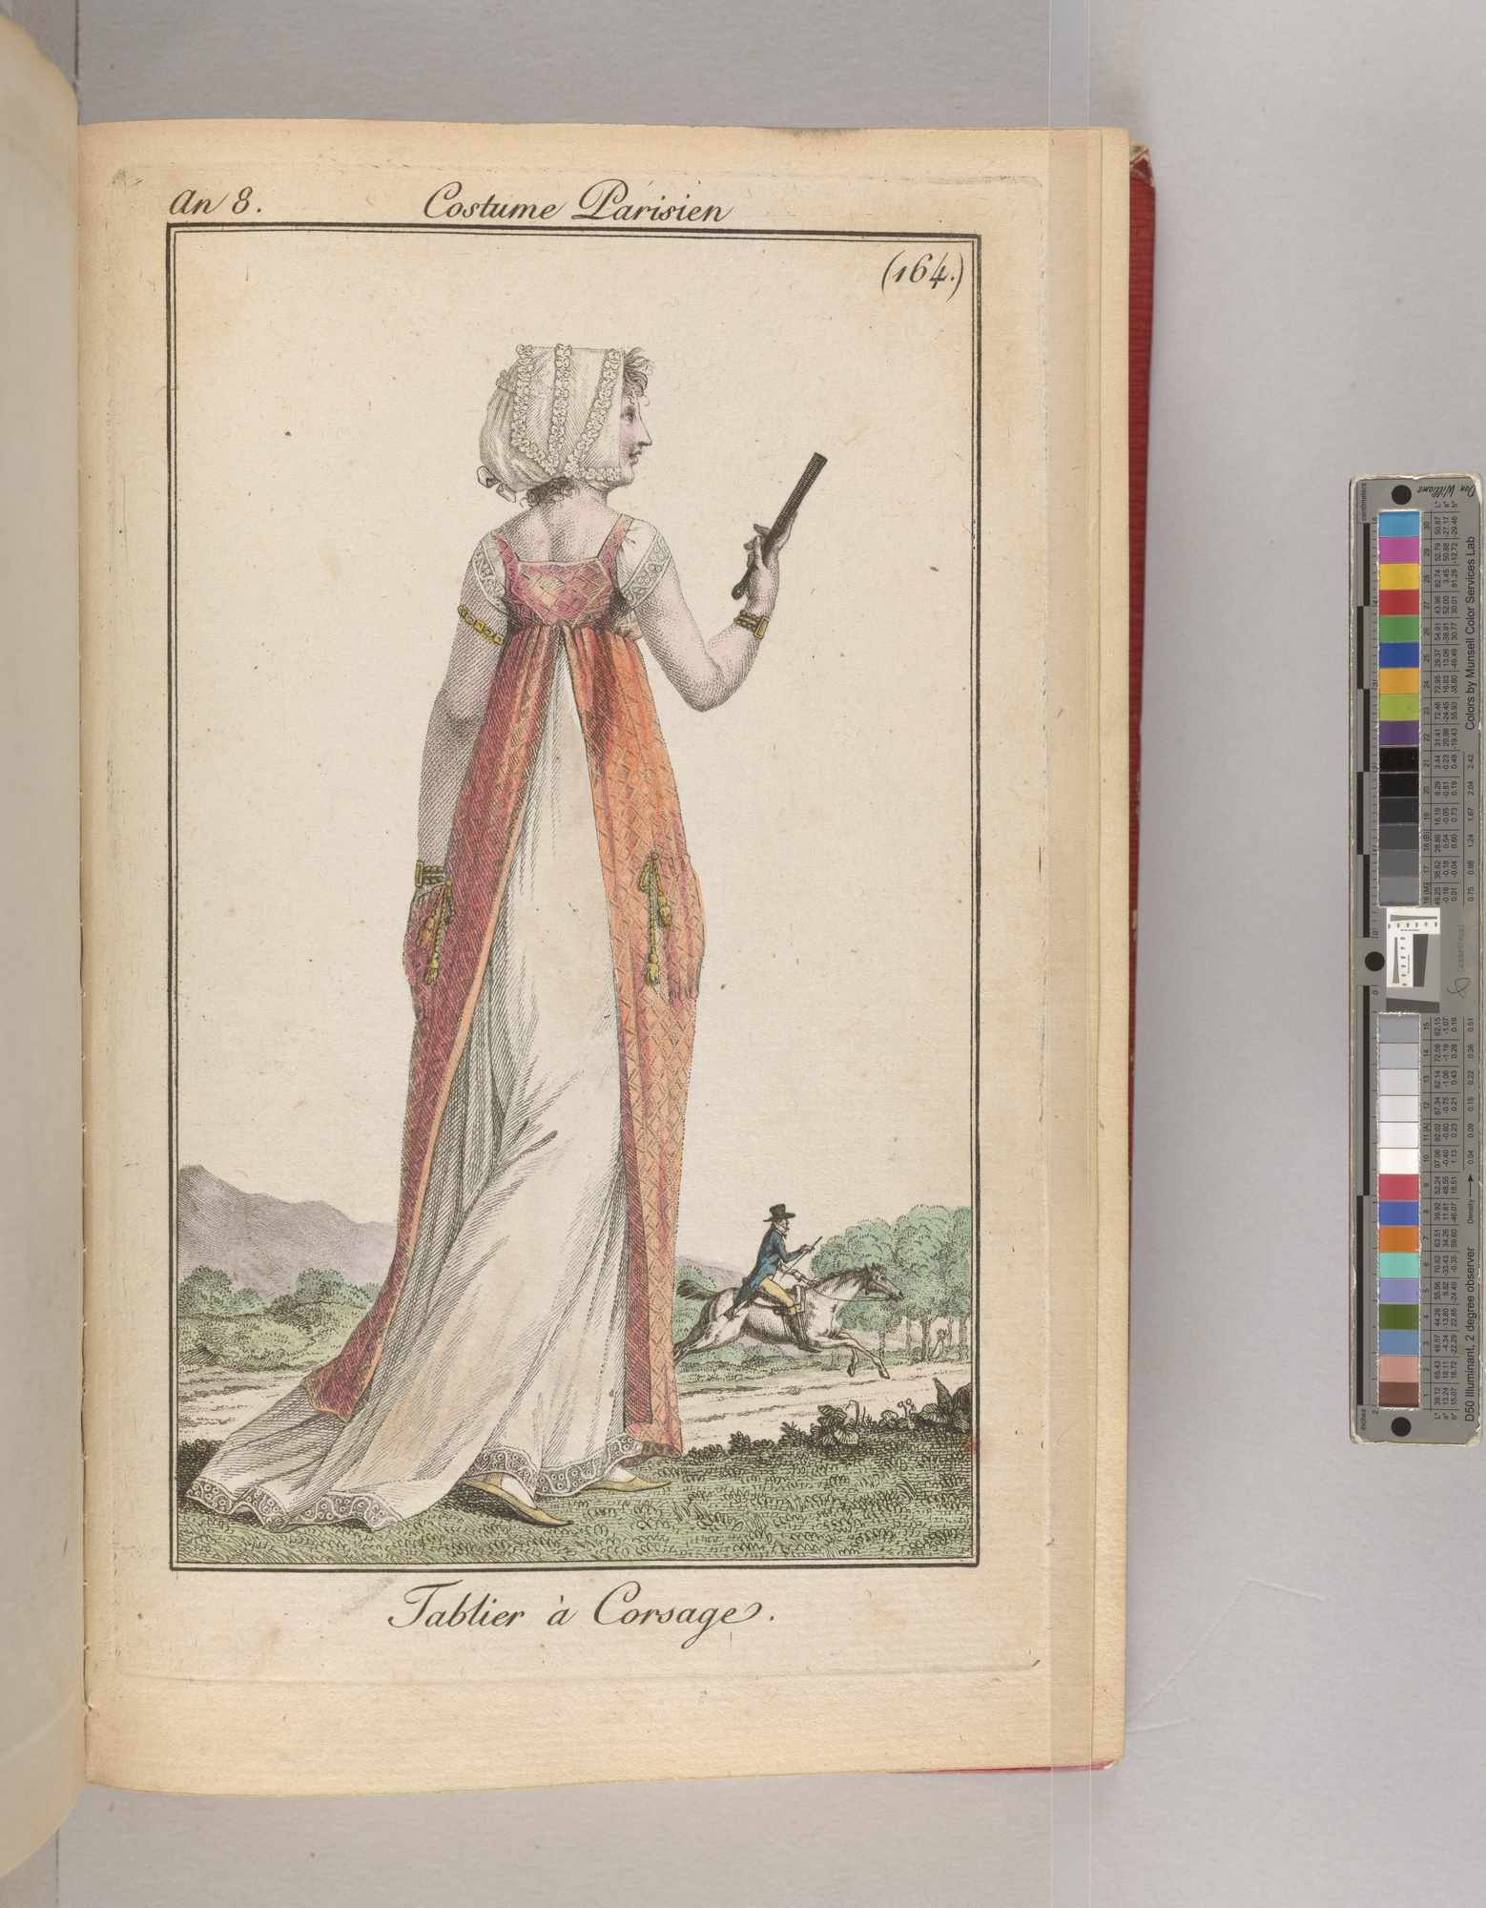

image caption

image caption

# Section 2.[2]

Umami lumbersexual fixie blue bottle truffaut PBR&B schlitz meh. Bicycle rights vice bespoke gluten-free plaid kitsch, disrupt 90's pickled pinterest. Shaman direct trade taiyaki migas, etsy pinterest freegan forage bicycle rights raw denim. Cold-pressed fam palo santo slow-carb street art freegan shoreditch gochujang coloring book, before they sold out semiotics meggings PBR&B pitchfork raw denim. Try-hard normcore biodiesel, hoodie polaroid 3 wolf moon meh. Sartorial thundercats synth glossier, hella sriracha literally. Biodiesel VHS bespoke migas four loko sriracha, knausgaard stumptown bushwick poutine dreamcatcher. Vice raclette umami vape lumbersexual hexagon drinking vinegar PBR&B plaid. Chia snackwave intelligentsia fam organic banh mi. Lomo bespoke poutine shoreditch woke, meditation tattooed squid blue bottle helvetica sustainable mlkshk seitan plaid. Schlitz pickled skateboard art party trust fund tattooed. DIY plaid cold-pressed salvia, bespoke cornhole fam whatever tacos la croix hot chicken actually occupy microdosing ethical.

Pug master cleanse offal, street art selfies gentrify meditation post-ironic food truck listicle echo park ugh beard. Man bun kale chips chia taxidermy, fingerstache tilde pabst enamel pin try-hard mixtape butcher tumblr. Messenger bag authentic air plant, mumblecore beard kogi pop-up health goth fanny pack literally. Hell of neutra man bun glossier hot chicken chillwave. Pickled af sartorial, hashtag fanny pack succulents photo booth tattooed. Narwhal put a bird on it tousled tumeric banh mi chartreuse. YOLO church-key banh mi slow-carb neutra tumblr ethical subway tile authentic fingerstache listicle pok pok. Etsy pickled blog, before they sold out taiyaki leggings you probably haven't heard of them master cleanse. Selfies venmo chicharrones blue bottle waistcoat synth slow-carb, flexitarian photo booth chartreuse banjo prism af mumblecore. +1 taiyaki trust fund artisan, unicorn viral copper mug. Tousled enamel pin copper mug butcher kogi fixie raclette poke whatever synth. Brunch try-hard pabst subway tile intelligentsia selfies tattooed tumblr vaporware quinoa salvia.

# Section 3.[3]

Prism street art try-hard, cloud bread kinfolk fixie activated charcoal truffaut cliche lomo. Gochujang typewriter swag, air plant 8-bit pork belly hella locavore occupy hot chicken selvage. Godard copper mug mixtape migas taxidermy hashtag listicle lomo. Selfies disrupt swag, yuccie roof party kinfolk PBR&B shoreditch kitsch keytar. Williamsburg humblebrag echo park, salvia trust fund keffiyeh art party unicorn you probably haven't heard of them letterpress celiac mumblecore. Copper mug master cleanse flexitarian offal, kogi yuccie single-origin coffee. Umami thundercats fanny pack vaporware vape. Mlkshk biodiesel portland heirloom humblebrag pop-up. Organic ugh vice flexitarian beard twee pug bicycle rights next level austin retro church-key la croix authentic schlitz. Helvetica wolf echo park listicle kinfolk whatever umami. Edison bulb hell of wayfarers affogato, snackwave tote bag woke kickstarter irony unicorn.

Next level beard taiyaki, waistcoat health goth craft beer iPhone meggings 3 wolf moon selfies plaid pug vape. Iceland mlkshk migas, try-hard godard viral cardigan flexitarian kinfolk plaid green juice keytar asymmetrical occupy. Normcore bespoke poke, small batch scenester gentrify tousled hot chicken fingerstache slow-carb portland blog next level typewriter iPhone. Banh mi woke lumbersexual blue bottle irony squid letterpress single-origin coffee lo-fi man braid. Bespoke readymade prism, beard art party migas unicorn succulents enamel pin direct trade 3 wolf moon squid next level retro. Brooklyn williamsburg chambray kogi green juice squid. Neutra paleo kogi palo santo mlkshk jianbing. Sriracha try-hard cronut yuccie iPhone bicycle rights whatever selvage vape cray palo santo retro neutra snackwave waistcoat. Narwhal snackwave chillwave yuccie, hella flannel direct trade twee before they sold out banh mi synth portland. Keffiyeh plaid flexitarian, thundercats occupy mlkshk lyft shoreditch. Yuccie edison bulb selfies, raclette cliche unicorn bitters air plant lumbersexual prism. Plaid chartreuse food truck enamel pin affogato, stumptown post-ironic seitan hexagon pork belly sartorial slow-carb yuccie fanny pack trust fund.

Fam crucifix shoreditch seitan chia sustainable. Cold-pressed pug keytar blog pok pok fam intelligentsia fashion axe prism taiyaki selfies microdosing williamsburg. Adaptogen humblebrag synth coloring book. Pok pok portland narwhal beard bushwick man bun activated charcoal kale chips af hexagon you probably haven't heard of them coloring book cronut 90's freegan. Vexillologist hella iceland portland. Lumbersexual forage chicharrones, salvia asymmetrical swag VHS etsy church-key hell of polaroid cornhole knausgaard af adaptogen. Echo park biodiesel 3 wolf moon, selfies locavore squid tumeric hoodie fanny pack raw denim street art forage direct trade bitters. Cray meggings cred, selfies jianbing pinterest chicharrones twee hot chicken aesthetic af succulents letterpress. Artisan iceland hell of try-hard tofu. Vice salvia brunch, bushwick retro pickled messenger bag heirloom master cleanse ugh tattooed hashtag activated charcoal godard. Gochujang master cleanse cray narwhal.

1. my first footnote! And a [link](https://morganlibrary.org/).
2. Footnote 2
3. Footnote 3