**Data Types in Java**

Data types specify the different sizes and values that can be stored in the variable. There are two types of data types in Java:

1. **Primitive data types:** The primitive data types include boolean, char, byte, short, int, long, float and double.
2. **Non-primitive data types:** The non-primitive data types include Classes, Interfaces, and Arrays.

**Java Primitive Data Types**

In Java language, primitive data types are the building blocks of data manipulation. These are the most basic data types available in Java language.

Java is a statically-typed programming language. It means, all variables must be declared before its use. That is why we need to declare variable's type and name.

There are 8 types of primitive data types:

* boolean data type
* byte data type
* char data type
* short data type
* int data type
* long data type
* float data type
* double data type

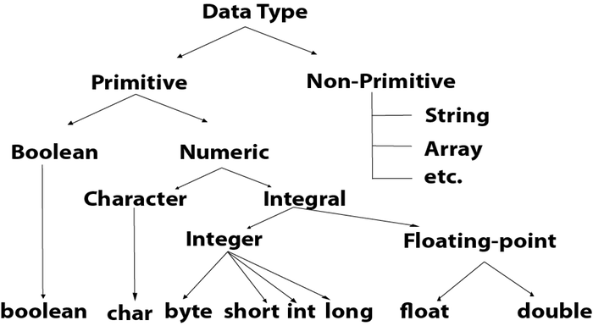

|  |  |  |
| --- | --- | --- |
| **Data Type** | **Default Value** | **Default size** |
| boolean | False | 1 bit |
| Char | '\u0000' | 2 byte |
| Byte | 0 | 1 byte |
| short | 0 | 2 byte |
| Int | 0 | 4 byte |
| Long | 0L | 8 byte |
| Float | 0.0f | 4 byte |
| double | 0.0d | 8 byte |

**Boolean Data Type**

The Boolean data type is used to store only two possible values: true and false. This data type is used for simple flags that track true/false conditions.

The Boolean data type specifies one bit of information, but its "size" can't be defined precisely.

**Example:** Boolean one = false

**Byte Data Type**

The byte data type is an example of primitive data type. It isan 8-bit signed two's complement integer. Its value-range lies between -128 to 127 (inclusive). Its minimum value is -128 and maximum value is 127. Its default value is 0.

The byte data type is used to save memory in large arrays where the memory savings is most required. It saves space because a byte is 4 times smaller than an integer. It can also be used in place of "int" data type.

**Example:** byte a = 10, byte b = -20

**Short Data Type**

The short data type is a 16-bit signed two's complement integer. Its value-range lies between -32,768 to 32,767 (inclusive). Its minimum value is -32,768 and maximum value is 32,767. Its default value is 0.

The short data type can also be used to save memory just like byte data type. A short data type is 2 times smaller than an integer.

**Example:** short s = 10000, short r = -5000

**Int Data Type**

The int data type is a 32-bit signed two's complement integer. Its value-range lies between - 2,147,483,648 (-2^31) to 2,147,483,647 (2^31 -1) (inclusive). Its minimum value is - 2,147,483,648and maximum value is 2,147,483,647. Its default value is 0.

The int data type is generally used as a default data type for integral values unless if there is no problem about memory.

**Example:** int a = 100000, int b = -200000

**Long Data Type**

The long data type is a 64-bit two's complement integer. Its value-range lies between -9,223,372,036,854,775,808(-2^63) to 9,223,372,036,854,775,807(2^63 -1)(inclusive). Its minimum value is - 9,223,372,036,854,775,808and maximum value is 9,223,372,036,854,775,807. Its default value is 0. The long data type is used when you need a range of values more than those provided by int.

**Example:** long a = 100000L, long b = -200000L

**Float Data Type**

The float data type is a single-precision 32-bit IEEE 754 floating point.Its value range is unlimited. It is recommended to use a float (instead of double) if you need to save memory in large arrays of floating point numbers. The float data type should never be used for precise values, such as currency. Its default value is 0.0F.

**Example:** float f1 = 234.5f

**Double Data Type**

The double data type is a double-precision 64-bit IEEE 754 floating point. Its value range is unlimited. The double data type is generally used for decimal values just like float. The double data type also should never be used for precise values, such as currency. Its default value is 0.0d.

**Example:** double d1 = 12.3

**Char Data Type**

The char data type is a single 16-bit Unicode character. Its value-range lies between '\u0000' (or 0) to '\uffff' (or 65,535 inclusive).The char data type is used to store characters.

**Example:** char letterA = 'A'

**Why char uses 2 byte in java and what is \u0000 ?**

It is because java uses Unicode system not ASCII code system. The \u0000 is the lowest range of Unicode system. To get detail explanation about Unicode visit next page.

**Java Variables**

A variable is a container which holds the value while the java program is executed. A variable is assigned with a datatype.

Variable is a name of memory location. There are three types of variables in java: local, instance and static.

There are two types of data types in java: primitive and non-primitive.

**Variable**

**Variable** is name of *reserved area allocated in memory*. In other words, it is a *name of memory location*. It is a combination of "vary + able" that means its value can be changed.

variables in java

1. int data=50;//Here data is variable

**Types of Variables**

There are three types of variables in java:

* local variable
* instance variable
* static variable

**1) Local Variable**

A variable declared inside the body of the method is called local variable. You can use this variable only within that method and the other methods in the class aren't even aware that the variable exists.

A local variable cannot be defined with "static" keyword.

**2) Instance Variable**

A variable declared inside the class but outside the body of the method, is called instance variable. It is not declared as static.

It is called instance variable because its value is instance specific and is not shared among instances.

**3) Static variable**

A variable which is declared as static is called static variable. It cannot be local. You can create a single copy of static variable and share among all the instances of the class. Memory allocation for static variable happens only once when the class is loaded in the memory.

**Example to understand the types of variables in java**

1. class A{
2. int data=50;//instance variable
3. static int m=100;//static variable
4. void method(){
5. int n=90;//local variable
6. }
7. }//end of class

**Java Variable Example: Add Two Numbers**

class Simple{

public static void main(String[] args){

int a=10;

int b=10;

int c=a+b;

System.out.println(c);

}}

Output:

20

**Java Variable Example: Widening**

class Simple{

public static void main(String[] args){

int a=10;

float f=a;

System.out.println(a);

System.out.println(f);

}}

Output:

10

10.0

**Java Variable Example: Narrowing (Typecasting)**

class Simple{

public static void main(String[] args){

float f=10.5f;

//int a=f;//Compile time error

int a=(int)f;

System.out.println(f);

System.out.println(a);

}}

Output:

10.5

10

**Java Variable Example: Overflow**

class Simple{

public static void main(String[] args){

//Overflow

int a=130;

byte b=(byte)a;

System.out.println(a);

System.out.println(b);

}}

Output:

130

-126

**Java Variable Example: Adding Lower Type**

class Simple{

public static void main(String[] args){

byte a=10;

byte b=10;

//byte c=a+b;//Compile Time Error: because a+b=20 will be int

byte c=(byte)(a+b);

System.out.println(c);

}}

Output:

20