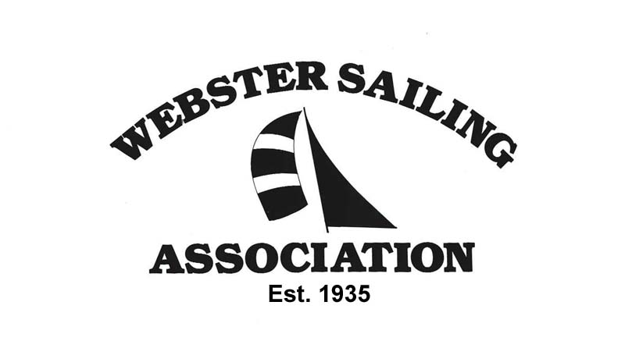
MEMBERSHIP APPLICATION

- You must own a sailboat to join the Webster Sailing Association.
- Fundamental knowledge of sailing recommended.
- There is a 20 foot maximum length allowed.
- Family membership runs from April 1st to November 30th.
- Dues average …first year $302.00…each year after $225.00 per year
- Insurance binder or $100,000 required for liability. (Usually part of homeowners insurance)
- Mooring or dry sailing parking. (Based on availability)

DATE____________________________

NAME (print)_______________________________________________________________________

(signature)_________________________________________________________________________

SPOUSE / SIGNIFICANT OTHER_______________________________________________________

NAMES OF CHILDREN RESIDING WITH YOU, WITH AGES _________________________________

___________________________________________________________________________________

ADDRESS___________________________________________________________________________

CITY_________________________________ STATE____________ ZIP CODE___________________

TELEPHONE (home)____________________________________

TELEPHONE (work)______________________________________

E-MAIL ADDRESS(ES) ________________________________________________________________

___________________________________________________________________________________

YOUR OCCUPATION _________________________________________________________________

WERE YOU REFERRED BY A WSA MEMBER? _______

IF YES, MEMBER’S NAME______________________________________________________________

(OVER)
HOW DID YOU HEAR ABOUT WSA? _____________________________________________________

SAILBOAT(S) THAT YOU OWN: HULL: STORAGE PREFERENCE:
TYPE LENGTH MONO / MULTI MOORING / DRY SAILING
____________________________________________________________________________________

____________________________________________________________________________________

____________________________________________________________________________________

____________________________________________________________________________________
(WSA PROVIDES DINGHIES FOR MOORING ACCESS, OR YOU MAY USE YOUR OWN)

NUMBER OF YEARS OF SAILING EXPERIENCE___________________________

HAVE YOU TAKEN SAILING LESSONS? ___________ IF YES, WHERE? _______________________

DO YOU HAVE ANY SAILBOAT RACING EXPERIENCE?___________________

ARE YOU INTERESTED IN RACING AT THIS TIME?_______________________

SPECIAL SKILLS THAT MIGHT HELP THE W.S.A. __________________________________________

____________________________________________________________________________________

PLEASE GIVE ANY ADDITIONAL INFORMATION YOU WISH TO FURNISH:

____________________________________________________________________________________
____________________________________________________________________________________
- APPLICANTS SHOULD BE AWARE THAT THE FIRST YEAR MEMBERSHIP IS PROBATIONARY; THAT CONTINUED MEMBERSHIP WILL BE REVIEWED AND VOTED ON BY THE EXECUTIVE COMMITTEE, AND BE BASED ON THE APPLICANT’S SAILING AND PARTICIPATION INVOLVEMENT.

- THIS ASSOCIATION IS RUN BY A GROUP OF COMMITTEES. IF YOUR APPLICATION IS
APPROVED YOU WILL BE REQUIRED TO SERVE ON AT LEAST ONE OF THESE COMMITTEES.
PLEASE INITIAL FOR AGREEMENT_______________

- EACH MEMBER AGREES TO ABIDE BY THE RULES AND BY – LAWS OF
THE WEBSTER SAILING ASSOCIATION. INITIALS _________________

- EACH MEMBER ACKNOWLEDGES THAT THE WEBSTER SAILING ASSOCIATION
ASSUMES NO RESPONSIBILITY OR LIABILITY FOR PERSONAL INJURY OR
PROPERTY DAMAGE WHILE ON WSA GROUNDS. INITIALS________________

PLEASE RETURN THIS APPLICATION TO:

Lee Amodeo, 755 Lebanan Hill, Southbridge, MA 01550
Phone: (508) 764-6411
Email: lramodeo@gmail.com

