Introduction to Mathematical Finance
Problem Sheet 2
Date due:
1. Which of the following is most accurate regarding a distribution of returns that has a mean greater than its median?
A. It is positively skewed.
B. It is a symmetric distribution.
C. It has positive excess kurtosis.
2. A distribution of returns that has a greater percentage of small deviations from the mean and a greater percentage of extremely large deviations from the mean compared with a normal distribution:
A. is positively skewed.
B. has positive excess kurtosis.
C. has negative excess kurtosis.
3. Which of the following types of data would most likely be organized as a two-dimensional array?
A. Panel.
B. Time series.
C. Cross sectional.
4. The harmonic mean of 3, 4, and 5 is:
A. 3.74.
B. 3.83.
C. 4.12.
5. Given the following observations:
2, 4, 5, 6, 7, 9, 10, 11
The 65th percentile is closest to:
A. 5.85.
B. 6.55.
C. 8.70.
6. A stock doubled in value last year. Its continuously compounded return over the period was closest to:
A. 18.2%.
B. 69.3%.
C. 100.0%.
A. XYZ Corp. Annual Stock Returns
20x1 | 20x2 | 20x3 | 20x4 | 20x5 | 20x6
22% | 5% | -7% | 11% | 2% | 11%
Assume an investor has a target return of 11% for XYZ stock. What is the stock’s target downside deviation?

B. A study of hedge fund investors found that their annual household incomes are normally distributed with a mean of $175,000 and a standard deviation of $25,000. How much is the percentage of hedge fund investors that have incomes greater than $150,000?
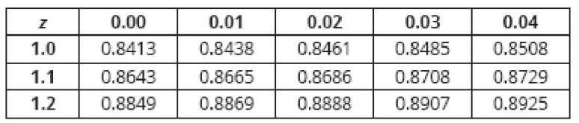

C. Given a threshold level of return of 0% and 4%, use Roy’s safety-first criterion to choose the optimal portfolio
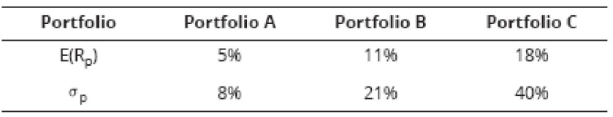

D. Use the following table to answer:
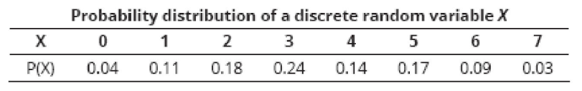
- What is the cdf of 5, or F(5)?
- What is the probability that X is greater than 3?
- What is $P(2≤X≤5)$?
- What is The expected value of the random variable X ?

E. A recent study indicated that 60% of all businesses have a fax machine. What is the probability that exactly four businesses will have a fax machine in a random selection of six businesses?

