**Introduction to Mathematical Finance**

**Problem Sheet 2**

**Date due: 2025-04-14**

1. Which of the following is **most accurate** regarding a distribution of returns that has a mean greater than its median?

A. It is positively skewed.  
B. It is a symmetric distribution.  
C. It has positive excess kurtosis.

2. A distribution of returns that has a greater percentage of small deviations from the mean and a greater percentage of extremely large deviations from the mean compared with a normal distribution:

A. is positively skewed.  
B. has positive excess kurtosis.  
C. has negative excess kurtosis.

3. Which of the following types of data would most likely be organized as a two-dimensional array?

A. Panel.  
B. Time series.  
C. Cross sectional.

4. The harmonic mean of 3, 4, and 5 is:

A. 3.74.  
B. 3.83.  
C. 4.12.

5. Given the following observations:

2, 4, 5, 6, 7, 9, 10, 11

The 65th percentile is **closest** to:

A. 5.85.  
B. 6.55.  
C. 8.70.

6. A stock doubled in value last year. Its continuously compounded return over the period was **closest** to:

A. 18.2%.  
B. 69.3%.  
C. 100.0%.

A. XYZ Corp. Annual Stock Returns

|  |  |  |  |  |  |
| --- | --- | --- | --- | --- | --- |
| 20x1 | 20x2 | 20x3 | 20x4 | 20x5 | 20x6 |
| 22% | 5% | -7% | 11% | 2% | 11% |

Assume an investor has a target return of 11% for XYZ stock. What is the stock’s target downside deviation?

B. A study of hedge fund investors found that their annual household incomes are normally distributed with a mean of $175,000 and a standard deviation of $25,000. How much is the percentage of hedge fund investors that have incomes greater than $150,000?

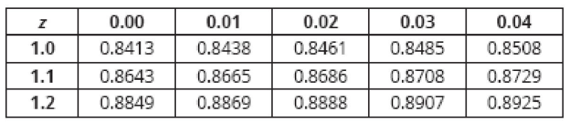

C. Given a threshold level of return of 0% and 4%, use Roy’s safety-first criterion to choose the optimal portfolio

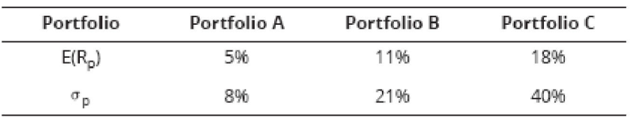

D. Use the following table to answer:

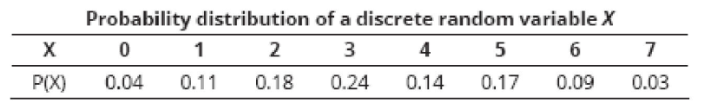

- What is the cdf of 5, or F(5)?  
- What is the probability that *X* is greater than 3?  
- What is ?  
- What is The expected value of the random variable *X* ?

E. A recent study indicated that 60% of all businesses have a fax machine. What is the probability that exactly four businesses will have a fax machine in a random selection of six businesses?