**Introduction to Mathematical Finance**

**Problem Sheet 3**

1. Which of the following is least likely a property of Student’s t-distribution?

A. As the degrees of freedom get larger, the variance approaches zero.  
B. It is defined by a single parameter, the degrees of freedom = n – 1.  
C. It has more probability in the tails and less at the peak than a standard normal distribution

2. To apply the central limit theorem to the sampling distribution of the sample mean, the sample is usually considered to be large if n is gr eater than:

A. 20.  
B. 25.  
C. 30.

3. The population’s mean is 30 and the mean of a sample of size 100 is 28.5. The variance of the sample is 25. The standard error of the sample mean is closest to:

A. 0.05.  
B. 0.25.  
C. 0.50.

4. When constructing a confidence interval for the population mean of a nonnormal distribution when the population variance is unknown and the sample size is large (n > 30), an analyst may acceptably use:

A. either a z-statistic or a t-statistic.  
B. only a z-statistic at α with n degrees of freedom.  
C. only a t-statistic at α/2 with n degrees of freedom.

5. An analyst who uses historical data that was not publicly available at the time period being studied will have a sample with:

A. look-ahead bias.  
B. time-period bias.  
C. sample selection bias.

6. Which of the following three bonds (similar except for yield and maturity) has the least Macaulay duration? A bond with:

A. 5% yield and 10-year maturity.  
B. 5% yield and 20-year maturity.  
C. 6% yield and 10-year maturity.

A. Annual returns on small stocks have a population mean of 12% and a population standard deviation of 20%. If the returns are normally distributed, calculate a 90% confidence interval on mean returns over a 5-year period.

B. A study was conducted by the British Department of Transportation to estimate urban travel time between locations in London, England. Data was collected for motorcycles and passenger cars. Simple linear regression was conducted using data sets for both types of vehicles, where Y = urban travel time in minutes and X = distance between locations in kilometers. The following results were obtained:

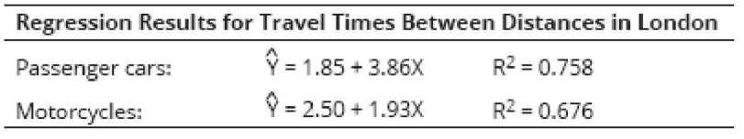

The estimated increase in travel time for a motorcycle commuter planning to move 8 km farther from his workplace in London is ?

Based on the regression results, which model is more reliable? Why?

C. An analyst is interested in predicting annual sales for XYZ Company, a maker of paper products. The following table reports a regression of the annual sales for XYZ against paper product industry sales. The correlation between company and industry sales is 0.9757. The regression was based on five observations.

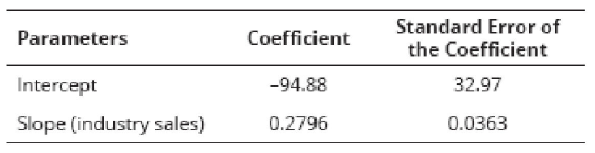

Calculate and interpret the R2 of the regression.

Based on the regression results, how much is XYZ Company’s market share of any increase in industry sales expected to be?

D. Assume a bond has an effective duration of 10.5 and a convexity of 97.3. Using both of these

measures, estimate the percentage change in price for this bond, in response to a decline in

yield of 200 basis points.