**Introduction to Mathematical Finance**

**Problem Sheet 4**

1. Which of the following statements about risk-averse investors is most accurate? A risk-averse investor:  
A. seeks out the investment with minimum risk, while return is not a major consideration.  
B. will take additional investment risk if sufficiently compensated for this risk.  
C. avoids participating in global equity markets.

2. The capital allocation line is a line from the risk-free return through:  
A. the global maximum-return portfolio.  
B. the optimal risky portfolio.  
C. the global minimum-variance portfolio.

3. Which of the following available portfolios most likely falls below the efficient frontier?  
 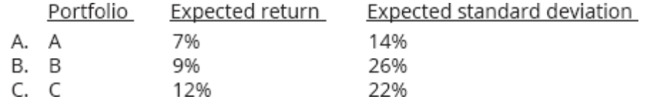

4. What is the risk measure associated with the capital market line (CML)?  
A. Beta risk.  
B. Unsystematic risk.  
C. Total risk.

5. Total risk equals:  
A. unique plus diversifiable risk.  
B. market plus nondiversifiable risk.  
C. systematic plus unsystematic risk.

6. Which of the following statements about the SML and the CML is least accurate?  
A. Securities that plot above the SML are undervalued.  
B. Investors expect to be compensated for systematic risk.  
C. Securities that plot on the SML have no value to investors.

7. Which of these return metrics is defined as excess return per unit of systematic risk?  
A. Sharpe ratio.  
B. Jensen’s alpha.  
C. Treynor measure.

8. As the number of stocks in a portfolio increases, the portfolio’s systematic risk:  
A. can increase or decrease.  
B. decreases at a decreasing rate.  
C. decreases at an increasing rate.

A. An investor put 60% of his portfolio into a risky asset offering a 10% return with a standard deviation of returns of 8% and put the balance of his portfolio in a risk-free asset offering 5%. What is the expected return and standard deviation of his portfolio?

B. The covariance of the market’s returns with a stock’s returns is 0.005 and the standard deviation of the market’s returns is 0.05. What is the stock’s beta?

C. According to the CAPM, what is the required rate of return for a stock with a beta of 0.7, when the risk-free rate is 7% and the expected market rate of return is 14%?   
According to the CAPM, what is the expected rate of return for a stock with a beta of 1.2, when the risk-free rate is 6% and the market rate of return is 12%?

D. The risk-free rate is 6%, and the expected market return is 15%. A stock with a beta of 1.2 is selling for $25 and will pay a $1 dividend at the end of the year. If the stock is priced at $30 at year-end, we should buy it or short it?

A stock with a beta of 0.7 currently priced at $50 is expected to increase in price to $55 by yearend and pay a $1 dividend. If the expected market return is 15%, and the risk-free rate is 8%, we should buy it or short it?