**What is a cell-cycle checkpoint and what are the consequences of loss of cell-cycle checkpoint genes? Describe the two checkpoint pathways that respond to DNA damage.**

In 1953, Alma Howard and Stephan Pelc introduced the concept of a temporally controlled four-stage eukaryotic cell-cycle [1]. The two scientists determined that DNA replication was limited to a specific period during interphase, termed S-phase, as phosphorus-32 radioisotope was only incorporated into bean-root-DNA within this interval [1]. Howard & Pelc noted the absence of DNA replication during G1 and G2, which precede and succeed S-phase respectively, and observed that a final ‘M-phase’ segregated replicated chromosomes into daughter cells.

This paradigmatic breakthrough laid the foundations for Leland Hartwell to demonstrate the existence of cell-cycle checkpoints, which link the pace of transition between the stages of cycle proposed by Howard & Pelc with the contingent success of various intracellular events. Checkpoints frequently arrest the cell-cycle due to DNA damage, detected either by the ATM or ATR-kinase dependent on the nature of the lesion. DNA damage is inevitable - whilst organisms can minimise exposure to environmental sources of genotoxic stress such as ultraviolet radiation, the most frequent mechanism of damage arises during the endogenous process of oxidative phosphorylation in aerobic respiration. Regardless of the origin, DNA damage threatens cell survival, promoting organ failure and crucially genomic instability, characterised as a hallmark of cancer by Hanahan and Weinberg in 2000 [2].

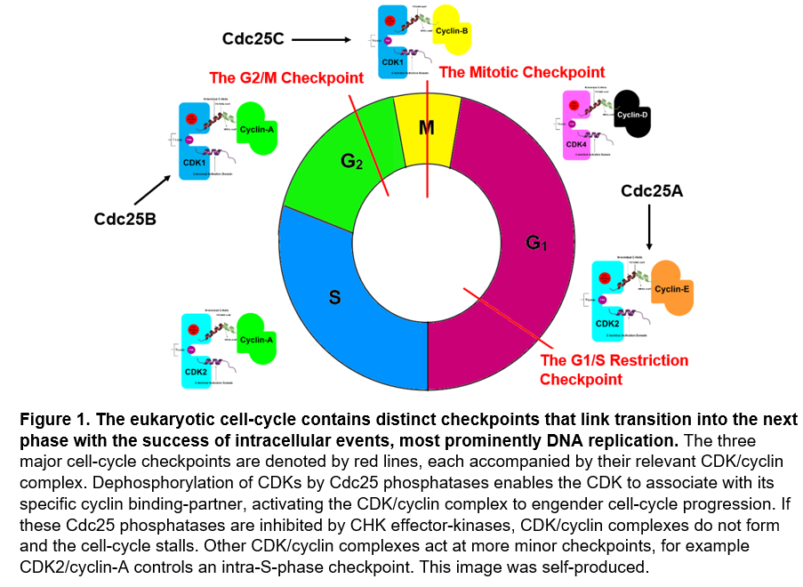It is therefore evolutionarily advantageous to strictly regulate cell division dependent upon the fidelity of component DNA, and eukaryotes have correspondingly evolved checkpoints that regulate advance through the phases of the cell-cycle, as shown in Figure 1. These checkpoints condition the transition between stages of the cell-cycle with the appropriate and accurate completion of preceding intracellular events, to ensure the genome has only been replicated once and DNA damage is repaired before the next phase of the cycle is entered. Protection against persistent incorporation of damaged DNA sequence is critical in avoiding a mutator phenotype; if one gene that maintains replicative fidelity becomes dysfunctional, this can significantly enhance the frequency of additional mutations in supplementary genes.

The inhibition of cell-cycle progression at checkpoints can be considered as the overarching consequence of signal-transduction pathways that detect DNA damage. Alternative stimuli such as nutrient unavailability can also arrest cell-cycle progression - for example in *Saccharomyces cerevisiae*, phosphate scarcity inactivates the PHO pathway, preventing phosphorylation and stabilisation of Cln3, a homologue of human cyclin-D [3]. Cln3 degradation prevents activation of its Cdk1 binding-partner, homologous to human CDK2 and 4, hence the cell-cycle is restricted at the G1-S checkpoint. Cln3 also provides our first example of how cell-cycle checkpoint gene-knockouts confer significant phenotypic effects; Δ*Cln3-*mutants display increased sensitivity to mating pheromone and a delay at the G1/S transition that can extend indefinitely [4].

Irrespective of the nature of the stimuli, the decision as to whether a checkpoint allows progression into the next phase of the cell-cycle is determined by the activation state of cyclin-dependent-kinases (CDKs) relevant to each specific stage of the cycle. This is exemplified by Cdk1 in *Saccharomyces cerevisiae*; Cdk1 activation is inconsequential to cell-cycle progression, except at the G1-S transition [4]. As displayed in Figure 1, different combinations of CDKs must be activated at each particular checkpoint to facilitate transition into the next phase of cell-cycle. However, whilst CDKs act as the ultimate effector of cell-cycle transduction pathways, their activity is only initiated through association with CDK-specific binding-partners called cyclins.

In monomeric CDKs, the catalytic T-loop pocket is inaccessible for target-protein substrates due to the close spatial proximity of the N-terminal C-helix and the C-terminal activation-domain. However, as shown in Figure 2, when a MRAIL-motif from a cyclin binds the PSTAIRE-motif from the C-helix of its partner CDK, the subsequent reorientation of the CDK separates the C-helix and activation-domain such that target-protein substrates can enter the T-loop. This conformational change also exposes ATP-binding residues, and concurrently facilitates phosphorylation of a key threonine residue (T160 in CDK2) by action of a CDK-activating-kinase.

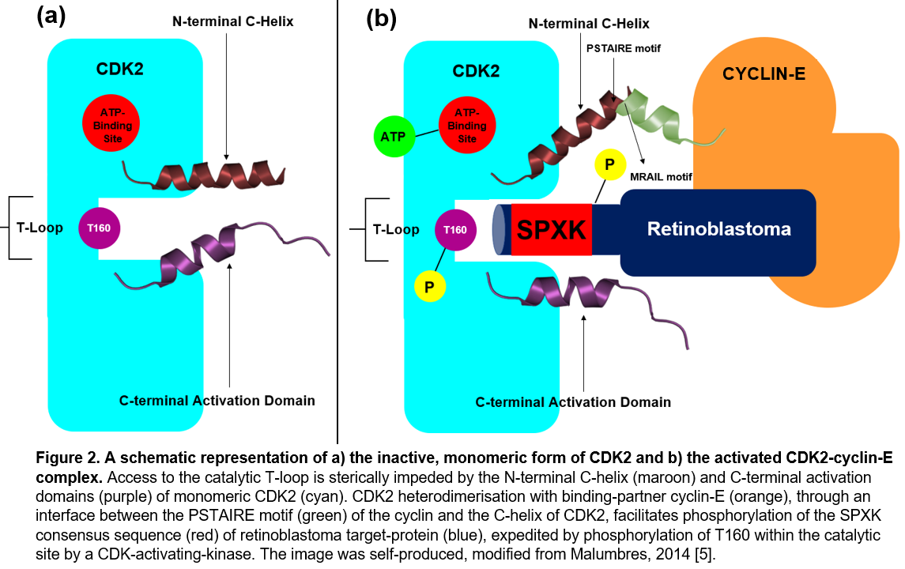

By stabilising the catalytic T-loop, T160-phosphorylation enables subsequent phosphorylation of SPXK consensus sequence on target-proteins [6]. As shown in Figure 2, these SPXK sequences delineate phosphorylation sites that modulate the activity of target-proteins – CDK2/cyclin-E-mediated phosphorylation inactivates retinoblastoma protein, which otherwise inhibits expression of cyclin-A and cyclin-E in a positive-feedback loop that restricts G1/S transition [7]. The loss of cell-cycle checkpoint genes encoding either CDK2 or cyclin-E therefore precipitates constitutive retinoblastoma activation. Using mice models, it has been experimentally demonstrated such constitutive retinoblastoma activation restricts both cell differentiation and apoptosis, and ultimately leads to the onset of hyperplastic lesions and breast adenocarcinomas [7].

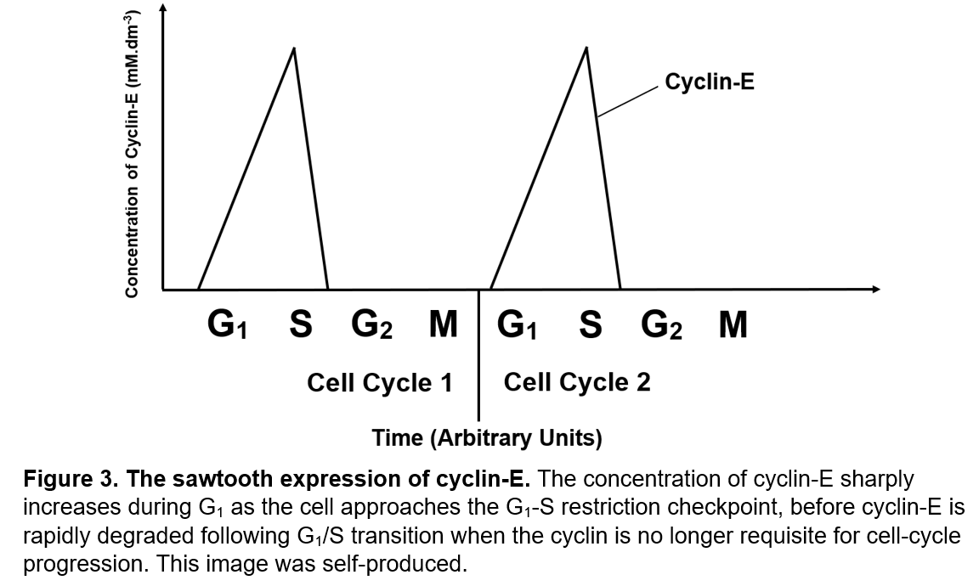As each cell-cycle transition is controlled by action of different cyclin-CDK partners, the expression of specific cyclins varies dramatically at different points of the cell-cycle. Figure 3 displays the sawtooth-expression of cyclin-E as the cell-cycle progresses. From the expression profile, we can predict that knock-out mutants of the *CCNE2* checkpoint gene, which encodes cyclin-E, will prompt cell-cycle arrest at the G1/S transition, and this was indeed determined experimentally in Δ*CCNE2-*mice [8]. *CCNE2* ablation was also shown to restrict cell proliferation and growth, whilst mice exhibited increased rates of tumorigenesis, corroborating use of cyclin-E as a prognostic marker for human breast-cancer [8]. Loss of the cell-checkpoint gene encoding CDK2, the binding-partner of cyclin-E, invoked similar but not equivalent phenotypic consequence; Δ*CDK2* mice remained viable, but entry into S-phase was delayed, reducing cell proliferation, and DNA replication was frequently dysregulated [9].

When cyclins are not required for progression from a specific phase of the cell-cycle, their degradation is expedited through ubiquitin-dependent proteolysis. This is particularly important at the mitotic checkpoint, where cyclin-B degradation is essential to the metaphase-to-anaphase transition, exit from mitosis and ultimately the start of a new cell-cycle. Cyclin-B degradation in M-phase is facilitated by the anaphase-promoting complex (APC). Once sister kinetochores are appropriately attached to opposite poles of the spindle, the APC is phosphorylated and activated by CDC20. The APC can then recognise D-box motifs with consensus sequence RxxLxxxxN in cyclin-B, which are polyubiquitinated by action of an E3-ubiquitin ligase to target the substrate for degradation by the 26S-proteasome [10]. Over 80% of colorectal tumours contain mutations within genes encoding one of the 11-13 constituent subunits of the APC-complex – it can therefore be concluded that loss of APC-complex genes would increase cancer predisposition and tumorigenesis [11].

Whilst it is evident that cyclin activity modulates cell-cycle progression, it is important to understand the signal-transduction pathways that control activation of these cyclin molecules. This is best examined through the ATM and ATR-pathways of DNA-damage response (DDR), which inactivate CDK/cyclin complexes by action of CHK effector-kinases following detection of DNA damage. The ATM and ATR pathways provide two convergent but not redundant methods of DDR. Both pathways are regulated by their respective eponymous serine/threonine-kinase transducer, which belongs to the phosphatidylinositol-3-kinase-like-kinase (PIKK) family. Figure 4 displays the function of each protein within both PIKK-regulated DDR-transduction pathways that provoke cell-cycle arrest.

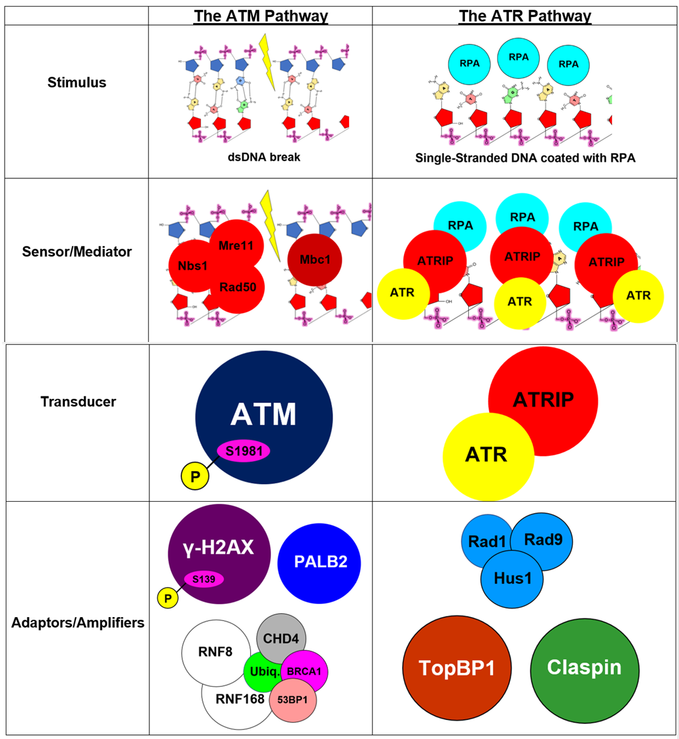

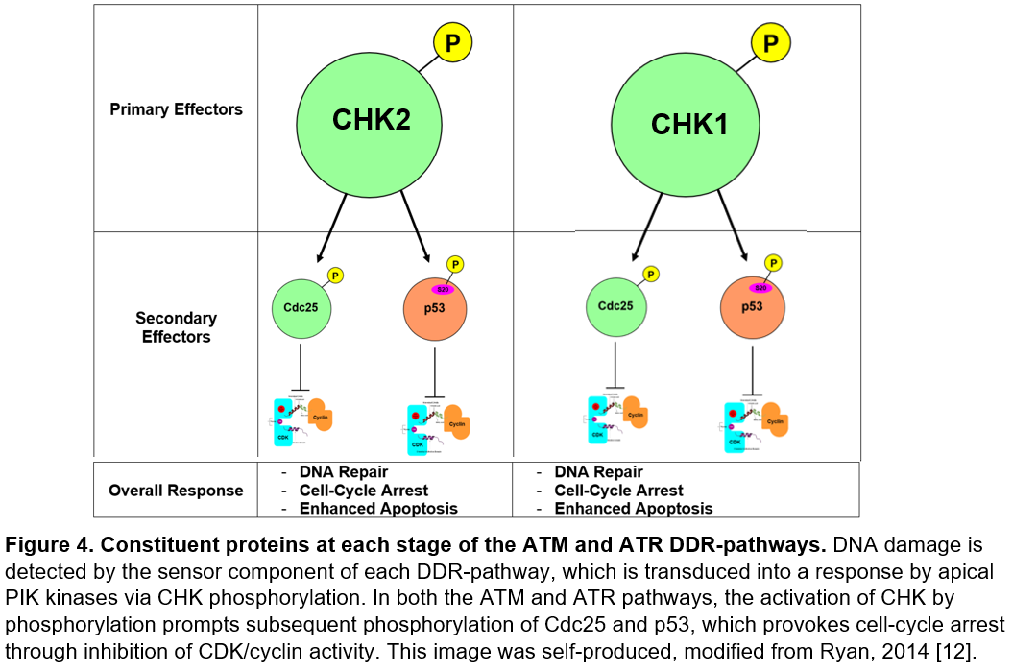In absence of double-stranded DNA (dsDNA) breaks, ATM exists as a catalytically inactive homodimer. ATM activation is facilitated through autophosphorylation of its serine-1981 residue, which provokes dissociation of the homodimer interface between the FAT-domain of one ATM monomer and the kinase-domain of the second, to remove steric hindrance of the ATM substrate-binding site [13]. ATM phosphorylation arises at dsDNA breaks, activated by the Mre11-Rad50-Nbs1 (MRN) complex, which recognises dsDNA-ends and migrates into flanking regions of DNA to phosphorylate and activate ATM.

Assembly of the MRN-complex at dsDNA breaks stimulates further recruitment of proteins that phosphorylate and activate ATM, which accordingly promotes additional recruitment of DDR proteins to the dsDNA substrate in a positive-feedback loop. For example, activated-ATM phosphorylates the serine-139 residue on H2AX histones, exposed through chromatin remodelling via HP1-β release due to the dsDNA break**.** This γ-H2AX is detected by an MDC1 mediator, which identifies and binds the post-translational epigenetic modification through its BRCT-domain [14]. The γ-H2AX/MDC1 interaction recruits the MRN-complex to the dsDNA break, which in turn activates a second ATM-kinase that phosphorylates the TQXF-domain of MDC1.

This phosphorylated TQXF-domain initiates recruitment of E3-ubiquitin ligases RNF8 and RNF168, which amplify activity of the ATM-pathway through a ubiquitin-cascade that ultimately recruits BRCA1 and 53BP1, facilitators of DNA-damage repair through homologous recombination (HR) [14]. These E3-ligases also mediate extensive chromatin decondensation proximal to the dsDNA break, by activating the CHD4 catalytic subunit of the NuRD complex. The increased exposure of H2AX stimulates ATM-kinase-mediated phosphorylation of serine-139, further amplifying ATM-activation and thus strengthening the activity of this DDR-pathway through positive-feedback.

Amplification of the ATM-pathway is critical to cell-cycle control because the ATM-kinase itself catalyses phosphorylation of the SCD-domain of CHK2, the primary effector-kinase of the ATM-pathway. The concentration of activated ATM-kinase therefore determines the extent of ATM-mediated cell-cycle arrest. When phosphorylated by ATM, activated-CHK2 regulates the cell-cycle primarily through interaction with two different proteins: Cdc25 phosphatase and the p53 tumour-suppressor.

In humans, there are three members of the Cdc25 family: Cdc25A-C, which are each inhibited at different stages of the cell-cycle through phosphorylation by activated-CHK2, stimulated by the ATM-pathway. This phosphorylation prevents the Cdc25 enzyme from dephosphorylating CDKs, hence CDK/cyclin complexes do not form, their downstream targets remain unphosphorylated, and the cell becomes unable to bypass cycle checkpoints. For example, phosphorylation of Cdc25A by activated-CHK2, formed as a consequence of the active ATM-pathway, prevents the Cdc25 phosphatase from removing two inhibitory phosphate-groups from adjacent threonine and tyrosine residues within the CDK2 active site. This impedes association of CDK2 with its cyclin-E binding-partner, thus the catalytic T-loop of the CDK cannot phosphorylate downstream targets that would allow cell-cycle progression. Retinoblastoma, for example, remains unphosphorylated and therefore active, hence the expression of both cyclin-E and E2F1-transcription-factor is downregulated and the cell-cycle cannot proceed beyond the G1-S checkpoint.

Activated-CHK2 also impedes progression of the cell-cycle through interaction with the p53 tumour-suppressor protein. p53 is a physiologically short-lived transcription-factor that can be stabilised by direct phosphorylation of its serine-20 residue by CHK2. In absence of serine-20 phosphorylation, Mdm2 binds this residue to mediate p53 degradation. However, serine-20 phosphorylation, induced by activated-CHK2, inhibits Mdm2-mediated p53-turnover, thus p53 accumulates. The cell-cycle is therefore arrested at the G1-S checkpoint through upregulation of p53-promoted genes, which include p21, a global inhibitor of CDK functionality.

The predominant function of p53, therefore, is to stall the cell-cycle, and allow the numerous mechanisms of DNA repair to avert inheritance of damaged genetic material by daughter cells. However, p53 can also directly expedite DNA repair, through repression of PFK-2 synthesis [15]. Glucose subsequently favours the pentose-phosphate-pathway of metabolism, which enhances nucleotide production to accelerate DNA repair, increasing the probability of cell-cycle progression [15]. p53 is not the only protein activated by DDR-pathways to accelerate DNA repair; ATM/ATR-pathways also promote PALB2 synthesis, which combines with Rad51-recombinase to initiate strand-invasion during HR.

It is therefore clear that dysregulation of the ATM-pathway will engender deleterious phenotypic consequences for cells through a variety of metabolic processes. Indeed, cell-cycle checkpoint genes including p53 and Cdc25 have been characterised as oncogenic; their dysfunction predisposes cells to cancer [16]. Moreover, mutation in the ATM-kinase transducer itself engenders ataxia-telangiectasia, a rare neurodegenerative disease that causes severe disability including impaired motor-coordination. Ataxia-telangiectasia is also distinguished by an increased incidence of cancer, as dsDNA breaks are not appropriately repaired. Accurate replication of cell-cycle checkpoint genes is therefore essential to preventing destructive mutator phenotypic outcomes, including cancer predisposition.

As displayed in Figure 4, the constituent proteins of the ATM and ATR DDR-pathways are near-distinct. Both pathways also respond to alternative stimuli; unlike ATM, the ATR-pathway is not activated by dsDNA breaks, at least not directly. In conjunction with binding-partner ATRIP, ATR instead detects long single-stranded regions of DNA coated with RPA, commonly located at stalled replication-forks. RPA facilitates binding of the Rad17/Rfc2-5 complex to these single-stranded regions of DNA; this complex then loads the PCNA-related Rad9-Rad1-Hus-1 (9-1-1) clamp at double-stranded/single-stranded DNA junctions. The presence of the 9-1-1-complex on DNA promotes colocalization of ATR/ATRIP with mediator proteins (including TopBP1 and claspin), which stimulate the ATR-kinase to phosphorylate and activate the major downstream checkpoint effector – CHK1.

Like CHK2 in the ATM-pathway, activated-CHK1 targets both p53 and the Cdc25 family for phosphorylation; both CHK-effectors invoke an equivalent response of cell-cycle arrest. This is not the only correspondence between the two mechanisms of DDR. The ATM-pathway promotes homologous recombination through the enhanced synthesis of both PALC2 and Mre11. The extensive strand resection during HR produces long single-stranded regions of DNA, which can be bound by RPA to concurrently initiate the ATR-pathway. Alternatively, dsDNA breaks can be introduced during ATR-mediated repair of stalled replication-forks, thus the ATR-pathway can also trigger initiation of ATM-mediated DDR.

These two pathways can therefore be considered components of an integrated circuit, with highly coordinated outputs that simultaneously arrest the cell-cycle and expedite DNA repair. Further research investigating loss of cell-cycle checkpoint genes is likely to observe that dysregulation of one DDR-pathway correlates with a degree of dysfunctionality in the other. Ultimately, defective DDR-transduction pathways will dysregulate progression between the four phases of the cell-cycle first described by Howard & Pelc in 1953.

**References:**

1. Howard, A. & Pelc, S. (1986). Synthesis of desoxyribonucleic acid in normal and irradiated cells and its relation to chromosome breakage. *International Journal of Radiation Biology and Related Studies in Physics, Chemistry and Medicine,* **49(2):** 207-218.

2. Hanahan, D., & Weinberg, R. A. (2011). Hallmarks of cancer: the next generation. *Cell,* **144(5):** 646-674.

3. Menoyo, S *et al.* (2013). Phosphate-activated cyclin-dependent kinase stabilizes G1-cyclin to trigger cell-cycle entry. *Molecular and cellular biology*, **33(7):** 1273-84.

4. Wijnen, H, *et al.* (2002). The G1-cyclin Cln3 promotes cell-cycle entry via the transcription-factor Swi6. *Molecular and cellular biology,* **22(12):** 4402-18.

5. Malumbres, M. (2014). Cyclin-dependent kinases. *Genome biology,* **15(6):** 1-10.

6. Brown, N., Noble, M. & Johnson, L. (1999). The structural basis for specificity of substrate and recruitment peptides for cyclin-dependent kinases. *Nature cell biology,* **1(7):** 438-443.

7. Jiang, Z & Zacksenhaus, E. (2002). Activation of retinoblastoma protein in mammary gland leads to ductal growth suppression, precocious differentiation, and adenocarcinoma. *The Journal of Cell Biology,* **156(1):** 185-98.

8. Geng, Y., Yu, Q., Sicinska, E., Das, M., Schneider, J. E., Bhattacharya, S., ... & Sicinski, P. (2003). Cyclin-E ablation in the mouse. *Cell,* **114(4):** 431-443.

9. Zhao, H., Chen, X., Gurian-West, M. & Roberts, J. M. (2012). Loss of CDK2 inhibitory phosphorylation in a CDK2AF knock-in mouse causes dysregulation of DNA replication and centrosome duplication. *Molecular and cellular biology,* **32(8):** 1421.

10. Choi, E., Dial, J., Jeong, D. & Hall, M. (2008). Unique D-box and KEN-box sequences limit ubiquitination of Acm1 and promote pseudosubstrate inhibition of the anaphase-promoting complex. *Journal of Biological Chemistry,* **283(35):** 23701-23710.

11. Kwong, L. & Dove, W. (2009). APC and its modifiers in colon cancer. *Apc Proteins,* **656:** 85-106.

12. Ryan, E., Hollingworth, R. & Grand, R. (2014). Activation of the DNA damage response by RNA viruses. *Biomolecules*, ***6*(1):** 2.

13. Maréchal, A. & Zou, L. (2013). DNA damage sensing by the ATM and ATR kinases. *Cold Spring Harbour perspectives in biology,* **5(9):** 12716.

14. Jungmichel, S. & Stucki, M. (2010). MDC1: The art of keeping things in focus. *Chromosoma,* **119(4):** 337-349.

15. Franklin, D., He, Y. & Leslie, P. *et al.* (2016). p53 coordinates DNA repair with nucleotide synthesis by suppressing PFKFB3 expression and promoting the pentose-phosphate-pathway. *Scientific reports,* **6(1):** 1-13.

16. Rother, K., Kirschner, R., Mössner, J. & Engeland, K. (2007). p53 downregulates expression of the G1/S cell-cycle phosphatase Cdc25A. *Oncogene,* **26(13):** 1949-1953.