（1）Directory Operation

Enter the following commands in sequence:

$pwd

$cd ~

$mkdir your_studentID

$cd your_studentID

$mkdir your_name

$ls

$rmdir your_name

$ls

Save a screenshot of the above command along with the corresponding results, you must have

your student number and name.

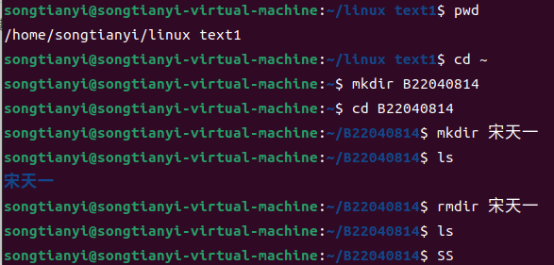

(2) File operation

Enter the following commands in sequence:

$pwd

$cd ~

$mkdir your_studentID

$cd your_studentID

$mkdir your_name

$ls

$rmdir your_name

$ls

$cd ~

$touch yourname.txt

$ls

$echo "hello world" > yourname.txt

$cat yourname.txt

$cp yourname.txt yourname2.txt

$mv yourname.txt yourstudentid.txt

$ls

Save a screenshot of the above command along with the corresponding results, you must have

your student number and name.

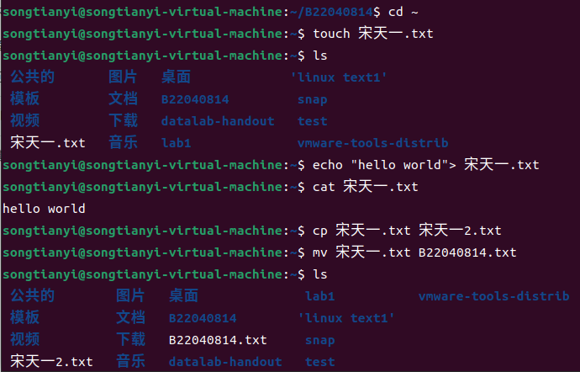

(3)User Management

Enter the following commands in sequence:

$whoami

$sudo su root

Enter the password of the current logged-in user, not the root password, and then enter:

#groupadd student

#whoami

#adduser yourstudentID

#usermod -g student yourstudentID

Follow the prompts to create the user and add the user to the student group.

Switch to the user.

#su yourstudentID

$cd ~

$touch yourname.txt

$ls -l

View the properties of the file, including the owner user and the group to which the owner user

belongs.

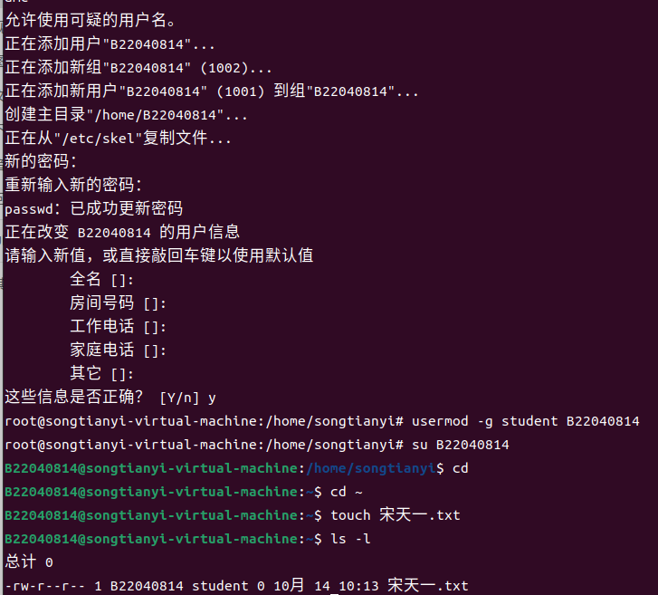

(4) Permission management

Enter the following commands in sequence:

$ touch demo

$ chmod 777 demo

$ chmod a-x demo # result is rw-rw-rw-

$ chmod go-w demo # result is rw-r--r--

$ chmod g+w demo # result is rw-rw-r--

$ chmod a= demo # result is ---------

$ chmod +t demo # result is --------T

$ chmod u+s demo # result is --S-----T

$ chmod u+rx demo # result is r-s-----T

$ chmod g+rws demo # result is r-srwS--T

After entering each line, run ls -l demo to view the result.

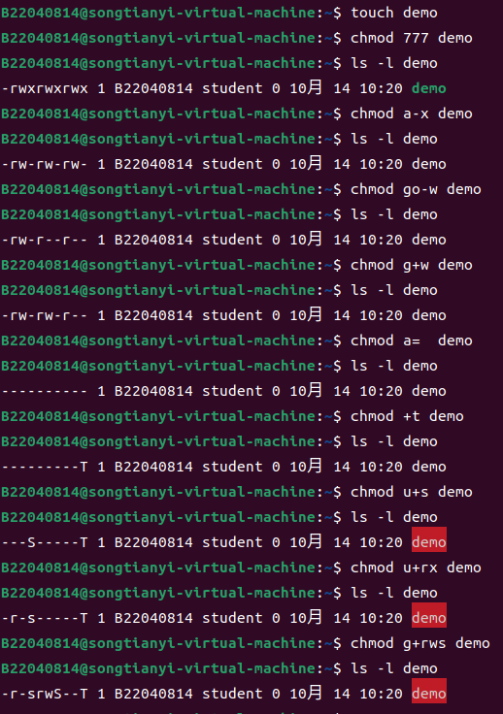

###(5) Other management

Create folder "others" in the main directory of the user, go to the folder, and create two files with

the name of any file. Then run the following commands in sequence.

$tar -czvf backup.tar.gz others

$ls -l

$tar -xzvf backup.tar.gz

$ls -l

Observe changes in the process.

Create a textfile file and make it as follows:

no, I study in njupt.

this line ends with 00

this line ends with .00

I am 25 years old.

He is 15. It is 16.00

wy is the short of my name.

Search for all lines beginning with the character "n" in the file textfile

$ grep ‘^n' textfile

Search the textfile for all lines ending in ".00"

$ grep '\.00$' textfile

Search for all lines in the textfile that contain the number 5, followed by the character ".", followed

by any character

$ grep '5\..' textfile

Search for all lines starting with the characters "w" and "y" in the file textfile

$ grep ‘^[wy]’textfile

