1. Obtain the system time, and check whether it is in the morning, afternoon, or evening.

#!/bin/bash

hour = `date +%H`

case $hour in

0[1-9] | 1[01] )

echo "Good morining !!"

;;

1[234567] )

echo "Good afternoon !!"

;;

\* )

echo "Good evening !! "

;;

Esac

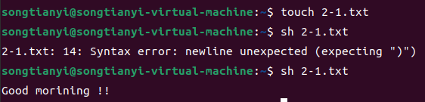

2. Input two number, check which one is greater, and output the result.

#!/bin/sh

echo "Enter the first integer:"

read first

echo "Enter the second integer:"

read second

if [ "$first" -gt "$second" ]

then

echo "$first is greater than $second"

elif [ "$first" -lt "$second" ]

then

echo "$FIRST is less than $second"

else

echo "$FIRST is equal to $second"

Fi

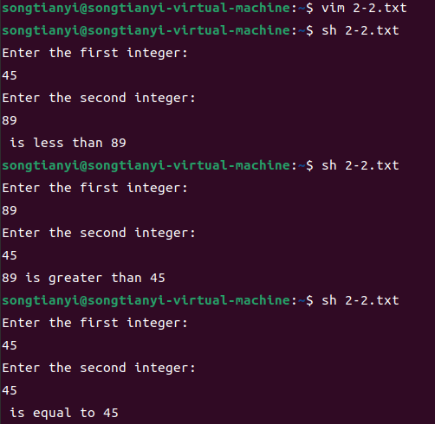

3. Find the minimal value in a given list.

#!/bin/bash

smallest=10000

for i in 8 2 18 0 -3 87

do

if test $i -lt $smallest

then

smallest=$i

fi

done

echo $smallest

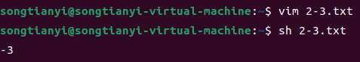

4. Calculate the number of executive file in the current

directory.

#!/bin/bash

count=0

for i in \*

do

if test -x $i

then

count=`expr $count + 1`

fi

done

echo Total of $count files executable

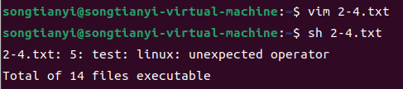

5. Check whether a given number is a prime, you have to

write a function, and call the function.

prime( )

{

flag=1

j=2

while [ $j -le `expr $1 / 2` ]

do

if [ `expr $1 % $j` -eq 0 ]

then

flag=0

break

fi

j=`expr $j + 1`

done

if [ $flag -eq 1 ]

then

return 1

else

return 0

fi

}

prime $1

if [ $? -eq 1 ]

then

echo "$1 is a prime!"

else

echo "$1 is not a prime!"

Fi