Stock Market Analysis and Prediction
Sujith S, Vedha Vishal K, Tharun Kumar V
Department of Mathematics, School of Advanced Sciences, Vellore Institute of Technology, Vellore, Tamil Nadu, India.
Guided By: Dr. Prashanta Kumar Mandal ( prashanta.mandal@vit.ac.in )

Abstract—This project represents a framework for stock market analysis and prediction by integrating traditional financial techniques with machine learning, deep learning and reinforcement learning models. This system uses real time and historical stock data to analyze trends, volatility and price movements using models such as Linear Regression, Logistic Regression, Random Forest, Support Vector Machine (SVM), XGBoost, LightGBM, Artificial Neural Networks (ANN), Recurrent Neural Networks (RNN), Long Short-Term Memory (LSTM), Gated Recurrent Units (GRU), Transformer Models, ARCH / GARCH, ARIMA, SARIMA, Prophet model, Kalman Filter, Deep Q-Network (DQN), Proximal Policy Optimization (PPO), A2C (Advantage Actor-Critic), Stacking (Ensemble of ML models), CNN + LSTM model and many more. The goal of the project is to compare and evaluate the performance of these models to identify which approach yield the most accurate result and reliable forecasts. By combining statistical forecasting analysis with AI techniques, this project provides a predictive system that support data-driven investment, decision-making and offers key points for market dynamics, volatility patterns and potential trading strategies.
Keywords—Stock Market Analysis, Machine Learning, Deep Learning, Time Series Forecasting, ANN, RNN, SVM, GRU, Financial Prediction, ARIMA, LSTM, Prophet, GARCH, Reinforcement Learning, Price Forecasting, Data Analytics, Trading Strategy.

Introduction
The Stock Market represents the dynamic and unpredictable component in the global economy, powered by combination of economic indicators, corporate performance, geopolitical events, investor sentiment etc. Predicting stock prices have been a long, complex challenge due to its market’s inherently volatile, non-linear nature and several other factors. The rise of data-driven technologies and availability of high-frequency trading data. The machine learning and deep learning have become the most powerful tools for modelling and forecasting market behaviour.
This project focuses on developing a unified framework that applies multiple analytical approaches to understand and predict stock market trends. By combining traditional financial analysis techniques such as fundamental and technical analysis with artificial intelligence models like machine learning, deep learning, time-series forecasting and reinforcement learning. The system aims to deliver predictive reports.
Each model contributes a unique strength to the project: traditional regression and ensemble models captures general market trends where as deep learning architectures like LSTM and GRU identifies temporal dependencies and long-term relationships. Time-series models like ARIMA and Prophet are used to handle seasonality and trend components, and reinforcement learning agents simulate trading strategies to optimize decision-making in the project.
By evaluating and comparing the results across all these diverse models, The project identifies the most effective forecasting techniques for stock price prediction. The outcome provides investors, analysts, and researchers with a approach to anticipate market movements, manage risk, and enhance investment strategies in the complex financial environment.

Methodology

Literature Review
No. | Reference | Year | Source / Type
[1] | Masini, R. P., Medeiros, M., & Mendes, E. F. Machine Learning advances for Time Series Forecasting. Journal of Economic Surveys, 37(1), 76–111. | 2023 | Journal Article
[2] | Pedregosa, F., et al. Scikit-learn: Machine Learning in Python. Journal of Machine Learning Research, 12, 2825–2830. | 2011 | Journal Article
[3] | Financial Time Series Models—Comprehensive Review of Deep Learning Approaches and Practical Recommendations. Eng. Proc., 39(1), 79. | 2023 | Conference Proceedings
[4] | Jaiswal, C. Machine Learning for Financial Forecasting. International Journal of Scientific Research in Science, Engineering and Technology, 10(1), 426–439. | 2023 | Journal Article
[5] | Szydłowski, K. Ł. & Chudziak, J. A. Hidformer: Transformer-Style Neural Network in Stock Price Forecasting. arXiv preprint. | 2024 | arXiv Preprint
[6] | Bisdoulis, K.-L. Assets Forecasting with Feature Engineering and Transformation Methods for LightGBM. arXiv preprint. | 2024 | arXiv Preprint
[7] | Bui, N. K. H. Transformer Encoder and Multi-features Time2Vec for Financial Forecasting. arXiv preprint. | 2025 | arXiv Preprint

Data Collection
The data for the project is collected from two reliable financial data sources — Yahoo Finance (yfinance) and Alpha Vantage API. The yfinance library is used to fetch historical and real-time stock data, including key indicators like Open, High, Low, Close, Adjusted Close and Volume enabling us to perform time-series forecasting and trend analysis. Additionally the Alpha Vantage API provides authenticated access to a whole bunch of financial dataset including technical indicators like RSI, MACD, and SMA along with real-time stock updates. By combining data from both sources. This project ensures that data is accurate and consistent which are suitable for the training of predictive models and to perform in depth stock market analysis.

Data Preprocessing
The dataset obtained from Yahoo Finance and Alpha Vantage is first cleaned and structured for modeling. The Missing values are removed using the dropna() function to ensure that the data is consistent. The Date column extracted from the index and a new feature called Day is created to represent the time progression numerically. The main variable of interest Close price is isolated for forecasting forming the core of the target data. The cleaned dataset is divided into training and testing data using an 80-20 ratio using train_test_split() from Scikit-learn library to ensure that the data is unbiased in evaluation. Additionally the scaling techniques like MinMaxScaler or StandardScaler are available for normalizing the numerical features, improving model performance and convergence during training the model. This preprocessing pipeline ensures that the data is consistent, numerical and well-structured for both machine learning and deep learning forecasting models.

Forecasting Model

The forecasting model combines multiple analytical techniques such as traditional analysis, machine learning, deep learning, time-series forecasting and reinforcement learning to predict stock price movements. Each model contributes a unique perspective, capturing the patterns, trends and the market volatility. Traditional methods provides the insights based on financial indicators and technical trends where as machine and deep learning models identify complex nonlinear relationships between historical data. The Time-series models handles the temporal dependencies and seasonality very easily, and the reinforcement learning model simulates trading strategies for dynamic decision-making. The final decision is retrieved from the collection of output from all the models providing a balanced recommendation that adopts to changing market conditions.

Data Preview
From Yahoo Finance (yfinance)

Date | Open | High | Low | Close | Adj Close | Volume
2025-01-02 | 140.55 | 142.10 | 139.80 | 141.75 | 141.75 | 35,482,300
2025-01-03 | 141.90 | 143.25 | 140.45 | 142.95 | 142.95 | 33,217,800
2025-01-06 | 143.10 | 145.60 | 142.75 | 145.20 | 145.20 | 40,352,100
2025-01-07 | 145.50 | 146.80 | 144.90 | 146.25 | 146.25 | 31,785,400
2025-01-08 | 146.40 | 147.10 | 145.30 | 145.75 | 145.75 | 29,546,200

From Alpha Vantage API

Date | Open | High | Low | Close | Volume
2025-01-02 | 140.50 | 142.05 | 139.75 | 141.70 | 35,480,000
2025-01-03 | 141.85 | 143.20 | 140.40 | 142.90 | 33,210,500
2025-01-06 | 143.05 | 145.55 | 142.70 | 145.15 | 40,350,200
2025-01-07 | 145.45 | 146.75 | 144.85 | 146.20 | 31,780,300
2025-01-08 | 146.35 | 147.05 | 145.25 | 145.70 | 29,540,800

Code Implementation and Visualization
Work Flow:

Fetching Stock Data based on User preference

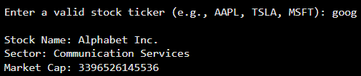

Fundamental Analysis

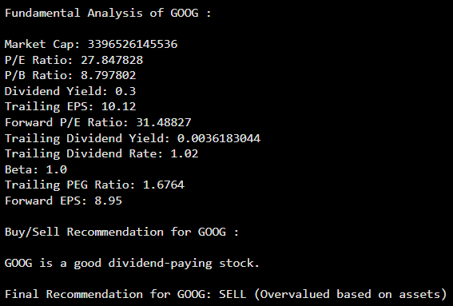

Technical Analysis
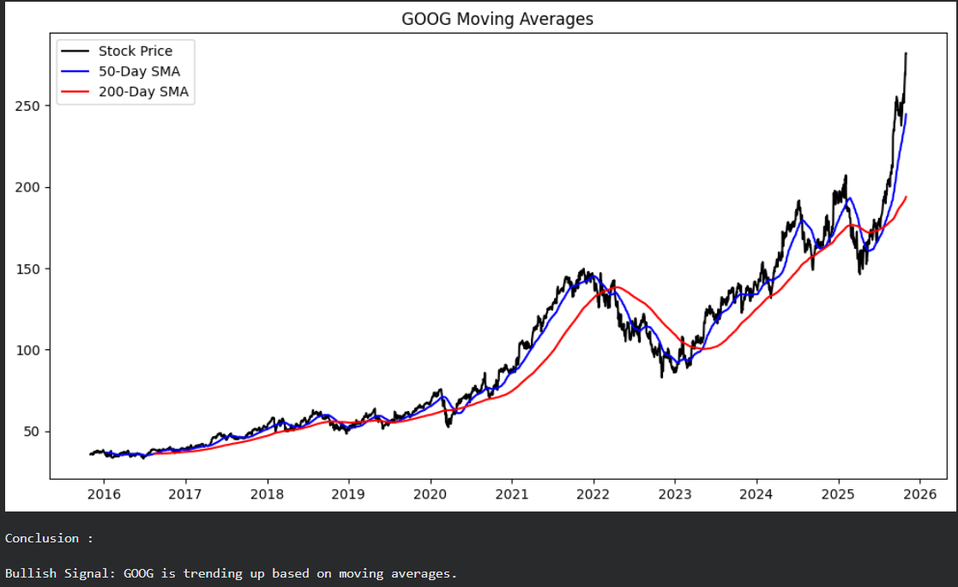

Random Forest Regressor & Classifier
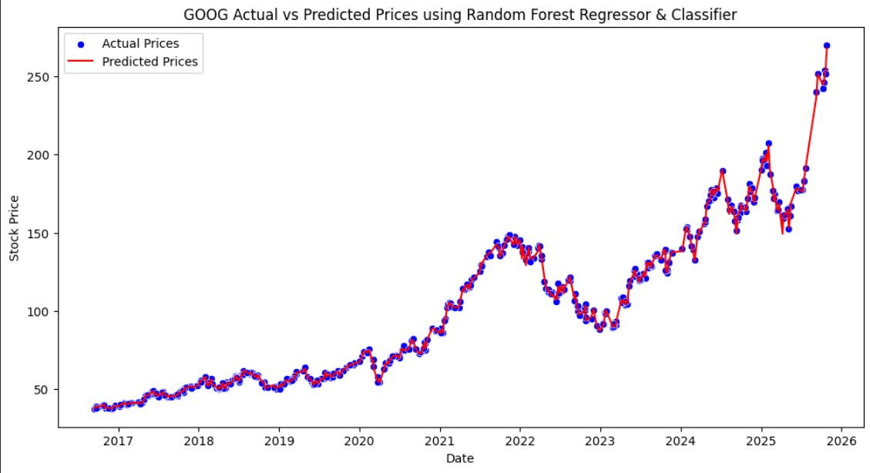

Recurrent Neural Networks (RNNs)
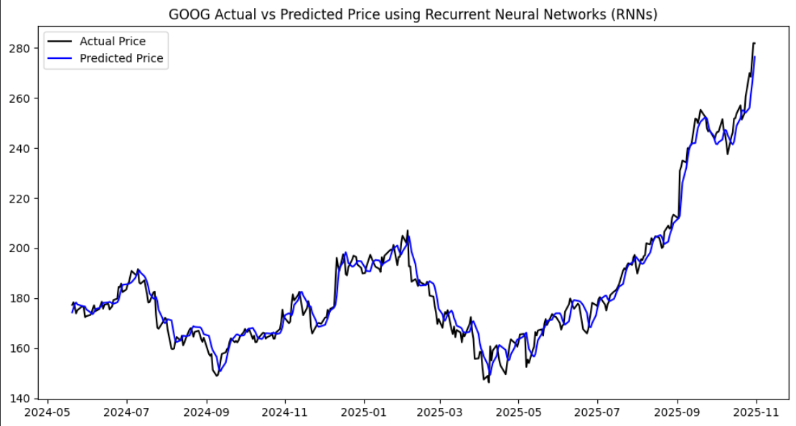

Kalman Filter
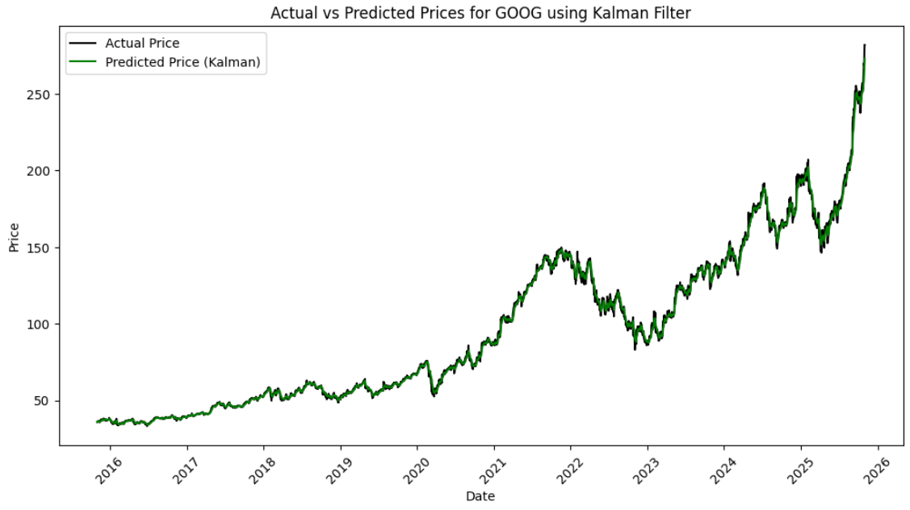

Deep Q-Network
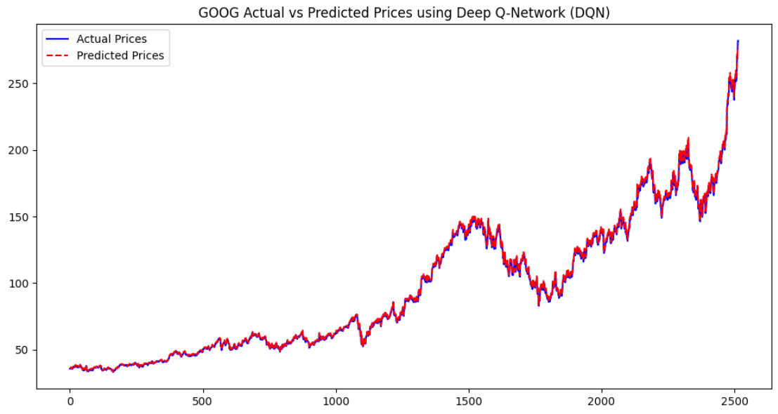

CNN+LSTM
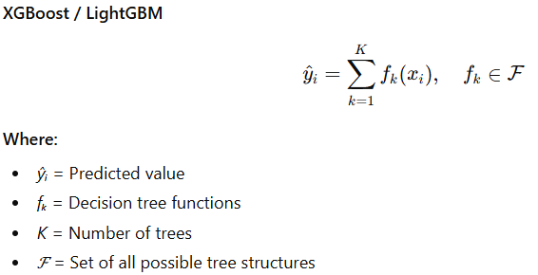
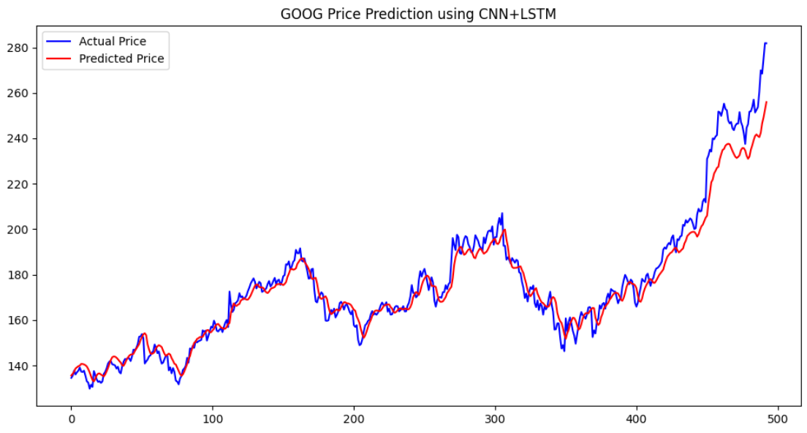

Equation
Traditional Analysis

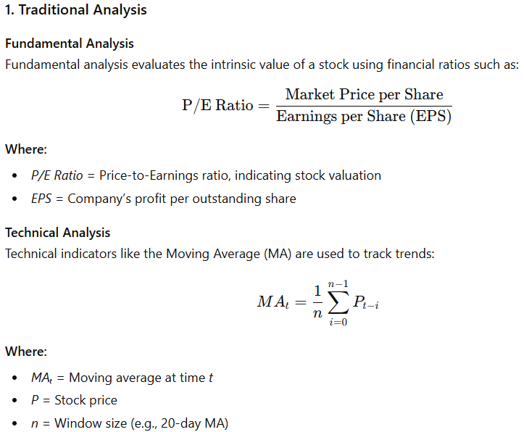

Machine Learning Models

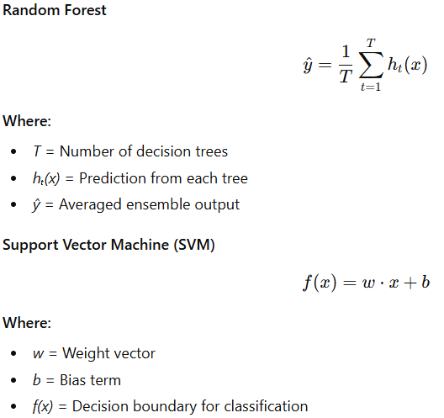
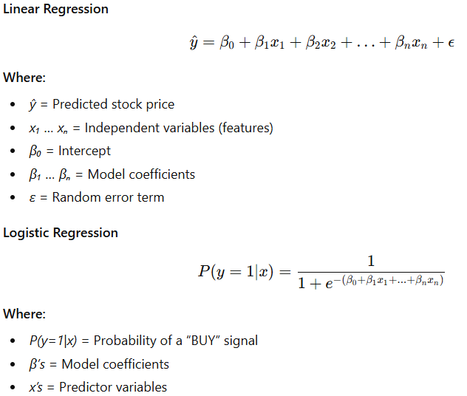

Deep Learning Models
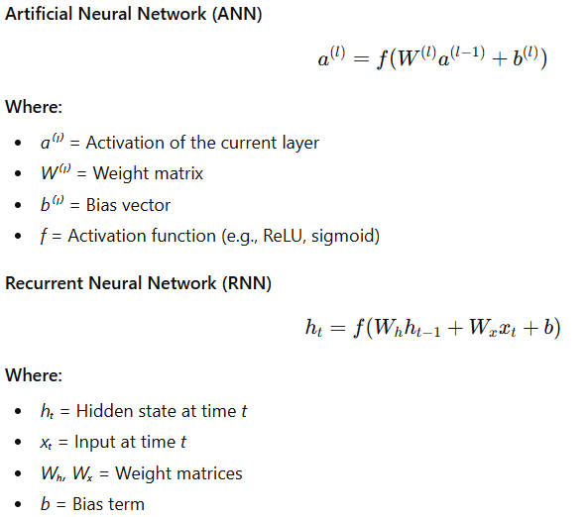
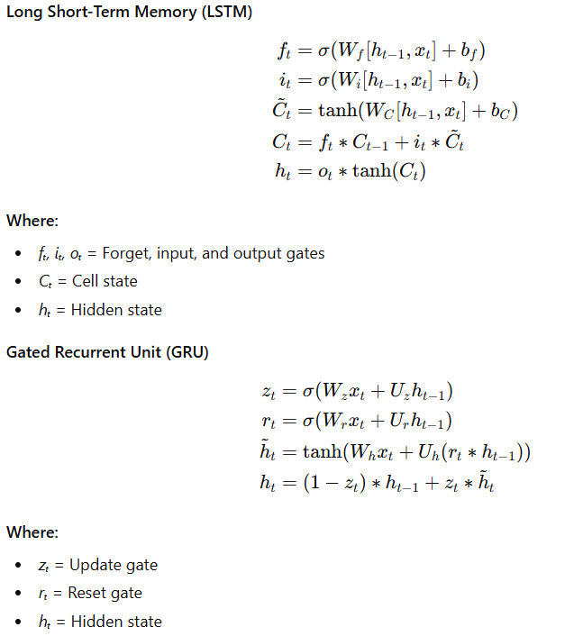

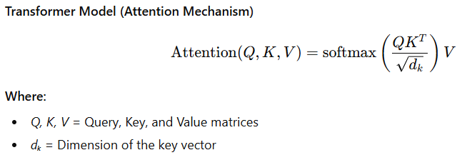

Time Series Forecasting

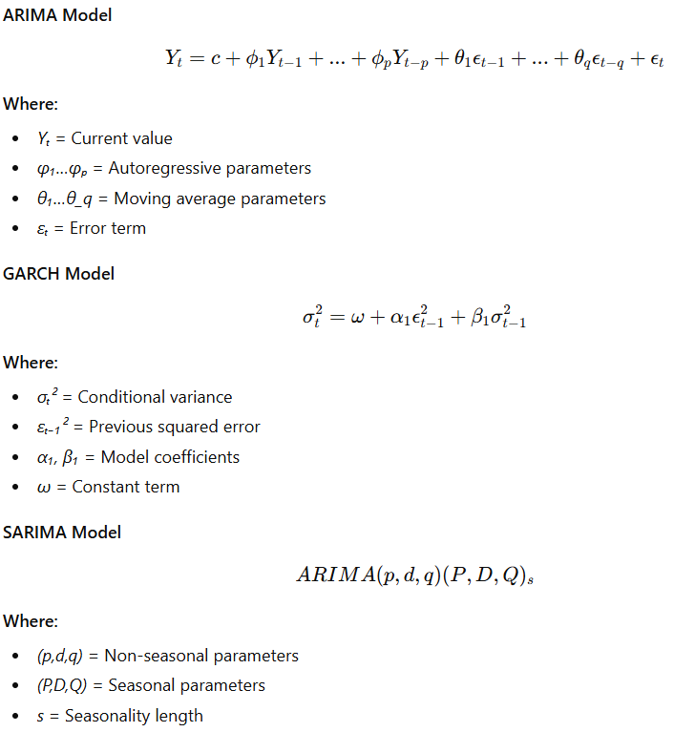

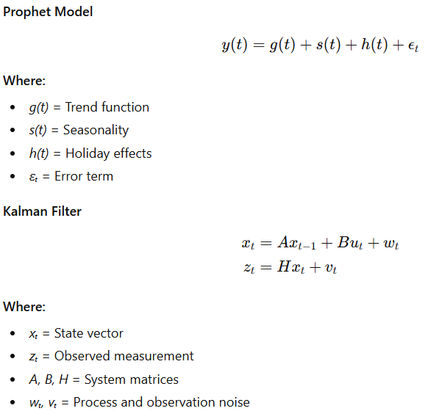

Reinforcement Learning Models
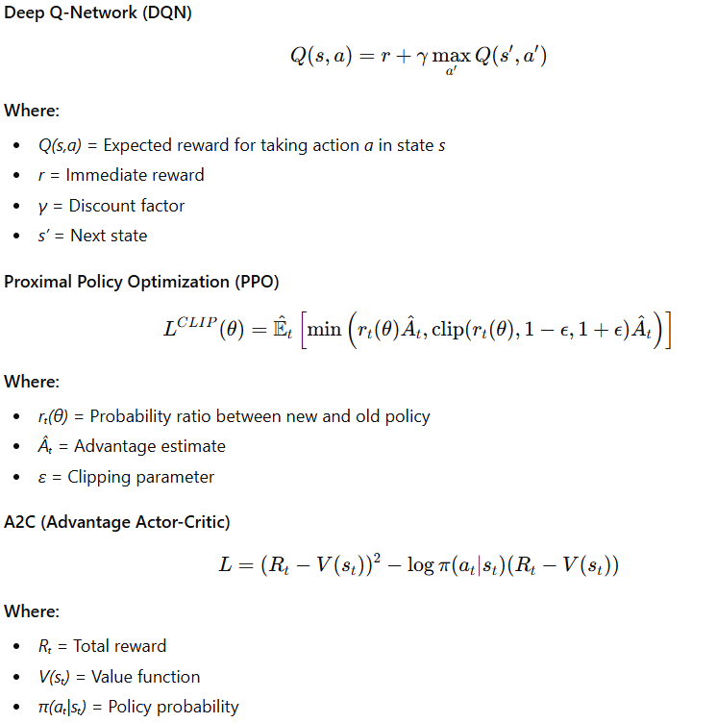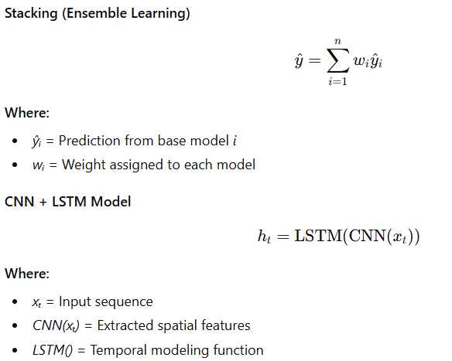

Result and Discussion
The forecasting results were derived from a combination of traditional, machine learning, deep learning, time-series, and reinforcement learning models applied to the GOOG (Alphabet Inc.) stock data. Each model independently generated a recommendation—Buy, Sell, or Hold—based on its analytical interpretation of historical trends, technical indicators, and forecasted patterns.

The majority of models, including Fundamental Analysis, Random Forest, LSTM, ARIMA, and XGBoost, indicated a Sell signal, suggesting bearish sentiment and potential downside risk. Only a small subset, such as Technical Analysis and a few reinforcement learning models like PPO, leaned toward a Buy recommendation, signaling limited short-term growth potential.

This strong consensus across most predictive models highlights the market’s cautious outlook on GOOG’s near-term performance. The consistent “Sell” sentiment implies possible overvaluation, weakened momentum, or unfavorable market indicators. However, it’s important to note that market dynamics are highly volatile and model-based predictions can shift rapidly with new data or economic events.
Overall, the integrated model ensemble collectively favors a Sell recommendation, Warning : This is not a financial advice we suggest investors should conduct their own research before entering new positions in the stock.

Conclusion

Analysis / Model | Recommendation
Fundamental Analysis | SELL
Technical Analysis | BUY
Time Series Forecasting | SELL
Linear Regression | SELL
Logistic Regression | SELL
Random Forest Regression & Classifier | SELL
Support Vector Machine (SVM) | SELL
XGBoost & LightGBM | SELL
Artificial Neural Networks (ANN) | SELL
Recurrent Neural Networks (RNN) | SELL
Long Short-Term Memory (LSTM) | SELL
Gated Recurrent Units (GRU) | SELL
Transformer Models | SELL
SARIMA Model | SELL
Prophet | SELL
Kalman Filter | SELL
Deep Q-Network (DQN) | SELL
Proximal Policy Optimization (PPO) | BUY
A2C (Advantage Actor-Critic) | SELL
Stacking Ensemble | SELL
CNN + LSTM | SELL
Metric | Value
Total BUY recommendations | 2
Total SELL recommendations | 19
Total HOLD recommendations | 0
Total Models used | 21
Decision Type | Probability
BUY | 9.52%
SELL | 90.48%
HOLD | 0.00%

Final Output from Project

The stock market analysis works on comprehensive set of analytical, machine learning, deep learning, time-series, and reinforcement learning models to evaluate the performance and future trends of GOOG stock. By combining all these diverse methodologies, this study achieved a great understanding of both short-term price movements and long-term market patterns. The collective output of all models indicated a dominant Sell recommendation, suggesting that current market signals reflect a potential downward trend or limited growth opportunity. This outcome describes the importance of integrating multiple analytical perspectives for more reliable predictions. Overall, the study demonstrates that hybrid modeling approaches can provide a one of the great framework for informed investment decision-making, though results should always be re-evaluated as new data becomes available.

References

- He, K., Yang, Q., Ji, L., Pan, J., & Zou, Y. (2023). Financial Time Series Forecasting with the Deep Learning Ensemble Model. Mathematics, 11(4), 1054.
- Sarlakifar, F. (2025). A Deep Reinforcement Learning Approach to Automated Stock Trading using xLSTM Networks (arXiv preprint).
- Cheridito, P. (2025). Reinforcement Learning for Trade Execution with Market Microstructure (arXiv preprint).
- ResearchGate (2025). Deep learning for time series forecasting: a survey (2025 review).
- Hong, Y. (2025). A Multi-layer Hybrid Multi-Task Learning Framework for Stock Prediction (arXiv).
- Lan, Q.-Y. (2025). News-Aware Direct Reinforcement Trading for Financial Markets (arXiv).
- Tu, T. (2025). CNN-Transformer Hybrid for Short- and Long-Term Dependencies in Finance (arXiv).
- Sonkavde, G., Dharrao, D. S., Bongale, A. M., Deokate, S. T., Doreswamy, D., & Bhat, S. K. (2023). Forecasting Stock Market Prices Using Machine Learning and Deep Learning Models: A Systematic Review, Performance Analysis and Discussion of Implications. International Journal of Financial Studies, 11(3), 94.
- Ke, G., et al. (2017). LightGBM: A Highly Efficient Gradient Boosting Decision Tree. Advances in Neural Information Processing Systems.
- Chen, T., & Guestrin, C. (2016). XGBoost: A Scalable Tree Boosting System. Proceedings of the 22nd ACM SIGKDD International Conference on Knowledge Discovery and Data Mining.
- Iyanuoluwa Ajiga, D., Adeleye, R. A., Tubokirifuruar, T. S., Bello, B. G., Ndubuisi, L. N., & Asuzu, O. F. (2024). Machine Learning for Stock Market Forecasting: A Review of Models and Accuracy. Finance & Accounting Research Journal, 6(2).
- ResearchGate (2025). Deep learning for time series forecasting: a survey (2025 review). (ResearchGate).
- Montazeri, S. (2025). Finding Optimal Trading History in Reinforcement Learning for Stock Market Trading (arXiv). (arXiv).
- Oyewola, D. O. (2025). Stock market prediction with optimized PLSTM-AL in smart systems (ScienceDirect article). (sciencedirect.com)

