Stock Market Analysis and Prediction
Sujith S, Vedha Vishal K, Tharun Kumar V
Department of Mathematics, School of Advanced Sciences, Vellore Institute of Technology, Vellore, Tamil Nadu, India.
Guided By: Dr. Prashanta Kumar Mandal ( prashanta.mandal@vit.ac.in )

Abstract—This project represents a framework for stock market analysis and prediction by integrating traditional financial techniques with machine learning, deep learning and reinforcement learning models. This system uses real time and historical stock data to analyze trends, volatility and price movements using models such as Linear Regression, Logistic Regression, Random Forest, Support Vector Machine (SVM), XGBoost, LightGBM, Artificial Neural Networks (ANN), Recurrent Neural Networks (RNN), Long Short-Term Memory (LSTM), Gated Recurrent Units (GRU), Transformer Models, ARCH / GARCH, ARIMA, SARIMA, Prophet model, Kalman Filter, Deep Q-Network (DQN), Proximal Policy Optimization (PPO), A2C (Advantage Actor-Critic), Stacking (Ensemble of ML models), CNN + LSTM model and many more. The goal of the project is to compare and evaluate the performance of these models to identify which approach yield the most accurate result and reliable forecasts. By combining statistical forecasting analysis with AI techniques, this project provides a predictive system that support data-driven investment, decision-making and offers key points for market dynamics, volatility patterns and potential trading strategies.
Keywords—Stock Market Analysis, Machine Learning, Deep Learning, Time Series Forecasting, ANN, RNN, SVM, GRU, Financial Prediction, ARIMA, LSTM, Prophet, GARCH, Reinforcement Learning, Price Forecasting, Data Analytics, Trading Strategy.

Introduction
The Stock Market represents the dynamic and unpredictable component in the global economy, powered by combination of economic indicators, corporate performance, geopolitical events, investor sentiment etc. Predicting stock prices have been a long, complex challenge due to its market’s inherently volatile, non-linear nature and several other factors. The rise of data-driven technologies and availability of high-frequency trading data. The machine learning and deep learning have become the most powerful tools for modelling and forecasting market behaviour.
This project focuses on developing a unified framework that applies multiple analytical approaches to understand and predict stock market trends. By combining traditional financial analysis techniques such as fundamental and technical analysis with artificial intelligence models like machine learning, deep learning, time-series forecasting and reinforcement learning. The system aims to deliver predictive reports.
Each model contributes a unique strength to the project: traditional regression and ensemble models captures general market trends where as deep learning architectures like LSTM and GRU identifies temporal dependencies and long-term relationships. Time-series models like ARIMA and Prophet are used to handle seasonality and trend components, and reinforcement learning agents simulate trading strategies to optimize decision-making in the project.
By evaluating and comparing the results across all these diverse models, The project identifies the most effective forecasting techniques for stock price prediction. The outcome provides investors, analysts, and researchers with a approach to anticipate market movements, manage risk, and enhance investment strategies in the complex financial environment.

Methodology

Literature Review

No. | Reference | Year | Source / Type
1 | Masini, R. P., Medeiros, M., & Mendes, E. F. Machine Learning advances for Time Series Forecasting. Journal of Economic Surveys, 37(1), 76–111. | 2023 | Journal Article
2 | Pedregosa, F., et al. Scikit-learn: Machine Learning in Python. Journal of Machine Learning Research, 12, 2825–2830. | 2011 | Journal Article
3 | Financial Time Series Models—Comprehensive Review of Deep Learning Approaches and Practical Recommendations. Eng. Proc., 39(1), 79. | 2023 | Conference Proceedings
4 | Jaiswal, C. Machine Learning for Financial Forecasting. International Journal of Scientific Research in Science, Engineering and Technology, 10(1), 426–439. | 2023 | Journal Article
5 | Szydłowski, K. L., & Chudziaj, J. A. Hidformer: Transformer-Style Neural Network in Stock Price Forecasting. | 2024 | arXiv Preprint
6 | Bisdoulis, K.-L. Assets Forecasting with Feature Engineering and Transformation Methods for LightGBM. | 2024 | arXiv Preprint
7 | Bui, N. K. H. Transformer Encoder and Multi-features Time2Vec for Financial Forecasting. | 2025 | arXiv Preprint
8 | He, K., Yang, Q., Ji, L., Pan, J., & Zou, Y. Financial Time Series Forecasting with the Deep Learning Ensemble Model. Mathematics, 11(4), 1054. | 2023 | Journal Article
9 | Sonkavde, G., et al. Forecasting Stock Market Prices Using Machine Learning and Deep Learning Models: A Systematic Review. International Journal of Financial Studies, 11(3), 94. | 2023 | Journal Article
10 | Iyanuoluwa Ajiga, D., et al. Machine Learning for Stock Market Forecasting: A Review of Models and Accuracy. Finance & Accounting Research Journal, 6(2). | 2024 | Journal Article
11 | ResearchGate. Deep Learning for Time Series Forecasting: A Survey (2025 Review). | 2025 | Survey Article
12 | ResearchGate. Deep Learning for Time Series Forecasting: A Survey (2025 Review). | 2025 | Survey Article
13 | Montazeri, S. Finding Optimal Trading History in Reinforcement Learning for Stock Market Trading. | 2025 | arXiv Preprint
14 | Oyewola, D. O. Stock Market Prediction with Optimized PLSTM-AL in Smart Systems. | 2025 | Journal Article (ScienceDirect)
15 | Sarlakifar, F. A Deep Reinforcement Learning Approach to Automated Stock Trading using xLSTM Networks. | 2025 | arXiv Preprint
16 | Cheridito, P. Reinforcement Learning for Trade Execution with Market Microstructure. | 2025 | arXiv Preprint
17 | Hong, Y. A Multi-layer Hybrid Multi-Task Learning Framework for Stock Prediction. | 2025 | arXiv Preprint
18 | Lan, Q.-Y. News-Aware Direct Reinforcement Trading for Financial Markets. | 2025 | arXiv Preprint
19 | Tu, T. CNN-Transformer Hybrid for Short- and Long-Term Dependencies in Finance. | 2025 | arXiv Preprint
20 | Ke, G., et al. LightGBM: A Highly Efficient Gradient Boosting Decision Tree. NeurIPS. | 2017 | Conference Paper
21 | Chen, T., & Guestrin, C. XGBoost: A Scalable Tree Boosting System. ACM SIGKDD. | 2016 | Conference Paper

Data Collection
The data for the project is collected from two reliable financial data sources — Yahoo Finance (yfinance) and Alpha Vantage API. The yfinance library is used to fetch historical and real-time stock data, including key indicators like Open, High, Low, Close, Adjusted Close and Volume enabling us to perform time-series forecasting and trend analysis. Additionally the Alpha Vantage API provides authenticated access to a whole bunch of financial dataset including technical indicators like RSI, MACD, and SMA along with real-time stock updates. By combining data from both sources. This project ensures that data is accurate and consistent which are suitable for the training of predictive models and to perform in depth stock market analysis.

Data Preprocessing
The dataset obtained from Yahoo Finance and Alpha Vantage is first cleaned and structured for modeling. The Missing values are removed using the dropna() function to ensure that the data is consistent. The Date column extracted from the index and a new feature called Day is created to represent the time progression numerically. The main variable of interest Close price is isolated for forecasting forming the core of the target data. The cleaned dataset is divided into training and testing data using an 80-20 ratio using train_test_split() from Scikit-learn library to ensure that the data is unbiased in evaluation. Additionally the scaling techniques like MinMaxScaler or StandardScaler are available for normalizing the numerical features, improving model performance and convergence during training the model. This preprocessing pipeline ensures that the data is consistent, numerical and well-structured for both machine learning and deep learning forecasting models.

Forecasting Model

The forecasting model combines multiple analytical techniques such as traditional analysis, machine learning, deep learning, time-series forecasting and reinforcement learning to predict stock price movements. Each model contributes a unique perspective, capturing the patterns, trends and the market volatility. Traditional methods provides the insights based on financial indicators and technical trends where as machine and deep learning models identify complex nonlinear relationships between historical data. The Time-series models handles the temporal dependencies and seasonality very easily, and the reinforcement learning model simulates trading strategies for dynamic decision-making. The final decision is retrieved from the collection of output from all the models providing a balanced recommendation that adopts to changing market conditions.

Data Preview
From Yahoo Finance (yfinance)

Date | Open | High | Low | Close | Adj Close | Volume
2025-01-02 | 140.55 | 142.10 | 139.80 | 141.75 | 141.75 | 35,482,300
2025-01-03 | 141.90 | 143.25 | 140.45 | 142.95 | 142.95 | 33,217,800
2025-01-06 | 143.10 | 145.60 | 142.75 | 145.20 | 145.20 | 40,352,100
2025-01-07 | 145.50 | 146.80 | 144.90 | 146.25 | 146.25 | 31,785,400
2025-01-08 | 146.40 | 147.10 | 145.30 | 145.75 | 145.75 | 29,546,200

From Alpha Vantage API

Date | Open | High | Low | Close | Volume
2025-01-02 | 140.50 | 142.05 | 139.75 | 141.70 | 35,480,000
2025-01-03 | 141.85 | 143.20 | 140.40 | 142.90 | 33,210,500
2025-01-06 | 143.05 | 145.55 | 142.70 | 145.15 | 40,350,200
2025-01-07 | 145.45 | 146.75 | 144.85 | 146.20 | 31,780,300
2025-01-08 | 146.35 | 147.05 | 145.25 | 145.70 | 29,540,800

Code Implementation and Visualization
Work Flow:

Fetching Stock Data based on User preference

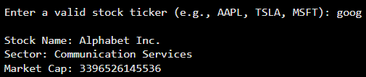

Fundamental Analysis

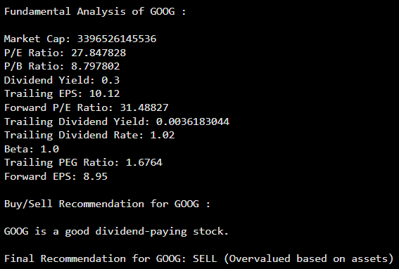

Technical Analysis
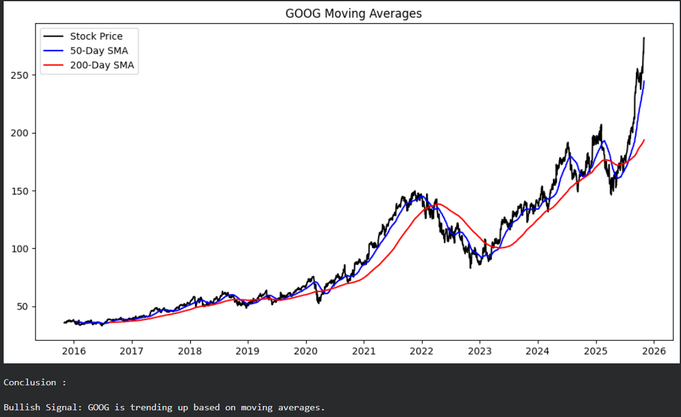

Random Forest Regressor & Classifier
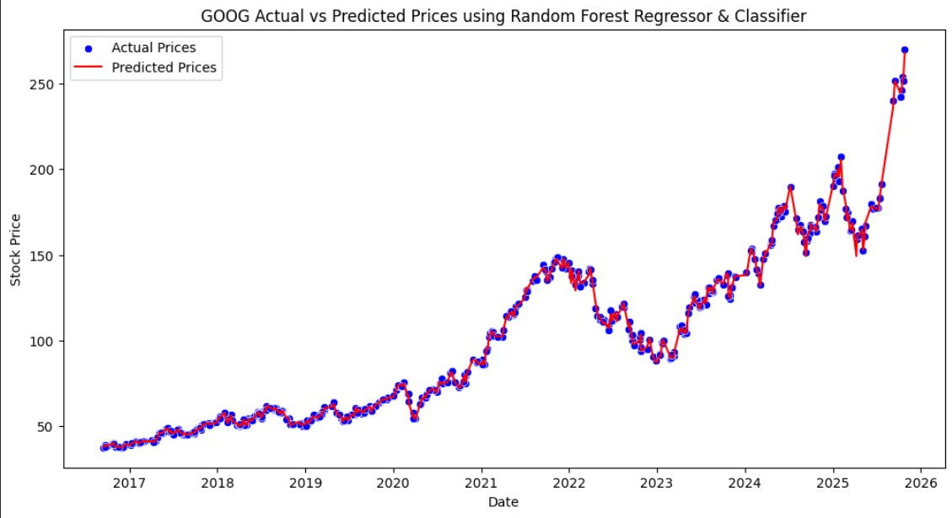

Recurrent Neural Networks (RNNs)
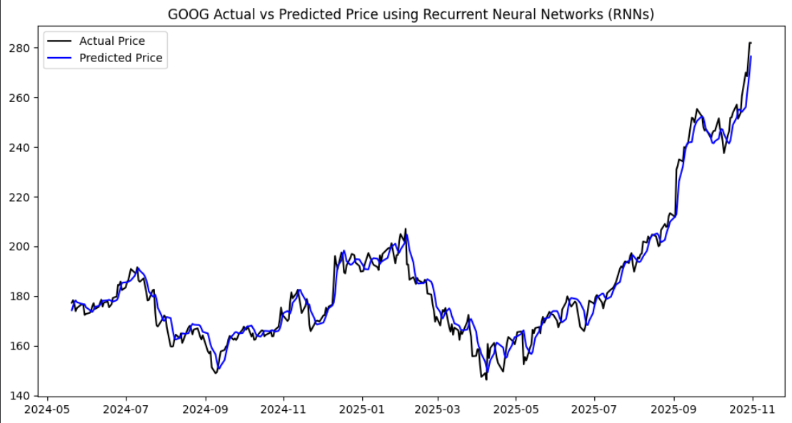
Kalman Filter
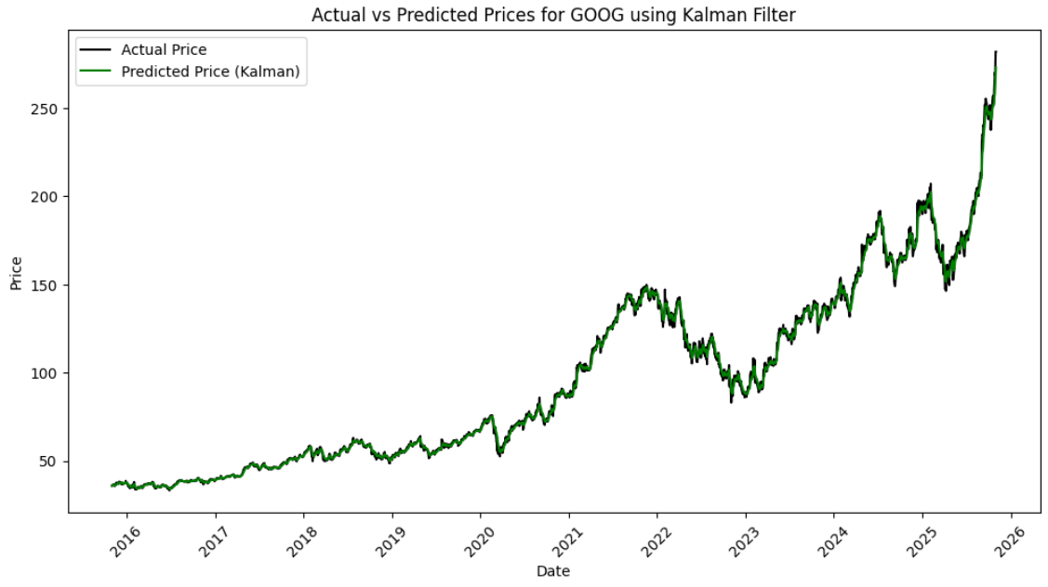

Deep Q-Network
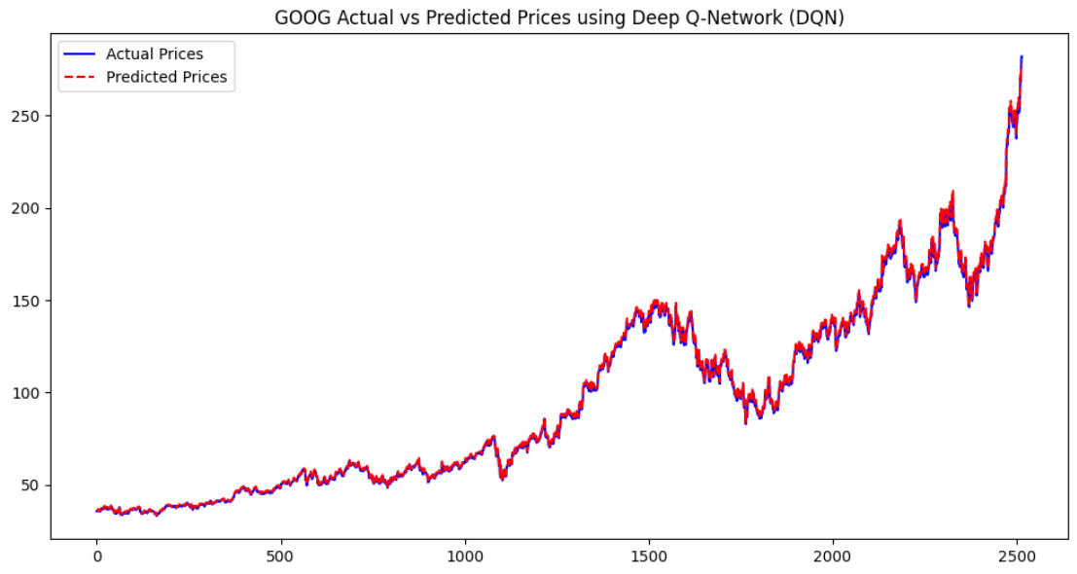

CNN+LSTM
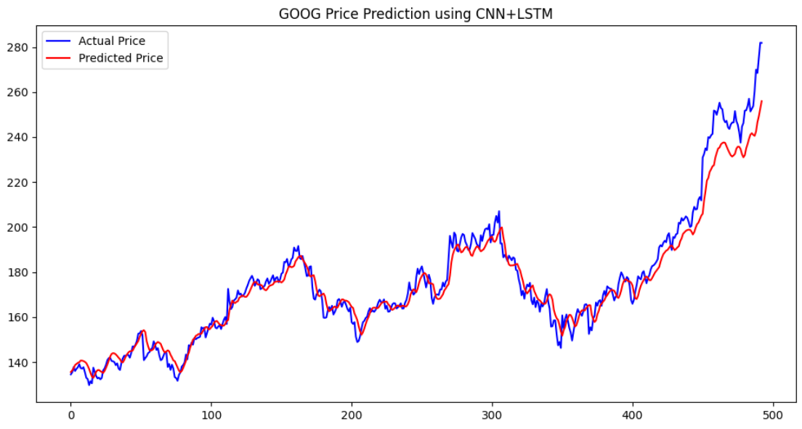

Equation
Traditional Analysis

Fundamental Analysis

Fundamental analysis evaluates the intrinsic value of a stock using financial ratios such as:

P/E Ratio = Market Price per Share / Earnings per Share (EPS)
Where:
P/E Ratio = Price-to-Earnings ratio, indicating stock valuation
EPS = Company’s profit per outstanding share

Technical Analysis

Technical indicators like the Moving Average (MA) are used to track trends:

MA_t = (1/n) Σ(i=0 to n−1) P_(t−i)
Where:
MA_t = Moving average at time t
P = Stock price
n = Window size (e.g., 20-day MA)

Machine Learning Models

Linear Regression
Models stock price as a linear function of input features.

ŷ = β₀ + β₁x₁ + β₂x₂ + … + βₙxₙ + ε
Where:
ŷ = Predicted stock price
x₁ … xₙ = Independent variables (features)
β₀ = Intercept
β₁ … βₙ = Model coefficients
ε = Random error term

Logistic Regression
Predicts buy or sell probability using a logistic function.

P(y=1|x) = 1 / (1 + e^(−(β₀ + β₁x₁ + … + βₙxₙ)))
Where:
P(y=1|x) = Probability of a “BUY” signal
β’s = Model coefficients
x’s = Predictor variables
Random Forest
Combines multiple decision trees to improve prediction accuracy.

ŷ = (1/T) Σ(t=1 to T) h_t(x)
Where:
T = Number of decision trees
h_t(x) = Prediction from each tree
ŷ = Averaged ensemble output

Support Vector Machine (SVM)
Finds an optimal boundary to classify market conditions.

f(x) = w · x + b
Where:
w = Weight vector
b = Bias term
f(x) = Decision boundary for classification

XGBoost / LightGBM
Uses boosted trees to capture complex non-linear patterns.

ŷ_i = Σ(k=1 to K) f_k(x_i), f_k ∈ F
Where:
ŷ_i = Predicted value
f_k = Decision tree functions
K = Number of trees
F = Set of all possible tree structures

Deep Learning Models

Artificial Neural Network (ANN)
Learns non-linear relationships through layered neurons.

a^(l) = f(W^(l) a^(l−1) + b^(l))
Where:
a^(l) = Activation of the current layer
W^(l) = Weight matrix
b^(l) = Bias vector
f = Activation function (e.g., ReLU, sigmoid)

Recurrent Neural Network (RNN)
Captures sequential dependencies in time-series data.

h_t = f(W_h h_(t−1) + W_x x_t + b)
Where:
h_t = Hidden state at time t
x_t = Input at time t
W_h, W_x = Weight matrices
b = Bias term

Long Short-Term Memory (LSTM)
Models long-term trends using gated memory cells.

f_t = σ(W_f [h_(t−1), x_t] + b_f)
i_t = σ(W_i [h_(t−1), x_t] + b_i)
C̃_t = tanh(W_C [h_(t−1), x_t] + b_C)
C_t = f_t * C_(t−1) + i_t * C̃_t
h_t = o_t * tanh(C_t)
Where:
f_t, i_t, o_t = Forget, input, and output gates
C_t = Cell state
h_t = Hidden state

Gated Recurrent Unit (GRU)
Efficiently captures temporal patterns with fewer gates.

z_t = σ(W_z x_t + U_z h_(t−1))
r_t = σ(W_r x_t + U_r h_(t−1))
h̃_t = tanh(W_h x_t + U_h (r_t * h_(t−1)))
h_t = (1 − z_t) * h_(t−1) + z_t * h̃_t
Where:
z_t = Update gate
r_t = Reset gate
h_t = Hidden state

Transformer Model (Attention Mechanism)
Uses self-attention to model long-range dependencies.

Attention(Q, K, V) = softmax((QKᵀ) / √d_k) V
Where:
Q, K, V = Query, Key, and Value matrices
d_k = Dimension of the key vector

Time Series Forecasting

ARIMA Model
Forecasts prices using autoregressive and moving average terms.

Y_t = c + φ₁Y_(t−1) + … + φ_pY_(t−p) + θ₁ε_(t−1) + … + θ_qε_(t−q) + ε_t

Where:
Y_t = Current value
φ₁ … φ_p = Autoregressive parameters
θ₁ … θ_q = Moving average parameters
ε_t = Error term

GARCH Model
Models changing market volatility over time.

σ_t² = ω + α₁ε_(t−1)² + β₁σ_(t−1)²
Where:
σ_t² = Conditional variance
ε_(t−1)² = Previous squared error
α₁, β₁ = Model coefficients
ω = Constant term

SARIMA Model
Captures seasonal patterns in stock data.

ARIMA(p,d,q)(P,D,Q)_s
Where:
(p,d,q) = Non-seasonal parameters
(P,D,Q) = Seasonal parameters
s = Seasonality length

Prophet Model
Decomposes trends, seasonality, and event effects.

y(t) = g(t) + s(t) + h(t) + ε_t
Where:
g(t) = Trend function
s(t) = Seasonality
h(t) = Holiday effects
ε_t = Error term

Kalman Filter
Estimates hidden states from noisy observations.

x_t = A x_(t−1) + B u_t + w_t
z_t = H x_t + v_t
Where:
x_t = State vector
z_t = Observed measurement
A, B, H = System matrices
w_t, v_t = Process and observation noise

Reinforcement Learning Models

Deep Q-Network (DQN)
Learns optimal trading actions via reward maximization.

Q(s,a) = r + γ max_a′ Q(s′, a′)

Where:
Q(s,a) = Expected reward for taking action a in state s
r = Immediate reward
γ = Discount factor
s′ = Next state

Proximal Policy Optimization (PPO)
Stabilizes policy updates during training.

L^CLIP(θ) = Ê_t [ min( r_t(θ) Â_t , clip(r_t(θ), 1−ε, 1+ε) Â_t ) ]
Where:
r_t(θ) = Probability ratio between new and old policy
Â_t = Advantage estimate
ε = Clipping parameter

A2C (Advantage Actor-Critic)
Jointly learns value estimation and policy control.

L = (R_t − V(s_t))² − log π(a_t | s_t) (R_t − V(s_t))
Where:
R_t = Total reward
V(s_t) = Value function
π(a_t | s_t) = Policy probability

Stacking (Ensemble Learning)
Combines multiple model outputs for better prediction.

ŷ = Σ(i=1 to n) w_i ŷ_i
Where:
ŷ_i = Prediction from base model i
w_i = Weight assigned to each model

CNN + LSTM Model
Extracts local features using CNN and models temporal patterns with LSTM.

h_t = LSTM(CNN(x_t))
Where:
x_t = Input sequence
CNN(x_t) = Extracted spatial features
LSTM() = Temporal modeling function

Result and Discussion
The forecasting results were derived from a combination of traditional, machine learning, deep learning, time-series, and reinforcement learning models applied to the GOOG (Alphabet Inc.) stock data. Each model independently generated a recommendation—Buy, Sell, or Hold—based on its analytical interpretation of historical trends, technical indicators, and forecasted patterns.

The majority of models, including Fundamental Analysis, Random Forest, LSTM, ARIMA, and XGBoost, indicated a Sell signal, suggesting bearish sentiment and potential downside risk. Only a small subset, such as Technical Analysis and a few reinforcement learning models like PPO, leaned toward a Buy recommendation, signaling limited short-term growth potential.

This strong consensus across most predictive models highlights the market’s cautious outlook on GOOG’s near-term performance. The consistent “Sell” sentiment implies possible overvaluation, weakened momentum, or unfavorable market indicators. However, it’s important to note that market dynamics are highly volatile and model-based predictions can shift rapidly with new data or economic events.
Overall, the integrated model ensemble collectively favors a Sell recommendation, Warning : This is not a financial advice we suggest investors should conduct their own research before entering new positions in the stock.

Conclusion

Metric | Value
Total BUY recommendations | 2
Total SELL recommendations | 19
Total HOLD recommendations | 0
Total Models used | 21
Decision Type | Probability
BUY | 9.52%
SELL | 90.48%
HOLD | 0.00%
Analysis / Model | Recommendation
Fundamental Analysis | SELL
Technical Analysis | BUY
Time Series Forecasting | SELL
Linear Regression | SELL
Logistic Regression | SELL
Random Forest Regression & Classifier | SELL
Support Vector Machine (SVM) | SELL
XGBoost & LightGBM | SELL
Artificial Neural Networks (ANN) | SELL
Recurrent Neural Networks (RNN) | SELL
Long Short-Term Memory (LSTM) | SELL
Gated Recurrent Units (GRU) | SELL
Transformer Models | SELL
SARIMA Model | SELL
Prophet | SELL
Kalman Filter | SELL
Deep Q-Network (DQN) | SELL
Proximal Policy Optimization (PPO) | BUY
A2C (Advantage Actor-Critic) | SELL
Stacking Ensemble | SELL
CNN + LSTM | SELL
Final Output from Project

The stock market analysis works on comprehensive set of analytical, machine learning, deep learning, time-series, and reinforcement learning models to evaluate the performance and future trends of GOOG stock. By combining all these diverse methodologies, this study achieved a great understanding of both short-term price movements and long-term market patterns. The collective output of all models indicated a dominant Sell recommendation, suggesting that current market signals reflect a potential downward trend or limited growth opportunity. This outcome describes the importance of integrating multiple analytical perspectives for more reliable predictions. Overall, the study demonstrates that hybrid modeling approaches can provide a one of the great framework for informed investment decision-making, though results should always be re-evaluated as new data becomes available.

References

- He, K., Yang, Q., Ji, L., Pan, J., & Zou, Y. (2023). Financial Time Series Forecasting with the Deep Learning Ensemble Model. Mathematics, 11(4), 1054.
- Sarlakifar, F. (2025). A Deep Reinforcement Learning Approach to Automated Stock Trading using xLSTM Networks (arXiv preprint).
- Cheridito, P. (2025). Reinforcement Learning for Trade Execution with Market Microstructure (arXiv preprint).
- ResearchGate (2025). Deep learning for time series forecasting: a survey (2025 review).
- Hong, Y. (2025). A Multi-layer Hybrid Multi-Task Learning Framework for Stock Prediction (arXiv).
- Lan, Q.-Y. (2025). News-Aware Direct Reinforcement Trading for Financial Markets (arXiv).
- Tu, T. (2025). CNN-Transformer Hybrid for Short- and Long-Term Dependencies in Finance (arXiv).
- Sonkavde, G., Dharrao, D. S., Bongale, A. M., Deokate, S. T., Doreswamy, D., & Bhat, S. K. (2023). Forecasting Stock Market Prices Using Machine Learning and Deep Learning Models: A Systematic Review, Performance Analysis and Discussion of Implications. International Journal of Financial Studies, 11(3), 94.
- Ke, G., et al. (2017). LightGBM: A Highly Efficient Gradient Boosting Decision Tree. Advances in Neural Information Processing Systems.
- Chen, T., & Guestrin, C. (2016). XGBoost: A Scalable Tree Boosting System. Proceedings of the 22nd ACM SIGKDD International Conference on Knowledge Discovery and Data Mining.
- Iyanuoluwa Ajiga, D., Adeleye, R. A., Tubokirifuruar, T. S., Bello, B. G., Ndubuisi, L. N., & Asuzu, O. F. (2024). Machine Learning for Stock Market Forecasting: A Review of Models and Accuracy. Finance & Accounting Research Journal, 6(2).
- Masini, R. P., Medeiros, M., & Mendes, E. F. (2023). Machine Learning advances for Time Series Forecasting. Journal of Economic Surveys, 37(1), 76-111.
- Pedregosa, F., et al. (2011). Scikit-learn: Machine Learning in Python. Journal of Machine Learning Research, 12, 2825–2830.
- Eng. Proc. (2023). Financial Time Series Models—Comprehensive Review of Deep Learning Approaches and Practical Recommendations. Eng. Proc., 39(1), 79.
- Jaiswal, C. (2023). Machine Learning for Financial Forecasting. International Journal of Scientific Research in Science, Engineering and Technology, 10(1), 426-439. (PhilPapers)
- Szydłowski, K. Ł. & Chudziak, J. A. (2024). Hidformer: Transformer-Style Neural Network in Stock Price Forecasting. arXiv preprint. (arXiv).
- Bisdoulis, K.-L. (2024). Assets Forecasting with Feature Engineering and Transformation Methods for LightGBM. arXiv preprint. (arXiv).
- Bui, N. K. H. (2025). Transformer Encoder and Multi-features Time2Vec for Financial Forecasting (arXiv preprint). (arXiv).
- ResearchGate (2025). Deep learning for time series forecasting: a survey (2025 review). (ResearchGate).
- Montazeri, S. (2025). Finding Optimal Trading History in Reinforcement Learning for Stock Market Trading (arXiv). (arXiv).
- Oyewola, D. O. (2025). Stock market prediction with optimized PLSTM-AL in smart systems (ScienceDirect article). (sciencedirect.com)

