**MVP for E Commerce Chat Bot**

Features:

* Text based AI chatbot that can complete the following:
  + Assist with Order Tracking

AWS services proposed:

* Amazon Lex for natural language understanding
* AWS Lambda for serverless compute

Integration Channel

* Website chat widget – creation of HTML based UI

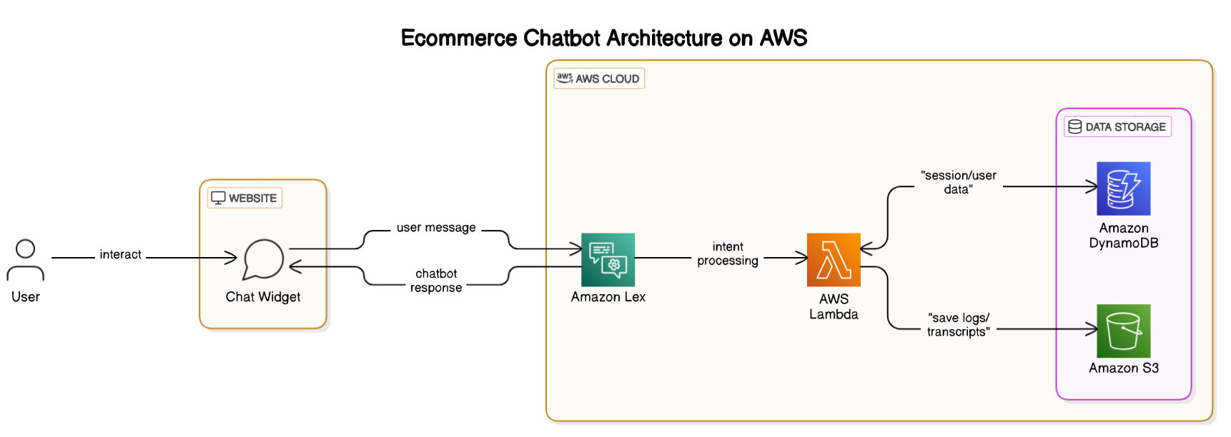

Proto type expected-

