**Create Database:**

import java.sql.Connection;

import java.sql.DriverManager;

import java.sql.SQLException;

import java.sql.Statement;

public class CreateDatabaseExample {

// JDBC URL, username, and password of MySQL server

private static final String URL = "jdbc:mysql://localhost:3306/";

**Output:**

private static final String USER = "root";

private static final String PASSWORD = "root";

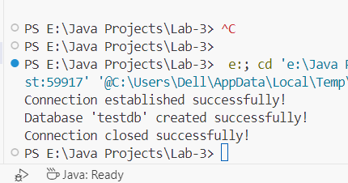

// JDBC variables for opening and managing connection

private static Connection connection;

private static Statement statement;

public static void main(String[] args) {

try {

// Load and register JDBC driver for MySQL

Class.forName("com.mysql.cj.jdbc.Driver");

// Establish the connection

connection = DriverManager.getConnection(URL, USER, PASSWORD);

System.out.println("Connection established successfully!");

// Create a statement

statement = connection.createStatement();

// Create a new database

String createDatabaseSQL = "CREATE DATABASE IF NOT EXISTS testdb";

statement.executeUpdate(createDatabaseSQL);

System.out.println("Database 'testdb' created successfully!");

} catch (ClassNotFoundException e) {

System.out.println("MySQL JDBC Driver not found.");

e.printStackTrace();

} catch (SQLException e) {

e.printStackTrace();

} finally {

// Close the statement and connection

try {

if (statement != null)

statement.close();

if (connection != null)

connection.close();

System.out.println("Connection closed successfully!");

} catch (SQLException e) {

e.printStackTrace();

}

}

}

}

**Echoclient:**

import java.io.BufferedReader;

import java.io.IOException;

import java.io.InputStreamReader;

import java.io.PrintWriter;

import java.net.Socket;

public class EchoClient {

public static void main(String[] args) {

String serverAddress = "localhost";

int port = 3306;

try (Socket socket = new Socket(serverAddress, port)) {

System.out.println("Connected to the server");

BufferedReader in = new BufferedReader(new InputStreamReader(socket.getInputStream()));

PrintWriter out = new PrintWriter(socket.getOutputStream(), true);

BufferedReader userInput = new BufferedReader(new InputStreamReader(System.in));

String message;

System.out.println("Enter messages to send to the server (type 'exit' to quit):");

while (!(message = userInput.readLine()).equalsIgnoreCase("exit")) {

out.println(message);

System.out.println("Server response: " + in.readLine());

}

System.out.println("Disconnected from the server");

} catch (IOException e) {

e.printStackTrace();

}

}

}

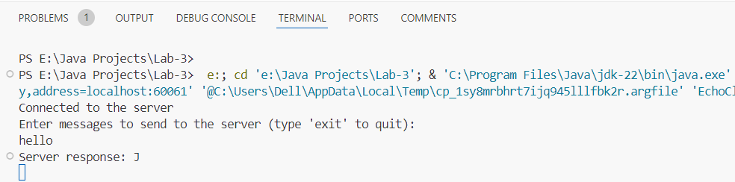

**Output:**

**Echoserver:**

import java.io.BufferedReader;

import java.io.IOException;

import java.io.InputStreamReader;

import java.io.PrintWriter;

import java.net.ServerSocket;

import java.net.Socket;

public class EchoServer {

public static void main(String[] args) {

int port = 1234;

try (ServerSocket serverSocket = new ServerSocket(port)) {

System.out.println("Server started. Listening on port " + port);

Socket clientSocket = serverSocket.accept();

System.out.println("Client connected");

BufferedReader in = new BufferedReader(new InputStreamReader(clientSocket.getInputStream()));

PrintWriter out = new PrintWriter(clientSocket.getOutputStream(), true);

String message;

while ((message = in.readLine()) != null) {

System.out.println("Received: " + message);

out.println("Echo: " + message);

}

System.out.println("Client disconnected");

} catch (IOException e) {

e.printStackTrace();

}

}

}

**Output:**

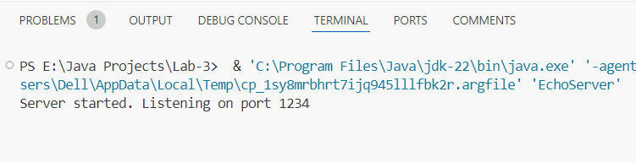

**JDBC Server:**

import java.sql.Connection;

import java.sql.DriverManager;

import java.sql.ResultSet;

import java.sql.SQLException;

import java.sql.Statement;

**Output:**

public class SimpleJDBCExample {

private static final String URL = "jdbc:mysql://localhost:3306/testdb";

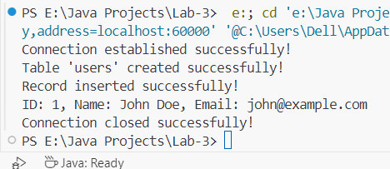 private static final String USER = "root";

private static final String PASSWORD = "root";

public static void main(String[] args) {

Connection connection = null;

Statement statement = null;

ResultSet resultSet = null;

try {

Class.forName("com.mysql.cj.jdbc.Driver");

connection = DriverManager.getConnection(URL, USER, PASSWORD);

System.out.println("Connection established successfully!");

statement = connection.createStatement();

String createTableSQL = "CREATE TABLE IF NOT EXISTS users (" +id INT AUTO_INCREMENT PRIMARY KEY, " +name VARCHAR(50) NOT NULL, " + "email VARCHAR(50) NOT NULL)";

statement.executeUpdate(createTableSQL);

System.out.println("Table 'users' created successfully!");

String insertQuery = "INSERT INTO users (name, email) VALUES ('John Doe', 'john@example.com')";

statement.executeUpdate(insertQuery);

System.out.println("Record inserted successfully!");

String selectQuery = "SELECT * FROM users";

resultSet = statement.executeQuery(selectQuery);

while (resultSet.next()) {

int id = resultSet.getInt("id");

String name = resultSet.getString("name");

String email = resultSet.getString("email");

System.out.println("ID: " + id + ", Name: " + name + ", Email: " + email);

}

} catch (ClassNotFoundException e) {

System.out.println("MySQL JDBC Driver not found.");

e.printStackTrace();

} catch (SQLException e) {

System.out.println("SQL Exception:");

e.printStackTrace();

} finally {

try {

if (resultSet != null)

resultSet.close();

if (statement != null)

statement.close();

if (connection != null)

connection.close();

System.out.println("Connection closed successfully!");

} catch (SQLException e) {

e.printStackTrace();

}

}

}

}