Process for uploading using flat file (enables calculations & better storage practices)

Connect to database, access may need to be granted first

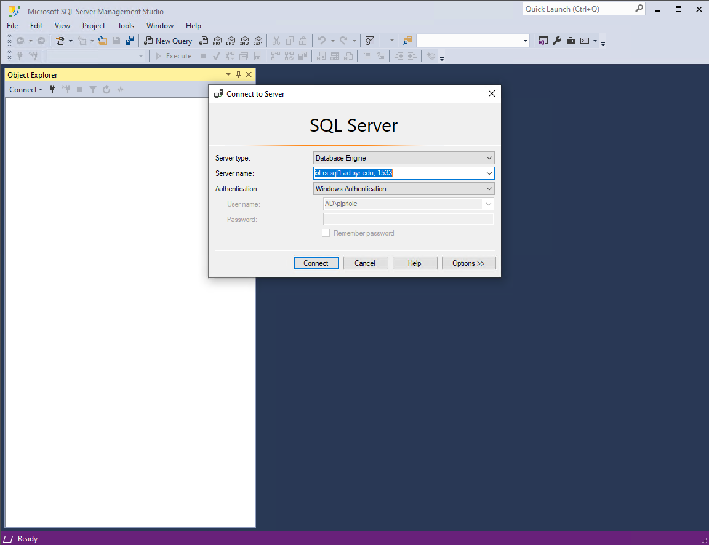

Right click on the PecanStreet dB & Select Import Flat File

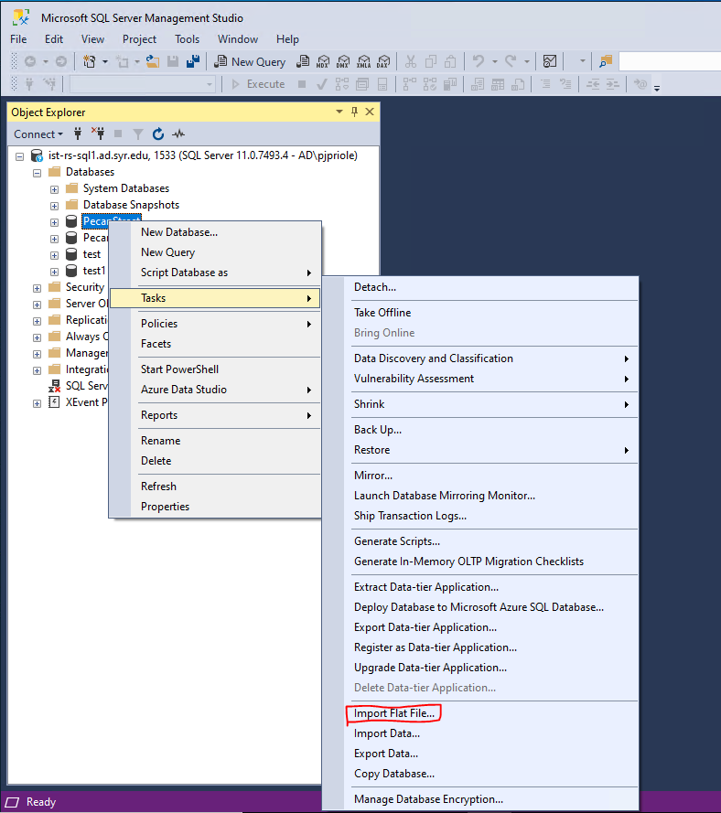

Select next

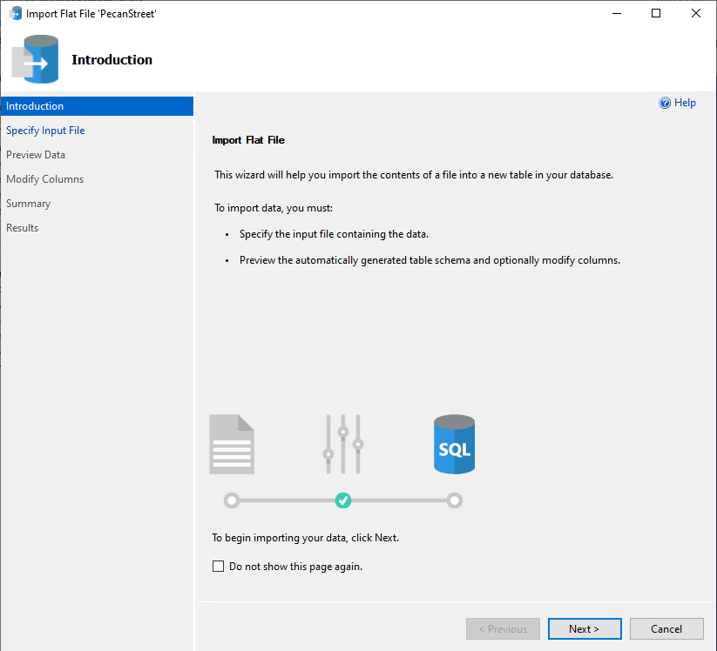

Specify de-compressed file

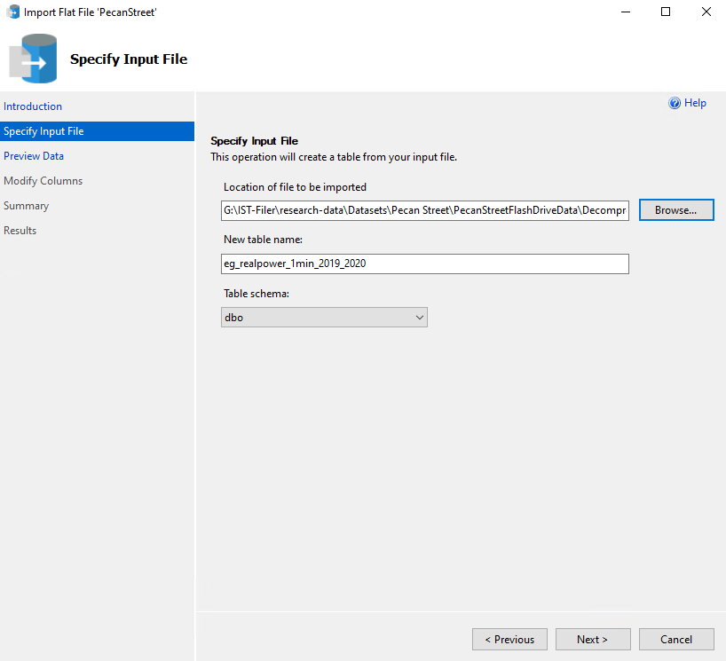

Do NOT use rich data type detection, click next

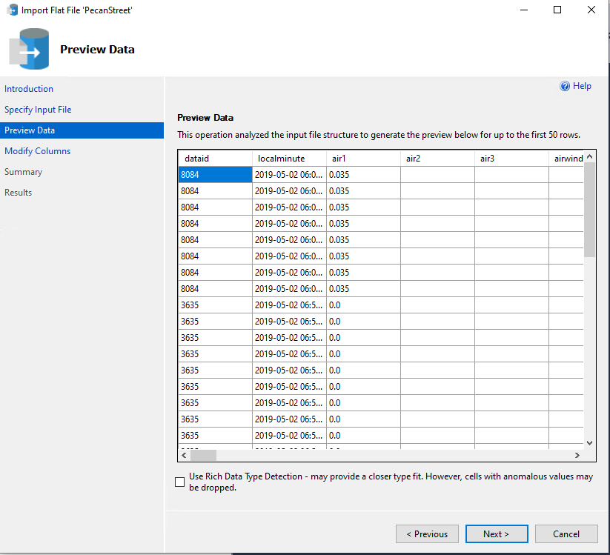

Change all columns other that dataid and localminute to float, & select Allow Nulls for EVERY COLUMN

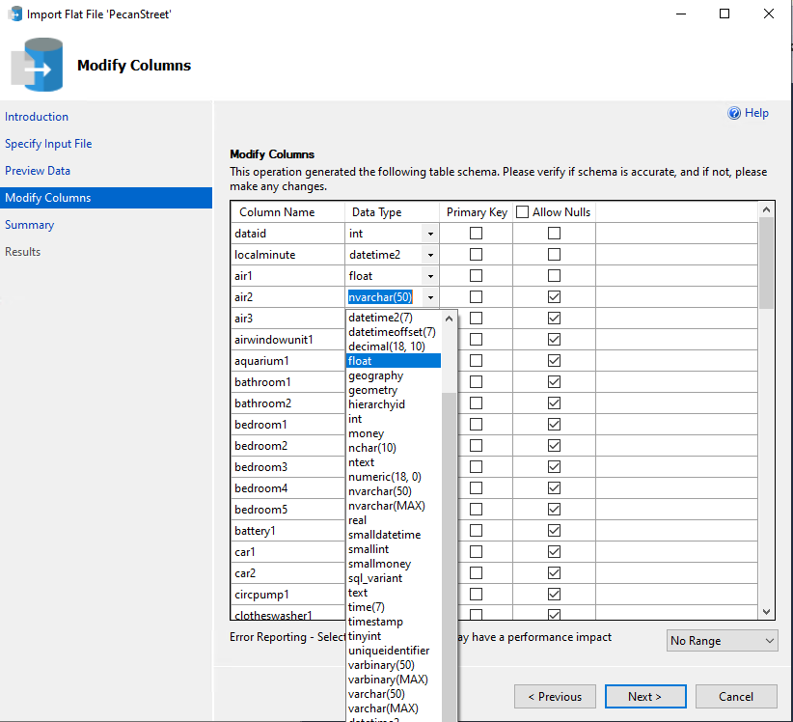

You may want to opt into error reporting then click next

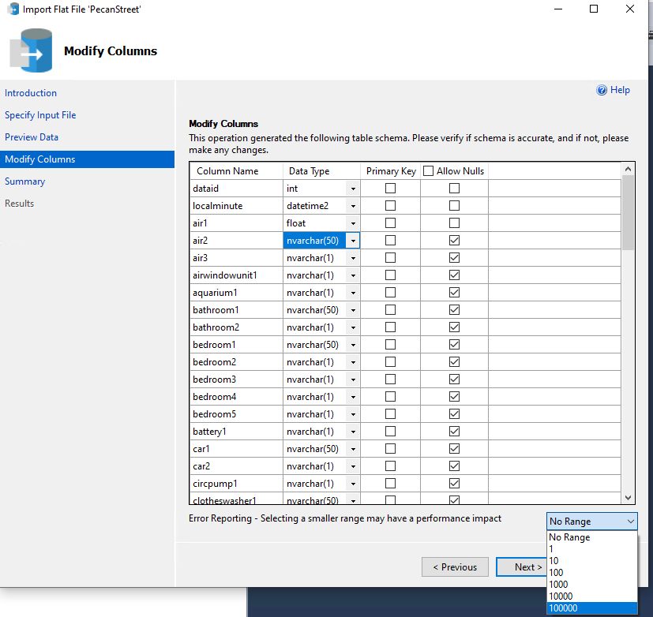

Click finish

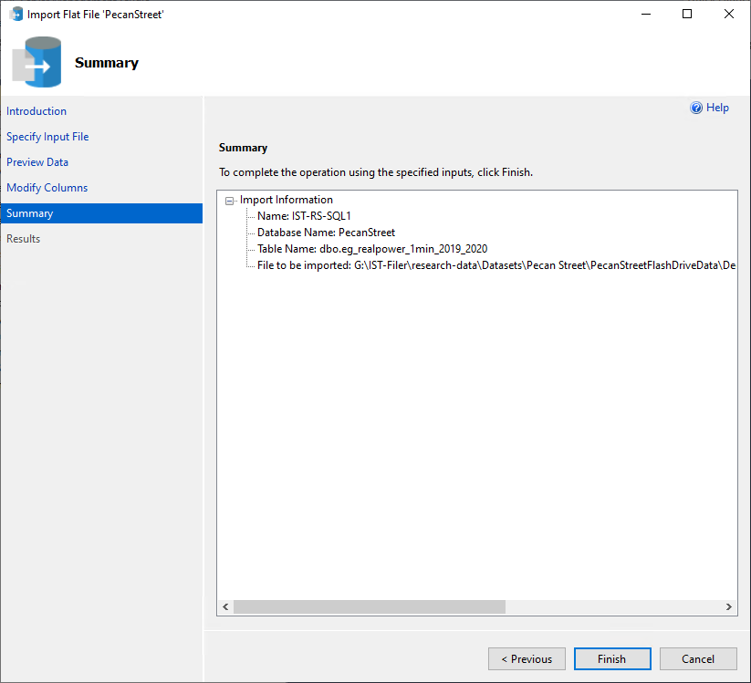

Wait…