You’ve Got Squares!
A guide to accessing your prepaid Su Squares account

To proceed you will need:
1. A private key and account number should be provided to you with this guide
2. A computer (not iPad) running Google Chrome with MetaMask
3. The URL for your favorite website
4. A cool catchphrase
5. A very small image you like (search the web for [10x10 pixel art])

Just follow these steps.

1. Open Google Chrome and set up MetaMask.
2. In the MetaMask menu, select the account switcher then choose Import Account.
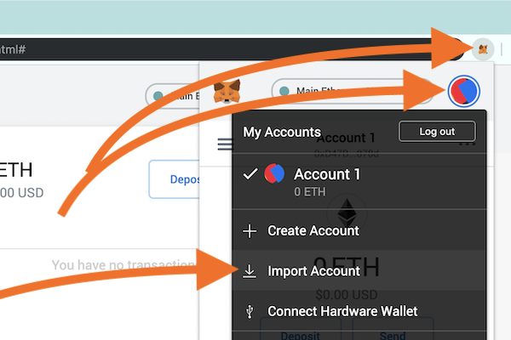

3. Paste in your private key and press IMPORT.
4. Rename this account immediately. A good name might be “INSECURE, got from Will.”
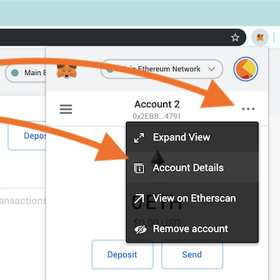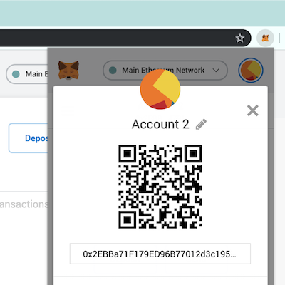

5. Next switch MetaMask to the Main Ethereum Network.
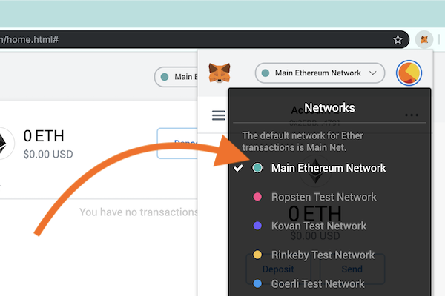

6. Visit https://tenthousandsu.com/ and click Personalize on the top right.
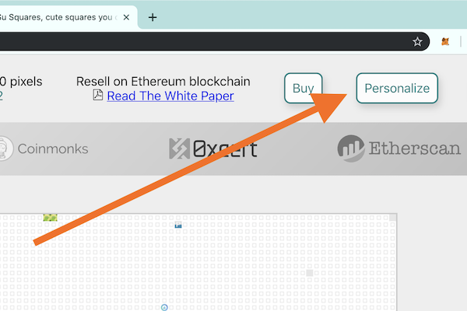

7. Click CONNECT to allow this website to know your public account number.
8. Now select the square you own further down the page.
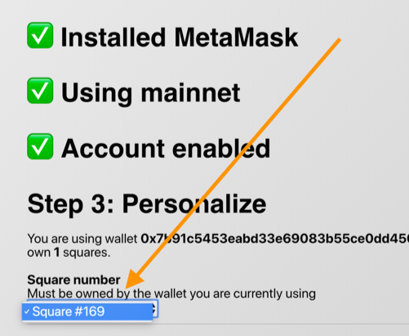

9. Enter your catch phrase (“square title”), favorite website (“square URL”) and use Choose File to add your picture. Then click Personalize Square (FREE). Approve the transaction. Now you should see a pending transaction on the page. Click for details. This may take between 30 seconds and a few minutes to settle (“confirmed”). After confirmed, your square will appear on https://tenthousandsu.com/ within 24 hours.

Discussion & next steps

Be careful, your MetaMask account is now still on the Main Ethereum Network. This means that you are spending real money for everything you do. If you will do development work, now is a good time to switch back to Ropsten Test Network to avoid confusion and mistakes later.

Your Su Square is personalized and owned with the private account key that you received from Will or Su. This is insecure because Will or Su also have the account key and they could take it back any time. Also, anybody that now or ever in the future gets access to your email or your phone will have full access to this account. Do not send funds to this insecure account.

To secure these assets you may like to move ownership of your Su Square and the excess funds (Ether) in this account to an account that you fully control. Before proceeding, make sure that you have saved a paper backup of your MetaMask account. This is under Settings → Reveal Seed Words. Keep these safe somewhere and treat this like cash, it could be valuable 10 years from now. $10 worth of Bitcoin from 2008 is worth enough now to retire comfortably.

Moving your assets is beyond the scope of this guide. But you might login to Open Sea (https://opensea.io) to “Gift” the Su Square from your insecure account to the secure account. After that you can use MetaMask to “send” Ether from your insecure account to the secure account. Note that sending assets (Su Squares and Ether) incurs a fee denominated in Ether. So if you send all the Ether out of the account then you will not be able to transfer the Su Square. Instead send the Su Square first and send the Ether that is remaining after that transaction is complete and settled.

