Risky Business - Quickfire Challenge

Experio is a consumer experience design consultancy that specializes in creating engaging retail experiences for local family-entertainment venues around the country.

We do this through four main competencies: Insights & Strategy, brand, environments, and architecture & Implementation. We develop a deep understanding of the consumers and translate that understanding into insights that we use to define stories and create environments and experiences that delight and integrate with the brand.

Market Analysis - [see source here](http://www.iaapa.org/resources/by-park-type/amusement-parks-and-attractions/industry-statistics)

Experio operates in the local family entertainment venue market and is positioned as a unique offering in the space. There are nearly 30,000 entertainment attractions in the United States, generating a total of 219 billion dollars of revenues annually. While analogous consultancies exist that focus on retail opportunities from a human-centered perspective, they do not target our same demographic: zoos, state parks, amusement parks, aquariums, museums, etc.

Our main competitor in the space would be playground equipment installation companies such as iPlayCo. We offer a fundamentally different service in that our primary value add is not simply a physical playscape, it is a physical, human, and digital solution that transforms how consumers think about and experience the brand. Large amusement park conglomerates such as Disney have units dedicated to innovating novel consumer experiences that small to medium sized venues are unlikely to be able to afford. Experio offers similar capacity to these venues that enables them to create unique experiences that capture their brand in a tangible way, generating business value in the process.

Business Model

We will sell our consulting services to family entertainment venues, like zoos, amusement parks, etc. We will charge an initial design fee for the concept, as well as construction fees. We will charge for materials on a per part basis. We will start with a niche within our market - local, smaller scale entertainment venues.

Marketing & Sales Strategy

Marketing and sales consists of a twofold approach, content/inbound marketing and a robust outreach program. First, we will compile several whitepapers researching the intricacies of concession wait times in entertainment venues. Similarly, the ways in which our innovative spaces actually provide utility in (1) reducing wait times (2) providing an overall better experience. By clearly documenting the inefficiencies of current lines, we will develop credibility and metrics of success with respect to improving the experience of waiting at entertainment venues. Second, compiling this data will fuel a cold call outreach plan intended to persuade decision makers on the basis of efficiency and growth primarily, and customer experience secondarily.

After developing an initial service offering, we will attend trade shows to further understand customer needs and acquire new customers at events like CinemaCON, Amusement Expo, American Association of Airport Executives Expo. We will then develop case studies to showcase the impact of our work, and use our contacts from trade shows and our personal network to distribute case studies and gain followers.

Our content/inbound marketing strategy consists of creating a blog and newsletter to demonstrate our thought leadership on optimizing recreational spaces and family entertainment venues. We will use cold-calling and cold-emailing strategies to acquire new customers, and upsell current customers on our offerings to continue to drive sales. Our sales team will focus on building customer relationships and encourage word of mouth advertising to gain new clients.

Manufacturing

Our manufacturing considerations range across our consulting projects and their locations. To address these needs, we will partner with local contractors and construction firms to build venues per our specifications and optimization suggestions. This will promote local economies and community support for these new and improved venues. Additionally, we will identify key vendors of children’s playgrounds in different regions across the country; for example, we can contact PlayTrails for assistance with Midwestern projects. When determining our construction and manufacturing partners, we will use the “Me2 Design Guide” to ensure team recommendations are inclusive of all children. Finally, we will create and compile guides for outdoor entertainment venue regulations by region.

Financial Projection

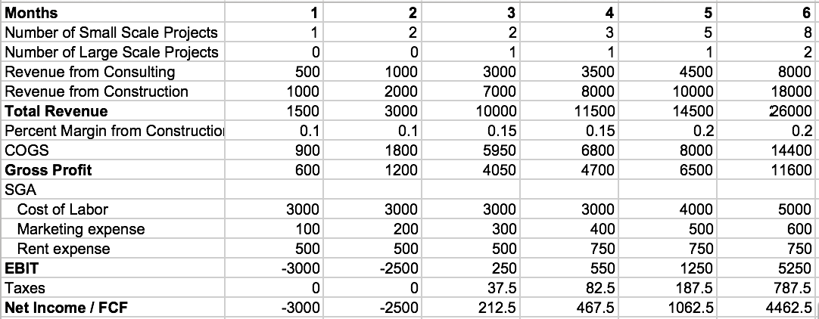

Due to the low starting cost of our company. We project that we will be able to recover our costs during the sixth month of operation. However, we will be experiencing a loss of 5500 during the first two months, an amount that we will not be able to afford given our current economic situations. Therefore, the $5000 provided by VFA will be used to cover those costs, which primarily composed of cost of marketing and cost of labor. The remaining $500 will be covered by the founders. However, this initial investment will see fruition really quickly as we project that our revenue will grow exponentially afterward.