**DEVOPS**

Devops is a software development methodology which improves the collaboration between developers and operations team using various automation tools.

These automation tools are implemented using various stages which a re a part of the Devops Life Cycle

**Is AWS better than Azure?**

Due to its almost 7-year operating history, **AWS has greater resources, infrastructure, and superior, scalable services than Azure**. More significantly, while Azure was attempting to catch up, Amazon could expand its cloud infrastructure by adding more servers and utilizing economies of scale more effectively.

**Is AWS DevOps in demand?**

**There's currently a huge demand for AWS DevOps Engineers** who can incorporate DevOps principles, application design, development and releases for businesses.

Which platform is best for DevOps?

**These are some of the popular DevOps automation tools:**

1. Jenkins. Jenkins. Jenkins is an open source and free automation server that helps automate software development processes such as building, facilitating CI/CD, deploying, and testing. ...
2. Docker. Docker. ...
3. Puppet. Puppet. ...
4. Apache Maven. Apache Maven. ...
5. Gradle. Gradle.

**Is DevOps same for AWS and Azure?**

**The major difference between AWS DevOps and Azure DevOps tools is their integration within the scope of their cloud environment and with third-party services**.

Which DevOps is in demand?

Let's look at the most in-demand DevOps jobs in 2022.  
...  
**DevOps Jobs in Demand in September 2022**

* AWS. AWS or Amazon Web Services DevOps engineers are in high demand this year. ...
* Kubernetes. ...
* Google Cloud Platform. ...
* Docker. ...
* Azure.

**Continuous Deployment ?**

What is continuous deployment in DevOps?

Continuous deployment is basically **when teams rely on a fully automated pipeline**. This practice fully eliminates any manual steps and automates the entire process. Therefore, continuous deployment ensures that code is continuously being pushed into production.

**Continuous Delivery?**

Continuous delivery **automates the entire software release process**. Every revision that is committed triggers an automated flow that builds, tests, and then stages the update. The final decision to deploy to a live production environment is triggered by the developer.

**What is meant by continuous integration?**

Continuous integration refers to **the build and unit testing stages of the software release process**. Every revision that is committed triggers an automated build and test. With continuous delivery, code changes are automatically built, tested, and prepared for a release to production.

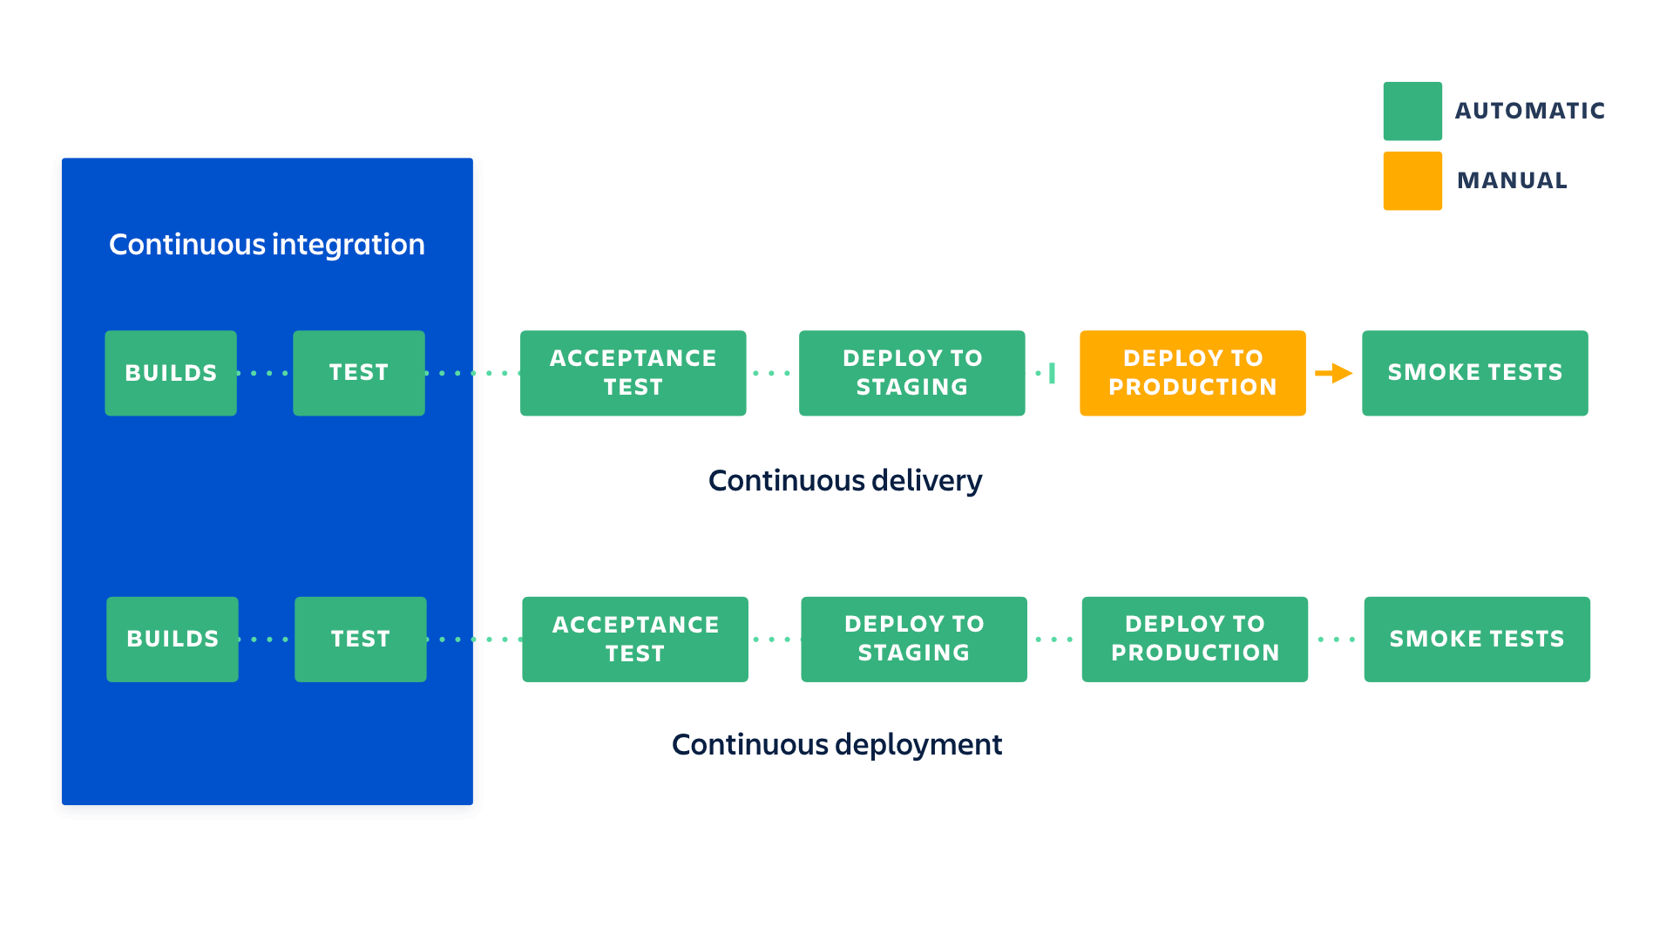

**What are the types of pipelines in DevOps?**

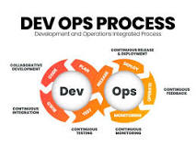

**These are:**

* Continuous Integration/Continuous Delivery (CI/CD) ...
* Continuous Testing/Continuous Deployment (CT/CD) ...
* Continuous Monitoring. ...
* Continuous Feedback. ...
* Continuous Operations. ...
* Tools and Control Environment. ...
* Build Server and Automation. ...
* DevOps Pipeline Deployment.

In networking, a packet is **a small segment of a larger message**. Data sent over computer networks*, such as the Internet, is divided into packets. These packets are then recombined by the computer or device that receives them.

**Secure Shell (SSH),** sometimes known as Secure Socket Shell, is a **UNIX-based** command interface and protocol for securely getting access to a remote computer.

**What do you mean interface?**

the place at which independent and often unrelated systems meet and act on or communicate with each other.

**A port** in networking is **a software-defined number associated to a network protocol that receives or transmits communication for a specific service**. A port in computer hardware is a jack or socket that peripheral hardware plugs into.

How do ports work?

**A port is a number used to uniquely identify a transaction over a network by specifying both the host, and the service**. They are necessary to differentiate between many different IP services, such as

web service (HTTP),

mail service (SMTP),

and file transfer (FTP).

Why is port used?

Each port is associated with a specific process or service. Ports **allow computers to easily differentiate between different kinds of traffic**: emails go to a different port than webpages, for instance, even though both reach a computer over the same Internet connection.

**What are the 3 types of ports?**

There are different types of ports available:

**Serial port**.

**Parallel port**.

**USB port**.

Transmission control protocol (TCP) and user datagram protocol (UDP) are foundational pillars of the internet, enabling different types of data transmission from a network source to the destination. TCP is more reliable, while UDP prioritizes speed and efficiency.

**TCP is a connection-oriented protocol, whereas UDP is a connectionless protocol**. A key difference between TCP and UDP is speed, as TCP is comparatively slower than UDP. Overall, UDP is a much faster, simpler, and efficient protocol, however, retransmission of lost data packets is only possible with TCP.

Which is better UDP or TCP?

**TCP is more reliable than UDP**. It transfers your data packets from your device to a web server. UDP is faster and simpler, but it doesn't guarantee the delivery of packets.

What is port in IP address?

Port numbers **identify a particular application or service on a system**. An IP address identifies a machine in an IP network and determines the destination of a data packet, while port numbers identify particular applications or services on a system.

IP stands for "**Internet Protocol**," which is the set of rules governing the format of data sent via the internet or local network. In essence, IP addresses are the identifier that allows information to be sent between devices on a network: they contain location information and make devices accessible for communication.

What are the 4 types of IP address?

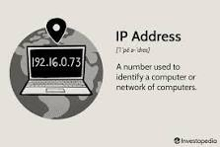

An internet protocol (IP) address allows computers to send and receive information.

There are four types of IP addresses:

**public, private, static, and dynamic**.

What devices uses IP address?

Every device that connects to your internet network has a private IP address. This includes **computers, smartphones, and tablets but also any Bluetooth-enabled devices like speakers, printers, or smart TVs**.

What is Ubuntu is used for?

Ubuntu is a Linux distro based on Debian. It is suitable for **cloud computing, servers, desktops, and internet of things (IoT) devices**. The main difference between Linux and Ubuntu is that the former is an operating system family based on Unix, while Ubuntu is a Linux distribution.