Практическая работа №3. PyTest. Тестирование класса AuthManager.
Выполнение всех тестов.
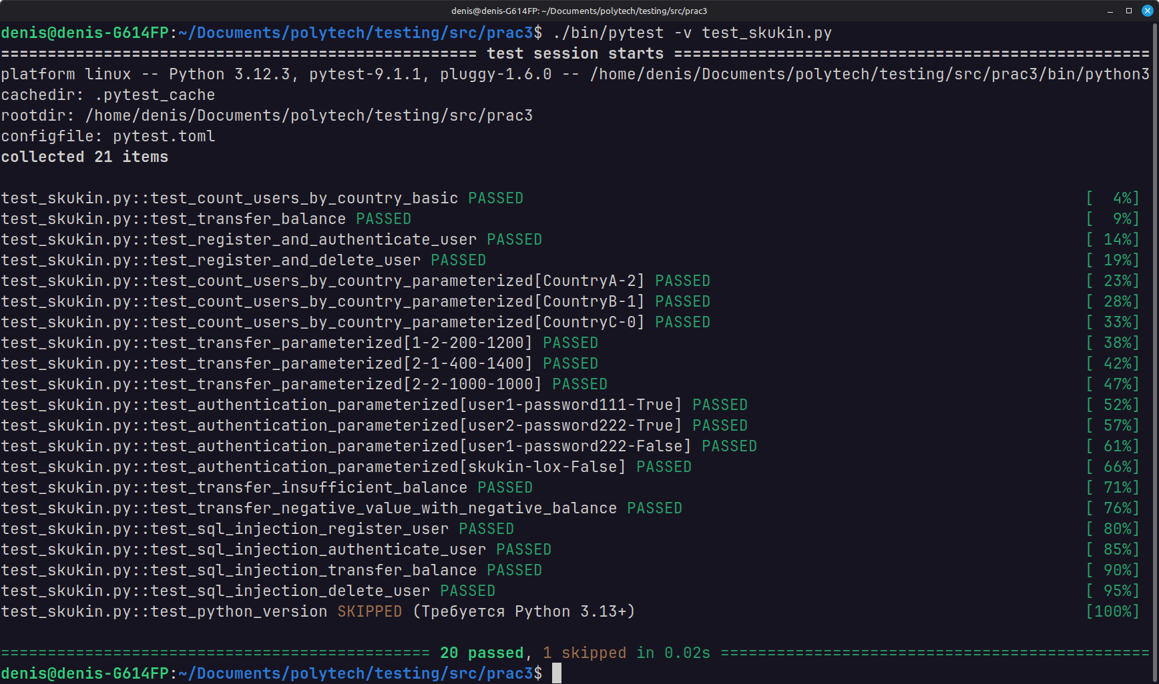
Прерывание тестов после 3 неудачных попыток
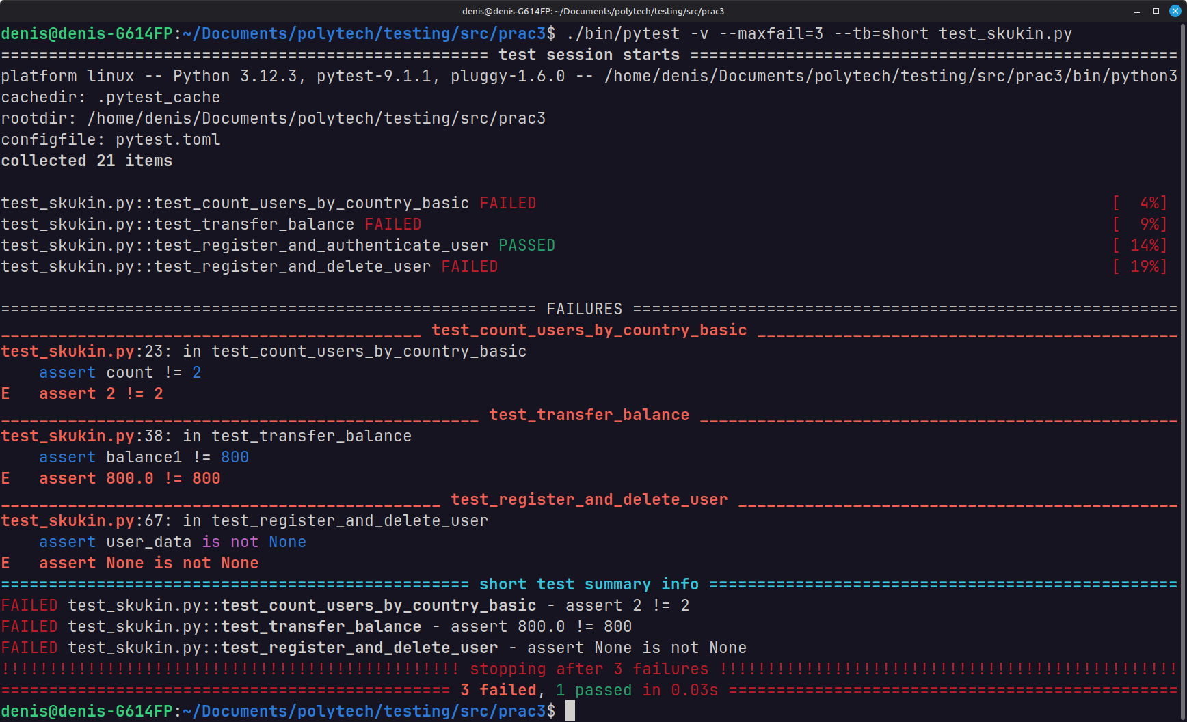

Выполнение тестов с меткой “basic”
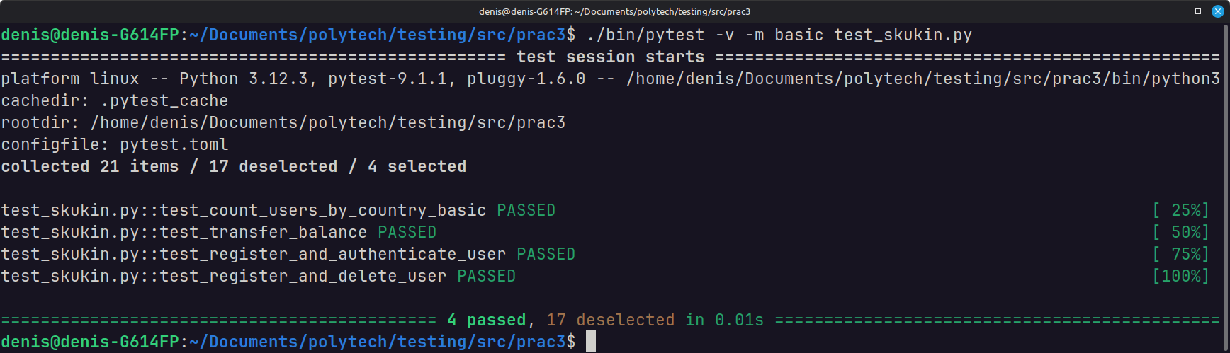
Выполнение тестов с меткой “parameterized”
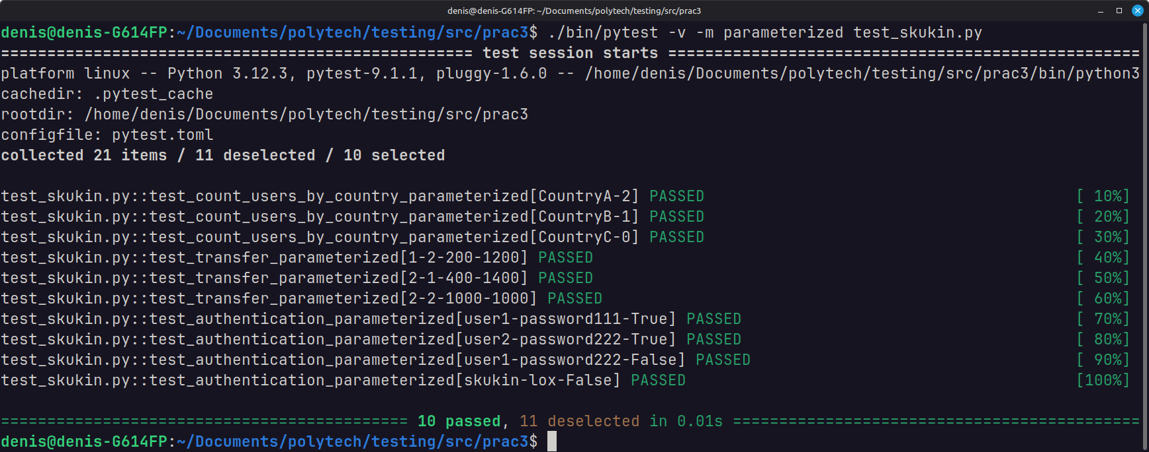
Выполнение тестов с меткой “exception”
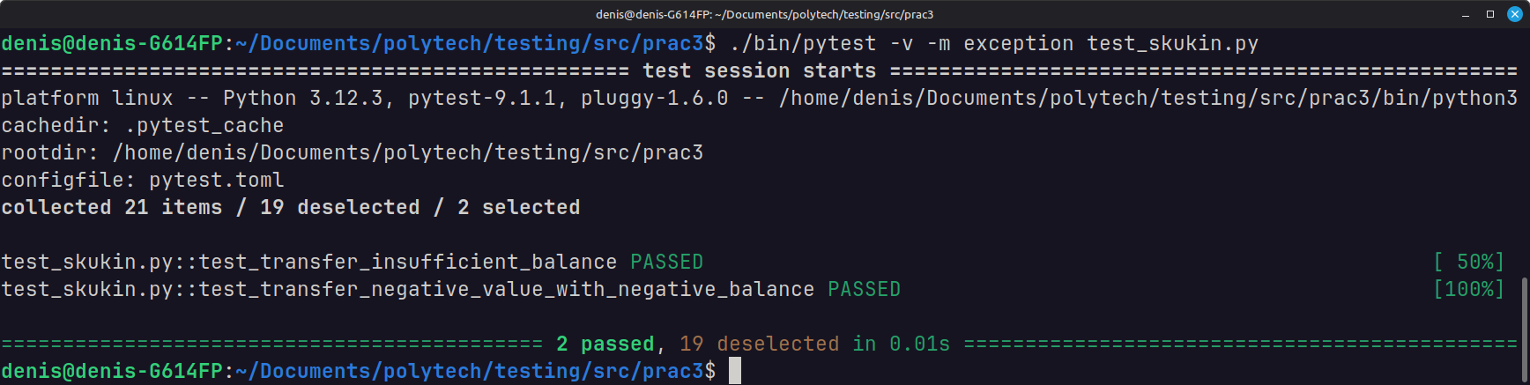
Выполнение тестов с меткой “sql_injection”
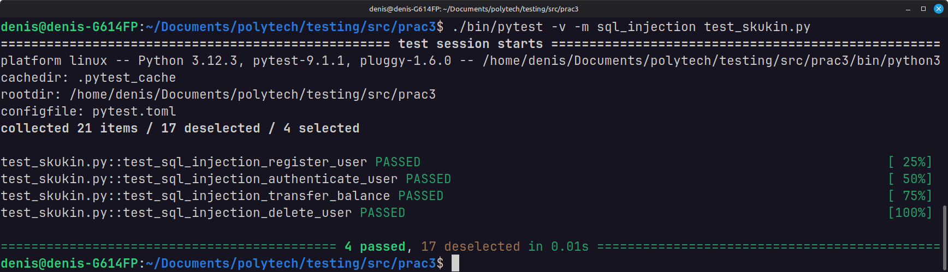

Использование фикстур:
@pytest.fixture
def db():
connection = sqlite3.connect(":memory:")
yield connection
connection.close()

@pytest.fixture
def auth_manager(db):
return AuthManager(db)
Выполнение каждого теста
Тест №1.
@pytest.mark.basic
def test_count_users_by_country_basic(auth_manager):
auth_manager.register_user("user1", "password123", "CountryA", 1000)
auth_manager.register_user("user2", "password123", "CountryA", 1000)
auth_manager.register_user("user3", "password123", "CountryB", 1000)
count = auth_manager.count_users_by_country("CountryA")
assert count == 2
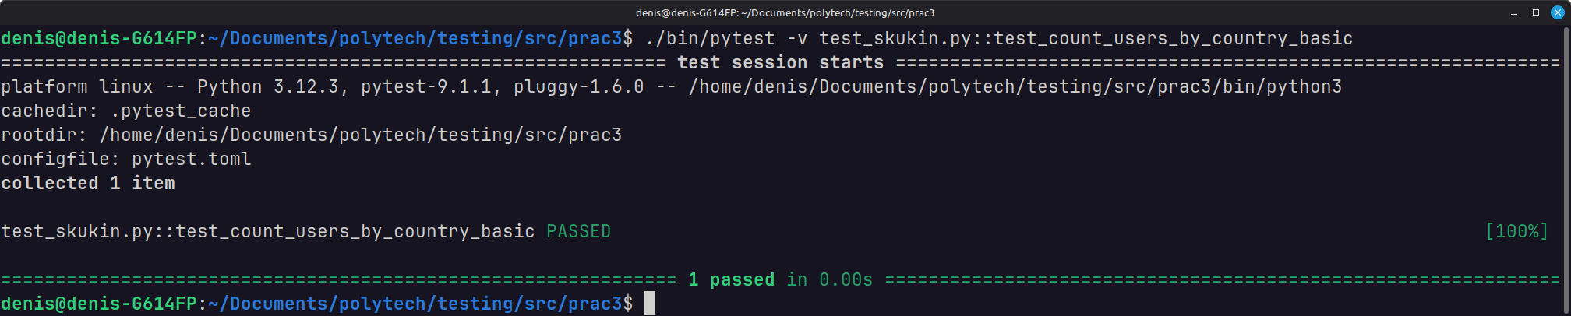
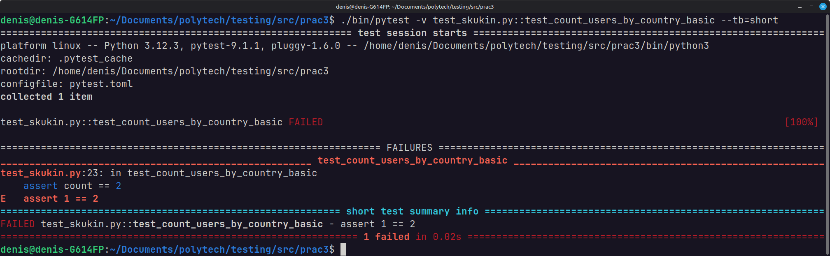
Тест №2.
@pytest.mark.basic
def test_transfer_balance(auth_manager, db):
auth_manager.register_user("user1", "password123", "CountryA", 1000)
auth_manager.register_user("user2", "password123", "CountryB", 500)
auth_manager.transfer_balance(1, 2, 200)
cursor = db.cursor()
cursor.execute("SELECT balance FROM users WHERE id = 1")
balance1 = cursor.fetchone()[0]
cursor.execute("SELECT balance FROM users WHERE id = 2")
balance2 = cursor.fetchone()[0]
assert balance1 == 800
assert balance2 == 700

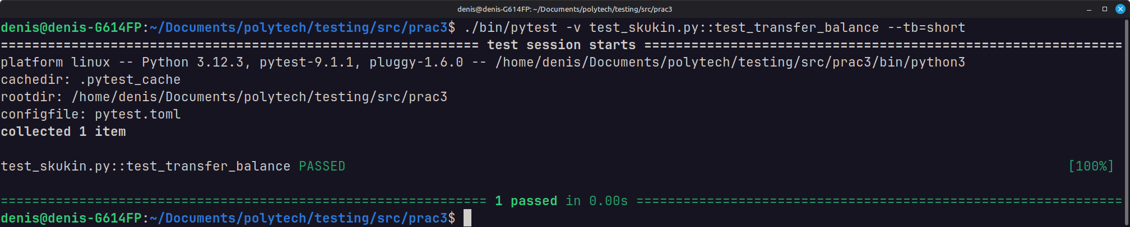
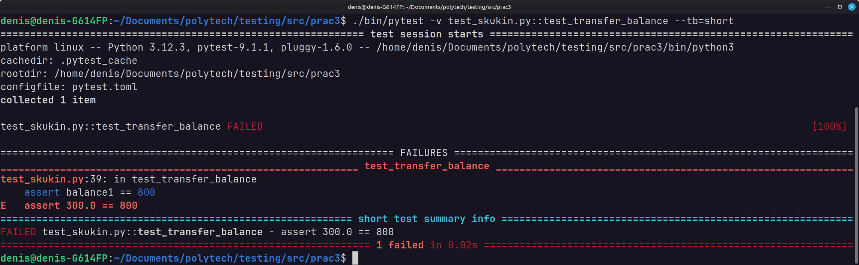
Тест №3.
@pytest.mark.basic
def test_register_and_authenticate_user(auth_manager):
username = "den4ik"
password = "my_super_password"
country = "Russia Motherland"
balance = 0xdeadbeef

registration_data = (username, password, country, balance)

auth_manager.register_user(*registration_data)
user_data = auth_manager.authenticate_user(*registration_data[0:2])

assert user_data[1:] == registration_data
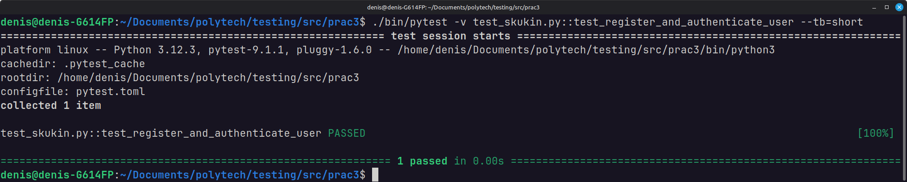
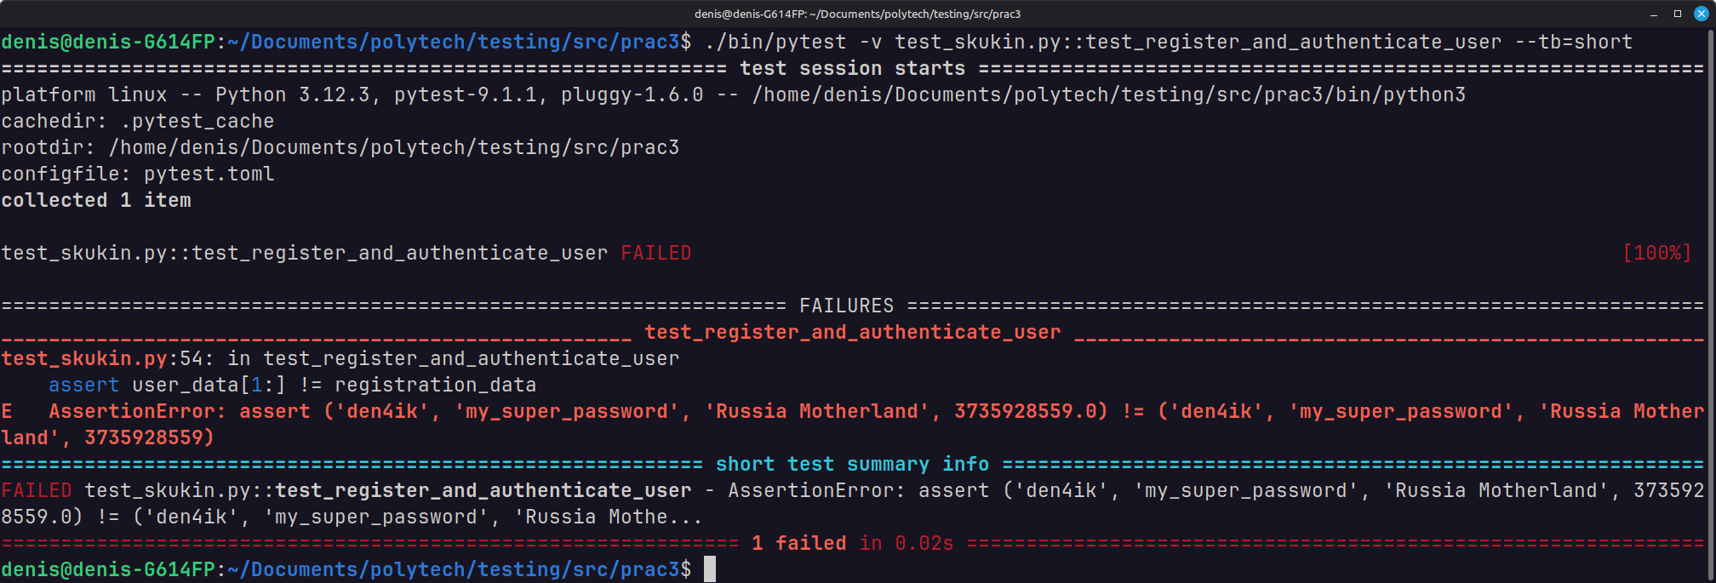
Тест №4.
@pytest.mark.basic
def test_register_and_delete_user(auth_manager):
username = "den4ik"
password = "my_super_password"
country = "Russia Motherland"
balance = 0xdeadbeef

registration_data = (username, password, country, balance)

auth_manager.register_user(*registration_data)
user_data = auth_manager.authenticate_user(*registration_data[0:2])
auth_manager.delete_user(user_data[0])
user_data = auth_manager.authenticate_user(*registration_data[0:2])

assert user_data is None
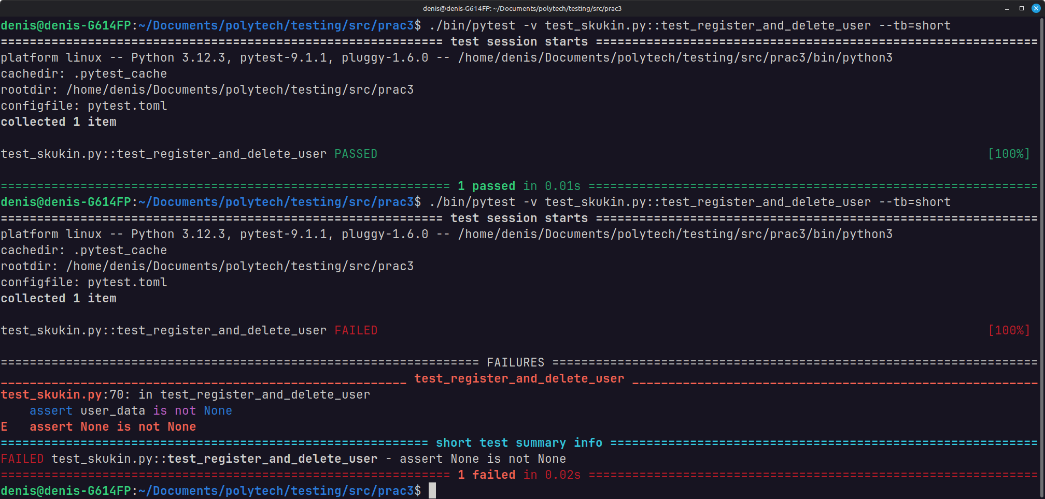
Тест №5.
@pytest.mark.parameterized
@pytest.mark.parametrize("country, expected_count", [
("CountryA", 2),
("CountryB", 1),
("CountryC", 0)
])
def test_count_users_by_country_parameterized(auth_manager, country, expected_count):
auth_manager.register_user("user1", "password123", "CountryA", 1000)
auth_manager.register_user("user2", "password123", "CountryA", 1000)
auth_manager.register_user("user3", "password123", "CountryB", 1000)
count = auth_manager.count_users_by_country(country)
assert count == expected_count
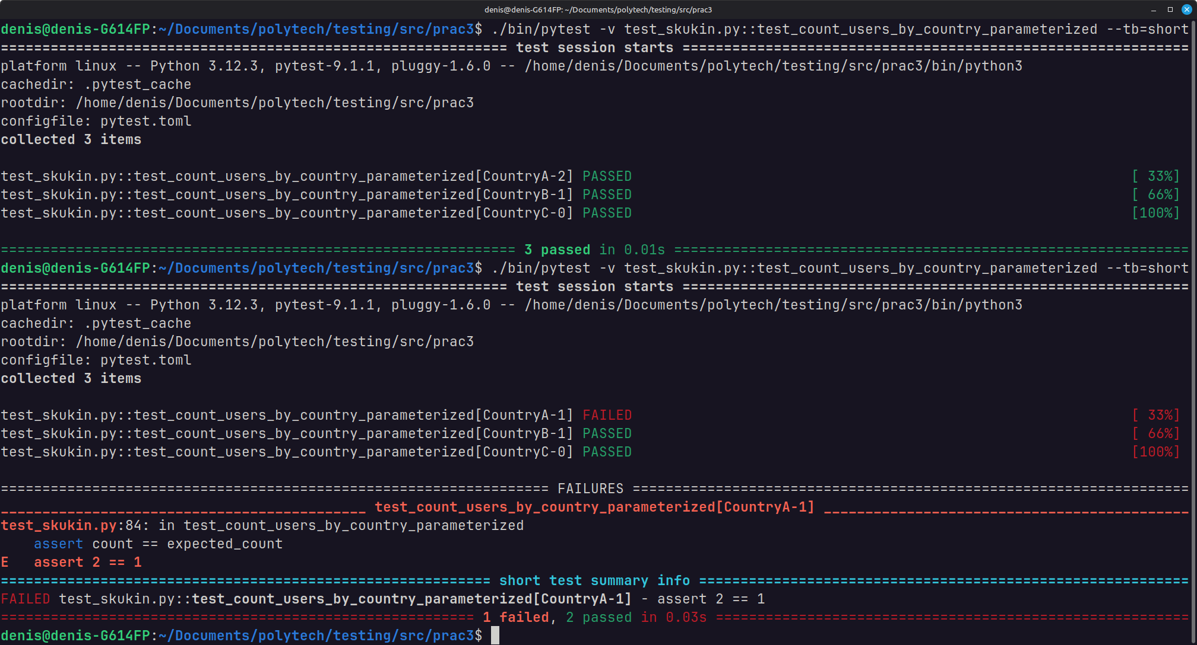
Тест №6.
@pytest.mark.parameterized
@pytest.mark.parametrize("transfer_from, transfer_to, transfer_amount, expected_balance", [
(1, 2, 200, 1200),
(2, 1, 400, 1400),
(2, 2, 1000, 1000)
])
def test_transfer_parameterized(auth_manager, transfer_from, transfer_to, transfer_amount, expected_balance):
auth_manager.register_user("user1", "password123", "CountryA", 1000)
auth_manager.register_user("user2", "password123", "CountryB", 1000)

auth_manager.transfer_balance(transfer_from, transfer_to, transfer_amount)
user_data = auth_manager.get_user_by_id(transfer_to)
assert user_data[4] == expected_balance
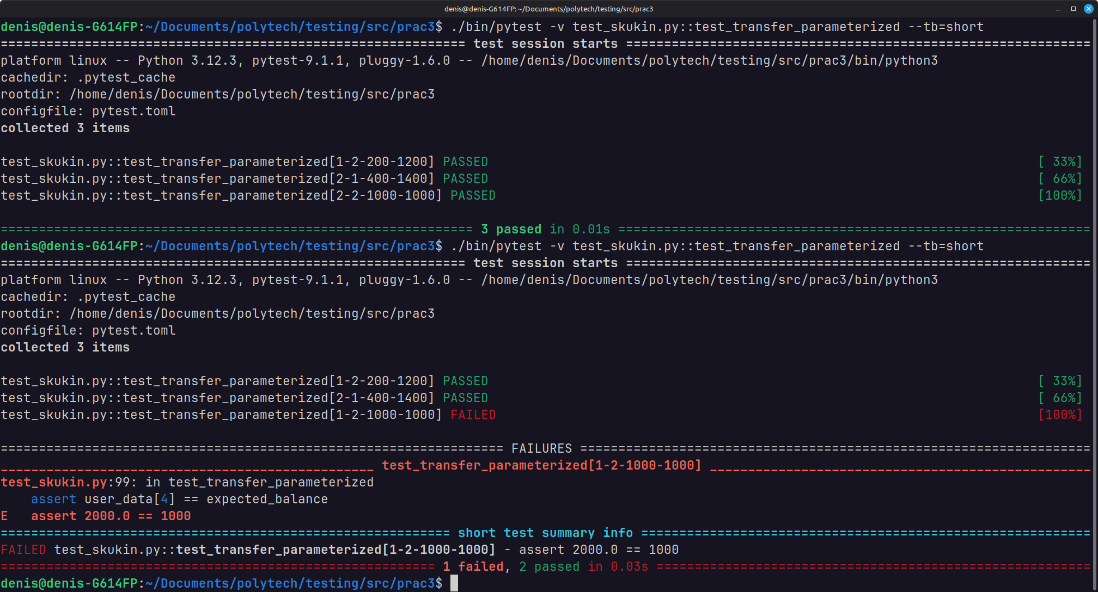
Тест №7.
@pytest.mark.parameterized
@pytest.mark.parametrize("user, password, expected_auth_result", [
("user1", "password111", True),
("user2", "password222", True),
("user1", "password222", False),
("skukin", "lox", False)
])
def test_authentication_parameterized(auth_manager, user, password, expected_auth_result):
auth_manager.register_user("user1", "password111", "CountryA", 1000)
auth_manager.register_user("user2", "password222", "CountryB", 1000)

user_data = auth_manager.authenticate_user(user, password)

is_authenticated = user_data is not None
assert is_authenticated == expected_auth_result
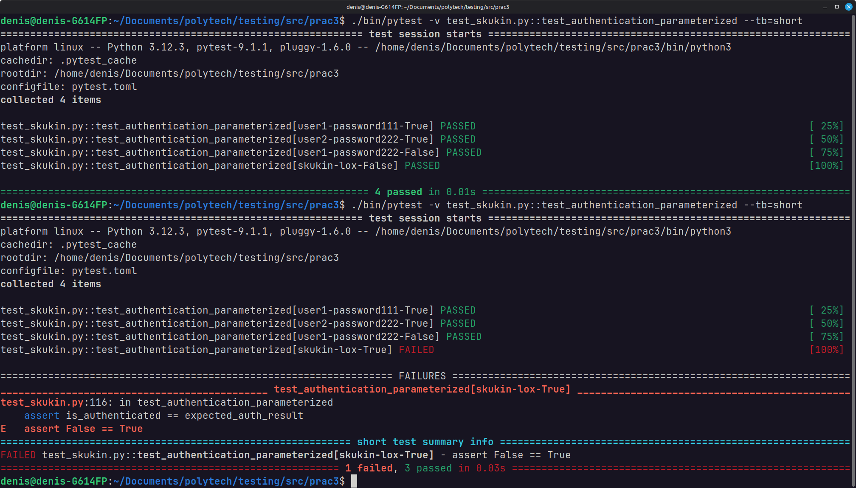
Тест №8.
@pytest.mark.exception
def test_transfer_insufficient_balance(auth_manager):
auth_manager.register_user("user1", "password123", "CountryA", 0)
auth_manager.register_user("user2", "password123", "CountryC", 1001)

with pytest.raises(ValueError):
auth_manager.transfer_balance(1, 2, 1000)
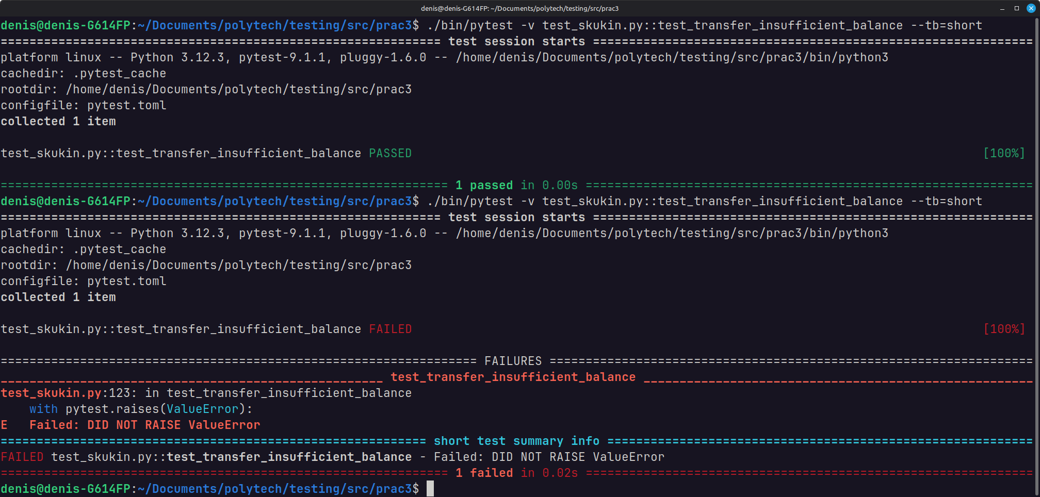
Тест №9.
@pytest.mark.exception
def test_transfer_negative_value_with_negative_balance(auth_manager):
auth_manager.register_user("user1", "password123", "CountryA", -1000)
auth_manager.register_user("user2", "password123", "CountryB", -1000)

with pytest.raises(ValueError):
auth_manager.transfer_balance(2, 1, -200)
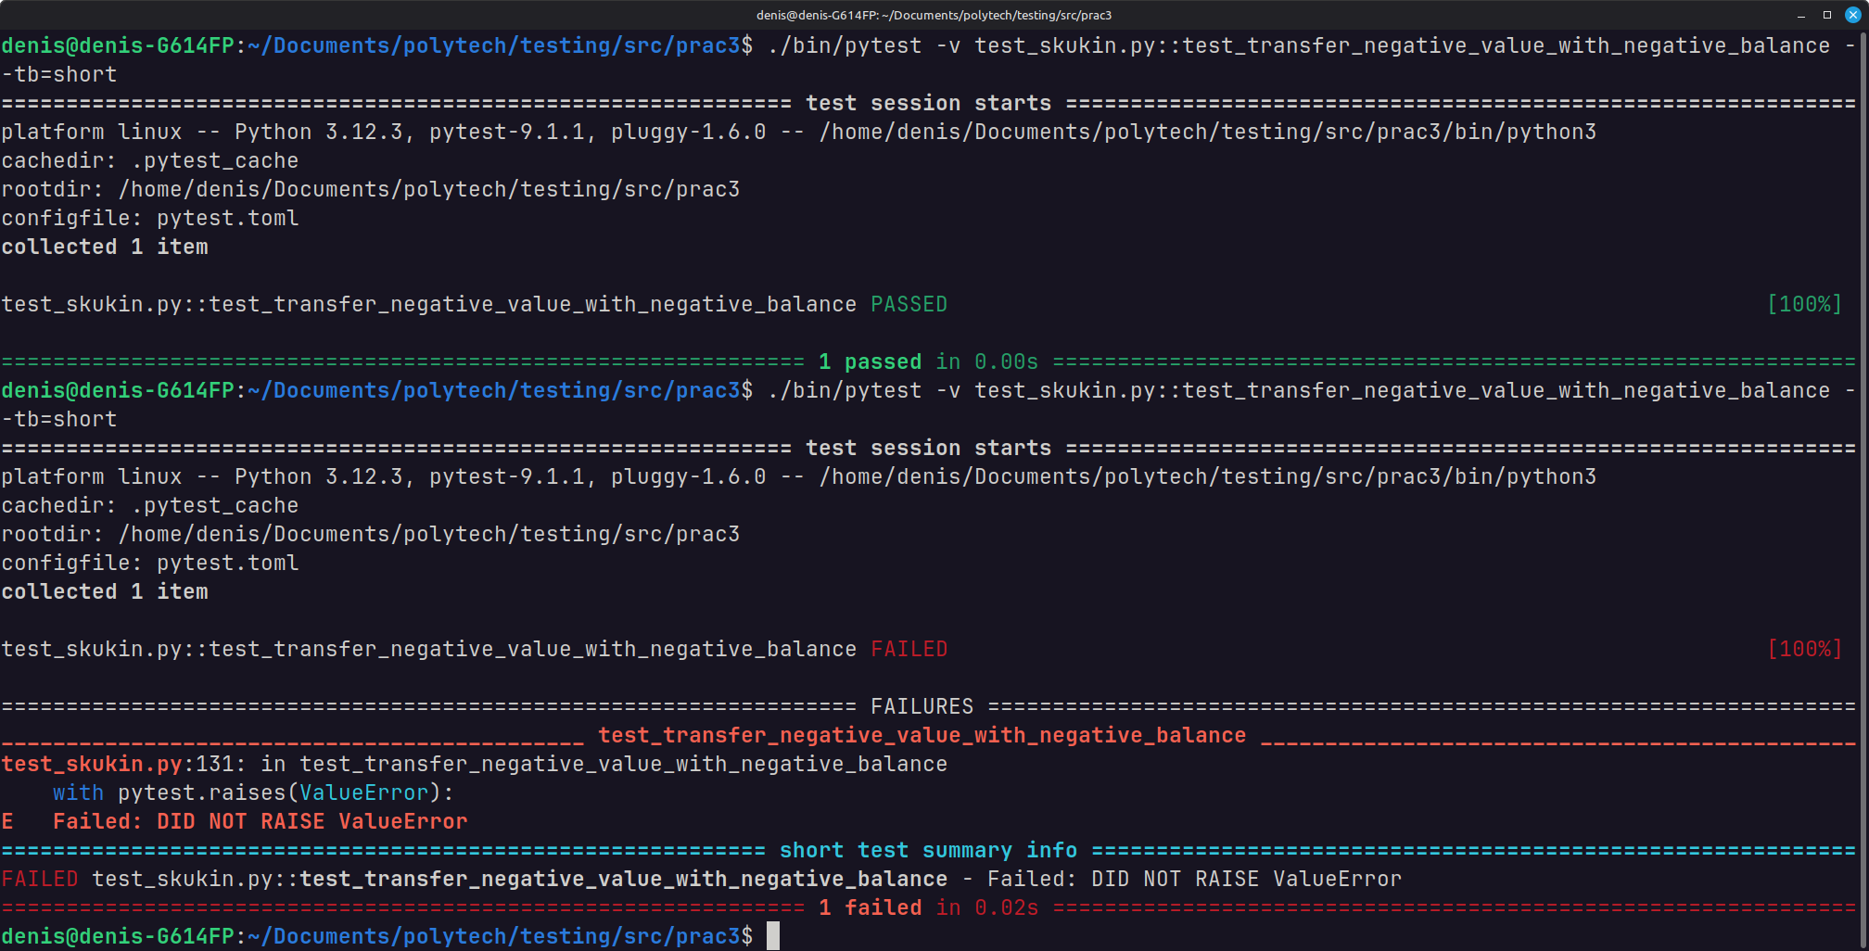
Тест №10.
@pytest.mark.sql_injection
def test_sql_injection_register_user(auth_manager, db):
auth_manager.register_user("testuser", "password123", "Country", 0)
cursor = db.cursor()
cursor.execute("SELECT name FROM sqlite_master WHERE type='table' AND name='users';")
tables = cursor.fetchall()
assert len(tables) == 1
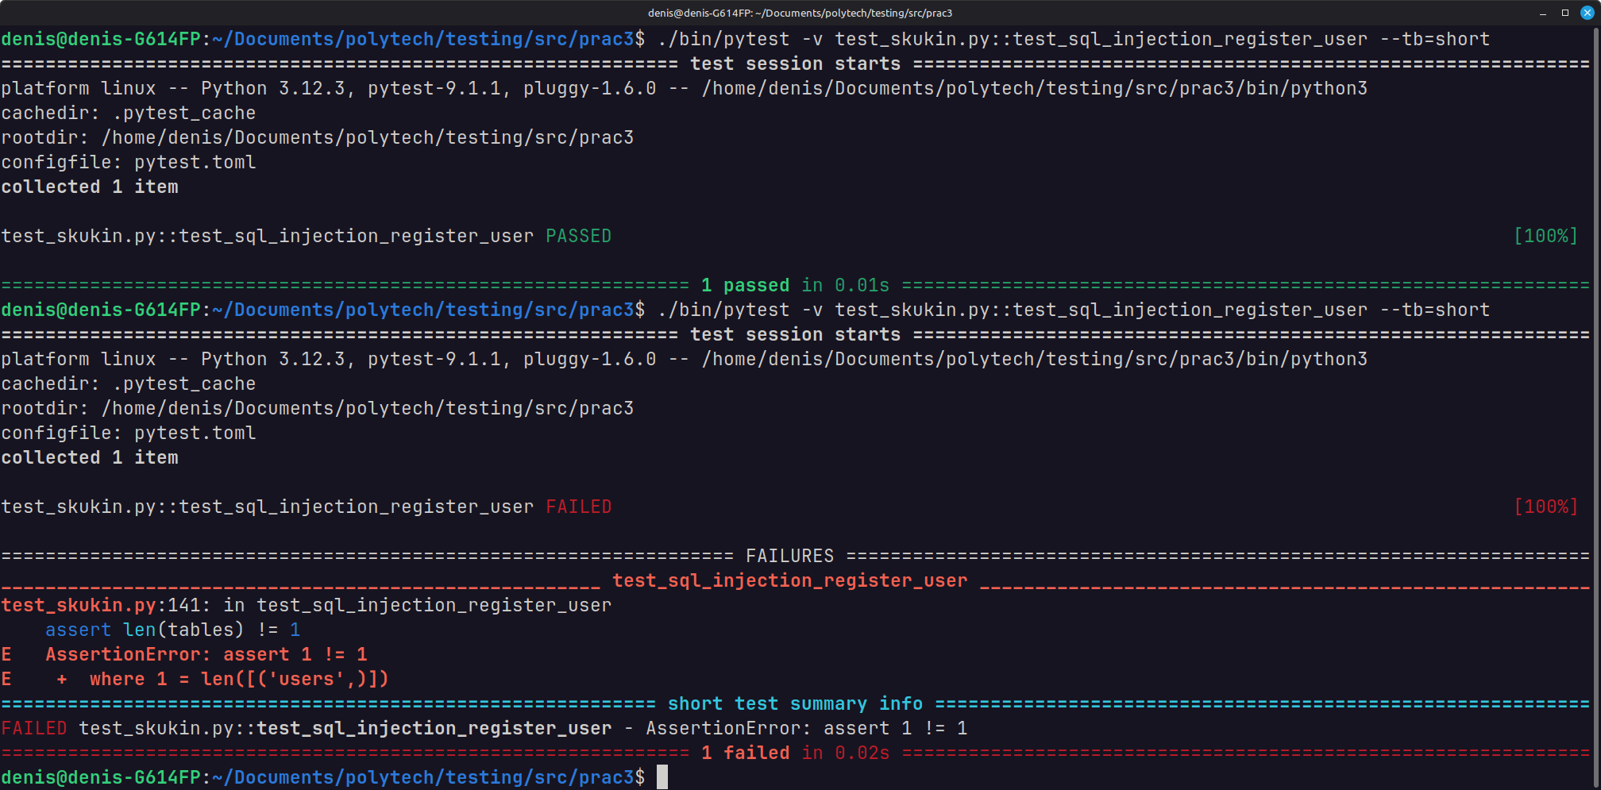
Тест №11.
@pytest.mark.sql_injection
def test_sql_injection_authenticate_user(auth_manager):
auth_manager.register_user("testuser", "password123", "Country", 1000)
user = auth_manager.authenticate_user("testuser' OR '1'='1", "password123")
assert user is not None
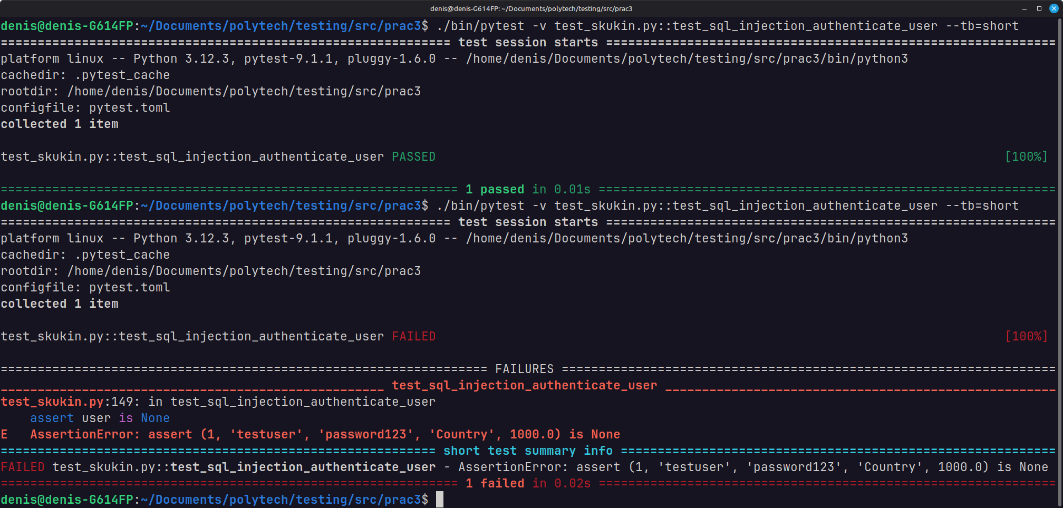
Тест №12.
@pytest.mark.sql_injection
def test_sql_injection_transfer_balance(auth_manager, db):
auth_manager.register_user("testuser1", "password123", "Country", 1000)
auth_manager.register_user("testuser2", "password123", "Country", 0)

for i in range(100):
auth_manager.transfer_balance(1, "0 OR 0=0 OR 'skukin'='cool'", 1000)

cursor = db.cursor()
cursor.execute("SELECT balance FROM users WHERE id = 1")
balance1 = cursor.fetchone()[0]
cursor.execute("SELECT balance FROM users WHERE id = 2")
balance2 = cursor.fetchone()[0]

assert balance1 == 1000
assert balance2 == 100000
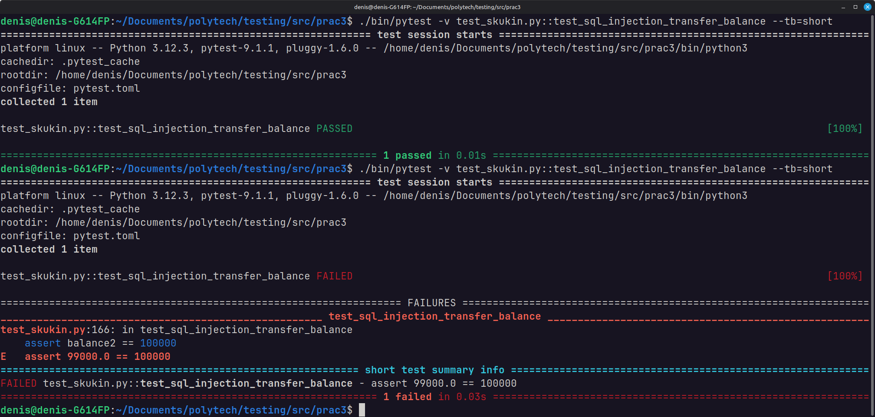
Тест №13.
@pytest.mark.sql_injection
def test_sql_injection_delete_user(auth_manager, db):
auth_manager.register_user("testuser", "password123", "Country", 1000)
auth_manager.register_user("testuser2", "password123", "Country", 1000)

auth_manager.delete_user("1337 OR 777=777")

cursor = db.cursor()
cursor.execute("SELECT * FROM users")
users = cursor.fetchall()

assert len(users) == 0
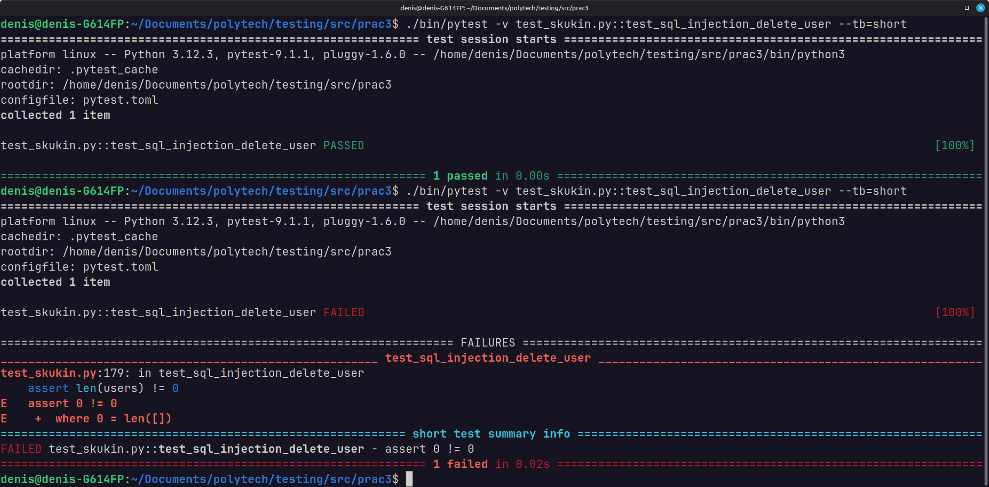

Тест №14.
@pytest.mark.skipif(sys.version_info < (3, 13), reason="Требуется Python 3.13+")
def test_python_version():
assert True
