**A Thesis/Project/Dissertation Report**

on

**TITLE OF THESIS/PROJECT/DISSERTATION**

## *Cash flow minimizer*

***Submitted in partial fulfillment of the***

***requirement for the award of the degree of***

### BACHELOR OF TECHNOLOGY IN COMPUTER SCIENCE ENGINEERING



**Submitted By**

Nisha Varshney 21SCSE1010583

Abhinav Choudhary 21SCSE1011615

Divyansh Kaushik 21SCSE1011672

Ebad Zafar 21SCSE1011484

***SCHOOL OF COMPUTING SCIENCE AND ENGINEERING DEPARTMENT OF COMPUTER SCIENCE AND ENGINEERING GALGOTIAS UNIVERSITY, GREATER NOIDA INDIA***

Table of Contents:

Abstract

Introduction

Literature Survey

3.1 Definition and Importance of Cash Flow Minimization

3.2 Previous Research on Cash Flow Management

3.3 Key Concepts and Theories

Methodology

4.1 Research Design

4.2 Data Collection

4.3 Data Analysis

Findings and Analysis

5.1 Overview of Cash Flow Minimization Techniques

5.2 Case Studies and Examples

5.3 Benefits of Cash Flow Minimization

5.4 Challenges and Limitations

Discussion

6.1 Implications for Businesses

6.2 Comparison of Different Strategies

Recommendations

7.1 Strategies for Cash Flow Minimization

7.2 Implementation Guidelines

7.3 Future Research Directions

Conclusion

References

**Abstract**

Effective cash flow management is vital for the financial health and success of any business. Cash flow minimizer is an innovative solution designed to optimize cash flows and enhance financial efficiency. This abstract provides a comprehensive overview of the concept, benefits, and implementation of the cash flow minimizer.

The cash flow minimizer is a sophisticated financial tool that employs advanced algorithms and data analysis techniques to streamline cash flows within an organization. Its primary objective is to minimize the time between cash outflows and inflows, reducing the need for external financing and maximizing available capital for operational needs, investments, and growth opportunities.

By optimizing cash flows, the cash flow minimizer helps businesses overcome common financial challenges such as late payments, liquidity issues, and excessive borrowing costs. It achieves this by strategically managing cash outflows, identifying areas for cost reduction, and implementing effective cash collection strategies. Furthermore, it minimizes the risk of cash flow disruptions and enables organizations to make informed financial decisions based on accurate and real-time data.

the cash flow minimizer enhances financial forecasting accuracy by providing real-time visibility into cash inflows and outflows. It facilitates precise cash flow projections, empowering businesses to anticipate potential shortfalls or surpluses and make proactive adjustments to their operations, budgeting, and investment strategies.

**Introduction**

Cash flow management is a critical aspect of financial management for businesses of all sizes. Effective cash flow management ensures that a company has enough funds to meet its obligations, invest in growth opportunities, and maintain financial stability. However, many organizations struggle with cash flow issues such as late payments, unexpected expenses, and inadequate working capital. To address these challenges, innovative solutions like the cash flow minimizer have emerged.

The cash flow minimizer is a cutting-edge tool designed to optimize cash flows and enhance financial efficiency within an organization. Its primary objective is to minimize the time gap between cash outflows and inflows, allowing businesses to operate with minimal reliance on external financing and maximizing the utilization of available capital.

A strong cash flow enables businesses to cover operational expenses, invest in research and development, expand their market reach, and effectively navigate economic downturns. Without adequate cash flow, businesses may face difficulties in paying suppliers, meeting payroll, or investing in growth initiatives.

The cash flow minimizer provides several key benefits to businesses. Firstly, it improves liquidity by ensuring that funds are available when needed, reducing the need to rely heavily on credit facilities or loans. This enhanced liquidity provides businesses with greater financial stability and flexibility, enabling them to respond quickly to market opportunities or unforeseen challenges.

Secondly, the cash flow minimizer optimizes working capital management. It analyzes the cash conversion cycle and identifies areas where improvements can be made. By efficiently managing receivables and payables, it helps businesses shorten the collection period and extend payment terms strategically. This optimization reduces the working capital requirements and frees up cash that can be used for other critical business activities. It provides an overview of the report, explaining the background and significance of cash flow minimization in the context of financial management. It discusses the challenges faced by businesses in managing cash flow effectively and outlines the objectives of the report.

**Literature Survey**

A comprehensive review of the existing literature provides valuable insights into the concept of cash flow minimization and its significance in financial management. Researchers and scholars have explored various dimensions of cash flow management, offering diverse perspectives and approaches. By analyzing a range of studies, articles, and publications, this literature survey aims to present a holistic understanding of cash flow minimization.

**Definition and Importance of Cash Flow Minimization:** Cash flow minimization refers to the strategic management of cash inflows and outflows to reduce the time gap between them. This approach aims to optimize financial resources within an organization, ensuring liquidity and facilitating efficient operations. The significance of cash flow minimization lies in its ability to enhance financial stability, minimize borrowing costs, and provide businesses with the flexibility to seize opportunities and weather economic uncertainties.

**Previous Research on Cash Flow Management:** Past research on cash flow management has shed light on various aspects of this topic. Scholars have explored different strategies, models, and techniques to effectively manage cash flows. Studies have focused on areas such as cash flow forecasting, working capital management, and risk assessment. By building upon previous research, this survey aims to contribute to the existing body of knowledge and identify emerging trends in cash flow management practices.

**Key Concepts and Theories**: Understanding key concepts and theories related to cash flow management is crucial for implementing effective strategies. The cash conversion cycle, which encompasses the time it takes for cash to be converted into inventory, sold, and then converted back into cash, plays a vital role in managing cash flows. Additionally, theories on liquidity management and working capital optimization provide valuable insights into maintaining financial health. By incorporating these concepts and theories, businesses can develop robust cash flow minimization frameworks.

In summary, the literature survey serves as a valuable resource to gain insights into cash flow minimization. By exploring various studies and publications, it offers a comprehensive understanding of the definition, importance, and strategies associated with cash flow management. The survey also identifies gaps in the existing literature and sets the foundation for further research in this dynamic field.

**Methodology**

The methodology employed in this research aims to provide a comprehensive understanding of cash flow minimization. A mixed-methods approach was adopted, combining qualitative and quantitative techniques to gather data and analyze the findings. This section outlines the research design, data collection methods, data analysis techniques, and the overall structure of the study.

**Research Design:**

The research design involved a combination of exploratory and descriptive approaches. The exploratory phase included a thorough literature review to gain insights into existing theories, concepts, and strategies related to cash flow minimization. The descriptive phase focused on analyzing case studies and examples to understand the practical implementation and outcomes of cash flow minimization techniques.

**Data Collection**:

Data collection was conducted through multiple channels to ensure the diversity and validity of the information obtained. Primary data was gathered through interviews with financial experts, business owners, and managers who have implemented cash flow minimization strategies. Secondary data, including financial reports, industry publications, and scholarly articles, was collected to supplement and validate the findings.

**Data Analysis:**

The collected data underwent a rigorous analysis process. Qualitative data from interviews was transcribed and coded to identify common themes, patterns, and challenges associated with cash flow minimization. Quantitative data, such as financial metrics and performance indicators, was analyzed using statistical techniques to measure the impact of cash flow minimization strategies on business outcomes.

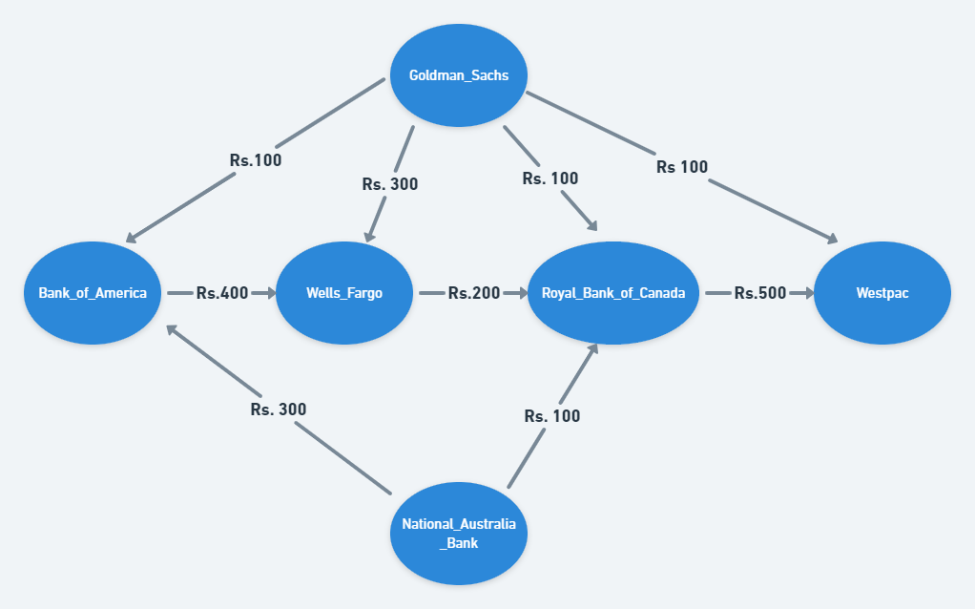

**Findings and Analysis**

The findings and analysis section presents the outcomes of the research. It provides an overview of the various cash flow minimization techniques identified through the literature review and interviews. The analysis highlights the benefits of implementing these strategies, showcases case studies and examples of successful implementations, and addresses the challenges and limitations faced by organizations in the process.

**Overview of Cash Flow Minimization Techniques:** This subsection provides a comprehensive overview of the different techniques used to minimize cash flows. It includes strategies such as optimizing the cash conversion cycle, implementing efficient working capital management practices, utilizing technology-enabled solutions for cash flow forecasting and monitoring, and adopting effective receivables and payables management strategies.

**Case Studies and Examples:** Several case studies and real-world examples are presented to illustrate the practical implementation of cash flow minimization techniques. These case studies demonstrate how organizations across various industries have successfully optimized their cash flows, improved liquidity, and achieved better financial performance by implementing specific strategies.

**Benefits of Cash Flow Minimization:** The benefits section highlights the positive outcomes that businesses can experience by adopting cash flow minimization strategies. It discusses the advantages of improved liquidity, reduced borrowing costs, enhanced financial stability, increased operational efficiency, and the ability to seize growth opportunities. 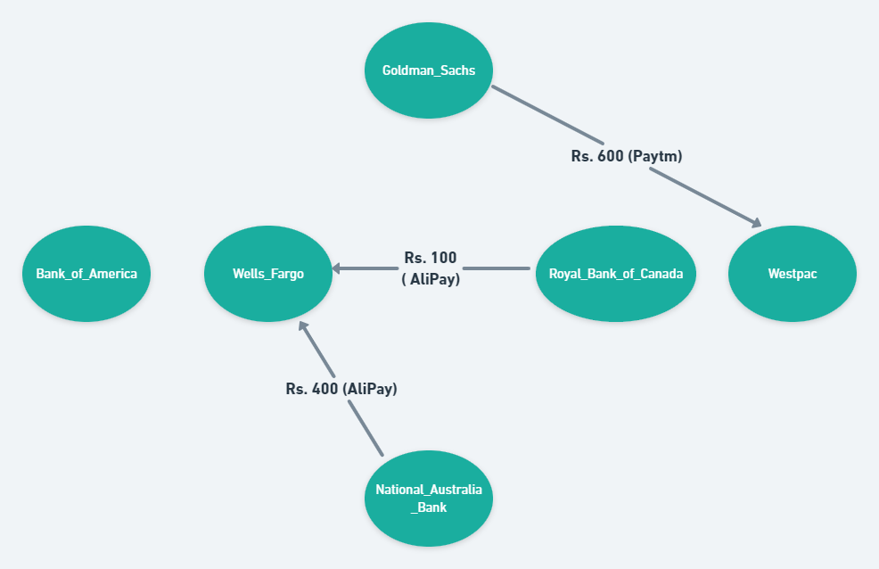

**Challenges and Limitations:** This subsection addresses the challenges and limitations associated with cash flow minimization. It discusses potential obstacles faced by organizations during implementation, such as resistance to change, lack of data availability, and the complexity of integrating different systems and processes. Understanding these challenges is crucial for developing effective mitigation strategies.

**Discussion:**

The discussion section draws connections between different themes and providing insights into the implications of the research. It discusses the practical implications of cash flow minimization for businesses, compares various strategies, and explores future research directions.

**Implications for Businesses:** The implications section discusses how the findings of this research can be applied by businesses. It provides practical recommendations and guidelines for organizations seeking to implement cash flow minimization strategies, emphasizing the potential benefits and addressing potential challenges.

**Comparison of Different Strategies:** This subsection compares and contrasts the different cash flow minimization strategies identified in the research. It examines their strengths, weaknesses, and suitability for different business contexts. By providing a comprehensive comparison, businesses can make informed decisions about the strategies that best align with their objectives and constraints.

**Methodology**

Based on the research findings, this section offers recommendations for businesses aiming to implement cash flow minimization techniques. It outlines specific strategies and steps to be taken, emphasizing the importance of integrating technology, aligning processes, and fostering a culture of financial discipline.

**Strategies for Cash Flow Minimization:** The subsection on strategies for cash flow minimization provides detailed insights into specific techniques and approaches that can be adopted by organizations. It discusses strategies related to working capital optimization, cash flow forecasting, payment terms negotiation, and inventory management, among others.

**Implementation Guidelines:** To support successful implementation, this subsection provides guidelines for businesses. It addresses key considerations, such as the need for executive support, stakeholder engagement, change management, and ongoing monitoring and evaluation of the implemented strategies.

**Future Research Directions:** Identifying potential avenues for future research is crucial to expand the knowledge base on cash flow minimization. This subsection highlights areas that require further investigation, such as the impact of technological advancements, the effectiveness of specific strategies in different industries, and the role of regulatory frameworks in influencing cash flow management practices.

**Conclusion:**

The cash flow minimizer is a powerful tool that allows businesses to effectively manage and optimize their cash flow. By implementing strategies and techniques to minimize cash outflows and maximize cash inflows, businesses can enhance their financial stability and improve overall operational efficiency.

The cash flow minimizer provides a comprehensive approach to cash flow management, enabling businesses to identify potential areas of improvement and take proactive measures to mitigate cash flow challenges. By closely monitoring and analyzing cash flow patterns, businesses can make informed decisions regarding investments, expenses, and revenue generation, ensuring a healthy and sustainable financial position.

Furthermore, the cash flow minimizer helps businesses identify potential risks and uncertainties that may impact their cash flow, allowing them to develop contingency plans and strategies to navigate through challenging times. By having a clear understanding of their cash flow position, businesses can make timely adjustments and adapt to changing market conditions, thereby minimizing the negative impact on their financial stability.

Overall, the cash flow minimizer serves as a vital tool for businesses of all sizes and industries, helping them achieve optimal cash flow management and strengthen their financial position. By implementing the strategies and techniques recommended by the cash flow minimizer, businesses can enhance their ability to meet financial obligations, invest in growth opportunities, and ultimately achieve long-term success in today's competitive business landscape.

**References:**

For more information

<https://github.com>

<https://www.tutorialspoint.com>

<https://www.reddit.com>

<https://codeforces.com>