**ACKNOWLEDGEMENT**

## It is our earnest duty to express our thanks to all those who contributed directly or indirectly to our project.

## Firstly we would like to thank RSSP’S MAHARASHTRA COLLEGE OF SCIENCE & COMMERCE,KOTHRUD, PUNE – 411 038 and Computer Science Department for giving us an opportunity. We would like to thank our Project Guide Prof. Mrs. Shobha Jagtap, who initiated us to complete this project and guided us timely.

## Last but not least we express our gratitude to all staff members and all our friends for their excellent suggestions and coordination.

## There might be some problems and extra requirements with this system. In future these problems will be corrected accordingly. For this your valuable suggestions are most welcomed.

**INDEX**

|  |  |  |
| --- | --- | --- |
| **Sr. No** | **Contents** | **Page No** |
| 1 | Problem Definition | 7 |
| 2 | Existing System and need for the new system | 8 |
| 3 | Scope of the work | 9 |
| 4 | Feasibility Study | 11 |
|  | Technical Feasibility | 11 |
|  | Economical Feasibility | 11 |
|  | Operational Feasibility | 11 |
|  | Hardware &software Requirement Specification | 12 |
| 5 | Requirement Analysis | 13 |
|  | fact finding methods | 13 |
| 6 | E-R Diagram | 15 |
| 7 | Normalized Database Design & Data Dictionary | 16 |
| 8 | Use-case Diagrams | 19 |
| 9 | Class Diagrams | 20 |
| 10 | Sequence Diagram | 21 |
| 11 | Activity Diagram | 22 |
| 12 | Component Diagram | 23 |
| 13 | Deployment Diagram | 24 |
| 14 | Use interface design | 25 |
|  | Input Screens using sample data | 25 |
|  | Reports | 33 |
| 15 | Testing & Implementation plan | 34 |
| 16 | User manual | 40 |
| 17 | Drawbacks, Limitations & Proposed enhancement | 43 |
| 18 | Abbreviations | 44 |
| 19 | Bibliography & References | 45 |

**Introduction:-**

We are very glad to introduce our project “**AUTOMATED TELLER MACHINE**”. Now a day each company or organization prefers the computerized paper-work. Definitely the computer system is more reliable than the manual works. The common human errors can be eliminated with the help of system.

An **Automated Teller Machine** (**ATM**) is a computerized telecommunications device that provides the customers of a financial institution with access to financial transaction in a public space without the need for a human clerk or bank teller. On most modern ATMs, the customer is identified by inserting a plastic ATM card with a magnetic stripe or a plastic smartcard with a chip that contains a unique card number and some security information.

ATMs are known by various other names including automated banking machine, money machine, bank machine, cash machine and Any Time Money in India.

An ATM card (also known as a bank card, client card, key card or cash card) is an ISO 7810 card issued by a bank, credit union or building society, Unlike a debit card, in-store purchases or refunds with an ATM card can generally be made in person only, as they require authentication through a personal identification number (PIN). In other words, ATM cards cannot be used at merchants that only accept credit cards.

**History of ATM Machines:**

[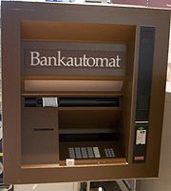](http://en.wikipedia.org/wiki/File:Fr%C3%BCher_Bankautomat_von_Nixdorf.jpg)

The first mechanical cash dispenser was developed and built by Luther George Simjian and installed in 1939 in New York City by the City Bank of New York, but removed after 6 months due to the lack of customer acceptance.

Thereafter, the history of ATMs paused for over 25 years, until De La Rue developed the first electronic ATM, which was installed first in Enfield Town in North London, United Kingdom on 27 June 1967 by Barclays Bank. This instance of the invention is credited to John Shepherd-Barron, although various other engineers were awarded patents for related technologies at the time. Shepherd-Barron was awarded an OBE in the 2005 New Year's Honours List. The first person to use the machine was the British variety artist and actor Reg Varney.

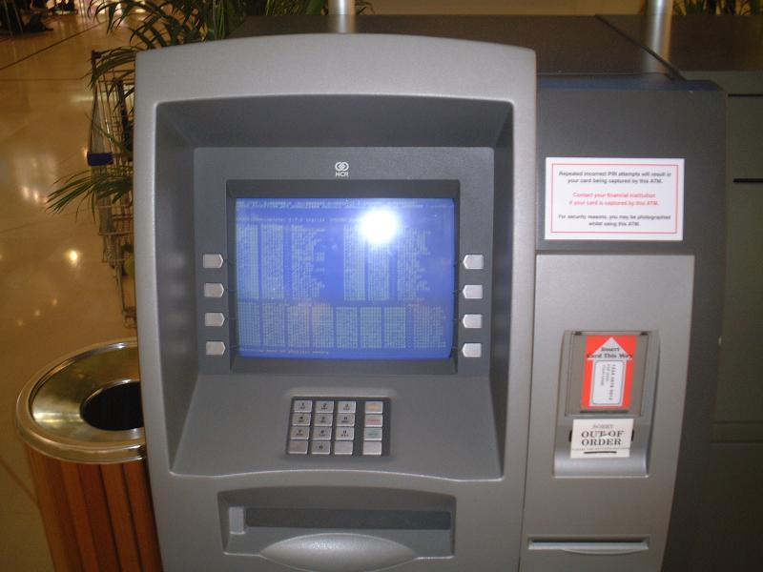

The first ATMs accepted only a single-use token or voucher, which was retained by the machine. These worked on various principles including radiation and low-coercively magnetism that was wiped by the card reader to make fraud more difficult. The machine dispensed pre-packaged envelopes containing ten pounds sterling. The idea of a PIN stored on the card was developed by the British engineer James Goodfellow in 1965.

ATMs first came into wide UK use in 1973; the IBM 2984 was designed at the request of Lloyds Bank.

**Problem Definition:-**

**Automated Teller Machine** (**ATM**) system is banking software developed to give facility of bank customer for 24hours & nearer to your location; therefore customer can do their transaction at any time at any place. This software is also help for bank, to minimize crowding of customer in bank premises & pressure of work on bank servants.

Now a day each company or organization prefers the computerized paper-work. Definitely the computer system is more reliable than the manual works. The common human errors can be eliminated with the help of system.

The main objective of ATM system is to help the organization in automating the whole manual processing of the existing system. This project should support multi user environment. The system is fully automated. ATM systemis designed to solve the purpose of clarifying system requirement. This system should be able to handle extremely large volumes of data. This system should capable to keep track of all detailed description of the account holder of banks.

The following details are involved in this ATM system project,

* ATM Card holder /account /bank customer detail.
* Daily transaction detail of each ATM card holder.

**Existing System:-**

* Existing system creates complexity in doing calculation of collection of money because it is manual.
* Existing system creates problems in maintaining records of book keeping.
* Existing system, there is large documentary work so it requires space for its storage.
* To do the documentary work there is need of extra staff worker.
* Existing system takes much more time to updating process of records.
* Due to existing system crowding of customer in bank premises are more & pressure of work on bank servants are also more.

**Need for the new system:-**

* The proposed system need to maintain all the records in computerized form.
* It is useful to store record systematically & accurately by using this system.
* It is useful to reducing the extra work which maintains the records of book keeping & paper less work.
* We can easily handle data efficiently & effectively.
* The storage space, extra workers, missing files all these possibilities are decreased through this system.
* This system helps to save time & cost spending on documentation.
* With the help of this system ATM card holder can see all the records about his account only at any time efficiently.
* The most important facility provided by this system is that, there is no any possibility of miss any records.
* This system is useful for recording daily transactions done by customers.
* So, this system helps to overcome the problems of previous system.
* An ATM card is an ISO card issued by a bank, credit union or building society. Unlike a debit card, in-store purchases or refunds with an ATM card can generally be made in person only, as they require authentication through a personal identification number or PIN. In other words, ATM cards cannot be used at merchants that only accept credit cards.

**Scope of the work:-**

As this is software it can be used by a wide variety of banks to automate the process of manually maintaining the records related to the each transaction of bank account holder. The main goal of this application is to provide very reliable & efficient service to bank account holder at any time & any location.

This system will cover the following modules,

1. Cash Withdrawal.
2. Balance Enquiry.
3. Mini Statement.
4. PIN Change.
5. Cash Deposit.
6. Loan Information.
7. Help Menu.

**Detail information about system modules,**

1. **Cash Withdrawal :-**

It mainly used for withdrawal of cash as per customer demand. For any authorized ATM card holder the ATM system requests for its ATM no & PIN no then customer to login in their accounts, then amounts are given to system and customer can withdraw amount.

1. **Balance Enquiry :-**

It refers to enquiry of bank balance of an authorized ATM card holder account to check for the resulting balance after certain transactions.

1. **Mini Statement:-**

It refers to enquiry of last ten transaction of an authorized ATM card holder. It includes deposit & withdrawal amount of transaction & also contains respective transaction date and current available balance.

1. **PIN Change:-**

It refers to the Change of PIN no of an authorized ATM card holder. I require giving system old PIN no of the ATM card & then giving new PIN no & confirm the new PIN no.

1. **Cash Deposit:-**

It mainly used for deposit cash amount to their bank account as per customer demand. It is easy process of deposit amount to their bank accounts without filling deposit sleep.

1. **Loan Information:-**

It mainly used for to give information about various bank loan rates to ATM card holder.

1. **Help Menu:-**

Help menu gives information about how to use ATM card when you give correct information to ATM system. I describe information about all transaction menus & what is used of each menu.

**Feasibility study:-**

## Feasibility Study is essential to evaluate cost & benefit of the proposed system. This is very important step because on the basis of this; system decision is taken on whether to proceed or to postpone the project or to cancel the project. Feasibility study forms the most important phase in the system development life cycle so that the people who are affected by the system benefit from the change. This involves some very crude estimates of schedules of completion of the proposed system and the cost of the system. This study ensures that the system meets the objectives of the organization before it can be approved for development. It also involves the study of different risks involved in developing the system.

The major areas to consider while determining the feasibility of a system are:-

* **Technical Feasibility:-**

## The technical feasibility study always focuses on the existing computer hardware, software and personal. This also includes need for more hardware, software or personal and possibility of procuring or installing such facilities.

## ATM is a system that can work on single stand alone Pentium machine with 128 MB RAM, Hard disk drive size of 80 GB, mouse, monitor and keyboard & it also require internet connection to corresponding computer. The equipments are easily available in the market, so technically the system is very much feasible.

* **Economical Feasibility: -**

## This feasibility is useful to find the system development cost and checks whether it is justifiable. The cost overheads include software and hardware maintenance cost, training costs that includes cost required for manpower, electricity, stationary etc. The proposed system will provide the right type of information at right time, and in the required format. This will save time required for decision-making and routine operations. Considering all these advantages, the cost overheads of the system are negligible. So the system is economically feasible.

* **Operational Feasibility : -**

It is also known as resource feasibility. The operation users of the system are expected to have minimum knowledge of computer. The developed system is simple to use, so that the user will be ready to operate the system. The proposed system is developed using JAVA programming language & Mysql database which is platform independent and user friendly. So the system is operationally feasible.

**Hardware Requirements:-**

* Processor: Pentium 4 or onwards.
* Hard Disc: 80GB.
* RAM: 128MB.
* Monitor: 15” Color Monitor.
* Mouse.
* Keyboard.

**Software Requirements:-**

Operating System: - Windows XP or onwards or Linux.

* Java Run Time Environment (JRE) – jdk1.5 (As Front End Tool).
* Mysql-connector-java-5.1.22-bin.
* MYSQL server (As Back End Tool).
* JCreator.

**Programming Languages Used**:-

In this system we use JAVA Platform for programming language.JAVA Platform means the environment which is used to run program.JAVA is platform independent language since no only single operating system can be required by the java. All the different operating system can execute the java programming language.

Java provides huge functionality that means it provide A huge library.

* Containing lots of reusable codes.
* An execution environment that provides services such as security.
* Portability across operating system.
* Automatic garbage collection.

**Requirement Analysis:-**

This involves studying the current system to find out how it is working and where the improvements should be made. These studies consider both manual and computer methods. Hence an early step in investigation is to understand situation.

Activities In Requirement Determination:

* Requirement Investigation:
* Requirement Specification:

1. **Requirement Investigation**:-

This activity is at the heart of system analysis. Using a variety of tools and skills analyst study the current system and documents its features for further analysis. Requirement investigation relies on the fact-finding techniques

1. **Requirement Specification**:-

The data produced during fact-finding investigation are analyzed to determine requirement specification. This is the description of features for new system.

**Fact Finding Techniques:-**

Fact-Finding is the formal process of using research, interviews, questionnaires, sampling and preferences. It is also called information about systems, requirements, and preferences. It is also called **Information Gathering** or **Data Collection**. Tools, such as data and process models, document facts, and conclusion are drawn from facts. If you can’t collect the facts, you can’t use the tools. Fact-Finding skills must be learned and practiced.

**Different types of Fact-Finding techniques are:**

* INTERVIEWS

* QUESTIONNAIRE

* RECORD REVIEW

* OBSERVATION

* **Interviews :**

Interview technique is used to collect the information from individuals groups. Analyst should select responds that are related with the system under study. In this method the interviewer (analyst) faces to face with respondent & records of his/her responses. This interviewer must plane in advance and should fully know the problems under consideration. He must choose a suitable time & place, so that the interviewer may feel at ease during interview.

* **Questionnaire:**

A questionnaire performs containing a sequence of questions to elicit information mostly from a large no of persons. Drafting of questionnaires requires skill. The questions must be clear, simple & to the point. They must be well organized from the point of view of the respondent and formulated in such a manner as to provide the data in so far as possible in the desired form. A questionnaire may be mailed to individuals who are requested to write the answer of each question and return complemented performs back by post.

* **Record view:**

Information related with the system may be present in the form of records like books, magazines, newspaper, historical documents, letters, journals, manuals, government publications. This kind of record review provides very valuable information to the analyst about the system, organization & various procedures & rules.

Record review may be performed in the beginning of study to collect initial information or at the end of the study to compare actual operations.

* **Observations:**

If information is not collected from the other fact-finding methods, then observation method is used. In this method analyst observes the flow of documents, way the process is carried out, step followed, the persons involved etc. If the analyst is familiar with the system then he/she knows what to observe and how to gather information. In experienced person may observe unnecessary things, which delays the system study.

**Entity Relationship Diagram:-**

Transaction

Maintains

ATM SYSTEM

1 1 1

Report

Generates

Accountdetail

Maintains

M M

1 M

Give information to

Request to

M

M 1

**Normalized Database Design & Data Dictionary:-**

**Database Table Design**:-

The general theme behind a database is to handle information as an integrated whole. A database is a collection of interrelated data stored with minimum redundancy to serve many users quickly and effectively. After designing the input and output, the analyst must concentrate on database design or how data should be organized around user requirements. The general objective is to make information access, easy quick, inexpensive and flexible for other users. During database design the following objectives are concerned:-

* Controlled Redundancy
* Easy to learn and use
* More information and low cost
* Accuracy
* Integrity

1. Table Name: - **accountdetail** It stores the information about account detail of ATM card holder.

|  |  |  |  |  |
| --- | --- | --- | --- | --- |
| **Field name** | **Data type** | **Size** | **Constraint** | **Description** |
| atmno | int | 20 | Primary key | ATM card no. |
| accno | int | 20 | Not Null | Account no of ATM card holder. |
| pinno | int | 10 | Not Null | PIN no of ATM card holder. |
| acctype | varchar | 50 | Not Null | Account type of ATM card holder. |
| name | varchar | 100 | Not Null | Name of the ATM card holder. |
| balance | float |  | Not Null | Available balance of ATM card holder. |
| expirydate | date |  | Not Null | ATM card expiry date. |

1. Table Name: - **transaction** It stores the information about each transaction created by ATM card holder.

|  |  |  |  |  |
| --- | --- | --- | --- | --- |
| **Field name** | **Data type** | **Size** | **Constraint** | **Description** |
| trid | int | 10 | Primary key | Transaction no |
| atmno | int | 20 | Foreign key | ATM card no. |
| accno | int | 20 | Foreign key | Account no of ATM card holder. |
| depositamt | float |  | Not Null | Deposit amount of ATM card holder. |
| withamt | float |  | Not Null | Withdrawal amount of ATM card holder. |
| avbalance | float |  | Not Null | Available balance of ATM card holder. |
| tdate | date |  | Not Null | Transaction date at which transaction occurred by ATM card holder. |

**Data Dictionary:**

The data dictionary of any system is an integral component of structure analysis, since data flow diagrams by themselves do not fully describe the subject under investigation about the system. A data dictionary is a catalog – a repository – of the elements in the system. These elements center on data and the way they are structured to meet user requirements and Money Exchange System needs. This step of creating a data dictionary is simultaneous with the process of making data flow diagram(s). Here all the data fields in their respective tables are allotted so as to access these data in the system. The data tables are created in a back-end tool like Microsoft Access, Mysql etc…. Here in the ATM System we are created database and tables using Mysql as it is the back-end tool used in the system.

The data dictionary consists of different major elements like Data Elements, Data Store [Tables Used], Data Flow, Processes and other External entities used in the system. The data dictionary stores details and description of these elements.

It is developed during data flow analysis and assists the analysts involved in determining the system requirements. Analysts use data dictionary for the following important reasons:

* To manage the details in large system.
* To communicate a common meaning for all system elements.
* To document the features of the system.

To facilitate analysis of the details in order to evaluate the characteristics and determine where system changes should be made. To locate errors and omissions in the system. The data dictionary contains different types of descriptions for the data flowing through the system:

**Data Elements** is the most fundamental level which is also considered as the building block for all other data in the system. It refers to all the different data used like fields, data item, etc. to make the system fully functional irrespective to the table used in the system. Here all the different type of fields used to make table are written sequentially without referring to the tables. This process helps in the process of **Normalization** of tables.

Next to Data Elements comes the **Data storage** which provides the information of where and how each data element is stored in which table and it also give information of any constraints if there. This step also gives knowledge of different data types used for different field and their size. All the normalized tables are showed in data storage.

**Data Flow** stage shows the flow of data in the system. This step is can be already seen in the data flow diagrams above in this document. This step refers to all the data flow paths were transactions are done in the computerized system.

The data flow step also includes different processes used in the system and it is followed by **External Entities** used in the system.

**Use-case Diagrams:-**

|  |
| --- |
| ATM System |

Technician

Bank

ATM card holder

**Class Diagrams:-**

Accountdetails

accno:integer

atmno:integer

pinno:integer

name:string

acctype:string

balance:float

expirydate:date

sname:string

+get_cash_withdraw():float

+give_cash_deposit():float

+ask_balance_enquiry():string

+get_mini_statement():string

+update_pin_no():integer

+get_loan_information():string

Transaction

trid:integer

atmno:integer

accno:integer

depositamt:float

withamt:float

avbalance:float

tdate:date

+ give_transaction_details():string

+provide_medicines()

1 1..*

1..*

1

ATM SYSTEM

atmno:integer

pinno:integer

+validate_atmno_pinno():boolean

+validate_account_type():boolean

+validate_cashwithdraw_limit():boolean

+manage_account_details():string

+manage_transaction_details():string

1..* 1

**Sequence Diagram:-**

:ATM card holder

:ATM SYSTEM

:Bank database

enter atm card no & pin no

validate atmno & pin no

request details of atm

give atm details

give response as name of card

request cash withdraw

validate per

day limit& balance update

give cash withdrawal details bank db

give cash amount and balance recpt give balance details

request for cash deposit amount give cash deposit details

give balance receipt give balance details update

bank db

request pin change validate old pin no

& update new pin no

Give new pin no details

give msg pin update successfully give details pin no update

request for balance enquiry bank db

request for balance details

give balance details

give details of balance

end

**Activity Diagram:-**

Handle code & show message

Verify atm no & pin no

[Incorrect]



[Correct]

Ask for transaction

Ask for deposit amount

Ask for balance enquiry

Ask for update pin no

Ask for withdrawal amount

[Amount not available] [Add amount] [Old pin! =]

Show balance & print it

Show balance & print it

[Amount available] [Old pin correct]

Finish transaction & print it

Show message pin no update successfully

Dispense cash & show balance & print it

**Component Diagram:-**

Welcome.java

atmdb.sql

Atmcardno.java

AccountType.java

TransactionMenu.java

CashDeposit .java

MiniStatement.java

BalanceEnquiry.java

CashWithdrawal .java

Help .java

Pinchange .java

LoanInformation .java

**Deployment Diagram:-**

Cash Dispenser

Receipt

Printer

ATM

Machine

Network Interface

Network connection

ATM

Network server

**Use interface design: - Input Screens using sample data:**

1. **Welcome screen:**

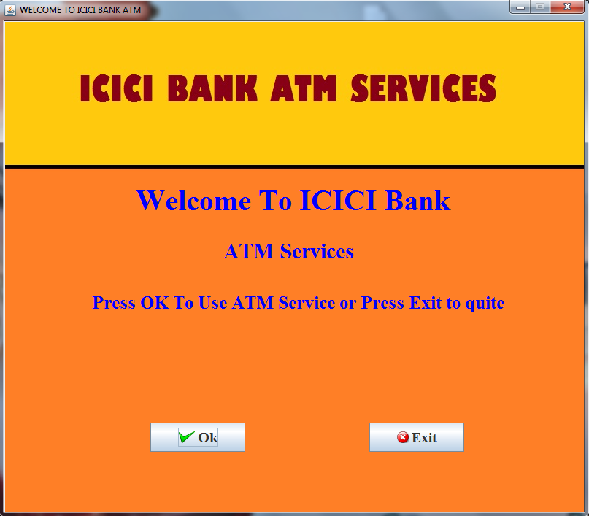

1. **ATM card no screen**: on success then below screen.

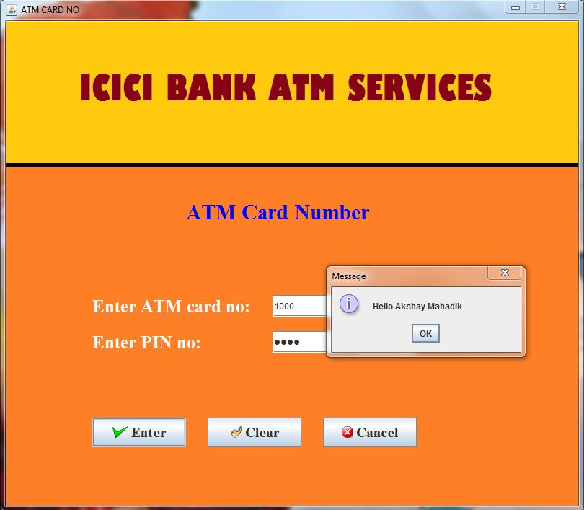

1. **ATM card no screen:** if enter wrong ATM no or PIN no.

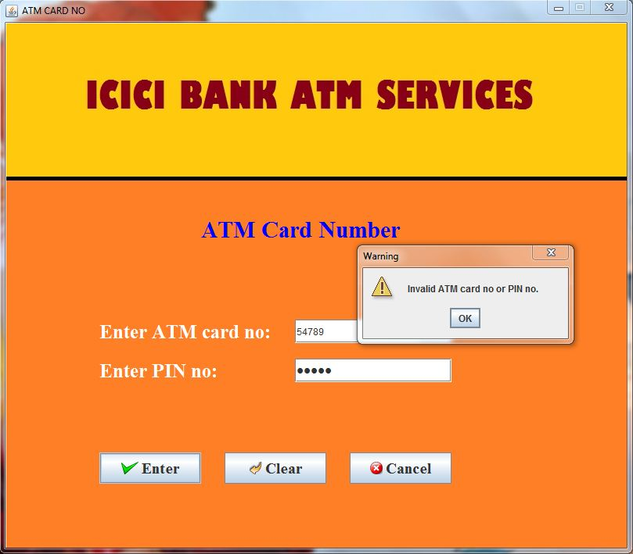

1. **ATM card no screen:** if ATM card is out expiry date

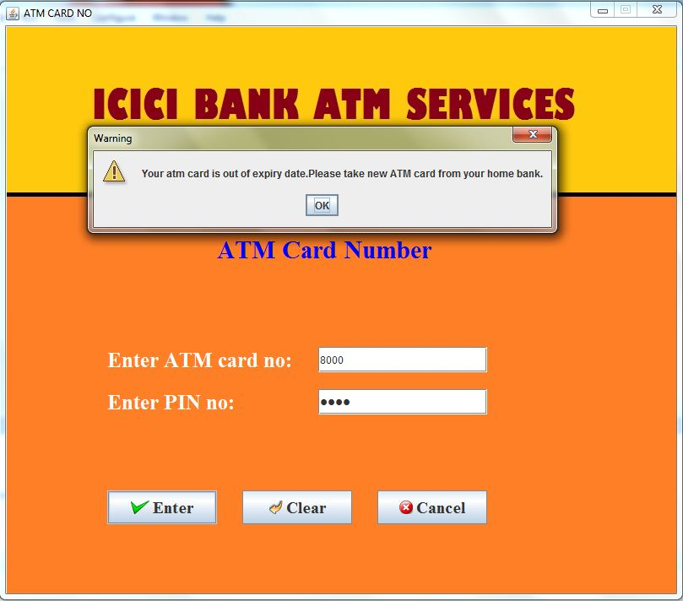

1. **ATM card no screen:** each screen display out of 20sec then below message.

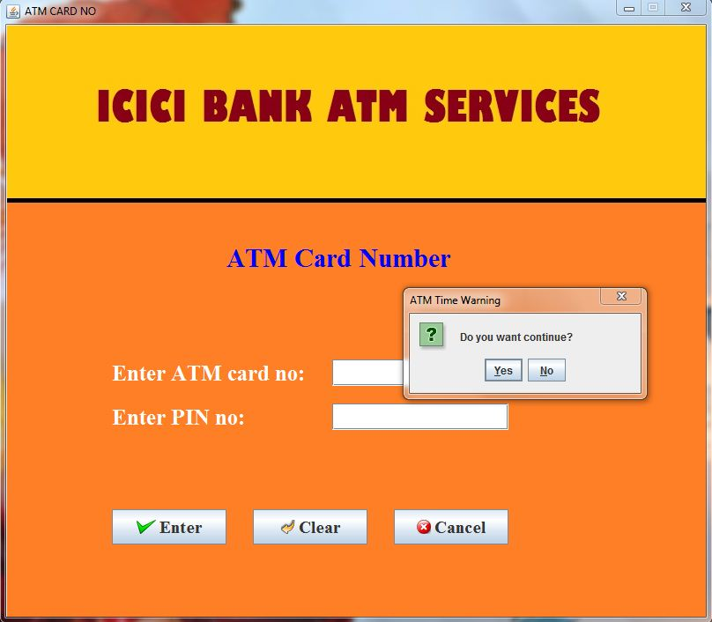

1. **Account type screen:** if account type is correct then go to transaction menu & wrong then appear below screen & go to welcome screen.

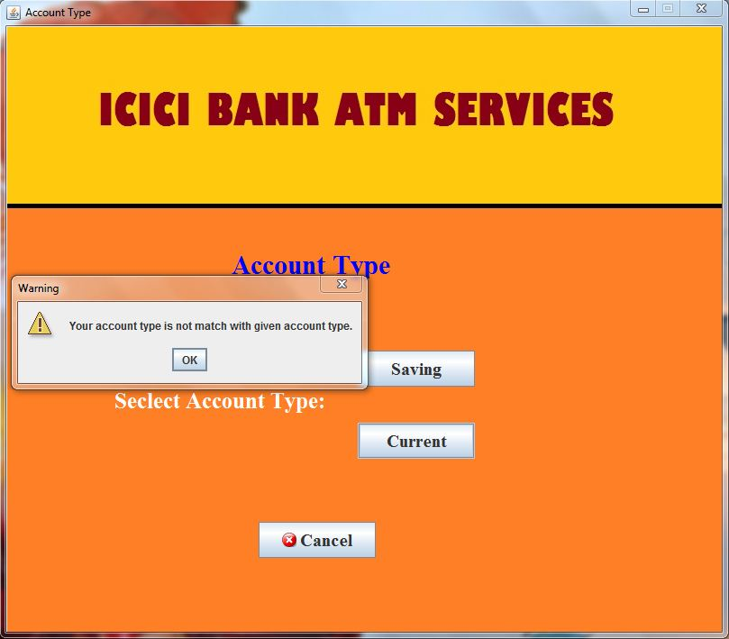

1. **Transaction menu screen:**

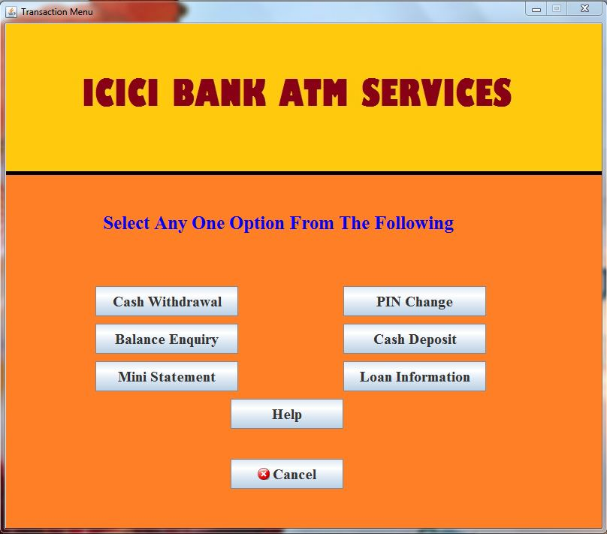

1. **Cash withdrawal screen:** if cash withdrawal is success then appear below screen, if we click on YES then go to balance enquiry screen, if NO then show available balance.

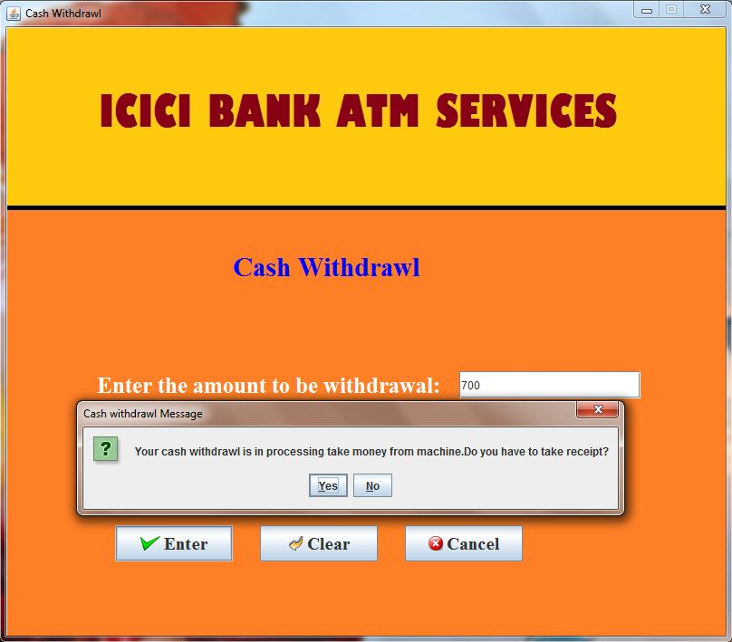

1. **Cash withdrawal screen:** if we enter amount >10000 then below appear screen.

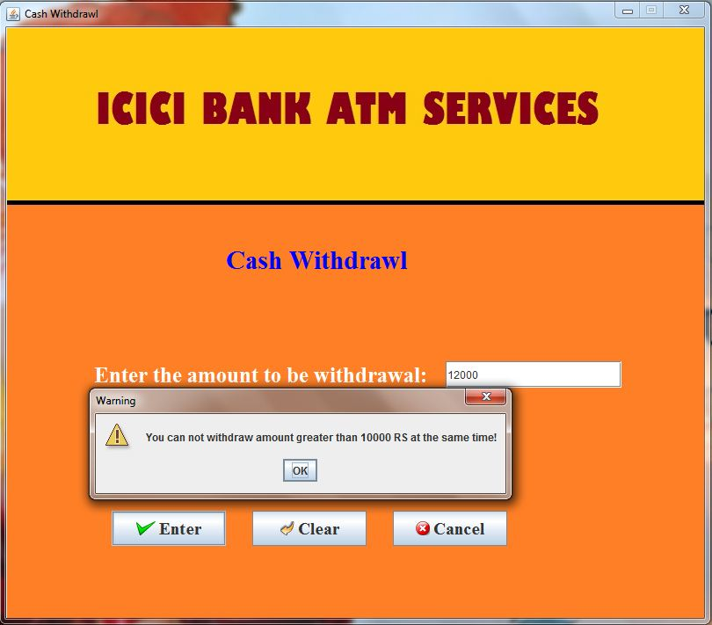

1. **Cash withdrawal screen:** if per day withdrawal amount >25000 then below appear screen if your account is saving & account is current then amount>50000.

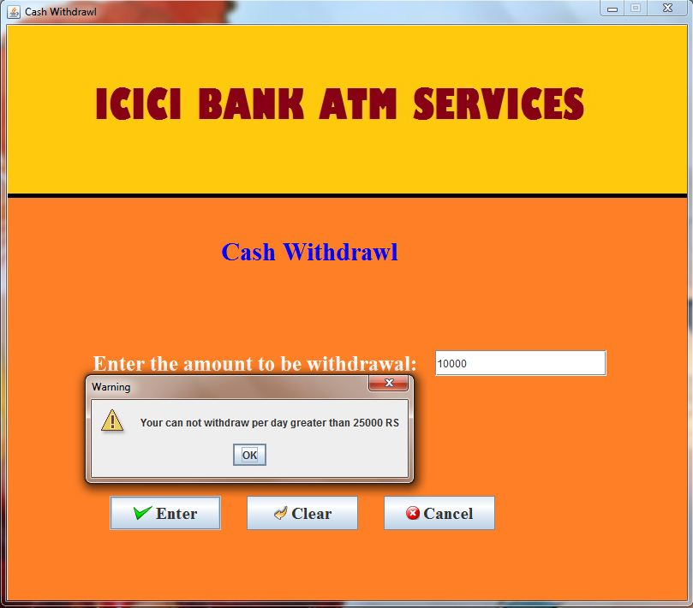

1. **Cash deposit screen:** if cash deposit is success then appear below screen, if we click on YES then go to balance enquiry screen, if NO then show available balance.

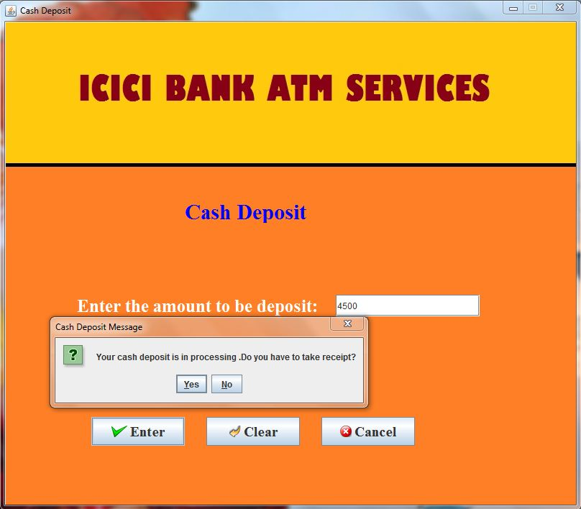

1. **Balance Enquiry screen:**

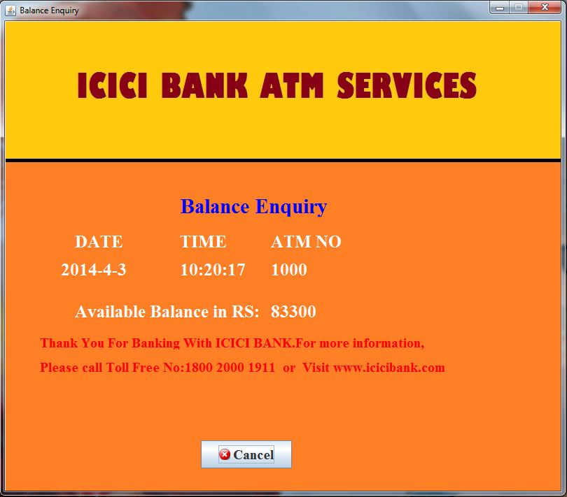

1. **PIN change screen:** if we enter old pin no correct and new & confirm pin no same then appear below screen.

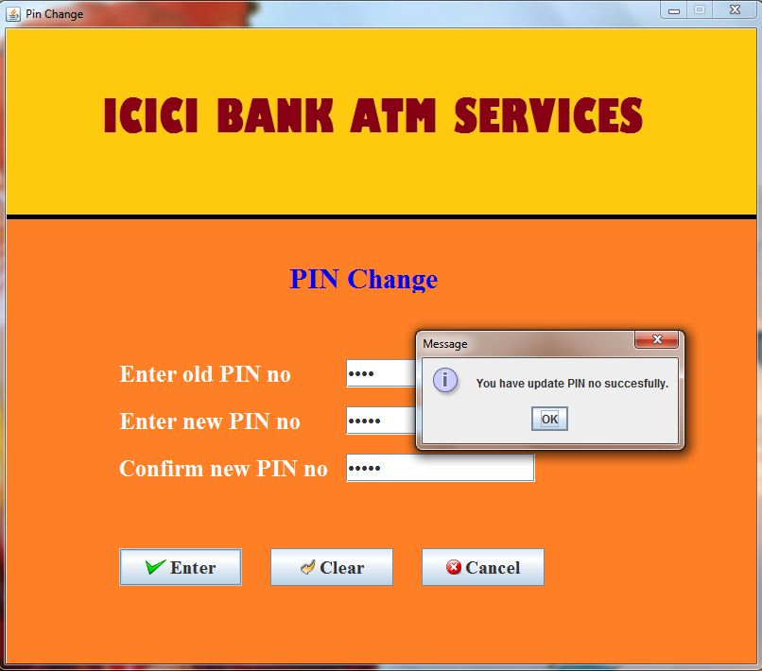

1. **PIN change screen:** if we enter old pin no wrong and new & confirm pin no same then appear below screen.

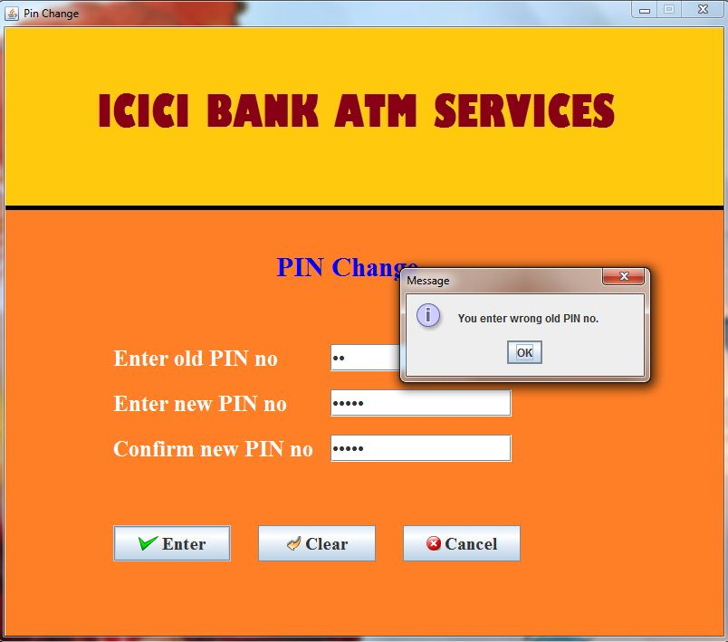

1. **PIN change screen:** if we enter old pin no correct and new & confirm pin no different then appear below screen.

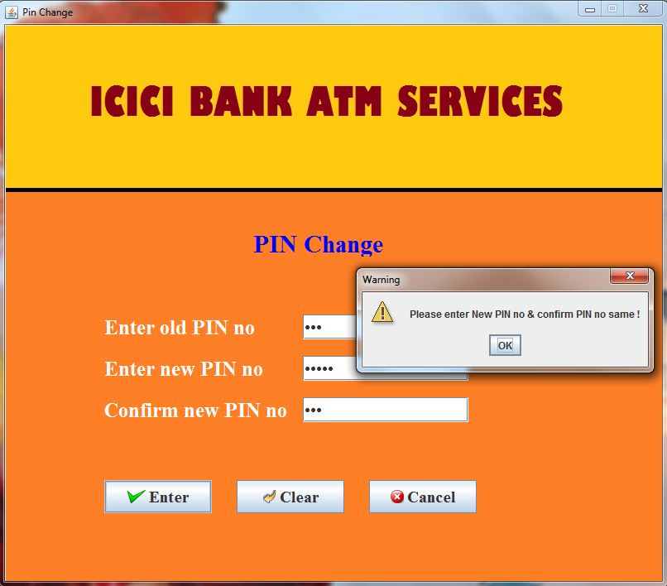

1. **Loan Information:**

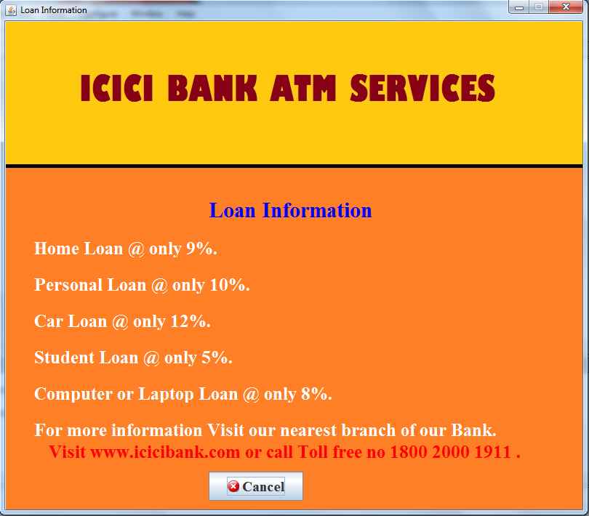

1. **Help screen:**

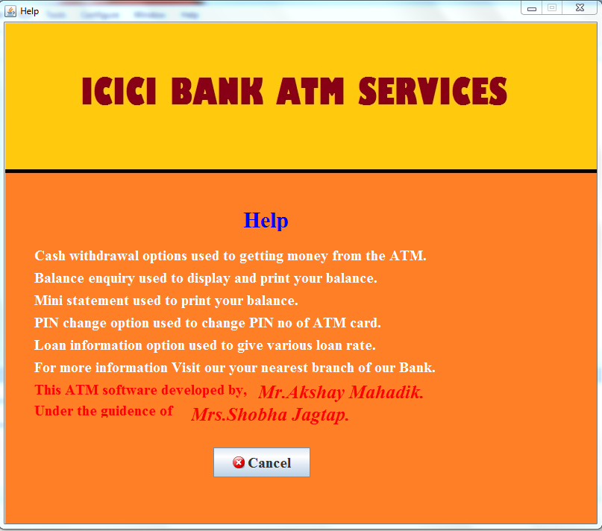

**Reports:** 1) **Mini statement screen:**

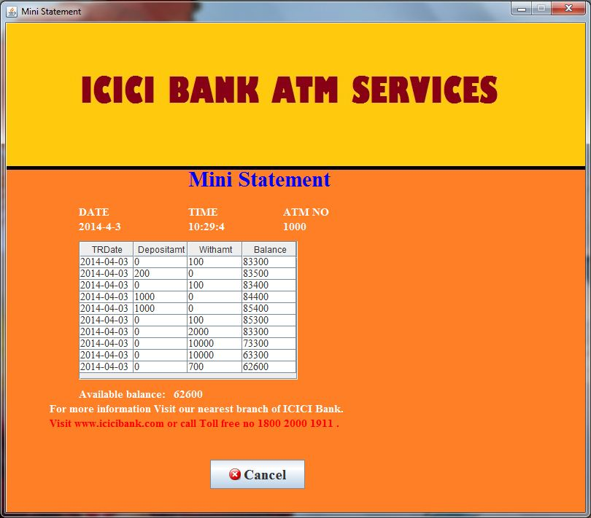

**Testing & Implementation plan:**

A process of executing a program with the goal of finding errors is Software Testing. A Software Testing Strategy helps to convert test case designs into a well-planned execution steps that will result in the construction of successful software. Software testing is a destructive process of trying to find the errors. The main purpose of testing can be quality assurance, reliability estimation, validation or verification.

**Principle of Testing:**

* All tests should be traceable as per the customer requirement.
* Resource planning should be in advanced.
* Test cases should not leave any fatal error.
* Test case should handle all critical functions.

Testing is the set of activities that can be planned in advance and conducted systematically. To define these activities templates are provided by different testing strategies.

**Unit Testing:**

At vertex of spiral, testing begins with unit testing. It aims at testing each component or unit of software to check its functionality, independently. Ensures that it works properly as a unit. Typical units are

• Interface: tested to check proper flow of information into and out of the program unit under test.

• Local data structures: tested to check integrity of data during execution.

• Boundary conditions: tested to ensure unit operates properly at boundaries to limit processing.

• Independent paths: tested to ensure all statements in the unit are executed at least once.

• Error handling paths: tested to check whether error messages are user friendly and corresponds to error encountered, whether they reroute or terminate process when error occurred.

• Common errors found during unit testing are: incorrect initialization, precision inaccuracy, mixed mode operation, incorrect arithmetic precedence etc.

**Integration testing**:

Further progressing the testing process, these units must be assembled or integrated to form complete software package. So integration testing focuses the problems of verification and construction.

**Validation testing**:

Taking one more outward turn along spiral, comes validation testing. It consists of higher order tests using validation criteria defined during requirement analysis phase. This test assures that software meets all functional, behavioural and performance requirements.

**Performance Testing:**

It concentrate on the transaction response time, throughput etc. It is designed to test the run-time performance of software within the context of an integral system. Performance testing is conducted throughout all steps of testing process.

**User Acceptance Testing:**

The major concern while developing any product is that the product must satisfy the user. Any acceptance testing validates & verifies whether the product is user acceptable or not. This test confirms the reliability of the product.

**Test Cases & Test Results**:-

|  |  |  |  |  |  |
| --- | --- | --- | --- | --- | --- |
| **Test no** | **Test name** | **Description** | **Expected**  **output** | **Actual**  **output** | **Result** |
| 1 | Validate ATM card no & PIN no. | Check for valid ATM card no & PIN no of ATM card no screen. | If ATM card no & PIN no is valid then **go to test no 2.**  If ATM card no & PIN no is not valid then display message “**Invalid ATM card no or PIN no.**” | If ATM card no & PIN no is valid then **go to test no 2.**  If ATM card no & PIN no is not valid then display message “**Invalid ATM card no or PIN no.**” | pass |
| 2 | Validate ATM card expiry date. | Check for ATM card expiry date is out of current date of ATM cards no screen. | If ATM card is in expiry date then display next screen as a “**Account Type**”  If ATM card is out of expiry date then display message “**Your ATM card is out of expiry date. Please take new ATM card from your home bank.**” | If ATM card is in expiry date then display next screen as a “**Account Type**”  If ATM card is out of expiry date then display message “**Your ATM card is out of expiry date. Please take new ATM card from your home bank.**” | pass |
| 3 | Validate each screen time. | Check for each screen timer is out of 20 seconds. | If each screen is timer is out of 20seconds then display messages “**Do you want to continue?**”  If user clicks on **YES** then **current screen is display 20seconds**.  If user clicks on **NO** then **current screen is exit** & display “**Welcome screen**” | If each screen is timer is out of 20seconds then display messages “**Do you want to continue?**”  If user clicks on **YES** then **current screen is display 20seconds**.  If user clicks on **NO** then **current screen is exit** & display “**Welcome screen**” | pass |
| 4 | Validate account type of ATM card holder. | Check for account type of ATM card holder of Account type screen. | If account type of ATM card holder is match then display next screen as “**Transaction Menu**”  If account type of ATM card holder is not match then display messages “**Your account type is not matched with given account type.**” & **current screen is exit** & display “**Welcome screen**” | If account type of ATM card holder is match then display next screen as “**Transaction Menu**”  If account type of ATM card holder is not match then display messages “**Your account type is not matched with given account type.**” & **current screen is exit** & display “**Welcome screen**” | pass |
| 5 | Validate withdrawal amount of saving account. | Check for withdrawal amount on current date & enter withdrawal amount is <=25000 of saving account of cash withdrawal screen. | If sum of withdrawal amount on current date & enter withdrawal amount of saving account is <=25000 then **go to test no 7.**  If sum of withdrawal amount on current date & enter withdrawal amount of saving account is !<=25000 then display message “**Your cannot withdraw per day greater than 25000 RS**” | If sum of withdrawal amount on current date & enter withdrawal amount of saving account is <=25000 then **go to test no 7.**  If sum of withdrawal amount on current date & enter withdrawal amount of saving account is !<=25000 then display message “**Your cannot withdraw per day greater than 25000 RS**” | pass |
| 6 | Validate withdrawal amount of current account. | Check for withdrawal amount on current date & enter withdrawal amount is <=50000 of current account of cash withdrawal screen. | If sum of withdrawal amount on current date & enter withdrawal amount of current account is <=50000 then **go to test no 7.**  If sum of withdrawal amount on current date & enter withdrawal amount of current account is !<=50000 then display message “**Your cannot withdraw per day greater than 50000 RS**” | If sum of withdrawal amount on current date & enter withdrawal amount of current account is <=50000 then **go to test no 7.**  If sum of withdrawal amount on current date & enter withdrawal amount of current account is !<=50000 then display message “**Your cannot withdraw per day greater than 50000 RS**” | pass |
| 7 | Validate withdrawal amount. | Check for withdrawal amount is >100 of cash withdrawal screen. | If withdrawal amount is >100 then **go to test no 8.**  If withdrawal amount is !>100 then display message “**You cannot withdraw amount less than 100 RS**” | If withdrawal amount is >100 then **go to test no 8.**  If withdrawal amount is !>100 then display message “**You cannot withdraw amount less than 100 RS**” | pass |
| 8 | Validate withdrawal amount. | Check for withdrawal amount is >10000 of cash withdrawal screen. | If withdrawal amount is >10000 then display message “**You cannot withdraw amount greater than 10000 RS at the same time**”  If withdrawal amount is !>10000 then **go to test no 9.** | If withdrawal amount is >10000 then display message “**You cannot withdraw amount greater than 10000 RS at the same time**”  If withdrawal amount is !>10000 then **go to test no 9.** | pass |
| 9 | Validate withdrawal amount. | Check for withdrawal amount is divisible by 100 of cash withdrawal screen. | If withdrawal amount is divisible by 100 then **go to test no 10.**  If withdrawal amount is not divisible by 100 then display message “**Amount should be multiple of 100**” | If withdrawal amount is divisible by 100 then **go to test no 10.**  If withdrawal amount is not divisible by 100 then display message “**Amount should be multiple of 100**” | pass |
| 10 | Validate withdrawal amount. | Check for withdrawal amount is > available balance ATM card holder of cash withdrawal screen. | If withdrawal amount is > available balance then display message “**Your cash withdrawal is in processing take money from machine. Do you have to take receipt?**,  If ATM card holder clicks on **YES** then go to “**Balance Enquiry** **Screen**”  If ATM card holder clicks on **NO** then display message “**Your available balance are: ---**"  If withdrawal amount is !> available balance then display message “**Your balance is less to withdraw amount**” | If withdrawal amount is > available balance then display message “**Your cash withdrawal is in processing take money from machine. Do you have to take receipt?**,  If ATM card holder clicks on **YES** then go to “**Balance Enquiry** **Screen**”  If ATM card holder clicks on **NO** then display message “**Your available balance are: ---**"  If withdrawal amount is !> available balance then display message “**Your balance is less to withdraw amount**” | pass |
| 11 | Validate old PIN no. | Check old PIN is correct of PIN Change screen. | If old PIN is correct then **go to test no 12.**  If old PIN is wrong then display message "**You enter wrong old PIN no.”** | If old PIN is correct then **go to test no 12.**  If old PIN is wrong then display message "**You enter wrong old PIN no.”** | pass |
| 12 | Validate New PIN no & Confirm PIN no. | Check New PIN is match with Confirm PIN no of PIN Change screen. | If New PIN is match with Confirm PIN no then display message “**You have update PIN no successfully.**”  If New PIN is not match with Confirm PIN no then display message “**Please enter New PIN no & confirm PIN no same !**” | If New PIN is match with Confirm PIN no then display message “**You have update PIN no successfully.**”  If New PIN is not match with Confirm PIN no then display message “**Please enter New PIN no & confirm PIN no same !**” | pass |

**User Manual:-**

* **Objective :**

The main objective of this user manual is to introduce the user with the available facilities in the ATM System. It provides a conceptual overview of the functioning of the system and the detailed discussion and reports.

This user manual is divided into following logical parts:

1. Getting Started.
2. Functioning of the system.

The information regarding how one can start with the ATM system and how to select appropriate buttons on the welcome screen can be seen and find in the **Getting Started** portion.

The **Functioning of the system** part deals with the description of the purpose of each of the menu items and screens. It also describes the functioning of the system i.e. where to input data, how to process it and the detailed information about the reports and their printing. This portion also describes the purpose of each input screen used in the system.

The error messages and their explanations and appropriate actions to be taken is handled by **Trouble Shooting** part of the user manual of this document.

* **Getting Started:**

To start the ATM system, the steps to be followed are:

1. Switch ON the terminal / computer.
2. Windows is loaded and goes the ATM project folder and in than run welcome.java file.
3. As soon as the welcome file is executing/running then click on ok button and next screen will be appear on the monitor as ATM card no.
4. Enter ATM card no and PIN no if it correct then go to account type screen, if wrong then re-enter.
5. Select the account type, if account type is correct then goes to the next screen as transaction menu if wrong then goes to the welcome screen.
6. Select any option from transaction menu screen and perform its respective operations.
7. To cancel the current screen clicks in cancel button and next screen appear as welcome.
8. To exit from the system clicks on the ‘EXIT’ button on the welcome screen.

* **Functioning of the System** **:**

This part of the user manual describes the basic functioning of the system the procedure to invoke the main menu which has been described previously.

When the transaction screen appears the user can select several operations that can be performed on the system.

The following is the list of processes or different transactions that can be performed directly through the transaction screen.

**Menu Explanation:-**

This section refers to the various types of interfaces which the user has to face during operating the computerized system of “System”.

The section refers with the entire interface [Screens] a user will have to face while operating the current system. It shows the various screens appearing for different transactions. All the screens of different transactions in the system are shown here.

Menus and links of ATM System are as follows;

1. **Welcome: -** This is main file of ATM system, byusing this we can enter to the ATM system & go to next screen as ATM card no.
2. **ATM card no: -** by using this we can enter the ATM card no and PIN no & these are correct then we go to next screen as Account type.
3. **Account Type: -** by using this we can press our account type if account type is match then go to next screen as Transaction. If account type is not match then display appropriate message and go to welcome screen.
4. **Transaction Menu: -** by using this we can go to various screens such as cash withdrawal, cash deposit, balance enquiry, mini statement, pin change, loan information and help.
5. **Cash Withdrawal**: - by using this we withdraw cash from our account.
6. **Cash Deposit**: - by using this we deposit cash to our account.
7. **Balance Enquiry: -** by using this we can see our available balance.
8. **Mini Statement: -** by using this we can see our last 10 transaction.
9. **PIN Change: -** by using this we can change or update our PIN no of ATM card.
10. **Loan Information: -** by using this we can see various loan rates such as home loan, car loan and personal loan.
11. **Help: -** by using this we can see how to operate existing system.

**Drawbacks:-**

1. ATM System requires 24 hours security therefore it requires security guards.
2. ATM System requires small shop to store machine therefore need to pay that shop rents.
3. If money in the ATM is not available then it takes some time to fill the money in the cash stock box in ATM machine.
4. If ATM card is lost & this lost ATM card uses any other person then it will become dangerous.

**Limitations:-**

1. Our system may become obsolete as in computer industry; technological developments are very fast, new software, new utilities may obsolete this system.
2. System security is ATM card no and PIN no dependent, if security about ATM card no and PIN no information is not maintained, system could be in great danger.
3. This system is constructed and developed for text environment so pack gives best appearance and performance under text environment but poor appearance on GUI environment.
4. System requires electricity to function; absence may result in chaotic situation in the organizational procedures.

**Proposed enhancement:-**

The system is designed keeping in mind the current requirements of the ATM. However some aspects were not considered and system can easily changing where shop requirements are changed.

Some of the enhancements can be:

* System can be design in GUI environment.
* System can be design to work without manpower by using Scratch card.
* The system can be made flexible so that new modules can be added at any given time.
* In future system can be construct the modules of fund transfer, mobile recharge, pay electricity bill can be developed.

**Abbreviations:-**

After we have completed the project we are sure that problem in the existing system would overcome. “**Automated Teller Machine (ATM). System”** process has been computerized reduced human error and to increase the efficiency. The main focus of this project is to lessen human efforts. The maintenance of record is made efficient, as all the records are stored in the database through which the data can be retrieved easily. The navigation control is provided in all form to navigate through large amount of records. Our main aim of the project is to provide correct banking services to customer of the bank at any time any place.

The problem which exited in earlier system, have been removed to large extent. The computerization of the “**Automated Teller Machine (ATM)System.”** will not only improve the efficiency but will also reduce human stress thereby indirectly improving human resources.

**References & Bibliography:-**

Material referred for the development of this “**Automated Teller Machine (ATM)System**” is as follows.

**Bibliography:-**

Books referred during project development**:**

1. Complete Reference Java 5. By Mr. Herbert Schilt.
2. JAVA 2 Black Book By Mr. Steven Holzner.
3. Software Engineering By Mrs. Sharada patil.

**Website Reference:-**

1. www.javaworld.com
2. [www.wikipedia.com](http://www.wikipedia.com)

**This project is Contributed by AKSHAY ANANT MAHADIK and Rahul Awasthi**